Is shopping online a good thing?

Advantages & disadvantages of shopping online
What items do people NOT tend to buy online?
What items do people buy online?

Why do you think that some people prefer not to buy certain items online?

High Street v Shopping Online
Statement  Does the statement apply more to the HIGH STREET or SHOPPING ONLINE? | HS/SO ?
You can shop 24x7, including Christmas day!
You might not be in when the item is delivered
Gives the greatest choice
If the item isn’t right, you have to pay to send it back.
It’s easy to compare prices
Great for independence if you are disabled
Most convenient
Easy to try before you buy

Advantages and Disadvantages to online shopping
Advantage or disadvantage to online shopping?  Sort the statement – is it an ‘advantage’ or ‘disadvantage’ ? | + / -
Convenience – there’s no-where to travel to.
Choice – there is a lot of choice
Try before you buy – you can’t see products before purchasing.
It might look different on screen to in reality.
You can’t pay with cash
By law, you can return the item in 7 days.

Fact of Fiction: How can you trust a web site?
You can trust a web site if… | Yes or No?
It looks professional.
It is a well known web site
It includes UK contact information
It asks you for your National Insurance number to confirm your identity.
It includes a bank logo where you type in payment details.
There is a padlock in the address bar
The address begins with http://
The address begins with https://
It forces you to create an “account” with the web site

Privacy
A cookie is a small text file that stores information about how your interactions with a web site, for example:
- Which web pages you’ve visited
- Which items you’ve placed into a shopping basket
- Passwords
You should delete cookies if you don’t want other people who use your computer to access this information, i.e. passwords.
Organisations can use cookies track how you use a web site and the products you add to a basket. They can use this information to suggest other products you might be interested in.
Can you….Explain what a cookie is?
Can you…Explain why people you may wish to delete cookies?

Online customer rights
http://www.clickschool.co.uk/cloze/?clozeId=82

colour | seven | only | faulty | refund | returns | refund | advantage
reason | law | resold | real | transaction | working

By , you can return an item to a shop for a refund if it is . If you change your mind over an item, e.g. it's quality or , real world shops do not have to give you a , though many shops will allow if items are unused and fit to be .
An of shopping online over -world buyers is that you have working days to change your mind. You can cancel an online and receive a full within the first seven days, without any at all.

Why do you think some stores are online whereas others only have a real-world shop? Consider staff, service, type of product, costs, size of business.

Sale of Goods Act – Goods must be of satisfactory quality, fit for purpose, as described, last a reasonable amount of time.
Distance Selling and E-commerce Regulations – Sellers must: clearly describe goods/services for sale, provide written order confirmation, provide 7-day cooling off period, offer a refund if goods take more than 30 days to arrive.

Setting up an online account
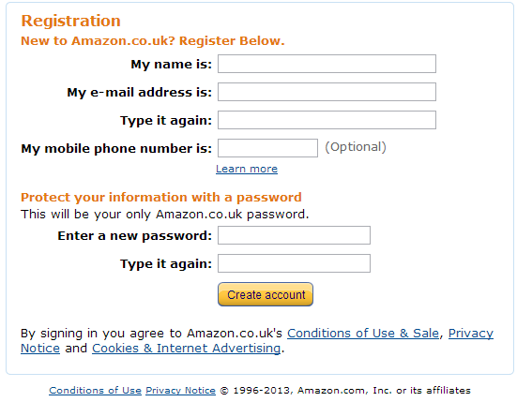
Some ‘fields’ are REQUIRED fields, this means you have to enter this information. Which is the only OPTIONAL field in the above form?

Why do you think it asks you for your mobile number?

Why does the password have to be entered TWICE?

One of the fields is VERIFIED and another one can be VALIDATED (a check to make sure that the data conforms to a rule, for example it starts in a certain way or is more than or less than a given number).
Which field is likely to be verified? _____________________________
Which field is likely to be validated? ____________________________
Account Activation
To activate an account, sometimes you have to click a link in an email sent to you by the web site. This is to verify that you typed in the correct email address.
What makes a STRONG password?
A strong password is hard to guess. They are at least 8 characters long, includes upper and lowercase letters and at least one symbol or number.
Bad passwords are: too short (therefore easy to hack) and too obvious, too simple (doesn’t include symbols, numbers etc therefore easy(ish) to hack)
Is this a good password? | Yes or No? | WHY?
Password
sm@rT13PANTS
GCSE123
cheddarcheese
M1iGH£RR74

How might someone get to know your password?

Remember my password?
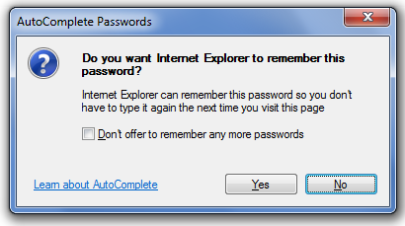
You should only consider this option if using a PRIVATE computer. If using a PUBLIC computer, the next person to use the computer could get into your account!

LOGGING OUT!
Remember to log out after using a web site on a public computer.

Secret Answer
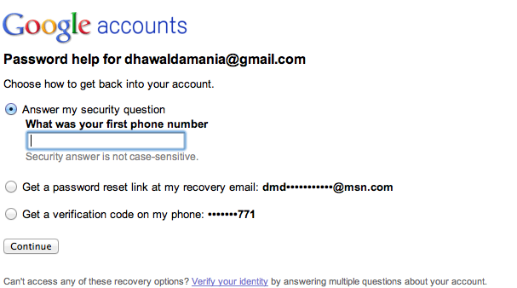
If you forget your password, you can get it back by:
- Answering a ‘secret’ question that only you know the answer to
- Getting a ‘reset’ hyperlink sent to your email inbox
- Getting a verification code sent to your mobile phone
Explain which of the above ‘reset’ methods you think is most convenient:

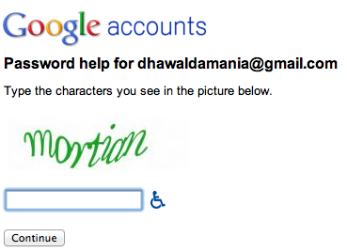
CHALLENGE RESPONSE Tests
These are used to stop automated software (‘robots’) from filling in the form. Robots can be designed to hack people’s accounts or send spam with online forms. Only a human should be able to verify the code, therefore stopping robots from being able to complete the form. They also add a level of security when logging in to sites such as for online banking.

e.g. 1: Captcha
The user has to type in the letters and/or numbers shown in a graphic.

e.g. 2: PIN Code
The user has to enter numbers from a PIN code using a drop down boxes.

Is it safe to pay online?
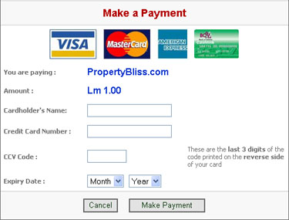 | 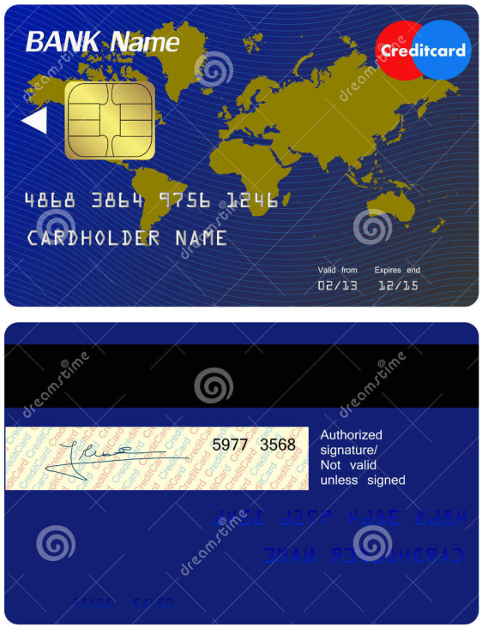
Circle the Credit Card Validation Code (CCV).
Bonus: Where is the error on the back of the above card?
CCVs are an added layer of security. If someone clones your credit or debit card, they won’t get the CCV number because it is not stored in the chip or the magnetic strip. This is required to process the transaction.
https:// means the organisation is using SSL (secure socket layer). The site has a security certificate. Your web browser will tell you if the certificate is out of date and therefore unreliable.
Make sure the site has https AND a padlock when making a payment.
https = data is encrypted = hackers can’t read the scrambled information.

Payment Methods
- Credit Card: the bank lends you the money when you make purchases. The buyer pays back the amount at a later date, sometimes with added interest.
- Debit Card: the money is taken directly from your account
- Third party account, e.g. PayPal – the PayPal account is funded by credit or debit card, or payments from other PayPal accounts.
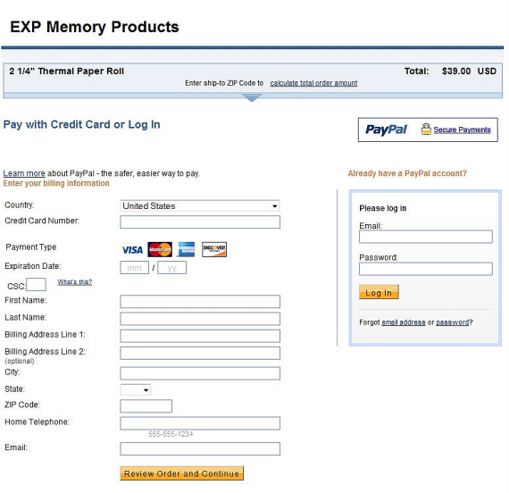
- Online gift voucher i.e. a code from a physical gift card is typed into the web site payment page. USEFUL IF YOU DO NOT WANT TO TYPE YOUR PAYMENT CARD NUMBER ONLINE
- Bank Transfer: payment is made via an online banking web site instead of through the shopping web site.

Third party payment processors >>>>>>>>>>>
It can be expensive and complicated for businesses to set up their own payment web site page because they have to purchase a security certificate and then connect to the banking system via payment gateways. It can be cheaper to use another web site to process payments on your behalf. E.g. PayPal, Sage

Verified by VISA / MasterCard Secure Code
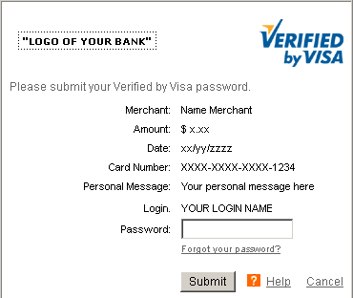
Another added level of security.
You can set up a password with your card. Every time you use a card, you have to type in the password. If someone has cloned your card, they won’t have the password so can’t use the cloned card online.

Quiz
Which of these do you NEVER need to type into a web site for them to process your payment  - Pin Number  - Card Number  - CCV Number  - Account Number  Simon is one of the 30% of Internet users who doesn’t like to type in his credit card details online. Which alternative method might he prefer?  - Debit Card  - Gift Card  To pay online using a bank transfer, you need:  - Online banking  - Debit Card  - Credit Card  - Gift Card | If the site is safe to make a payment, you should see:  - Padlock  - HTTP  - HTTPS  - Verified by Visa logo  If someone clones your card, what information will he/she not have which can stop them using it to pay for goods online?  - CCV Number  - Account Number  - Verification password/secure Code password  - Expiry date  CCVs are stored on the magnetic strip of a card. Is this…  - True  - False
EXAM QUESTION
1. Discuss the benefits and drawbacks to customers of shopping online [6].
2. Gia wants to buy a new pair of shoes. She decides to shop online.
(a)(i) Give two advantages of shopping online for shoes rather than buying from a shop. [2]
(a)(ii) Give one disadvantage of buying shoes online [1]
3. Other than the card number, what two other pieces of information do you need to enter from a card when paying online
4. Explain why web sites have CAPTCHA tests.

Online Banking
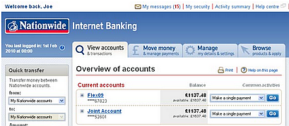
- Convenience - no queuing in banks, open 24x7
- Pay people directly and quickly online with no need for paper cheques or debit cards
- Transfer money to and from savings accounts to maximise interest
  - Interest: money that the bank gives you as a ‘thank you’ for lending them money.
- Keep track of transactions to improve budgeting
- Environmentally friendly: view statements online rather than those on paper sent in the post.

Avoiding online fraud
How criminals steal payment card details:
- ‘Skim’ the card when you’re not looking and create a clone
- Tamper chip and pin devices and ATMs to capture PINs and card details
- Write viruses* to steal passwords when using a computer by recording key presses and/or screen captures.
- Pretend to be calling from a bank/police, requesting PIN numbers
- Raiding bins with old receipts containing card details
- Phishing emails pretending to be from a bank requesting customers ‘reconfirm’ their security details on a fake web site
Offer advice on how to avoid becoming a victim of fraud.
*A common type is a Trojan. A Trojan is something that appears to be one thing, but actually contains a hidden nasty. For example it would be a virus infected game that is more sinister than it looks!

How to spot a phishing email:
- Impersonal: “Dear Valued Customer,”
- Badly written
- A sense of urgency: “You need to confirm your account with 24 hours or your account will be blocked”
- False links: The email ‘header’ or email ‘body’ contain false lines. E.g. www.nnationwide.com
- Attachments “Your parcel was not delivered. Please fill in and return the attached document”

How criminals use stolen card information
CNP Fraud (Customer not present) – criminals can make purchases over the phone where only the card number, expiry date and CVV number are needed to process a transaction (i.e. no pin is required).
KNOWLEDGE CHECK:
- Why do people use online banking?
- What methods do criminals use to capture card details?
- How can you avoid becoming a victim of card fraud?
- How do customers use stolen card information?

Personal data
Some companies e.g. Facebook, sell personal information. This information can be provided by you, or by your friends. It can be sold to marketing companies to help them to better direct marketing campaigns. Some companies sometimes misuse personal data or have data (e.g. payment card data, passwords) stolen.
Businesses can use your past shopping purchases to inform you of offers that may be relevant to you.
DISCUSSION POINTS:
- Do you think this is an invasion of your privacy?
- Are companies right to sell your personal information?
- Why is electronic data so much easier to misuse than paper data?

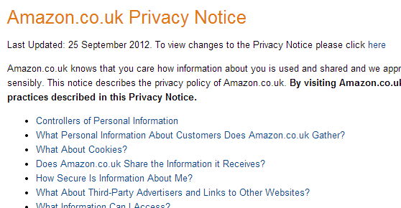
Protecting Data
The Data Protection Act 1998 is designed to protect your personal information.

Privacy Policy
Reputable companies have a privacy policy on their web sites to tell you exactly how your personal information is used.
It can be worth reading the small print!

How do you buy online?
Number these statements to put them into the most logical order:
Confirm the order
Enter payment information
Receive order confirmation and tracking number
Browse the web site for products
Add product to virtual basket
Track the order status
Enter delivery details
Select delivery options

