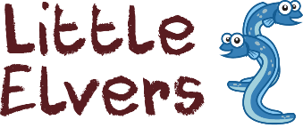

**Learning, growing, achieving together**

***An Active Learning Trust Academy***

**Behaviour Policy**

**September 2020**



# **School Ethos**

At Isle of Ely Primary School, we have the following core values:

|  |  |  |
| --- | --- | --- |
|  | **Empower** | To **empower** every pupil to take responsibility for their learning and confidently make decisions and choices for themselves. |
|  | **Include** | To **include** all children within our school and appreciate and celebrate our similarities and differences. We see children’s abilities, likes and dislikes as a learning opportunity for all and one which can enrich our lives. |
|  | **Community** | To value and develop strong partnerships with our parents and the wider **community** acknowledging our unique role within it and contributing as citizens. |
|  | **Inspire** | To **inspire** a love of learning and create a thirst for knowledge so that every pupil strives for personal and academic excellence. |
|  | **Support** | To **support** every child and ensure they feel valued and safe. To provide an environment where they can be recognised for their individual strengths, talents, effort and progress |
|  | **Respect** | To create an atmosphere of mutual **respect** and consideration for the ideas, values and feelings of others. |

These values are embedded across all aspects of the school to ensure a culture of positivity and inclusivity.

# **Rationale**

This policy outlines our approach to behaviour management throughout the school. It is recognised that appropriate behaviour is a pre-requisite to effective teaching and learning. Our philosophy is research-based and interwoven with the school’s ethos.

# **Aims for behaviour at Isle of Ely Primary School**

* For children and adults to be **ready** to learn, engage and consider the needs of others.
* To teach and expect **respect** for individuals, the school and its property, adhering to our values and ethos.
* For children and adults to keep themselves and others **safe.**

# **Roles and Responsibilities**

It is the responsibility of all members of a school community to develop prosocial[1] behaviour. Staff are expected to lead by example and support each other in promoting high quality interactions with others.

**The role of adults (including staff, parents, governors and community visitors)**

* To promote an awareness of everybody’s individual needs.
* To model pro-social behaviour and take pride in their school, their class, their work, their environment and their relationships with others.
* To treat children fairly, consistently and sensitively, demonstrating visible kindness.
* To celebrate and praise children’s achievements, successes and efforts.
* To collaborate effectively to find solutions to antisocial[2] behaviour.
* To actively teach children about prosocial behaviour.

**The role of children**

* Be ready to learn.
* To show respect to other people and the school environment, acting in line with the school’s values.
* To behave in a prosocial way so that they keep themselves and others safe.

# **The Curriculum**

We teach children how to behave in a prosocial manner through modelling, positive praise and direct teaching. Pupils are encouraged to participate actively in PSHE, PE and RE lessons as well as daily assemblies, all of which embed the school’s core values and ethos.

Staff are encouraged to create well-ordered and inviting learning environments that are conducive to high quality learning for all pupils. Playground staff promote a variety of activities so that team work, co-operation, fair play and sportsmanship are encouraged.

# **Praise, Reward and Celebration**

We believe that learners should be praised for demonstrating prosocial behaviour in school. There are a number of ways to do this including:

* **Recognition boards**

Children’s names are displayed on a classroom board to show that they are following the school’s rules.

* **House points**

Each child is allocated a vertical House team when they join the school so that they are working with children in every year group, including their siblings. Points can be awarded for excellent work, prosocial behaviour and taking part in a range of school competitions. These points are collected each week and the totals presented in the Headteacher’s celebration assembly.

* **Celebration assembly**

Each week an assembly is held to celebrate children’s achievements. Classroom staff decide upon a ‘star of the week’ and this child is presented with a certificate from the Headteacher and their name is added to the whole school’s ‘Recognition Board’.

# **Therapeutic Approaches**

We follow the Thrive Approach which is based on established neuroscience, attachment theory and child development. With a Thrive practitioner and a Pastoral Support Assistant working within the setting, our school is able to support children who are demonstrating distressed and / or antisocial behaviour. Staff create bespoke support plans for these children to ensure that there is a positive change in behaviour and improvement in a child’s mental health.

There is a distinction between developmental behaviour and persistently unacceptable, antisocial behaviour. Some children, including those with SEND (who have specific needs that impact on their behaviour), may find it difficult to maintain the high standard of behaviour. Therapeutic approaches, individualised plans and the support of external agencies may be required to ensure these children flourish at our school.

# **Consequences and Sanctions**

Alongside Thrive, we also follow the Cambridgeshire STEPS programme which aims to recognise pro and antisocial behaviour, emphasising the need to reflect, repair and restore.

Staff are trained to recognise the degree of seriousness and the kind of behaviour consequences that should be used. They must ensure that the consequences are reasonable, proportionate and necessary to adhere to the school rules of ‘Be Ready, Be Respectful, Be Safe’.

There are two types of consequences:

* **Educational Consequences**

The goal for this is to stop a child’s antisocial behaviour and support them in making prosocial choices. This involves helping to teach the child to learn from their behaviour.

Example: Child running down the corridor is asked to come back and walk down the corridor at break.

* **Protective Consequences**

The goal is to protect and therefore keep everyone safe including the child.

Example: Child has break at a different time to his/her peers as has shown extreme antisocial behaviour.

Sometimes, more serious or persistent antisocial behaviours need to be addressed by members of the Senior Leadership Team and / or the SENDCo. After any consequence has been issued, there is an expectation that the class teacher will work with the child, offering them an opportunity to repair and restore their relationship with peers and / or staff involved by completing a TalkTime sheet.

# **Behaviour Management Protocol**

When a child is not demonstrating prosocial behaviour, staff will manage each situation as discreetly as they can so as not to cause embarrassment to the child. Staff aim to use few words when talking to the child, making them aware of the pro-social behaviour they should be demonstrating. It is the responsibility of the class teacher to manage behaviour.

In class, staff will:

* 1. observe the antisocial behaviour
  2. use tactical ignoring and / or distraction techniques
  3. check the task set and alter the activity if needed
  4. work alongside the child briefly, using positive reinforcement methods
  5. consider whether the behaviour is difficult or dangerous.

In outdoor areas, staff will:

1. observe the antisocial behaviour
2. use tactical ignoring and / or distraction techniques
3. ask the child to change activity to work with an alternative group or within a different zone of the playground
4. walk alongside the child, briefly speaking to them about prosocial behaviour choices
5. consider whether the behaviour is difficult or dangerous.

If the antisocial behaviour continues, the staff will make a decision based on their professional judgement as to whether it constitutes difficult or dangerous behaviour.

Examples of difficult behaviour: Putting their equipment down, refusing to start their work, rocking on their chair, poking peers, going under the table, putting equipment in their mouth, shouting out, refusing to share equipment, refusing to come into class, struggling to transition to the next topic, wandering around.

Difficult behaviour includes high anxiety behaviours, where there is not imminent danger such as swearing, pushing, kicking, spitting, shouting and throwing objects.

Dangerous behaviour: Where someone or something is in imminent danger.

This will lead to an appropriate pathway of support and intervention:

|  |  |
| --- | --- |
| **Difficult behaviour:** | **Dangerous behaviour:** |
| 1. Remind and refocus.  2. Give the pupil limited choices (“this or this”).  3. Temporary removal from the activity (quick job / distraction).  4. Move pupil within the class.  5. Discuss possible consequences.  6. Send pupil to a partner teacher’s classroom with work (refocus on return with positive reinforcement).  7. Talk Time sheet completed with class teacher and pupil. | 1. Teacher to use the de-escalation script (SLT member on call if needed).  2. Provide a supportive environment for the pupil to calm.  3. Ensure other pupils are safe.  4. Once calm, undertake Talk Time with the pupils involved.  5. SLT member to review the incident with staff involved and determine consequences together.  6. Teacher to ensure educational and protective consequences are followed through.  7. Teacher to debrief with SLT.  8. Teacher or SLT member to inform the parent/carer of the incident and measure put into place to help their child learn. |

1. **Reasonable force**

The Department for Education recognises that in some situations, reasonable force is needed to keep children and staff safe. They have a clear definition on what reasonable force is and when / why it should be used.

There are a number of staff at Isle of Ely who have had the appropriate, up-to-date training from Team Teach on safer restraint. No member of staff ever wants to use this training but there are circumstances when this is the only option. During / after such an event, parents will be called.

Staff will also be offered an opportunity to debrief with a member of the Senior Leadership Team or Governing Body.

1. 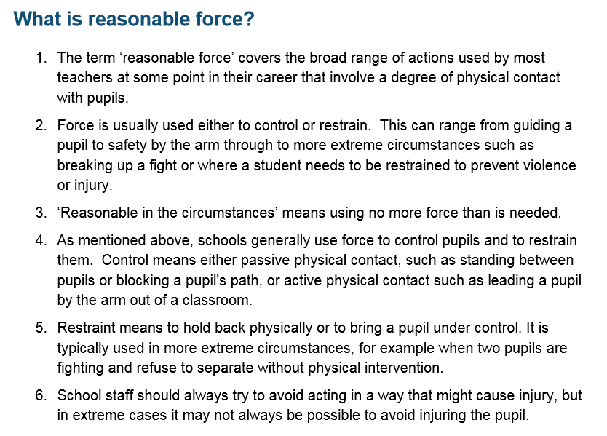**Reporting**

Both prosocial and antisocial behaviour will be recorded. All TalkTime sheets to be given to SLT for recording and monitoring.

1. **Parental involvement**

As a school we understand the importance of the partnership and communication with parents and therefore we will communicate with parents about the behaviour of their child when a TalkTime sheet has been completed parents will be informed at the end of the day. If antisocial behaviour continues and more than 5 TalkTime sheets have been completed in a Half Term the teacher will meet informally with parents to discuss support strategies. If a further 3 TalkTime sheets have been completed or there has been dangerous behaviour parents will meet with Class Teacher and a member of SLT and/or SENDCO.

Prosocial behaviour will be shared with parents with ‘Stars of the week’ being celebrated on the Newsletter.

The behaviour policy will be shared with parents annually.

**Appendix 1**

**De-escalation Script**

* **Learner’s name**
* **I can see something has happened**
* **I am here to help**
* **Talk and I will listen**
* **Come with me and……..**

Appendix 2

**Talk Time**

|  |  |
| --- | --- |
| **Name:** |  |
| **Date:** |  |
| **Completed with:** |  |

How were you feeling?

What happened?

How can you repair?

How could you be prosocial next time?

What were the antisocial actions?

1. Prosocial: relating to or denoting behaviour which is positive, helpful, and intended to promote social acceptance and friendship.
2. Antisocial: unwilling or unable to associate in a normal or friendly way with other people.