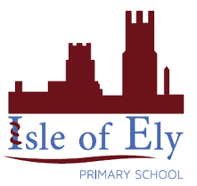

**Learning, growing, achieving together**

***An Active Learning Trust Academy***

**Behaviour Policy**

**September 2024**

|  |  |
| --- | --- |
| **Lead author/initiator(s):** | Natalie Godfrey, Deputy Head teacher |
| **Approved by:** | , Chair of Governors |
| **Approval Date:** | September 2024 |
| **Review Date:** | September 2025 |
| **Version No:** | 2.0 |
| **Ratified by:** | Local Governing Body (Isle of Ely & Chesterton Primary Schools) |
| **Date Ratified:** |  |
| **Signed :** | |
| **Review Timetable:** | Bi-annual Review |
| **Review:** | The document should be updated bi-annually after ratification or earlier if there is any new local or national guidance, changes in process or legislation. |
| **Purpose of Document:** | To comply with legislation & guidance including: |
| **Implementation:** | The policy can be accessed via the Staff Share and through any mandatory updates. |
| **Dissemination:** | The policy will be available to all staff, teaching and non-teaching, and to the wider public via the website. |

# **ActiveLearningTrust_logo_mono_edited**

# **School Ethos**

At Isle of Ely Primary School, we have the following core values:

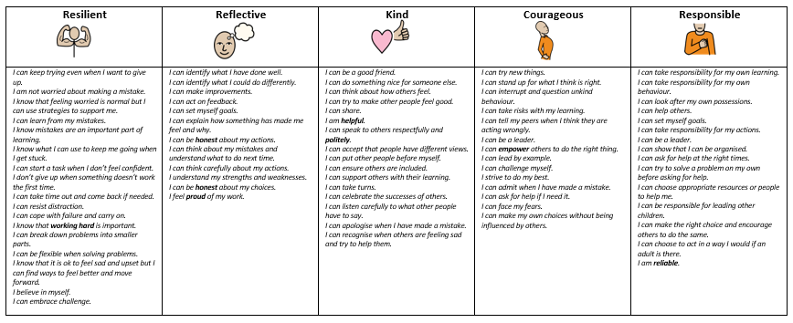

As part of the Active Learning Trust we ensure that our behaviour policy is built upon six principles:

1. High expectations
2. Clarity of systems and processes
3. Consistency
4. Parental support and partnership
5. All staff understanding and knowing their role
6. Loving

Further explanation of these six principles can be found in the ALT behaviour guidance documents. We use these principles when evaluating behaviour and attitudes across the school to ensure that it is consistently high.

# **Rationale**

This policy outlines our approach to behaviour management throughout the school and sits alongside our behaviour curriculum. It is recognised that appropriate behaviour is a pre-requisite to effective teaching and learning. Our philosophy is research-based and interwoven with the school’s ethos. All behaviour is communication, what is happening and why.

# **Aims for behaviour at Isle of Ely Primary School**

* A school culture that reflects the school values of kind, courageous, reflective, responsible, respectful and resilient is created.
* All children are aware of what valued behaviour and detrimental behaviour looks like.
* All children understand and follow class and school based routines and expectations.
* Pupils are self-reflective of their own behaviours.
* When pupils do misbehave, all members of staff are able to consistently follow the behaviour policy.

# **Roles and Responsibilities**

It is the responsibility of all members of a school community to develop valued[[1]](#footnote-2) behaviour. Staff are expected to lead by example and support each other in promoting high quality interactions with others. Behaviour incidents are ‘teachable moments’. Each restorative conversation and consequence is an opportunity to reflect upon what has happened, understand it better and learn how to do things differently.

**The role of Senior Leaders**

Leaders are highly visible throughout the school day and routinely engage with pupils, parents and staff on maintaining the behaviour culture. Leaders ensure that new staff are inducted clearly into the school’s behaviour culture and regularly revisit and train staff to meet their duties. The Deputy Head teacher for vulnerable pupils tracks the children’s behaviour through the use of Class Dojo and behaviour logs and supports staff in responding to behaviour incidents.

**The role of staff:**

Staff are responsible for:

• Implementing the behaviour policy consistently in relation to our three school rules

• Modelling valued behaviour

• Teaching the behaviour curriculum

• Treating children fairly, consistently and sensitively, demonstrating visible kindness.

• Providing a personalised approach to the specific behavioural needs of particular pupils

• Recording both valued and detrimental behaviour on Class Dojo and Behaviour Logs

**The role of children:**

To follow our three school rules:

|  |  |  |
| --- | --- | --- |
| Safe | Ready | Respect |
| * We follow instructions. * We do not tolerate bullying or unkindness of any kind. * We walk sensibly around school. * We sit sensibly in the classroom. * We tell an adult if we are feeling worried about anything. * We stay safe online. * We use equipment safely. | * We arrive at school on time every day. * We wear the correct uniform or PE kit. * We show we are ready for learning by not talking and facing the front of class. * We complete learning on time. * We make sure we have the correct equipment for lessons. * We take part fully in lessons and try our best. | * We always listen to adults and peers. * We use good manners and are polite. * We hold doors open for people. * We respect difference and know that we are all equal. * We look after our school. * We respect school property by looking after it. * We look after the environment. * We respect everyone’s right to learn. * We speak kindly and politely. * We show tolerance for others. * We value the opinions of others even if they are different from our own. |

**The role of parents**:

Parents can help by recognising that an effective School Behaviour Policy requires close co-operation between parents, teachers and children. Parents should discuss the school rules with their child, emphasising that they support the rules. Attending Parents’ Evenings and parents’ functions and by developing informal contacts with school helps to reinforce their support for the Policy. Learning and teaching cannot take place without sound discipline and parents should recognise that staff will deal with behaviour problems patiently and positively.

Parents are expected to:

• Reinforce and support their child in following the three school rules.

• Inform the school of any changes in circumstances that may affect their child’s behaviour

• Discuss any behavioural concerns with the class teacher

# **The Curriculum**

We teach children how to behave in a positive manner through modelling, positive praise and direct teaching – please see our Behaviour Curriculum document. Pupils are encouraged to participate actively in PSHE, PE and RE lessons as well as daily assemblies, all of which embed the school’s core values and ethos.

Staff are encouraged to create well-ordered and inviting learning environments that are conducive to high quality learning for all pupils. Playground staff promote a variety of activities so that team work, co-operation, fair play and sportsmanship are encouraged.

# **Praise, Reward and Celebration**

We believe that pupils should be praised for demonstrating valued behaviour in school. There are a number of ways to do this including:

* **Recognition boards**

Children’s names are displayed on a classroom board to show that they are following the school’s rules or demonstrating a school value.

* **House points**

Each child is allocated a vertical House team (Red, Blue, Green and Yellow) when they join the school so that they are working with children in every year group, including their siblings. Points can be awarded for following the three school rules or demonstrating the school values and are recorded on Class Dojo. These points are collected each week and the totals presented in the Headteacher’s celebration assembly. At the end of each half term, the house with the most points is able to have a collective reward as decided by the house captains e.g. extra playtime, non-school uniform, milkshake and a cartoon.

* **Celebration assembly**

Each week an assembly is held to celebrate children’s achievements linked to the school values. Classroom staff can choose children to receive a Head Teacher’s Award for demonstrating any of the school values and these are presented in assembly and shared on the whole school recognition board.

# **Therapeutic Approaches**

We follow the Thrive Approach which is based on established neuroscience, attachment theory and child development. With a Thrive practitioner and a Pastoral Support Assistant working within the setting, our school is able to support children who are demonstrating dysregulated and / or detrimental behaviour. Staff create bespoke support plans for these children to ensure that there is a positive change in behaviour and improvement in a child’s mental health.

There is a distinction between developmental behaviour and persistently unacceptable, detrimental behaviour. Some children, including those with SEND (who have specific needs that impact on their behaviour), may find it difficult to maintain the high standard of behaviour. Therapeutic approaches, individualised plans and the support of external agencies may be required to ensure these children flourish at our school.

# **Consequences and Sanctions**

There will be times when children behave unacceptably. Children need to discover where the boundaries of acceptable behaviour lie, as this is a part of growing up.

Alongside Thrive, we also follow the Therapeutic Thinking programme which aims to recognise valued and detrimental behaviour, emphasising the need to reflect, repair and restore.

Staff are trained to recognise the degree of seriousness and the kind of behaviour consequences that should be used. They must ensure that the consequences are reasonable, proportionate and necessary to adhere to the school rules of ‘Be Ready, Be Respectful, Be Safe’.

After any consequence has been issued, there is an expectation that the class teacher will work with the child, offering them an opportunity to repair and restore their relationship with peers and / or staff involved by holding a restorative conversation.

There are two types of consequences (see appendix 2 for examples):

* **Educational Consequences**

The goal for this is to stop a child’s detrimental behaviour and support them in making valued behaviour choices. This involves helping to teach the child to learn from their behaviour.

Example: Child running down the corridor is asked to come back and walk down the corridor at break.

* **Protective Consequences**

The goal is to protect and therefore keep everyone safe including the child.

Example: Child has break at a different time to his/her peers as has shown extreme detrimental behaviour.

Sometimes, more serious or persistent detrimental behaviours need to be addressed by members of the Senior Leadership Team.

# **Behaviour Management Protocol**

When a child is not demonstrating valued behaviour, staff will manage each situation as discreetly as they can so as not to cause embarrassment to the child in a caring, supportive and fair manner, having regard to the age of the child. Staff aim to use few words when talking to the child, making them aware of the valued behaviour they should be demonstrating. It is the responsibility of the class teacher to manage behaviour.

Staff will observe the detrimental behaviour and consider whether the behaviour is difficult or dangerous based on their professional judgement.

**Dangerous behaviour:** Behaviour which will imminently result in injury to self or others, damage to property or behaviour that would be considered criminal if the person was the age of criminal responsibility, such as racist abuse.

**Difficult behaviour:** Behaviour that is detrimental, but not dangerous.

*Difficult behaviour includes high anxiety behaviours, where there is not imminent danger such as swearing, spitting, shouting and throwing objects.*

This will lead to an appropriate pathway of support and intervention:

|  |  |  |
| --- | --- | --- |
| 1 | 2 - Behaviour log completed | 3 – Behaviour log completed and SLT involvement |
| Low level disruption including:   * Calling out * Chatting * Off task * Making noises * Not following instructions * Inappropriate noise level * Swinging on chair | * **Persistent** low level disruption after reminder is given * Refusal to complete learning * Wandering around or leaving class * Name calling/insults * Disrespectful body language e.g. rolling eyes, shrugging, stomping feet etc * Talking back disrespectfully * Taking others’ belongings without asking * Throwing objects * Refusing to come into class * Going under the table and refusing to come out * Swearing * Shouting * Spitting | * **Persistent** level 2 behaviours – *three behaviour logs within the same half term* * Dangerous behaviour * Bullying * Homophobia * Racism * Repeated inappropriate ‘banter’, teasing etc * Physically hurting others * Inappropriate online behaviour * Carrying an offensive weapon * Play fighting * Theft * Damage to property * Sexual misconduct |
| Staff may use these strategies:   * Remind and refocus * Tactical ignoring/distraction techniques * Adjust the task if needed * Work alongside child briefly * Positive reinforcement strategies e.g. proximal praise * Give the pupil limited choices – ‘this or this’ * Move pupil within the class * Discuss possible consequences if behaviour is not improved | * Pupil may be sent to a partner teacher’s classroom with work (refocus on return with positive reinforcement) * Educational/protective consequence * Restorative conversation with pupil and member of staff who initially dealt with the behaviour * Behaviour log completed and recorded on Class Dojo * Parents contacted by class teacher | * See below for dangerous behaviour which needs de-escalating * Educational/protective consequence * Restorative conversation with pupil and member of staff who initially dealt with the behaviour * Behaviour log completed and recorded on Class Dojo * Parents contacted by class teacher and/or SLT * SLT involvement – children may be placed on report with a personalised target linked to the three rules for at least a week   *If behaviour is not improved whilst a child is on report, the Deputy Head teacher for vulnerable pupils and Class Teacher (and SENDCo if the pupil has an identified SEN) will use the Therapeutic Thinking tools to analyse and implement a personalised behaviour plan to support the pupil.* |

|  |
| --- |
| **Dangerous behaviour which requires de-escalation (SLT or Pastoral Support can be called if needed):** |
| 1. Teacher to use the de-escalation script (see Appendix 1).  2. Provide a supportive environment for the pupil to calm.  3. Ensure other pupils are safe.  4. Once calm, undertake restorative conversation with the pupils involved.  5. SLT member to review the incident with staff involved and determine consequences together.  6. Teacher to ensure educational and protective consequences are followed through.  7. Teacher to debrief with SLT.  8. Teacher or SLT member to inform the parent/carer of the incident and measure put into place to help their child learn. |

1. **Child-on-Child abuse**

We recognise that child-on-child abuse can manifest itself in many ways. We have created a whole school protective ethos in which child-on-child abuse, including sexual violence and sexual harassment will not be tolerated and provided training for staff about recognising and responding to child-on-child abuse, including raising awareness of the gendered nature of peer abuse, with girls more likely to be victims and boys perpetrators. We have included within the curriculum, information and materials that support children in keeping themselves safe from abuse, including abuse from their peers and online and we provide high quality Relationship and Sex Education (RSE) and/or enrichment programmes including teaching about consent. We ensure that staff members follow the procedures outlined in this policy when they become aware of child-on-child abuse, referring any concerns of child-on-child abuse to the Designated Safeguarding Lead (or deputy) in line with safeguarding reporting procedures. If child-on-child abuse happens, the following protocol will be put in place:

* Immediate protective consequences implemented
* Both children’s parents informed
* Restorative conversations with both parties facilitated by the Deputy Head teacher for vulnerable pupils
* Support put in place for both parties
* Recorded on Myconcern
* SLT to monitor and check in with both parties regularly

1. **Reasonable force**

The Department for Education recognises that in some situations, reasonable force is needed to keep children and staff safe. They have a clear definition on what reasonable force is and when / why it should be used.

There are a number of staff at Isle of Ely who have had the appropriate, up-to-date training from Team Teach on safer restraint. No member of staff ever wants to use this training but there are circumstances when this is the only option. During / after such an event, parents will be called.

Staff will also be offered an opportunity to debrief with a member of the Senior Leadership Team or Governing Body.

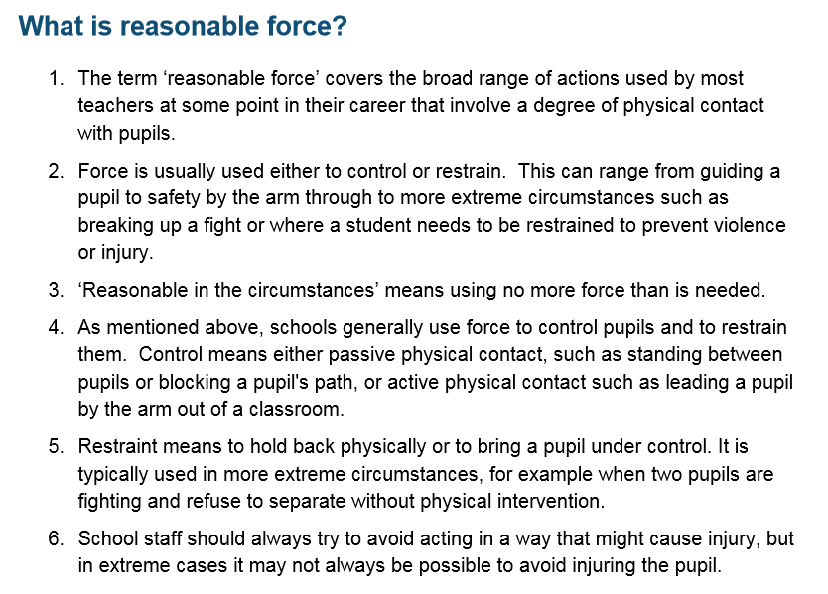

1. **Reporting**

Both prosocial and antisocial behaviour will be recorded on Talk Time sheets. All Talk Time sheets to be given to SLT for recording and monitoring. These are tracked by our Deputy Head for vulnerable pupils

1. **Parental involvement**

As a school we understand the need for a positive and helpful relationship between school and parents based on open communication, mutual respect, and collaborative problem-solving and seek to gain valuable insights into a pupil’s home environment and individual needs, enabling us to tailor interventions effectively. Parental involvement promotes consistency between home and school environments, reinforcing expectations and reinforcing positive behaviours across settings and empowering parents as active partners, cultivating a sense of community and shared responsibility for the outcomes for pupils.

If a behaviour log is completed the Class Teacher will inform parents at the end of the day and this will also be logged on Class Dojo for parents to see as a ‘Behaviour Log point’ – this will not take any house points away and is set to zero. If a pupil receives three behaviour logs in within the same half term, the Deputy Head teacher for Vulnerable Pupils will meet with parents and the pupil will be placed on report for at least a week with a personalised target relating to our three school rules. If behaviour is not improved whilst a child is on report, the Deputy Head teacher for Vulnerable Pupilsvulnerable pupils and Class Teacher (and SENDCo if the pupil has an identified SEN) will use the Therapeutic Thinking tools to analyse and implement a personalised behaviour plan to support the pupil ensuring parents are consulted and informed.

Valued behaviour is shared with parents through the use of Class Dojo where parents can see the house points their child has been given for any of the school rules or values. Children who have received Head Teacher Awards during Celebration Assembly, will be shared on the Class Dojo school timeline. , will be shared

1. **Banned Items**

This list below of banned items is not exhaustive but if we believe a child has brought any one of these items to school, a member of SLT can search the pupil:

* Drugs, alcohol, knives, cigarettes, porn, any weapon and stolen property

The behaviour policy will be shared with parents annually.

**Appendix 1**

**De-escalation Script**

* **Learner’s name**
* **I can see something has happened**
* **I am here to help**
* **Talk and I will listen**
* **Come with me and……..**

**Appendix 2**

**Examples of Educational Consequences**

|  |  |  |
| --- | --- | --- |
| Behaviour | Rule Broken | Educational Consequences |
| Consistently shouting out | Ready  Respect | Deliberate practice at break time |
| Not completing work | Ready | Complete work at either break or lunchtime |
| Saying unkind words | Respect | Write a letter of apology |
| Talking in the line | Ready  Respect | Children practise walking up and down the corridor at break/lunchtime |
| Make a mess | Ready  Respect | Child cleans up the mess |
| Break something | Respect | Repair/replace and apologise. Write a poster about the meaning of respect |
| Consistently talking over others | Respect | Deliberate practise/written reflection |
| Spitting on tables | Respect  Safe | Clean the tables |
| Hurting someone | Respect  Safe | Write a letter of apology  Poster of ways to play safely  Plus protective consequence |

**Examples of Protective Consequences**

|  |  |  |
| --- | --- | --- |
| Behaviour | Rule Broken | Protective Consequence |
| Hurting someone | Safe  Respect | Loss of break times |
| Shadow an adult who can point out examples of good behaviour |
| Separate break times |
| Differentiated teaching space |
| Removal |
| Suspension |

All consequences should be derived though logic and naturally follow an action.

**Appendix 3**

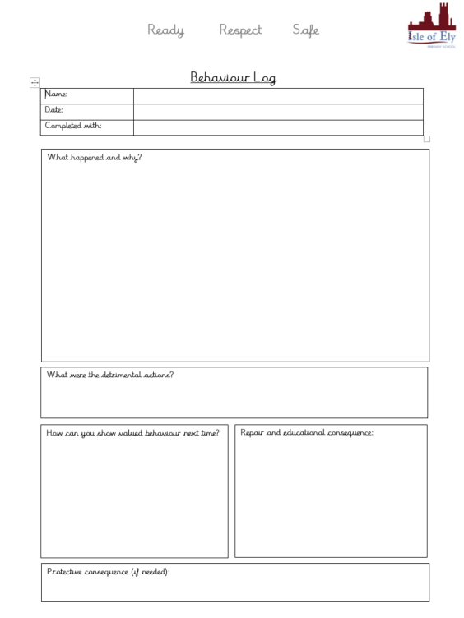

**Appendix 1**

|  |  |
| --- | --- |
| **Rapid Equality Impact Assessment Tool** | |
| When looking at the impact on the equality groups, you must consider the following points in accordance with General Duty of the Equality Act 2010:  In summary, those subject to the Equality Duty must have due regard to the need to:   * eliminate unlawful discrimination, harassment and victimisation; * advance equality of opportunity between different groups; and * foster good relations between different groups | |
|  |  |

|  |  |  |
| --- | --- | --- |
| **EQUALITY IMPACT ASSESSMENT – WHAT IS THE IMPACT TO DIFFERENT GROUPS IN SOCIETY?** | | |
| **Choose either Positive or Negative impact.**  **POSITIVE it could benefit or would have very little or no impact. NEGATIVE it could disadvantage.**  **Please provide supporting comments, both on positive and negative impacts.**  **You may be asked to complete a FULL EQUALITY IMPACT ASSESSMENT to understand the impact further.** | | **COMMENTS** |
|  | **Positive or negative?** |  |
| **Age**: Consider and detail across age ranges on old and younger people. This can include safeguarding, consent and child welfare. | **Positive** |  |
| **Disability**: Consider and detail on attitudinal, physical and social barriers. | **Positive** |  |
| **Race**: Consider and detail on difference ethnicities | **Positive** |  |
| **Sex**: Consider and detail on boys and girls, men and women | **Positive** |  |
| **Gender reassignment**: (including transgender) Consider and detail on transgender and transsexual people. This can include issues such as privacy of data and harassment | **Positive** |  |
| **Sexual orientation**: Consider and detail on heterosexual people as well as lesbian, gay and bi-sexual people. | **Positive** |  |
| **Religion or belief**: Consider and detail on people with different religions, beliefs or no belief. | **Positive** |  |
| **Pregnancy and maternity**: Consider and detail on working arrangements, part-time working, and infant caring responsibilities. | **Positive** |  |
| **Marriage and civil partnership status** | **Positive** |  |
| **Environment**: Consider impact on transport, energy and waste | **Positive** |  |
| **Other identified groups**: Consider and detail and include the source of any evidence on different socio-economic groups, area inequality, income, resident status (migrants) and other groups experiencing disadvantage and barriers to access e.g. Language barriers. | **Positive** |  |
| **Were any NEGATIVE impacts identified?** | No |  |
| **If YES please contact the Equality & Diversity Lead to complete a full Equality Impact Assessment** | | |

1. Valued behaviour: relating to or denoting behaviour which is positive, helpful, and intended to promote social acceptance and friendship. [↑](#footnote-ref-2)