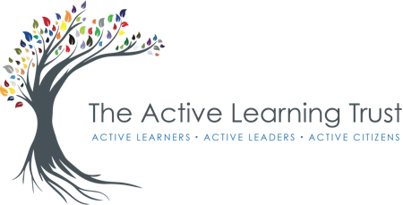

Consultation on Admission Arrangements for 2025/26
30th October 2023 to 8th December 2023
In accordance with the Department for Education’s School Admissions Code, The Active Learning Trust is required to consider Published Admission Numbers (PANs) for all its schools on an annual basis.
In addition, the Admissions Code states that “there is a requirement that Admission Authorities MUST consult on their admission arrangements at least once every 7 years, even if there have been no changes during that period, and no changes are being proposed”. This consultation paper has been written to meet that requirement and no changes are being recommended to the Published Admission Number (PAN) for the Active Learning Trust schools that are listed.
As the Admitting Authority, and to comply with the requirement listed above, The Active Learning Trust (ALT) is seeking views on the admission arrangements for the admissions year 2025-26. All schools within the ALT follow the Admissions Code and the law relating to admissions. This accords with the Trust’s funding agreement with the Department for Education.
Cambridge County Council will continue to co-ordinate the admission arrangements for the normal year of entry (Year 7 for secondary schools and Year R for primary schools) and ALT will continue to administer in-year applications and appeals. Parents wishing to apply for a school place outside of a normal year of entry should email: ALTAdmissions@activelearningtrust.org for further information.
The current Published Admission Numbers (PANs) are listed below. Arrangements for when a school receives a higher number of applications than it has places available will remain the same, with an over-subscription criteria being used to determine which pupils are allocated a place.
Children who have a Statement of Special Educational Needs, or an Education, Health and Care plan which names the school, must by law be offered a place at that school.
Given below is a summary of the oversubscription criteria proposed:
For applications to the normal year of entry, these criteria will be applied according to the circumstances existing by midnight at the end of the closing date for applications. For in-year applications, these criteria will be applied according to circumstances existing at the time of applications.
A: A ‘looked after child’ or child who was previously looked after, but ceased to be so because they were adopted or became subject to a child arrangement order or special guardianship arrangements immediately following having been looked after. (A looked after child is a child who is (a) in the care of a local authority, or (b) being provided with accommodation by a local authority in the exercise of its social services functions (see definition in section 22(1) of the Children Act 1989).
This includes children who appear to the Admission Authority to have been in state care (i.e. in the care of or accommodated by a public authority, religious organisation or any other provider whose sole/main purpose is to benefit society) outside of England but ceased to be so as a result of being adopted only.
B: Children with a sibling attending the school at the time of application who is reasonably expected to still be attending the school at the proposed time of admission.
C: Other children by distance from the school with priority for admission being given to those living nearest to the school as measured by a straight line.

As part of the consultation process, you are entitled to give your views on the admission arrangements.
Full details of each school’s arrangements can be found on individual school websites.
You can do this by either:-
Writing to Admissions, The Active Learning Trust, c/o Cromwell Community College, Wenny Road, Chatteris, Cambs., PE16 6UU or Emailing: ALTAdmissions@activelearningtrust.org
Responses must be received no later than noon on 8th December 2023.

SCHOOL | PAN
Neale-Wade Academy | 240
Cromwell Community College – secondary phase | 240
Cromwell Community College -primary phase | 30
Kingsfield Primary School | 60
Earith Primary School | 20
Chesterton Primary School | 30
Isle of Ely Primary School | 60

