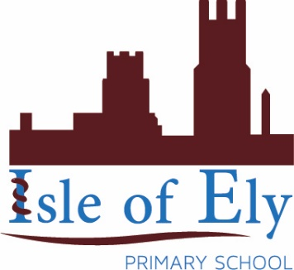

Learning, growing, achieving together
An Active Learning Trust Academy

Enforced Closure Policy
January 2021

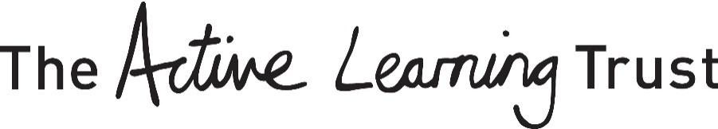

Enforced School Closure
In the event of disruption due to adverse weather conditions or for example heating failure or heavy snow, Isle of Ely Primary School considers the safety of all children, staff and visitors. Any decision taken to close the school will be made as quickly as possible by the Head teacher, at 0800 at the latest, and we will notify all parents and carers as follows:
Radio
We will inform BBC Radio Cambridgeshire, Star Radio and Heart, our local radio stations. Please ensure you listen early and keep up to date for any announcements and/or updates. They will also publish the information of school closures on their website:
www.bbc.co.uk/radiocambridgeshire
https://www.heart.co.uk/cambridge/
www.star.radio
If you do not hear or see Isle of Ely Primary School listed on their website, this means we will be open and your child is required to attend school as normal.
Text Message
We will inform parents/carers by text message via parentmail. It is essential that we hold the most up to date contact details, including mobile, work and landline telephone numbers.
Website
An announcement will be published on our school website. This will be on the homepage, at the top of the page and will inform you of the closure.
Twitter
We will make a post on our schools’ Twitter page for parents/carers to see. This can be found by following:
@isleofelyschool
Local Authority
Details of all school closures will be found on the Local Authority’s website.
https://www.cambridgeshire.gov.uk/residents/children-and-families/schools-learning/school-term-dates-closures/school-closures

