Homework pack for students attending Isle of Ely Primary School

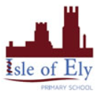
General Offline Work:
The staffing team has put together a list of activities and websites that your children can partake in whilst off school. Below is a menu of offline activities that do not rely on an internet connection or access to a computer.
Early Years – Reception
Big Question: Is Rosie clever or is the fox silly?
Personal, social and emotional- feelings and sharing | - Read stories together and discuss themes within the book.  Our focus story for the next two weeks are:  Rosie’s Walk by Pat Hutchins  https://www.youtube.com/watch?v=eifx8qR7U_8  Where, Oh Where, is Rosie's Chick by Pat Hutchins https://www.youtube.com/watch?v=whP9GVKn4AE  You can also share one of these stories with your child:  - Mr. Gumpy’s Outing by John Burningham https://www.youtube.com/watch?v=Mi_DV_DWN8M  - Beware of the Cat by Jill Eggleton  https://www.youtube.com/watch?v=r5QWSgfLM-4  - Planting a Rainbow by Lois Ehlert  https://www.youtube.com/watch?v=sti3PXBeVag  - Up, Down, and Around Gardening Book by Katherine Ayres https://www.youtube.com/watch?v=IFUwZJVDifU  - Oliver's Vegetables by Vivian French and Alison Bartlett https://www.youtube.com/watch?v=UcxnE4Xh0-g  - Farmer Duck by Martin Waddell and Helen Oxenbury  https://www.youtube.com/watch?v=KnMMNCJHd0s  Oxford owl books- https://www.oxfordowl.co.uk/for-home/find-a-book/library-page/?view=image&query=&type=book&age_group=Age+4-5&level=&level_select=&book_type=&series=#  Encourage the children to talk about  - Characters feelings and why they could be feeling that way  - Character’s actions and their consequences  - What is going to happen next – anticipating the key events  - Play board games to practice taking turns, waiting and following instructions.  - Start a Feelings Diary – encourage your child to choose one emotion they experienced each day and talk about what made them feel that way. You find a feelings diary and chart, as well as other helpful resources, here:  https://www.partnershipforchildren.org.uk/what-we-do/childrens-wellbeing-activities-for-teaching-staff-and-families.html
Writing -  Practice handwriting- Read Write Inc. | 1. Create a story map to show fox’s adventures as he follows Rosie.  2. Write a short sentence for each picture, i.e. Fox stands on the rake. Fox falls in the pond.  3. Draw a map of Rosie’s way around the farm.  4. Use the map and the sentence starter ‘Rosie went...’ to write labels for her steps, i.e. ‘Rosie went around the pond.  Tricky words- https://www.youtube.com/watch?v=TvMyssfAUx0  https://www.youtube.com/watch?v=R087lYrRpgY  Encourage your child to use their Fred Talk and Fred Fingers to help them write the words.
Reading - Phonics  Story focus:  ‘Rosie’s Walk’ and ‘Where, Oh Where, is Rosie’s Chick’ by Pat Hutchins | 1. Review Set 1 sounds and letter formation. (m,a,s,d,t,i,n,p,g,o,c,kb,f,e,l,h,sh,r,j,v,y,w,th,z,ch,qu,x,ng,nk)  2. RWI daily exercises for Set 1/2 sounds.  3. Create words using Set 1 and set 2 sounds and ask the children to Fred Talk and Read the word to spot whether they can identify the sounds. i.e: write mat for your child to say ‘m-a-t mat’ or ‘sh-i-p ship’  4. Ask your child to identify the special friends in their writing or reading.  5. Have a go at learning the new sounds:  - igh (fly high) using online RWI lesson:  Read Write Inc (RWI) Phonics Lesson Speed Sounds Set 2 – ‘igh’  https://www.youtube.com/watch?v=Y46--B_7BMs  - ay (May I play)  https://www.youtube.com/watch?v=WL_-QHxJnFQ  - oo (Poo at the zoo)  https://www.youtube.com/watch?v=5s5P-iSSJsU  - ee (What can you see?)  https://www.youtube.com/watch?v=M1uW4OtU7aU  Set 1 Sounds - https://www.youtube.com/watch?v=hCBzNnSSxds  Set 2 Sounds - https://www.youtube.com/watch?v=qlU3Dg8upXM  Read, Write Inc - https://www.youtube.com/channel/UCo7fbLgY2oA_cFCIg9GdxtQ  Phonics play- https://www.phonicsplay.co.uk/ Username: march20 Password: home  Bumble bear- https://www.youtube.com/watch?v=j5DVMNVG2Ms
Maths – number formation, counting to 20, money | - Count in ones up to 20, going forwards and backwords.  Count jumps, claps, steps; count loudly, quietly or using silly voices (i.e. in a bossy voice, whisper or squeaking like a mouse).  - Count on from a given number, ask a child to recall a number you point to and count on forwards. You can do it inside or outside, for example using digits in house numbers and counting steps from that number (up to twenty).  - Introduce repeating patterns, you can create repeating patterns using paint and fingers; rocks, leaves and sticks; by lining up toys or everyday objects, such as cutlery.  - Continue comparing money. How many different ways can you make 5p, 10p and 20p?  Continuous:  Number formation - https://www.youtube.com/watch?v=qfcbWmASibk  Numbers bonds to 10- https://www.youtube.com/watch?v=lD9tjBUiXs0  Shape- https://www.youtube.com/watch?v=svrkthG2950  Doubles - https://www.youtube.com/watch?v=8jOzhiACB68  Money- https://www.topmarks.co.uk/Search.aspx?q=money  Topmarks- https://www.topmarks.co.uk/Search.aspx?Subject=16&AgeGroup=1 Some really good interactives games for counting, ordering and adding numbers.  Days- https://www.youtube.com/watch?v=oKqAblcwFOA
Expressive arts and design | 1. Create a farm for Rosie to walk around.  2. Make face masks or puppets to retell Rosie’s Walk story.  3. Pretend you are a hen walking around the farm or a fox following the hen. What sound will you make? How will you move? What would you look like? How would you feel to the touch? Think about colours and textures.  4. Make a hen or fox collage, using things you can find in your house or outside.  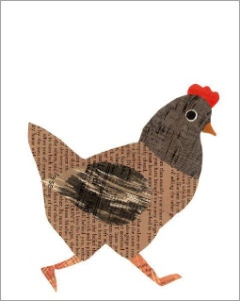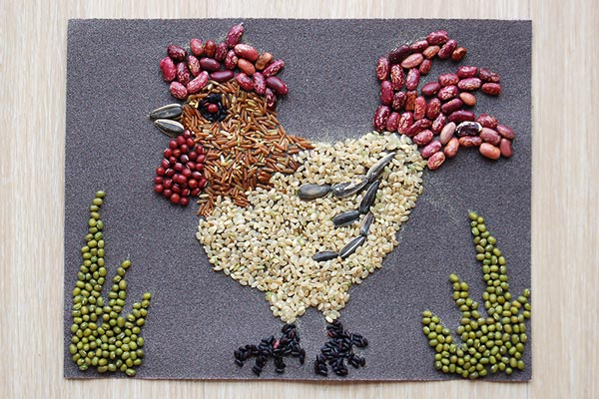  Here is a simple idea for a fox collage https://www.youtube.com/watch?v=NEK9_EzKlXQ
Understanding the world- changes | - Find out about a lifecycle of a hen.  https://www.youtube.com/watch?v=gt5CRD34BKM  2. Draw a picture of a hen’s lifecycle. Can you add labels, i.e. egg, chick, hatch?  4. Compare the life cycles of a bee and a hen.  5. What other animals can you see on the farm? Play an ‘I went to the farm and saw..’ game with your child. Each person names something they might see on the farm and the next person has to add another item to the list, remembering to say what the other person/people saw.  6. What do hens need to stay alive? What do foxes need?  Do hens and foxes need the same things to stay alive?  Listen to the Cbeebies radio programmes about chickens:  https://www.bbc.co.uk/cbeebies/radio/my-pet-and-me-chickens  and farms:  https://www.bbc.co.uk/cbeebies/radio/my-pet-and-me-farm?collection=radio-my-pet-and-me
Physical | Here are some useful links to keep your children active:  - Joe Wicks 9am PE - https://www.youtube.com/user/thebodycoach1  - Go Noodle - https://www.youtube.com/user/GoNoodleGames  - Cosmic yoga- https://www.youtube.com/user/CosmicKidsYoga  - imoves – They offer activities for parents and teachers to keep children active - www.imoves.com/imovement-signup  - Get Set 4 PE – They will be setting daily activity tasks on twitter for every day that schools are closed – go to twitter.com and search for @GetSet4PE  - Create an obstacle course in the house or in the garden. What can you go across/ around/ past/through/under/over?

Year 1
English | Each week, the children are going to:  - Practice spelling a selection of red words (Red Rhythms from Read Write Ink)  - Practice spelling a selection of green words (Fred Fingers from Read Write Ink)  - A grammar skill  - A vocabulary activity  - A short burst writing activity  Week 1  Red Words some, saw, her, all and watch  Green Word Single-syllable words: wrong, quick, Multi-syllabic words: problem, began, very  Grammar A verb shows us what someone or something is doing, e.g swims, runs, hops, jumps, shouts. Verbs can be in the present tense (to explain what is happening now) or can be in the past tense (to explain what has already happened). Verbs in the past tense often end in –ed. Can you think of as many verbs that could have the –ed ending? E.g. jumped Some past tense verbs don’t end in –ed. E.g. swam Can you think of any?  Vocabulary Good writers try to develop a wide vocabulary and use a variety of words to make their writing more interesting for the reader. What other words could you use for the word flapped? What other words could you use for the word happy? What other words could you use for the word hungry?  Short Burst Writing Read the story and write the answers to the Big Questions. The duckchick - In spring, Mama hen laid six eggs. One day, when she was busy keeping them warm in her nest, she noticed that egg 6 was bigger than the others. ‘Why is it so big?’ she clucked to herself. The first five eggs soon began to hatch and out popped five soft, fluffy chicks. Then there was another very big cccc-r-a-ck and egg 6 hatched too. But this chick wasn’t soft and fluffy like the rest. Mama hen was shocked. This chick was a duckchick! “Cluck!” went Mama hen, and the chicks clucked too. “Quack!” went the duckchick. Mama hen took all the chicks down to the pond. She showed them how to peck grubs from the mud, but the duckchick wasn’t interested. He flapped his long wings, stretched his long neck and jumped into the water. “Cluck!” went Mama hen and the chicks. “Quack!” went the duckchick. When they had eaten as many grubs as they could, Mama hen led the chicks onto a log. They were having so much fun hopping along, they didn’t notice a fox spying on them from a nearby bush… Big Questions – - What do you think will happen to the chicks? - What do you think Mama Hen thought of the duckchick? - What do you think the duckchick look liked? - What noises do you think the duckchick made?  Week 2  Red Words where, worse, could, how and school  Green Word Single-syllable words: milk, have Multi-syllabic words: cannot tomorrow  Grammar An apostrophe can show that some letters are missing in words. When we push two words together, we sometimes drop one or two letters, but an apostrophe shows the place of the missing letters. For example I am turns into I’m as the a has been dropped and replaced. Have a go with these words: I will, he is, he has, it is, it has.  Vocabulary Good writers try to develop a wide vocabulary and use a variety of words to make their writing more interesting for the reader. What other words could you use for the word hot? What other words could you use for the word cold? What other words could you use for the word tired? See if you can write a word for each one that does not have the same meaning. For example cold does not have the same meaning at hot, but warm does.  Short Burst Writing You are going to write a diary entry about waking up in the morning and feeling ill. You need to write it to you parent explain how you feel. Think about: - The time you wake up. - How you feel. - Why you think you feel like that.. - What you think you need to do to feel better.  Please continue to practice the following:  Handwriting using letter join  Username: eg1826  Password: home  Please continue to practice the following common exception words for Year 1 -  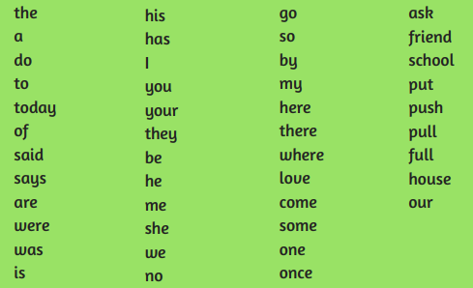
Reading - Phonics | Helpful links –  Daily :  https://www.ruthmiskin.com/en/find-out-more/home-reading/  Other :  Set 1 Sounds - https://www.youtube.com/watch?v=hCBzNnSSxds  Set 2 Sounds - https://www.youtube.com/watch?v=qlU3Dg8upXM  Set 3 Sounds -https://www.youtube.com/watch?v=n-Y4Ha4e7j4  Everyday please access the website provided to partake in a Phonics Lesson and complete the following activities to embed the sounds.  Go through Set 1, 2 and 3 phonics sounds with your children using flashcards regularly.  Write in to words and ask the children to Fred Talk and Read the words to spot whether they can identify the sounds.  Challenge – Get the children to write words you sound to them.
Maths – | Helpful links -  Daily Lessons :  https://whiterosemaths.com/homelearning/year1  We will be continuing with week 6 in the week commencing 1st June.  The worksheets to go with each daily video lesson can be found on our school website here: https://isleofelyprimary.org/class-pages/white-rose-maths  Some practical ideas for you to do at home alongside the worksheets:  We are learning about mass and capacity.  Can you help with some cooking or do some baking? How will you measure the ingredients? Which ingredient weighs the most/least?  Find some containers around your home and fill them with water.  Order the containers from the one with the smallest capacity to the one with the largest capacity.
Topic | Geography:  LO: I can name and locate the continents and oceans of the world.  Continents - North America, South America, Africa, Europe, Asia, Antarctica and Oceania.  Oceans - Pacific, Atlantic, Artic, Southern and Indian.  Use an atlas to find out what the seven continents and five oceans of the world oceans are and where they are located.  These songs can help you to remember them:  https://www.youtube.com/watch?v=K6DSMZ8b3LE  https://www.youtube.com/watch?v=X6BE4VcYngQ  Some suggested activities:  You could create your own globe using paper, a paper plate, balloon or papier mache and label the continents and oceans.  You could make the continents out of spaghetti, string, lego or playdoh.  You might have your own idea to create your own globe!  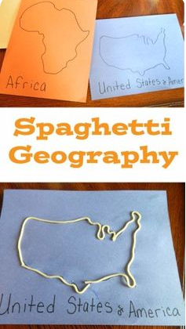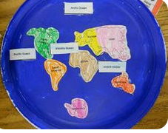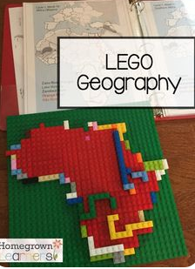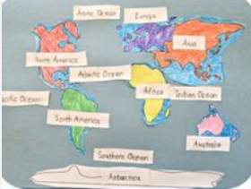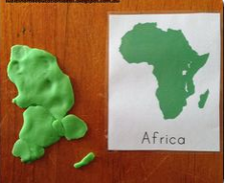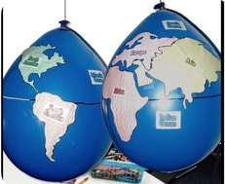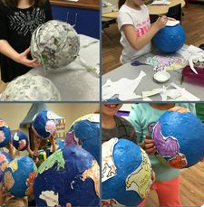  Science  LO: To identify the four seasons of the year and describe each  I can name the four seasons of the year  I can explain what the weather would be like in each season  How many seasons do we have in the UK?  What are the seasons called?  What might you see in each season?  How might you feel in each season?  Complete the page titled ‘The four seasons’ in the Science workbook emailed out to Year One parents. Label each box with a different season, ensure that you place the seasons in order starting with summer. In each box represent the season using either a picture or words, include what you might see in this season. For example leaves falling in autumn etc.  If you cannot access, the booklet, make your own version on a piece of paper.  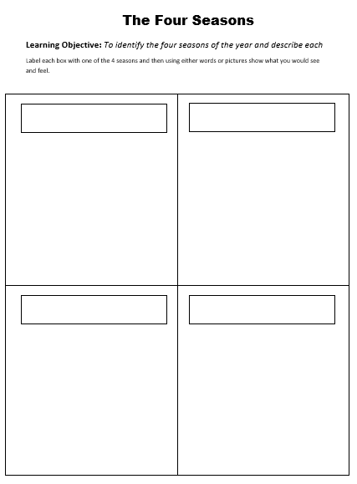  Art  LO: To develop line technique when drawing straight and curved lines.  Practise drawing straight lines and curved lines.  Can you draw your lines in different directions? Can you draw your lines close together and spaced further apart? Can you experiment with different thicknesses of lines?  What patterns can you create?  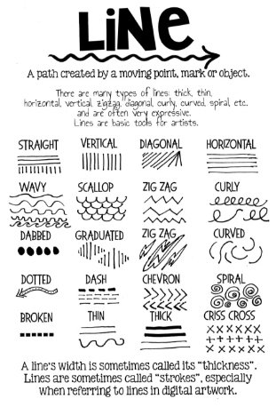
Other Subjects | Computing and Interactive Activities – Purple Mash  Music - Continue to use Charanga  Religious Education – https://www.bbc.co.uk/teach/class-clips-video/religious-studies-ks1-the-jewish-story-of-hanukkah/z47wxyc  Religion: Judaism  Theme: Chanukah  Key Question: Does celebrating Chanukah make Jewish children feel closer to God?  Suggested Activities
Keeping active | Here are some useful links to keep your children active –  Go Noodle via youtube or login.  imoves – They offer activities for parents and teachers to keep children active - www.imoves.com/imovement-signup  Get Set 4 PE – They will be setting daily activity tasks on twitter for every day that schools are closed – go to twitter.com and search for @GetSet4PE

Year 2
Writing - Conjunctions | Conjunctions  We are starting this half term by looking at coordinating conjunctions. A conjunction links two words of phrases together. For example:  I went to the shop and I bought some apples.  I could have written two sentences, ‘I went to the shop’ and ‘I bought some apples’ but instead I used the word and to join them together. This is because they both have the same value in the sentence and they are both related to the same idea or topic, going to the shop. So we coordinate them to create a better sentence. Common coordinating conjunctions include ‘and’, ‘but’ and ‘or’.  To start this activity I like you to write three sentences. One sentence about something you did or saw last week, something you saw or did yesterday and something you saw or did today. For example:  I saw a bird chirping in the tree  Once you have written three sentences I would like you to try and add a coordinating conjunction to each, for example:  I saw a bird chirping in the tree and it was beautiful.  Complete this for all three sentences trying to use a different conjunction for each. Once completed rewrite them in your best handwriting and draw a picture representing one of your sentences.
Reading - Phonics | To support your reading, please continue the phonics work we gave you previously. It is important to keep revising the sounds!  - Go through Set 1, 2 and 3 phonics sounds with your children and practise creating sounds using each word, following this say a word which contains this sound and ask them to segment it and then spell it.  - View the appendix entitled ‘Key Stage 1 Common Exception Words’, these are words student should mostly be able to read and spell by the end of year 2. Choose 5 words per week and practise Look, Say, Cover, Write, Check.  Set 1 Sounds - https://www.youtube.com/watch?v=hCBzNnSSxds  Set 2 Sounds - https://www.youtube.com/watch?v=qlU3Dg8upXM  Set 3 Sounds -https://www.youtube.com/watch?v=n-Y4Ha4e7j4  In addition to this, please continue to read as much as possible and take this time to develop a love of reading.  It is important and very fun to read lots of different types of books and genres, if you would like something different why not explore some poetry. Poetry can be very fun. See the attachment ‘Land of Nod’ by Robert Louis Stevenson to get you started. If you have a favourite poem why not try and learn it off by heart, that way you can share it with family and friends wherever you go.
Maths – Addition, Subtraction and Money | This half term we are going to be moving onto measurement, including looking at length and weight. However It is important that you continue to practise your number bonds to 20, your doubles and your skip counting by 2s, 5s and 10s.  - Number bonds to 10 and 20 – Continue to practise your number bonds to 10 and then 20. Find yourself a pack of cards or a dice, pick a card, for example 5, and then say what number you would need to add to 10. To challenge yourself what number would you need to make 20. Turn it into a game with someone else, first to say the correct number gets a point.  - Skip counting – Starting at 0 count up in 2s, 5s and 10s. For each of these count for 12 numbers, for example for 10s you would count to 120. Once you are comfortable doing this start practise counting backwards to zero too.  - Measurement – Challenge, I would like you to find a tool to measure length with. In your house good options may be a ruler or a measuring tape. In your house I would like you to try and find items which are the following lengths – 10cm, 30cm, 50cm and 1 metre. Remember to start the measuring at 0, not where the ruler or measuring tape starts. How many can you find for each of these lengths?
Theme | In History this half term we will be exploring a range of significant individuals from Cambridgeshire. Can you think of any people from Ely or Cambridgeshire who were significant in British History? Make a list of any you can think of.  If you are finding this hard, have a think about some of the street names in Ely which are named after people, have a think about a very famous house in Ely which people travel to see. From your list pick one of these people to explore further, if you have access to a computer use that, otherwise books are a great resource, also ask some people you know what they know about your chosen individual, you will be surprised. For your chosen person make a poster and include:  - Their name  - A picture  - Where they are from and  - A couple of sentences of why they are famous.
Keeping active | Please continue to stay active during this time!  There are links online such as PE with Joe Wicks, if you have access to the internet.  A bonus task this week is to create a new game or sport which you can play with someone in your house. Think carefully about the equipment you will need and what rules you will need to make it fair. Once you have created it give it a test run to see if it is fair, fun and gets your heart rate up.

Year 3
English | English  Print the Talk 4 Writing Home learning booklet – half size is fine. We will be setting tasks to compliment this booklet on Purple Mash. If you need it printed for you contact the school and a printed copy can be supplied. https://www.talk4writing.co.uk/wp-content/uploads/2020/04/Y3-Dean-Stone-Trolls.pdf  - Read stories you have at home that are set by the coast or in rocky places. Collect words from the stories you read that describe the landscape and together write definitions for them.  - Talk and write about the things you like in a warning story, the things that surprised you and if you have read similar stories. Encourage your child to think about the vocabulary used to set the scene and build suspense.  - In a warning tale think about what the characters are being warned not to do. How does the author show us something is dangerous?  - Think of interesting adjectives to describe a photo of an Icelandic landscape (you could use a photo in a magazine or book). Try to use all your senses and think about adjectives to build mood. Try listing the things you see – now write 5 adjectives for each thing.  - Write sentences using the adjectives you have collected. Can you use commas to list 2 in a sentence? Can you add to the sentence using a connective? e.g. The smooth, cold iceberg shimmered in the deep, blue lake.  - Prepositions are words that tell the reader where things are. Use propositions to describe a setting e.g. Below, the sea bubbled and foamed. Above, the full moon glared down.  - Use the underlying pattern of the warning tale ‘Stone Trolls’ to plan your own warning tale.  - Tell someone your new story using the plan as a prompt.  - Write your own warning tale using your plan. Try to use adjectives to describe the setting, with commas to list them. Try to use prepositions to describe where things are.  - Read your work carefully and check the spellings, that each sentence makes sense and that you have a new paragraph for each part of the story.  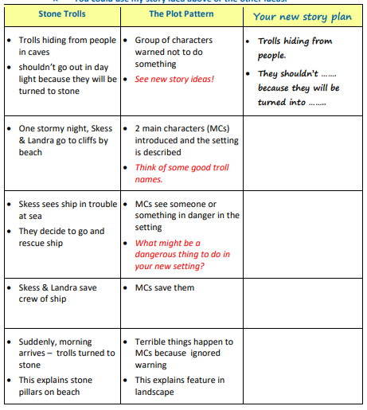
Spelling- Use your spelling menus from your homework books to practise these words.  You can also look back over the spelling rules from previous homework and check you still know them! | Please find the link below the Year 3 Summer 2 spelling booklet, which can be printed and worked through daily. It has lots of fun activities to help your child learn their spellings.  https://documentcloud.adobe.com/link/review?uri=urn:aaid:scds:US:e5103ee4-7b2e-493a-aa86-a5e235309e8a  There is also a link for the summer 1 booklet for reference or extra practise below.  https://documentcloud.adobe.com/link/review?uri=urn:aaid:scds:US:85089a8b-3ba6-42fc-acd8-ccd9fc15510b  If you need help printing the booklet, please do not hesitate to contact the school and we can arrange this.
Reading - Read any available texts daily and discuss information. | - Identify key facts and make inferences around the text you are reading.  - Some starting questions for fiction could be:  - How do you think the characters felt/why?  - What is your favourite part/why?  - What do you think will happen next?  - What would you say if you met a character in the story?  - Here is useful link to some more questions: file://2024srv001/staff$/CBurnford/Downloads/Reading%20prompt%20cards.pdf
Maths – Fractions  TT rockstars and timestables | Maths  - Look at 2d shapes and identify the edges and angles.  - Make a set square. Use it to find right-angles around the house.  - Acute angles are smaller than a right angle (90 degrees). Obtuse angles are larger than a right angle. Find the times the hands of a clock make obtuse and acute angles.  - Describe a shape to a partner e.g ‘My shape has 3 right angles and 2 obtuse angle’. How many ways could they draw your shape.  - Use a ruler to accurately draw and measure lines to the mm.  - Learn about vertical and horizontal lines and sort shapes by the number of each they contain. How many can you see in one of Mondrian’s pictures.  - Parallel lines never meet, perpendicular lines meet at a right angle. Find parallel and perpendicular lines in your house, or on a walk e.g window frames, railway lines, sign posts.  - Cut out a selection of 2D shapes. Sort them according to the number and type of features: right angles, obtuse angles, acute angles, parallel lines, perpendicular lines, sides, sides of equal length etc.  - Make nets of 3D shapes and fold and unfold them. Make 3D shapes out of playdough and straws – the straws are edges, the playdough can make the vertices.  - Count the number of edges, faces, vertices (points where 3 edges join) and curved surfaces on 3D shapes. Use these features to describe shapes and see if a partner can guess which one correctly.  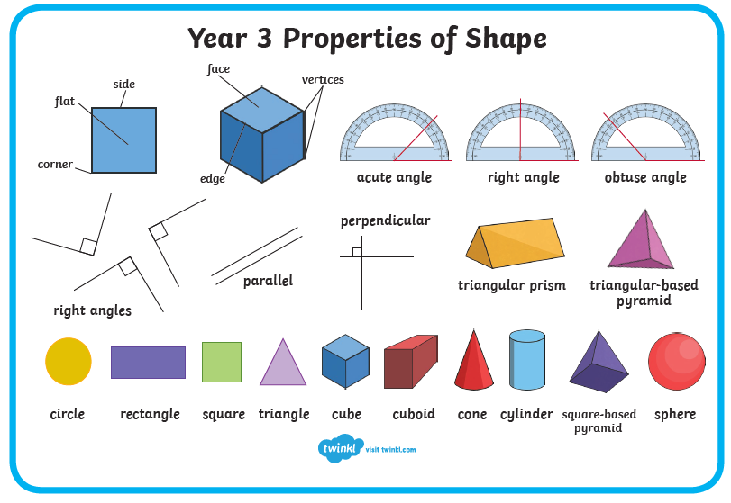
Theme  GROW WITH THE FLOW | DT – Bread  Powerpoints and resources can be accessed here if you set up a free parent log-in: https://www.twinkl.co.uk/resource/tp2-d-027-planit-dt-ks2-the-great-bread-bake-off-unit-pack  · Find out where flour comes from and draw a comic strip showing how it gets from the farm to the shops. https://www.youtube.com/watch?v=y8vLjPctrcU  · Look at the ‘healthy plate’ and food pyramid. Where is bread?  · Bake bread rolls or pizza.  · Think about different flavours you could add to bread – maybe have a tasting session to see which you like.  · Design your own bread, draw how you will shape it and label the special ingredients to add.  · Make the bread you designed and ask your family to score the taste, texture, smell and appearance.  History – Egyptians  Powerpoints and resources can be accessed here if you set up a free parent log-in: https://www.twinkl.co.uk/resource/t2-h-031-ancient-egypt-powerpoint  · Make a timeline showing when the Ancient Egyptian civilization (around 3150–330bc) was. Try to add other important events that you remember from your learning at school.  · Find Egypt on a map. Where were other ancient civilisations sited? Use the Knowledge Organiser for help. · Tour the Tutankhamun exhibition in London and learn about the artefacts there:  https://tutankhamun-london.com/see-do/ ·  Watch videos about Ancient Egypt at BBC Bitesize  https://www.bbc.co.uk/bitesize/topics/zg87xnb  · Make a model mummy and sarcophagus or a model pyramid. Why did the Egyptians make these?  · Look at hieroglyphic writing. Can you write about a day as an Ancient Egyptian using them? https://www.twinkl.co.uk/resource/t2-h-018-crack-the-hieroglyphs-egyptain-god-names-worksheet  Science – Humans and other Animals  Powerpoints and resources can be accessed here if you set up a free parent log-in: https://www.twinkl.co.uk/resource/tp2-s-022-planit-science-year-3-animals-including-humans-unit-pack · Watch BBC Bitesize videos: https://www.bbc.co.uk/bitesize/topics/z9339j6  · Make a skeleton with card and split pins, or print one out. Can you name the bones?  · Make the tallest tower you can with soft playdough. Now make the tallest tower you can with playdough and sticks/straws. Can you use your models to explain one reason why we need a skeleton? Repeat the investigation making a cage/protective barrier like your ribs cage.  · Sort the foods in the cupboard into different food groups. Can you use the healthy plate to plan a balanced meal for lunch?  · Why do we need food – find out what different types of food are important for. Make a poster to persuade people to eat a balanced diet by telling them why it is important.  · The Eat Happy Project has several videos to prompt discussions about healthy eating. https://www.youtube.com/watch?v=mMHVEFWNLMc&list=RDCMUCiGAAbnpbIYqZeCFeA4K_nQ&start_radio=1&t=27  · All animals and humans need food – make a chart showing the foods different animals eat.  · All vertebrates have a spine, invertebrates don’t. Cut pictures from a magazine or draw or write the names of some animals and sort them into invertebrates and vertebrates.  · Use playdough, lego, knex or any other building materials you have to make models of some joints. Can you find a hinge joint, ball and socket joint on your body?
Keeping active | Here are some useful links to keep your children active:  - Where possible, take your child on lots of adventure walks to explore the world around them!  - We are currently learning cricket and rounders at school, it would be a nice idea to practise, throwing, catching and batting skills where possible.  - Go Noodle via youtube or login  - imoves – They offer activities for parents and teachers to keep children active - www.imoves.com/imovement-signup  - Get Set 4 PE – They will be setting daily activity tasks on twitter for every day that schools are closed – go to twitter.com and search for @GetSet4PE

Year 4
English –  Practice your handwriting using letter join www.letterjoin.co.uk | - Please work through the attached talk4writing booklet called ‘Mission Possible’ as our English unit for the next two weeks. There is a text to read, comprehension and grammar tasks to complete and activities to support building up to writing your own story.  - Practise the following homophones: plane/plain, weather/whether, who’s/whose, mist/missed, meddle/medal and fair/fare/fayre. Make sure you know the difference in their meanings!  - Try some of these creative writing ideas: https://tfwconsulting.wixsite.com/jamiethomas/blog/  - Join Pie Corbett at 9.30am each weekday at Radioblogging.net for interactive language games and creative writing.  - Practise the Year 3/4 statutory spelling words below using the spelling menu activities in your homework books.  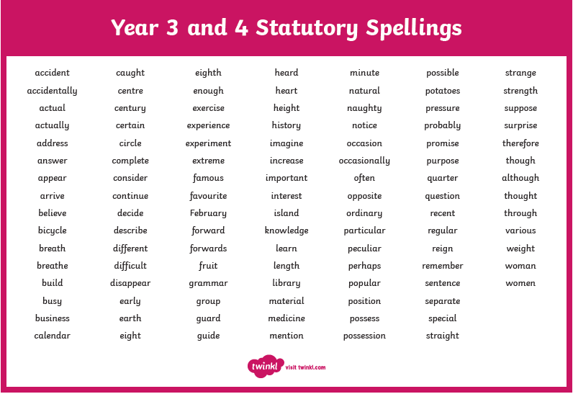  - Follow the English lessons at Oak National Academy: https://www.thenational.academy/online-classroom/year-4/english#subjects
Reading | - Keep reading! Aim to read a range of text types such as stories, diaries, fact files and newspapers. ‘The World Junior’ is a good magazine for children who are interested in the news, animals, science and sport.  - Use a dictionary to look up the meaning of any words you don’t understand and keep a record of these definitions so you can look over them again.  - Write about the books you have read. Perhaps a book review or a summary of the story. Could you write a diary in role as one of the characters?  - Read some non-fiction books and create your own news broadcasts to share the information you have learnt.  - Listen to Miss Fitzpatrick reading Harry Potter and the Philosopher’s Stone https://www.youtube.com/playlist?list=PLhGn0c9jpOLdcsA7LX-IfeZ8nyvTHsT4J New videos will be added regularly.
Maths – | - Follow the local weather forecast for a week and plot it on a line graph.  - Count out all the different colours of clothes you have and plot on a bar chart. You could draw your bar chart or create one using items around the house e.g. pasta, cereal or rice.  - Look for tables and graphs in newspapers or on the news, have a think about the scale they have used and what they are representing. See if you can interpret the graph and write questions based on the information presented.  - Find examples of obtuse, acute and right angles around the house – compare them with each other.  - Draw different shapes and work out which ones have the smallest angle, largest angle etc. How many different shapes can you create with right angles?  - Find out what the words ‘isosceles’, ‘scalene’ and ‘equilateral’ mean. Draw examples of each of them. What is the same and what is different about them?  - Draw and label the following shapes: rhombus, parallelogram, trapezium, square and rectangle. Can you explain what these are?  - Using a mirror, find lines of symmetry in different shapes around the house.  - Create a symmetrical drawing by drawing on one side and then mirroring it on the other.  - Follow the Oak National Academy Maths lessons: https://www.thenational.academy/online-classroom/year-4/maths#subjects  - Keep up with ttrockstars at www.ttrockstars.com  - Access the White Rose Maths home learning videos here: https://whiterosemaths.com/homelearning/year-4/
Theme – Walk like an Egyptian | - Make a timeline showing when the Ancient Egyptian civilization (around 3150–330bc) was. Try to add other important events that you remember from your learning at school such as the Stone Age.  - Find out some significant events from Ancient Egypt and place them onto a timeline in chronological order.  - Find Egypt on a map. Where were other ancient civilisations sited? Use the Knowledge Organiser on the class pages for help.  - Find out where flour comes from and draw a comic strip showing how it gets from the farm to the shops. https://www.youtube.com/watch?v=y8vLjPctrcU  - Look at the ‘healthy plate’ and food pyramid. Where is bread?  - Watch BBC Bitesize videos to find out about our skeleton and muscles: https://www.bbc.co.uk/bitesize/topics/z9339j6  - Make a skeleton with card and split pins, or print a template out. Can you name the bones?  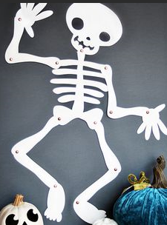  - Make the tallest tower you can with soft playdough. Now make the tallest tower you can with playdough and sticks/straws. Can you use your models to explain one reason why we need a skeleton? Repeat the investigation making a cage/protective barrier like your rib cage.
Keeping active | Here are some useful links to keep your children active:  - www.gonoodle.com – guided dance, mindfulness and brainercise activities  - Dance with Oti Mabuse on youtube  - Diverse dance lessons at www.twitter.com/diversedancemix  - PE with Joe Wicks at 9am on youtube  - imoves – They offer activities for parents and teachers to keep children active - www.imoves.com/imovement-signup  - Get Set 4 PE – They will be setting daily activity tasks on twitter for every day that schools are closed – go to www.twitter.com and search for @GetSet4PE
Other skills | - Go on www.duolingo.com or download the duolingo app to practise your German.

Year 5
We are using Purple Mash to set many tasks for the children, give them a chance to show off their hard work to their peers and to communicate with them. It would be beneficial if they could access this too during this period of home learning.
Writing – | Think about your target bookmarks and improving your writing stamina. We know lots about how to write good introductions, noun phrases, modals, power of three, many different types of punctuation ( . , ! ? : ; - ), paragraphing and linking these, higher level vocabulary, emotive language, descriptions, atmosphere, ‘show me, not tell me’.  Each of these activities should make use of an exploring, planning, drafting, writing and editing stage over a few days.  - Keep going with the diary about your day to day routine; what have you got up to? What have you learnt? What have you enjoyed? Set yourself a daily goal to achieve the next day.  - A) Create a list of containers; it could be anything from a matchbox to a city. How many different ones can you think of and how creative can you get? Here is a start for you: library, drawer, suitcase, barn, village…  B) Create a list of emotive words; words that you feel. Get creative here too! Here is a start for you: joy, fury, wrath, wonderment, excitement.  C) Pick your favourite container and emotive word. This is going to be the start of a poem or story! How many words/phrases can you think this item would have in it? Write these down to help you ‘brain dump’ your ideas.  D) Think about how that item came to be, where it is, and what happens when you open it… This gets better the more creative you’ve gone!  - Create a ‘Chimera’! This is an Ancient Greek animal that had the head of a lion, body of a goat and tail of a snake. If you were to create your own chimera, what animals would you draw inspiration from? Think carefully about why it would have those features: what’s its habitat, food, behaviours? If it’s a water animal for example, it will need gills. If it’s a grazing animal, it will need big ears to hear for predators. Label your drawing with the animals that inspired it and reasons for picking them. The bigger and more detailed the picture, the better!  - An alien has come to visit you on a student-exchange from planet Kriggon. They speak perfect English but they have never before seen what life is like on Earth. They can’t even understand how glass works: “What is this invisible force field that won’t let me pass?” You ask them if they would like to help themselves to a glass of squash but everything stumps them: how do you open a cupboard? Is a bowl a good vessel for drink? What is squash? What is a tap and how do I turn it on? I can put ice in my drink? Have some fun pretending to be the Alien and testing your family to guide you around common household tasks. Pick your funniest household task and write up a detailed set of instructions to help remind your Alien on how to do it.  - We practised persuasive writing a while ago and what skills are needed to be particularly persuasive: emotive language, strong modals, facts and statistics, quotes, powerful statements, clear explanations and examples. Use these skills to write a persuasive letter or speech on whether or not sitting tests is an important part of learning. These tests can take the form of weekly times tables and spellings tests, all the way up to SATS! You may want to spend some time collecting information and researching facts before starting your final writing.
Reading – | With book choices, check out the book list at book trust (see separate list). Mr Turner and Mrs Hunter will be reading some of these books so would love to hear about what you have enjoyed.  - Keep going with the book reviews! Write a book review of a new book you have read, including; a title, the author, genre, target audience, summary, review comments and star rating.  - Write a letter to a character or author of a book you have just read. Think carefully about what you would want to say to them and what questions you may have. Many authors will receive letters, so it may be that you do want to post them off!  - Keep practising some of the spellings below! You can use these to create your own dictionaries, use them in sentences or even attempt sentences which use as many of these as possible.  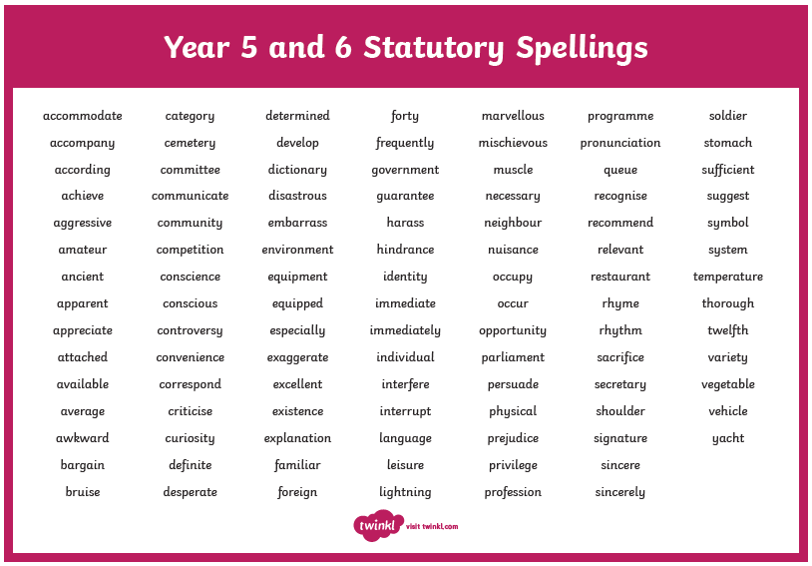
Maths – | Websites and apps: TT Rock Stars, PiXL Times Tables, numbots.  There are daily lessons on White Rose Maths online that come in video form. https://whiterosemaths.com/homelearning/year-5/  We will be continuing with Week 6, Week commencing June 1st.  These link directly with the attached worksheets. If there are any problems with the learning, please refer to the White Rose Link above in the first instance.
Theme – | Science websites:  https://thekidshouldseethis.com/  https://www.natgeokids.com/uk/  Other good websites for home-learning include:  https://www.bbc.co.uk/bitesize/levels/zbr9wmn  https://www.stem.org.uk/home-learning/primary  https://www.hamilton-trust.org.uk/blog/learning-home-packs/  https://classroomsecrets.co.uk/free-home-learning-packs/  - Science: Evaporation. Place a dish of water in the sun. What do you notice happens to the water in this weather? Now try dissolving salt into the water, you’ll need to dissolve as much salt as you can. When you can’t dissolve any more salt, the water is ‘saturated’. What happens when you leave this in the sun? Are there other things you could very about this experiment to see different results?  - Science: You’re probably seeing a lot of flowers out at the moment. Take some time to buy or pick a few (be mindful of where you do this) and become a botanist. Carefully dissect (take them apart to see the pieces) and write down any observations. Is there somethings all flowers have in common? What’s different between them? Can you name any of the parts?  - P.E: Set up an Obstacle Course in your home or garden! These don’t need a lot of space. Sometimes it could be a station where you need to do 5 hand stands or a 10 second plank. Make sure an adult checks over the course to see it is safe then have a go at timing your trials! Challenge your family to beat your score.  - Art: You learnt a lot about pop art earlier in the year. See if you can put these skills to the test and create a beautiful and detailed picture or comic strip from your favourite film or book!  - Music: hopefully soon, we will all be able to meet up again! If you were to have a party with your family, what musicians or songs would you choose for your party playlist? Since you’re now a curator, you’ll need to write an introduction to explain your music choices!  - Art: If you haven’t had a go at the Fitzwilliam museum activities please continue to use this link: https://www.fitzmuseum.cam.ac.uk/lookthinkdo/about  - History: You’re going to go back in time. How far, is your choice! Will you go back to Roman, Egyptian or Victorian times? You can take three things with you. What will you take and why? Think carefully about how it will benefit you (or if it will work! Phones without electricity or signal won’t be much good…) and how the people of the time will react. You could probably teach them of many things too; germs and engines would be revolutionary to them!  - Geography: When you go for a walk, see if you can get a map of that area. There are many, many types of maps to look at. A good website for ordnance maps is below. Any symbols you’re not sure of? Use the key. Have a go at using the map to plan your route, predict what you will see, if there are any inclines and think about distances.  https://osmaps.ordnancesurvey.co.uk/

Computer Based Work:
Please note that we are giving out these website addresses in good faith and that children’s use of the internet should be monitored by an adult within the home at all times.
A separate ‘additional information’ list has also been sent to you. Please refer to that for more details on some of the school learning platforms.
https://www.purplemash.com/login/ | In Years 1-5 class teachers have set a range of work that can be completed on PurpleMash. Once your child saves and submits their work, teachers can then respond with feedback. If your child does not have their login, please contact their classroom teacher by emailing the office.
https://classroomsecrets.co.uk/free-home-learning-packs/ | Home learning packs for all year groups.
https://primarystarseducation.co.uk/covid-19-year-1/ | Year 1 home learning pack.
https://primarystarseducation.co.uk/covid-19-year-2/ | Year 2 home learning pack.
https://whiterosemaths.com/homelearning/ | Maths revision / home learning.
https://ttrockstars.com/ | TT Rockstars – website to practise times tables. Year 2 – 5 have login details for this.
https://thekidshouldseethis.com/ | Curious videos to enhance children’s knowledge of science.
https://www.natgeokids.com/uk/ | Activities and quizzes relating to science and nature.
https://scratch.mit.edu/explore/projects/games/ | Computer programming tool for children in KS2 or above.
https://www.bbc.co.uk/bitesize/levels/z3g4d2p | BBC activities for KS1 and Early Years.
https://www.bbc.co.uk/bitesize/levels/zbr9wmn | BBC activities for KS2.
https://blockly.games/?lang=en | Simplistic website for basic computer programming.
https://www.dkfindout.com/uk/ | Research website for children.
https://www.twinkl.co.uk/resources/extra-subjects-parents/school-closures-category-free-resources-parents/school-closures-free-resources-parents | Twinkl has a whole range of resources for parents to download.
https://play.numbots.com/?#/account/school-login-type | Maths game.
Child friendly search engines:
https://www.kiddle.co/
https://wackysafe.com/
https://www.alarms.org/kidrex/
https://www.safesearchkids.com/

Additional Reading:
Being off school offers children an ideal opportunity to read. Please see https://home.oxfordowl.co.uk/books/free-ebooks/ for access to free eBooks.

Recommended book lists and story-based websites:
0 - 8 year olds
https://www.booktrust.org.uk/booklists/1/100-best-0-5/
https://www.booktrust.org.uk/booklists/1/100-best-books-6-8/
https://www.storyplace.org/

9 – 11 year olds
https://www.booktrust.org.uk/booklists/1/100-best-books-9-11/

General
https://www.storynory.com/
http://www.professorgarfield.org/pgf_mrsp.html
http://en.childrenslibrary.org/
https://freekidsbooks.org/

