Homework pack for students attending Isle of Ely Primary School

Whilst children are off school, please keep them in a routine as this will help to keep them settled. We would suggest that children get up, make their bed and have breakfast preferably before 9am. It is important to give your children opportunities to have some exercise and fresh air. Think about staggering ‘play times’ throughout the day.
Using the resources below, children could then spend the ‘school day’ learning. At most schools, children break around 10:30am, eat lunch around midday and have an afternoon break at about 2:15pm.
All children have a login for Pixl Edge App which will provide core skills and values training. On top of this, there are logins for Purple Mash, TT Rockstars and Pixl Unlock (vocabulary focus). Please see the list of websites included in this pack for additional support.
Thank you for all of your support and we hope to resume normal practice as soon as possible.

Mrs. Surtees and the staff at Isle of Ely Primary School

General Offline Work:
The staffing team has put together a list of activities and websites that your children can partake in whilst off school. Below is a menu of offline activities that do not rely on an internet connection or access to a computer.
Early Years – Nursery
Reading - Story  Story focus:  The very hungry caterpillar  By Eric Carle | 1: Create some of the props in the story and encourage your child to retell the story or create their own.  2: Try and share a story with your child every day, leave pauses in familiar stories for your child to fill in the gaps.  3: Collect a selection of objects from around the house and encourage children to try and make up a story. They may need help to start this off. The story can be as silly and as random as the children like.  4: Encourage children to make up their own story book, they could draw pictures, mark make. Talk to your child afterwards about who is in the story etc.  5: Set some quite time aside for children to be able to independently explore a wide range of books, picture, bath, fabric, magazines - whatever you have at home.
Writing/Mark making | 1: Fruit or veg printing if you have any spare, or use different vegetable peelings. E.g. orange skins, banana skins, stones or seeds from fruits etc.  2: If you are able to go out into the garden and collect some leaves, try printing with them or doing leaf rubbings.  3: Play cafes with your child ask them to write a menu with all their favourite foods.  4: If you have any sand or flour at home in a small tray or dish ask the children to make caterpillar trails. They could use either their finger or a paint brush etc. they may wish to have a go at writing some of their letters from their name in this too.  5: Free drawing - encourage your child to hold the make making tool in a tripod grip.
Communication and Language | 1: Place a selection of fruit and vegetables in a bag, ask the children to place their hand in the bag and try and guess what it is without looking, encourage lots of descriptive language.  2: Play eye spy with colours “I spy something the colour …..”  3: Talk about the days of the week with the children (ask them if they remember the days of the week song). See if your child can remember them in sequence. Ask the children if they can tell you the initial sound at the beginning of each day.  4: Sit / lay somewhere quite inside/outside ask the children to close their eyes for 1 minuet and just listen. Ask your child what they heard, ask them to imitate the sounds they heard.  5: Try to introduce your child to two new words a day linked to the story. This could be to do with the way the caterpillar moved .i.e. created, wriggles or when describing the butterfly .i.e. vibrant, graceful etc. when taking about the foods you might use words like .i.e. delicious, scrumptious etc. building on the children’s existing vocabulary. Try to mention these words as much as you can and put them into real sentences.
Maths | 1: If you have the story or can access it through the internet re-read it pausing for the children to count the various foods.  2: Look at the different fruits and encourage the children to order them by size. If they complete this with ease, collect another group of objects from around the house for them to order by size.  3: Look at patterns just like a butterfly - where in your house can you find a pattern?  4: Have a go at making your own pattern. You could use coloured blocks, beads, coloured cars etc.  5: Using your thumb print (dipped in paint) create different sized caterpillars then ask the children to cut them out and size order them. Ask the children to count how many thumb prints they used in each one. Make a number line and ask the children if they can identify the correct number on the line. Some may wish to have a go at writing the number too.
Expressive arts and design | 1: Be as creative as you can to create a caterpillar of your own; play dough, scraps of material, old egg boxes, pipe cleaners and beads, lolly pop sticks and pompoms, an old sock or whatever you can get your hands on.  2: Have a try and make a butterfly by folding your paper in half and painting on only one side before folding it over and pressing it down to create the other half of the butterfly.  3: If you have any flowers either inside or outside have a go at drying the flowers in between two sheets of paper. Place them under something heavy and leave somewhere warm for them to dry out this may take a couple of weeks but you can keep checking them.  4: Use some junk modelling to make something from the story or from a story your child likes.  5: Use a kitchen/toilet roll to dip in paint to create a caterpillar.
Physical | 1: Cut out some leaves and create holes in them, then using either some wool or old shoe lace encourage children to thread them around the leaf.  2: Sing the song sleeping bunnies, change the animal to caterpillar, butterfly etc. Encourage the children to think about how these animal/bugs might move.  3: Using a selection of one handed tools .i.e. scissors, play dough tools etc. ask your child to create a caterpillar/ butterfly.  4: The caterpillar hides in his cocoon before turning into a butterfly – have a game of hide and seek or hide a toy for your child to find.  5: Play a game of Simon Says. Encourage lots of different movements, .i.e. running on the spot, start jumps, crouching down small, stretching up high etc.
UW | 1: Encourage your child to take a photo of some of the activities they have tried at home either on a camera, phone or ipad etc.  2: Just like the butterfly, in spring we see a lot of new beginnings talk about the changes in the seasons.  3: Go on a spring hunt in your garden or look out your window, ask the children to draw any new flowers or bugs they have found.  4: Keeping on spring, talk to your children about all the baby animals that are being born at the moment. See if your children can name the babies of the following animals; horse, cow, chicken, sheep, pig, rabbit etc.  5: If you have got anything growing in the garden, encourage children to keep a diary of how it changes and the differences they see, getting bigger, changing colour etc.
PSED | 1: Talk to your child about healthy eating/ eating a balanced diet.  2: Get children involved in helping to prepare a snack/meal. Talk about washing your hands first and how to keep safe in the kitchen.  3: Play a game which involves turn taking/ sharing.  4: Ask your children how they thought the caterpillar felt once he had eaten all the food then again once the caterpillar had turned into a butterfly.  5: Encourage independence at meal times, children can help set the table, clear away and attempt to cut their own food etc.

Little Elvers 18th – 22nd May
Reading - Story  Room on the Broom  Story focus:  Various activities based around the story | - To read the story with your grown up.  - Re-read the story when it gets to the las word of the sentence, pause. Can your child tell you the word?  - To retell the story through creating their own characters. (This could be drawn on paper and use lollypop stick or collected twigs from outside)
Writing/Mark making | 1: Make your own list for a potion. What sort of things would you put into a cauldron?  (Can the children draw a picture and mark make. Adults can scribe the meaning)  2: Draw your favourite character from the book.  3: using spaghetti (made into a broom) to paint a picture. If you don’t have spaghetti you could collect some small branches to make into paint brushes.  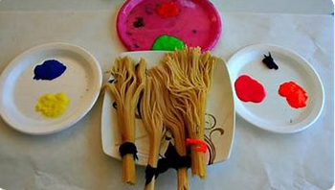  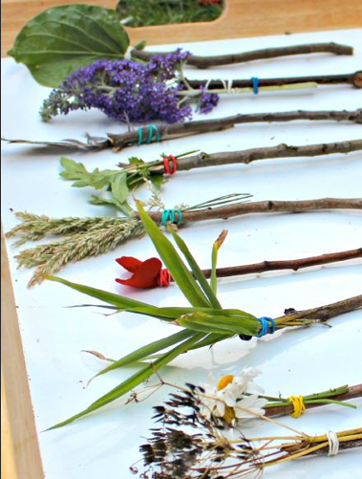
Communication and Language | 1: Looking at rhyming words in the story – playing silly soup (This game is on Tapestry)  2: Ask your child to suggest an alternative ending  3: Ask your child what part of the story is their favourite part
Maths | 1: Adding items to their own potions counting items they use.  2: Threading beads onto a pipe cleaner or string and count the total amount.  3: 1st 2nd 3rd 4th and 5th sequencing of the characters that go onto the broom
Expressive arts and design | 1: Create a broomstick.  2: Design a wand.  3: Design and create a new character for the story. You can use junk modelling, painting, playdough or a medium of your own choice.
Physical | !:painting rocks with the story characters  2:making spider webs using paper plate and wool  3:helping around the house using indoor broom outdoor broom  4:What’s the time Mrs witch – game to play  5: obstacle course linking to the story
UW | 1: Take part in a scavenger hunt to collect items that may have been hidden around the house or outdoors.  2: Draw a map of the witch’s adventure.  3: Look at how the weather changes throughout the story. Can you look at the weather every day this week and record using pictures what it is like. Was it the same all week?
PSED | 1: Dress up as one of the characters and retell the story.  2: Look at the expressions of each character. How are they feeling? Can you draw a picture that shows an emotion.  3: Play a board game with your family.

Early Years – Reception
4th – 15th May Mini Beasts
Personal, social and emotional- feelings and sharing | 1. Play board games. Encourage children to take turns and identify numbers on a dice.  2. Read as many stories together and discuss themes within the book. ‘Why do you think this is happening?, how is this person feeling?, What could happen next?’  3. Paint a rock for someone else to see on their walk. Talk about why people are doing this.  4. Create a feelings jar and talk about the different feelings and how we can overcome them.  Oxford owl books- https://www.oxfordowl.co.uk/for-home/find-a-book/library-page/?view=image&query=&type=book&age_group=Age+4-5&level=&level_select=&book_type=&series=#  Encourage the children to talk about characters feelings and why they could be feeling that way.
Writing -  Practice handwriting- Read Write Inc. | 1. Design your favourite meal. ‘My favourite meal is…because’. Encourage your child to have a go and completing this sentence independently.  2. Write a story map for ‘The Very Hungry Caterpillar’. Remember to include Once upon a time and the end.  3. Write a diary entry of the caterpillar’s day.  4. Create an information leaflet for looking after a mini beast/insect.  5. Write a life cycle for a mini beast/insect.  6. Write some tricky words. (I, go, no, to, go, she, he, the, said, put)  Tricky words- https://www.youtube.com/watch?v=TvMyssfAUx0  https://www.youtube.com/watch?v=R087lYrRpgY  Encourage your child to use their Fred Talk and Fred Fingers to help them write the words.
Reading - Phonics  Story focus:  ‘The Very Hungry Caterpillar’ by Eric Carle. | 1. Review Set 1 sounds and letter formation. (m,a,s,d,t,i,n,p,g,o,c,kb,f,e,l,h,sh,r,j,v,y,w,th,z,ch,qu,x,ng,nk)  2. RWI daily exercises for Set 1/2 sounds.  3. Create words using Set 1 and set 2 sounds and ask the children to Fred Talk and Read the word to spot whether they can identify the sounds. i.e: write mat for your child to say ‘m-a-t mat’ or ‘sh-i-p ship’  4. Ask your child to identify the special friends in their writing or reading.  Set 1 Sounds - https://www.youtube.com/watch?v=hCBzNnSSxds  Set 2 Sounds - https://www.youtube.com/watch?v=qlU3Dg8upXM  Read, Write Inc - https://www.youtube.com/channel/UCo7fbLgY2oA_cFCIg9GdxtQ  Phonics play- https://www.phonicsplay.co.uk/ Username: march20 Password: home  ‘The Very Hungry Caterpillar’ - https://www.youtube.com/watch?v=vkYmvxP0AJI&t=21s
Maths – number formation, counting to 20, addition | 1. Count to 20. Count jumps, claps, mini beast’s legs, count loud, quiet and use different voices.  2. Practice number formation up to 20.  3. Compare money. How many different ways can you make 5p, 10p and 20p?  4. Time- highlight the days of the week from the hungry caterpillar. Ask your child what day it is and how they know? How many days are in a week?  Number formation - https://www.youtube.com/watch?v=qfcbWmASibk  Numbers bonds to 10- https://www.youtube.com/watch?v=lD9tjBUiXs0  Shape- https://www.youtube.com/watch?v=svrkthG2950  Doubles - https://www.youtube.com/watch?v=8jOzhiACB68  Money- https://www.topmarks.co.uk/Search.aspx?q=money  Topmarks- https://www.topmarks.co.uk/Search.aspx?Subject=16&AgeGroup=1 Some really good interactives games for counting, ordering and adding numbers.  Days- https://www.youtube.com/watch?v=oKqAblcwFOA
Expressive arts and design | 1. Create a bug den  2. Make a mini beast. How many legs? How many wings? How many spots?  3. Make a habitat for a mini beast to live in.  4. Observe and draw a mini beast.  5. Recreate the life cycle of a mini beast. This could be through a drawing, painting rocks or a drama piece.  6. Create a caterpillar using a repeating pattern for its body.  7. Create butterfly wings using card board.
Understanding the world- changes | 1. Name different types of mini beats. (lady bird, butterfly, caterpillar, centipede, dragonfly)  2. Look at what a life cycle is.  3. Look at different life cycles such as, a frog’s, caterpillar’s and human’s  4. Compare the life cycles of a caterpillar and a human.  5. Go on a walk and see how many mini beasts you can find, take note of where you found them.  Life cycle- https://www.bbc.co.uk/bitesize/topics/zgssgk7/articles/zwn6mnb
Physical | Here are some useful links to keep your children active:  - Joe Wicks 9am PE - https://www.youtube.com/user/thebodycoach1  - Go Noodle - https://www.youtube.com/user/GoNoodleGames  - Cosmic yoga- https://www.youtube.com/user/CosmicKidsYoga  - imoves – They offer activities for parents and teachers to keep children active - www.imoves.com/imovement-signup  - Get Set 4 PE – They will be setting daily activity tasks on twitter for every day that schools are closed – go to twitter.com and search for @GetSet4PE  - Dance to the Ugly bug ball https://www.youtube.com/watch?v=XXSOJH4KmZw&list=PLj-3XAbfDmAxeKYuUAvBI27MNwbg2PV5q
Honey cake recipe:

Ingredients

For the icing
- 55g/2oz icing sugar
- 1 tbsp clear honey
- hot water

- 170g/6oz clear honey
- 140g/5oz butter
- 85g/3oz light muscovado sugar
- 2 eggs, beaten
- 200g/7oz self raising flour, sieved
- water

Method
- Preheat oven to 180C/350F/Gas 3 and butter and line the bottom of a 7in/18cm cake tin.
- Measure the honey, butter and sugar into a large pan. Add a tablespoon of water and heat gently until melted.
- Remove from the heat and mix in the eggs and flour.
- Spoon into the cake tin and bake for 40-45 minutes until the cake is springy to the touch and shrinking slightly from the sides of the tin.
- Cool slightly in the tin before turning out onto a wire rack.
- While the cake is still warm, make the icing by mixing the sugar and honey together with 2-3 teaspoons of hot water. Trickle over the cake in whatever design takes your fancy.

Reception - 18th – 22nd May Save the bees
Big question: Why is it important to save the bees?
Personal, social and emotional- feelings and sharing | Read as many stories together and discuss themes within the book.  The Honeybee by Kirsten Hall and Isabelle Arsenault https://www.youtube.com/watch?v=-Uk-9qXntyE  The Very Greedy Bee by Steve Smallman and Jackie Tickle https://www.youtube.com/watch?v=q2N6wmqafu8  Please please the bees by Gerald Kelley https://www.youtube.com/watch?v=uWWHZPuubKo  Oxford owl books- https://www.oxfordowl.co.uk/for-home/find-a-book/library-page/?view=image&query=&type=book&age_group=Age+4-5&level=&level_select=&book_type=&series=#  Encourage the children to talk about characters feelings and why they could be feeling that way.
Writing -  Practice handwriting- Read Write Inc. | 1. Write a story map to show the life cycle of a bee.  2. Observe and write an action log for a bee.  3. Create an information leaflet for looking after a bee.  4. Describe a bee.  Tricky words- https://www.youtube.com/watch?v=TvMyssfAUx0  https://www.youtube.com/watch?v=R087lYrRpgY  Encourage your child to use their Fred Talk and Fred Fingers to help them write the words.
Reading - Phonics  Story focus:  ‘Bumble bear’ by Nadia Shireen | 1. Review Set 1 sounds and letter formation. (m,a,s,d,t,i,n,p,g,o,c,kb,f,e,l,h,sh,r,j,v,y,w,th,z,ch,qu,x,ng,nk)  2. RWI daily exercises for Set 1/2 sounds.  3. Create words using Set 1 and set 2 sounds and ask the children to Fred Talk and Read the word to spot whether they can identify the sounds. i.e: write mat for your child to say ‘m-a-t mat’ or ‘sh-i-p ship’  4. Ask your child to identify the special friends in their writing or reading.  Set 1 Sounds - https://www.youtube.com/watch?v=hCBzNnSSxds  Set 2 Sounds - https://www.youtube.com/watch?v=qlU3Dg8upXM  Read, Write Inc - https://www.youtube.com/channel/UCo7fbLgY2oA_cFCIg9GdxtQ  Phonics play- https://www.phonicsplay.co.uk/ Username: march20 Password: home  Bumble bear- https://www.youtube.com/watch?v=j5DVMNVG2Ms
Maths – number formation, counting to 20, money | 1. Count to 20. Count jumps, claps, bee’s legs, count loud, quiet and use different voices.  2. Practice number formation up to 20.  3. Compare money. How many different ways can you make 5p, 10p and 20p?  4. Set up a bee yard to sell honey. Create a price list and encourage your child to work out how much money they need to buy 1 honey pot and 2 honey pots.  Continuous:  Number formation - https://www.youtube.com/watch?v=qfcbWmASibk  Numbers bonds to 10- https://www.youtube.com/watch?v=lD9tjBUiXs0  Shape- https://www.youtube.com/watch?v=svrkthG2950  Doubles - https://www.youtube.com/watch?v=8jOzhiACB68  Money- https://www.topmarks.co.uk/Search.aspx?q=money  Topmarks- https://www.topmarks.co.uk/Search.aspx?Subject=16&AgeGroup=1 Some really good interactives games for counting, ordering and adding numbers.  Days- https://www.youtube.com/watch?v=oKqAblcwFOA
Expressive arts and design | 1. Create a hive for the bee.  2. Make a honey cakes (recipe below)  3. Dress up as a bee.  4. Make a bee.  5. Observe a bee from a distance. What does it sound like? What does it look like? How does it move?  6. Draw a bee
Understanding the world- changes | 1. Look at the different types of bees.  2. Find out what bees make and what they need to make it.  3. Look at the life cycle of a bee  4. Compare the life cycles of a bee and a human.  5. Go on a walk and see how many bees you can find, be careful not to get too close!  6. What do bees need to stay alive?  Life cycle- https://www.bbc.co.uk/bitesize/topics/zgssgk7/articles/zwn6mnb  About bees- https://www.youtube.com/watch?v=ta154f5Rp5Y
Physical | Here are some useful links to keep your children active:  - Joe Wicks 9am PE - https://www.youtube.com/user/thebodycoach1  - Go Noodle - https://www.youtube.com/user/GoNoodleGames  - Cosmic yoga- https://www.youtube.com/user/CosmicKidsYoga  - imoves – They offer activities for parents and teachers to keep children active - www.imoves.com/imovement-signup  - Get Set 4 PE – They will be setting daily activity tasks on twitter for every day that schools are closed – go to twitter.com and search for @GetSet4PE  - Dance to the Ugly bug ball https://www.youtube.com/watch?v=XXSOJH4KmZw&list=PLj-3XAbfDmAxeKYuUAvBI27MNwbg2PV5q

Year 1
Year 1 Menu of Offline Activities

YouTube Playlist, this is also found on your class website pages - https://www.youtube.com/playlist?list=PLyzXmAZ_7A__I3PuycgQIwIWe7caNZvDL

We will be uploading our videos daily onto our Year 1 Purple Mash blog as well as sending an email out to you daily with the links for the videos via parent mail.

Please remember to also complete the 2do’s on Purple Mash as well as uploading and sending us any of your work via 2Email.

English | Supertato by Paul Linnet and Sue Hendra (https://www.youtube.com/watch?v=rze89HB9u8g)  Videos will be uploaded to the YouTube channel twice a week which will give children activities to last for the whole week. Please follow these in order to access the English learning.  Other suggested activities –  - Innovate and write your own version of Supertato, thinking about the story structure and including your character description from Week 2. (1 week)  Story Structure – Opening, Build-up, Problem, Resolution and Ending.  - Plan and write a piece of poetry about a Superhero and their 5 senses, linking to the Science work. (2 weeks)  Remember a poem must have rhyming words.  Please continue to practice the following:  Handwriting using letter join  Username:eg1826  Password: home  Common exception words for Year 1  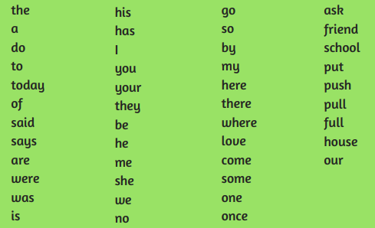
Reading - Phonics | Helpful links –  Daily :  https://www.ruthmiskin.com/en/find-out-more/home-reading/  Other :  Set 1 Sounds - https://www.youtube.com/watch?v=hCBzNnSSxds  Set 2 Sounds - https://www.youtube.com/watch?v=qlU3Dg8upXM  Set 3 Sounds -https://www.youtube.com/watch?v=n-Y4Ha4e7j4  Everyday please access the website provided to partake in a Phonics Lesson and complete the following activities to embed the sounds.  Go through Set 1, 2 and 3 phonics sounds with your children using flashcards regularly.  Write in to words and ask the children to Fred Talk and Read the words to spot whether they can identify the sounds.  Challenge – Get the children to write words you sound to them.
Maths – | Helpful links -  Daily Lessons :  https://whiterosemaths.com/homelearning/  https://www.themathsfactor.com/  Other :  https://www.ncetm.org.uk/  https://classroomsecrets.co.uk/  For your upcoming maths lessons please access the YouTube videos which are uploaded 3 times a week and the White Rose Maths Daily Lessons. This is what we have previously taught from in Year 1 and so therefore continues the learning, however we have adjusted some of the White Rose inputs to meet the needs of our Year 1 children.  Other suggested activities –  - Investigate fractions looking specifically at 1/2 and 1/4.  Can you find 1/2 or a 1/4 of an amount?  Can you 1/2 or 1/4 an object?  Can you create a poster on fractions?  - Think about position and direction and explore navigation.  Can you navigate around an obstacle course using the correct language?  Can you create a repeating pattern using shapes or objects?  Can you describe where an object is in relation to another object?
Topic | Below are our three key questions the children should be able to answer by the end of Summer A. You will find Science, DT and History. You will find suggested activities and the learning objectives in the instructions and on the YouTube videos which are uploaded daily.  Science – Video uploaded every Wednesday – Which super sense would be your super power?  DT – Video uploaded every Tuesday - Where would you get food to keep you fit and healthy?  History – Video uploaded every Thursday - Do you think Florence Nightingale was a real life superhero?  Science  Learning Objective - Identify, name, draw and label the basic parts of the human body and say which part of the body is associated with each sense.  Suggested Activities -  - Draw a picture of your body. Can you label the basic body parts?  - Identify the five senses. Can you draw a picture of each of the senses?  - Link the senses to your body parts. Which body part is associated with each sense?  - Can you explore the different senses around your house? What can you see, hear, taste, touch and smell? Write and/or draw all your ideas down.  DT  Learning Objective - Understand where food comes from.  Suggested Activities -  - Investigate your fridge and cupboards at home. Can you research where these foods have come from? Create a poster to show your findings.  - Can you draw a food plate of a balanced diet? Think about what your diet should consist of. Remember that there are 5 different food groups.  - Can you make a fruit salad? Think about the different ways you could prepare your fruit? What tools might you need to make your fruit salad?  - Create a plan for your ideas.  - Remember to evaluate your work. What went well? What would you do differently next time?  History  Learning Objective - Explore the lives of significant individuals in the past who have contributed to national and international achievements. Some to compare aspects of life in different periods.  Suggested Activities -  - Research Florence Nightingale. Why was she well known? Can you write these down?  - When was Florence Nightingale well known in relation to other historical events? Can you draw a time line of historic events that you have learnt about in Year 1 so far?  - What is the difference between hospitals in the Crimean War and now? Can you draw the difference? Can you label the differences?  - Can you make a poster to explain why Florence Nightingale is so important and impact she had?
Other Subjects | Computing and Interactive Activities – Purple Mash  Music - Continue to use Charanga  RE – Judaism (Shabbat) – Video uploaded every Monday.  - Is Shabbat important to Jewish children?  - To be able to empathise with Jewish children by understanding what they do during Shabbat and why it is important to them.  PSHE - Our responsibilities – Video uploaded every Friday.  - To be able to name some people who look after us and some of their responsibilities towards us.  - To identify jobs and responsibilities we have at school.  - To identify responsibilities I have to my friends, family and class.  Free Time –  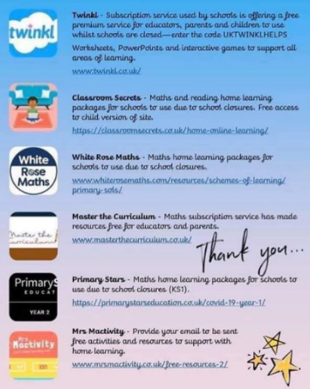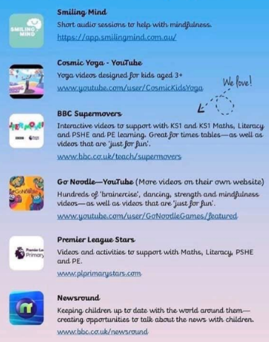  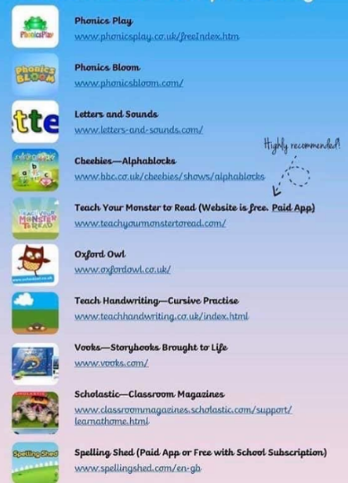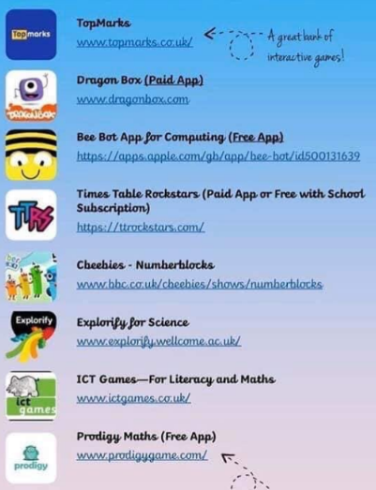
Keeping active | Here are some useful links to keep your children active –  Go Noodle via youtube or login.  imoves – They offer activities for parents and teachers to keep children active - www.imoves.com/imovement-signup  Get Set 4 PE – They will be setting daily activity tasks on twitter for every day that schools are closed – go to twitter.com and search for @GetSet4PE

Year 2
Writing - Nouns and Adjectives | Nouns and Adjectives  To start this activity I would like you to write at least three sentences describing your garden or local park, you don’t necessarily need to go to it, use your imagination. Make sure it is in your best handwriting and you have tried your best with your spelling. Once completed underline the nouns in your sentence, remember a noun is a person, a place or a thing. So it may be the name of a person, it could be a swing or it could be the grass. Once you have underlined these words I would like to add an adjective to them, for example:  There is a swing in my garden. There is a huge swing in my beautiful garden.  I saw a bird in the park. I saw a pretty bird in the empty park.  Once you have completed this for all three sentences, rewrite it in your best handwriting and draw a picture of the park or garden you have described.
Reading - Phonics | Pick your favourite book, it could be a picture story book or a chapter book. Write a book review explaining why it is your favourite book, include:  - The name of the book  - Why you like it so much  - Who your favourite character is, or if it is a non-fiction book  - What your favourite page is  - What your favourite part of the book is  - Why someone else should read it  - And include a picture of your favourite part  To support your reading, please continue the phonics work we gave you previously. It is important to keep revising the sounds!  - Go through Set 1, 2 and 3 phonics sounds with your children and practise creating sounds using each word, following this say a word which contains this sound and ask them to segment it and then spell it.  - View the appendix entitled ‘Key Stage 1 Common Exception Words’, these are words student should mostly be able to read and spell by the end of year 2. Choose 5 words per week and practise Look, Say, Cover, Write, Check.  Set 1 Sounds - https://www.youtube.com/watch?v=hCBzNnSSxds  Set 2 Sounds - https://www.youtube.com/watch?v=qlU3Dg8upXM  Set 3 Sounds -https://www.youtube.com/watch?v=n-Y4Ha4e7j4  In addition to this, please continue to read as much as possible and take this time to develop a love of reading.
Maths – Addition, Subtraction and Money | - Number bonds to 10 and 20 – Continue to practise your number bonds to 10 and then 20. Find yourself a pack of cards or a dice, pick a card, for example 5, and then say what number you would need to add to 10. To challenge yourself what number would you need to make 20. Turn it into a game with someone else, first to say the correct number gets a point.  - Addition and Subtraction – Continue to use the “Adding and Subtracting in Year 2” guide to work through the different types of questions.  - Statistics – Pick a question of your choice to explore, it could be something like ‘What is my families favourite colour?’ or ‘What is the most common shoe size in my family?’. Once you have your question, collect your data, ask as many people as you can. This could be just within your house or you could email or message your extended family. Complete a tally chart to collect this information. Once completed turn this data into a bar chart with the amount of people asked along the side and the categories along the bottom, for example blue, red, yellow, green. Complete the bar chart and give it a title, you could even use your question as the title.
Theme | In Geography, we continue our new questions ‘Why are some countries hotter than others?’.  Last week you would have started to identify countries on a map or globe and noted whether their climate was hot or cold. This week we are going to start building up our vocabulary to allow us to talk about what we see as a Geographer would. The first task for you is to find your work from last week, if you were able to print off a map, or find an atlas or a map to look at. On the map or atlas I would like you to see if you can find the equator. The equator is an imaginary line which runs around the centre of the earth, right between the South Pole and North Pole. Draw this line on to your work or with your finger draw the line around your globe or across your map. All of the countries above that line we say are in the Northern Hemisphere and all the countries under that line we say are in the Southern Hemisphere. With this in mind complete the following activities:  - Make a list of all the countries you recognise in the Northern Hemisphere  - Make a list of all the countries you recognise in the Southern Hemisphere  - What do you notice about how close the hot countries are to the equator?  - What do you notice about how close the cold countries are to the equator?  - Write a couple of sentences to answer these questions  As well as answering questions about the world, another skill Geographers have is to observe the world around us. With this in mind, one last task for you to do is to make a weather chart. On your weather chart, write the season we are in, the date and day of the week and the weather you observe. We will use this next time to compare to a different country in the world.
Keeping active | Please continue to stay active during this time!  There are links online such as PE with Joe Wicks, if you have access to the internet.  A bonus task this week is to create a new game or sport which you can play with someone in your house. Think carefully about the equipment you will need and what rules you will need to make it fair. Once you have created it give it a test run to see if it is fair, fun and gets your heart rate up.

Year 3
English | Non-fiction Persuasive writing  Wk1  - Look at adverts in a magazine or web page, talk about how they get the readers’ attention with pictures and colour, how true the claims are (‘best chips in the world!’), the use of slogans and logos.  - If you are allowed, cut an advert out of a magazine and stick it in the middle of the page. Label all the features of an advert.  - Invent your own logo – What would your brand be? What might you sell? Who does your logo need to appeal to?  - Write your own catchy slogans. Can you use rhymes, alliteration or puns to make them easy to remember just like we did when we learnt about headlines.  - Try to convince someone in your household to do something e.g. give you a biscuit, read you a story, tidy your room by using good reasons and polite persuasion – no whining or shouting!  - Make a poster to persuade people to buy something or a topical poster to persuade people to wash hands, stay at home or cover their mouths when coughing.  Wk2  - Look at the persuasive text included ‘Dogs make the best pets’. Check your child understands what all the features that are labelled are and their purpose. https://www.youtube.com/playlist?list=PLTCzXKdxBpDD2Pap27TZUudIHGE5rgwSi  - Read ‘Dogs make the best pets’. Write the reasons the author gives that dogs are the best. Choose your favourite animal and think of 3 reasons it is the best pet to have.  - Collect sentence openers from persuasive texts and use them to write your own sentences to convince someone your type of pet is the best. You can also use the word mat included for ideas.  - Write an introduction paragraph about the best type of pet. Try to include rhetorical questions e.g. Have you ever felt lonely at home? Would you like something to cuddle?  - Use the word mat to write a conclusion paragraph summarizing the reasons you have given for the best type of pet.  - Check your work and then write your whole persuasive text out in your neatest handwriting.  Wk3  This week we will be writing to persuade our families to take us to our favourite place for our first family outing after lockdown. You need to think of a place you love to go eg. the farm, a zoo, cinema, shopping or restaurant.  - Mind-map all the reasons you and your family might like to go to the place you have decided on. Put the location in the middle, and members of your family on each branch. Try to think of 3 things each person likes about the place you are going.  - Make a poster advertising the place you wish to go – remember to include slogans, pictures and a logo. You’ll need to include some information to help people find your location too – a web-link or address.  - Record a radio advert for the place you want to go. For a radio advert you can make up a catchy jingle!  - Decide who you are going to be trying to persuade – is it Mum who will decide where to go, or Grandad or siblings who need convincing? Talk about how the reasons we give and the language we use varies depending on our audience.  - Make a plan. Use 5 boxes – Introduction, Reason 1, Reason 2, Reason 3 and Conclusion.  - Use your plan and the word mat to write a letter to persuade the person you have chosen why they should take you to that place. Try to include varied sentence openers, rhetorical questions and facts.  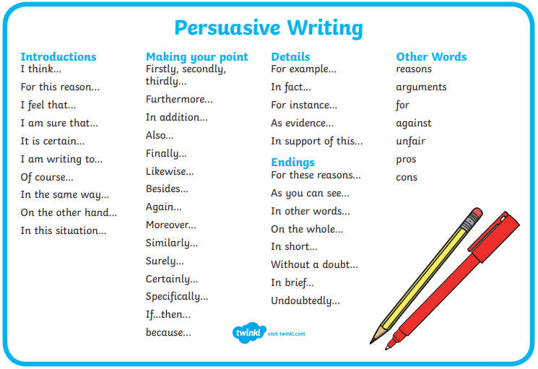
Spelling- Use your spelling menus from your homework books to practise these words.  You can also look back over the spelling rules from previous homework and check you still know them! | - Set a timer for 1 minute – how many nouns can you write? Do the same for verbs, adjectives and adverbs? You can try with other word classes too, i.e. prepositions, conjunctions, pronouns. · Write funny sentences using a words from your list – can you use one from each word class? · Make an extended noun phrases about your family, friends, pets, toys, i.e. my shaggy old cat sitting in a chair; lots of colourful Lego. · Play Consequences with your family – write three adjectives, fold the paper so no one can see and pass to the next player, they add the next part and fold the paper, continue the story following this pattern: line 2) the name of first character; 3) one or more adjectives; 4) second character; 5) where they met; 6) first character said;7) second character said 8) what happened next; 9) the consequence – what happened in the end. Now read the story out loud! · Remember to use good punctuation A , . ? “” ! · Keep practicing Year 3 and 4 Spellings
Reading - Read any available texts daily and discuss information. | - Identify key facts and make inferences around the text you are reading. 1. Some starting questions for fiction could be: 2. How do you think the characters felt/why? 3. What is your favourite part/why? 4. What do you think will happen next? 5. What would you say if you met a character in the story? · Here is useful link to some more questions: file://2024srv001/staff$/CBurnford/Downloads/Reading%20prompt%20cards.pdf
Maths – Fractions  TT rockstars and timestables | - This half term we should have been learning about time, continuing with fractions and looking at statistics. To continue to support your child’s learning, please access White Rose via the link below for the next fraction lessons. This will allow your child free access to the materials, powerpoints, activities and lessons we would have been teaching. There are some powerpoints that use sound and have a teacher speaking, so please make sure your speakers work! There are even downloadable answers if you would like to mark your child’s work. Please take pictures and attach them to the blog or billboard on Purple Mash. Alternatively you could email them to us via purple mash. We would LOVE to see what your child is doing!  - https://whiterosemaths.com/homelearning/year-3/  - To support your hildren with adding fractions, why not try and make a board game that the whole family can play? Remember, if the denominator is the same number, you only need to add the numerator (1/4 + 2/4 = ¾). In year 3 we only look at adding fractions with the SAME denominator.  - You could also create some fortune tellers, with adding and subtracting fraction questions. Why not try googling how to make them, Earwig’s love these!  - To help your child with time, why not create a paper clock and support them with 5 minute intervals, quarter to, quarter past, 5 to, 5 past and intervals of time.  - In year 3 we also calculate time, for example ‘Miss Burnford arrived at school at 8:00am, she was there for 1 hour and 15 minutes, what time did she leave”? These sorts of questions are brilliant when made into a board game with challenge cards!  - We all love playdough- could you make a playdough clock?  - Time bingo is a really fun game, use your clock to show your child the time, if they have the time on the clock on their sheets they can cross it out. The first player to shout time bingo wins!  - If you have a hula hoop and chalk, why not make a hula hoop clock?  - For statistics, why not take your child out to count cards, or trees on their daily walk and plot what they see on a bar chart or line graph? You child could get data from anywhere, the amount of different foods in your house, the colour of socks- anything!  - Could you make bar charts and line graphs from cheerio’s, pasta or any other food items?  - 3D bar charts could be made with toilet rolls and a bit of paint- I’d love to see pictures of these!  - If you have chalks, line graphs and bar charts could be plotted outside.  - Once you have completed your data gathering and plotting on graphs, remember to ask your child questions such “what is the most popular colour car”, “if you the most popular colour car and the least popular car colour how many would there be”?, “How many cars were there in total”?  - Add in some more data of your own and get your child to add it to the graph- this is a great way to make sure they fully understand graphs.  - PICTOGRAMS- Draw a pictogram chart where 1 picture means a specific number, this is also a brilliant way to see how much your child understands (see image below)  TIME ACTIVITIES  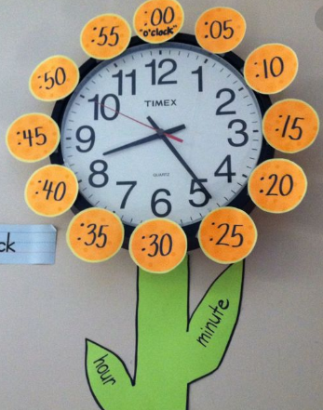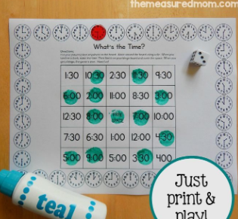  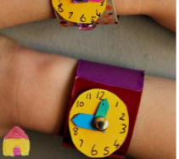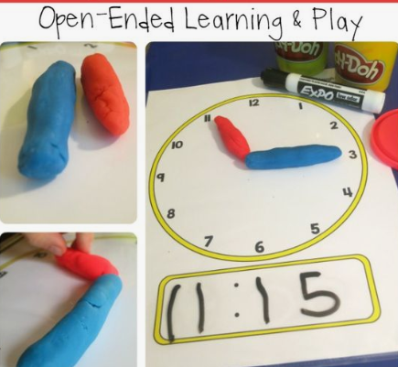  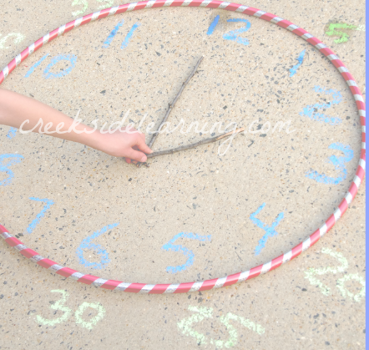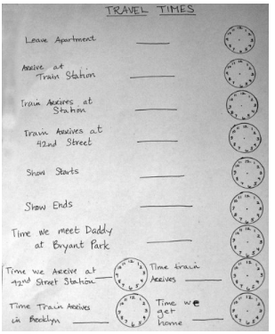  STATISTICS  Pictograms  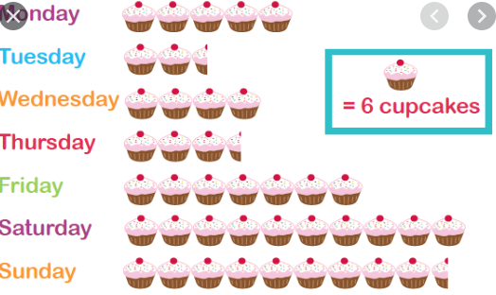  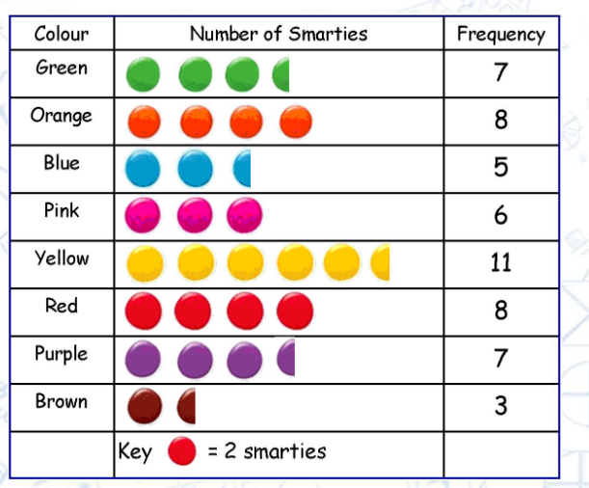
Theme  GROW WITH THE FLOW | This half term our topic is ‘Grow with the Flow’. In science we are exploring parts of a flower, in Geography we are learning about the water cycle and in Art we are exploring Monet and painting water and plants. Below are some ways of supporting your child with this topic.  Science  - Identify and describe the functions of different parts of flowering plants: roots, stem/trunk, leaves and flowers-dissect plants or flowers, stick them on paper and label the parts and their functions.  - Explore the requirements of plants for life and growth (air, light, water, nutrients from soil, and room to grow) and how they vary from plant to plant- conduct an experiment using different plans (cress seeds) and deprive them of differing elements (sunlight, air, water, soil) see which ones grow best! Write up the methodology and outcomes!  - Why not use the script in this link to create a play about plant life! It’s only 20 minutes! https://www.stem.org.uk/system/files/elibrary-resources/legacy_files_migrated/2124-4.4_script.pdf  - Create a poster/ play/ song to investigate the way in which water is transported within plants  - Create a chronological report to explore how the part of a plant that flowers play in the life cycle of flowering plants, including pollination, seed formation and seed dispersal  Geography  - Research and explore the water cycle by using the knowledge organiser provided, make a water cycle grow bag using a sandwich bag, sharpies and some water! This is a great way to bring the water cycle to life.  CHALLENGE: Could you create a bag for each step of the water cycle?  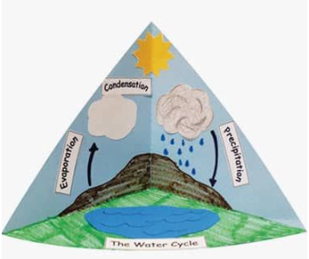  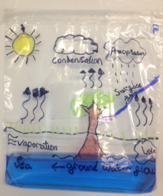  - Create a 3D water cycle trigram.  - Try a water cycle in a bottle experiment  Art  - Research and explore Monet.  - Create a fact file about him.  - Try recreating some of his art- could you use your Monet art to represent the water cycle?  - Visit a virtual museum. Go online and explore the collections.  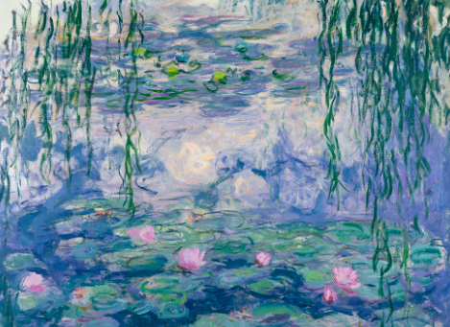
PSHE | - Think about one positive change the current situation brought – it may be less pollution, lots of families spending more time together.  - Call a family member  - Make a card for someone’s birthday or a celebration coming up  - Write down 5 things you are grateful for.  - A feelings diary can help your child to identify feelings and help them understand that feelings change.  Try to spend time talking about one or two feelings your child has had each day. If they have difficult feelings (anxious, lonely, sad or frustrated) tell them that it’s okay to feel like this and completely normal, especially because of everything that is happening.  You can find an example of a feelings diary and other resources here: https://www.partnershipforchildren.org.uk/what-we-do/childrens-wellbeing-activities-for-teaching-staff-and-families.html
RE | - What is Sikhism? Watch the clips about the main beliefs of Sikhism, Gurdwara – the Sikh place of warship and Guru Granth Sahib – the holy book.  https://www.bbc.co.uk/teach/class-clips-video/religious-studies-ks2-what-is-sikhism/zn4h382  - Explore the main beliefs, worship and the holy book in Christianity  https://www.bbc.co.uk/teach/class-clips-video/religious-studies-ks2-my-life-my-religion-christianity/zjmmvk7  - Think about what the two religions have in common. Which values do they share?
Keeping active | Here are some useful links to keep your children active:  - Where possible, take your child on lots of adventure walks to explore the world around them!  - We are currently learning cricket and rounders at school, it would be a nice idea to practise, throwing, catching and batting skills where possible.  - Go Noodle via youtube or login  - imoves – They offer activities for parents and teachers to keep children active - www.imoves.com/imovement-signup  - Get Set 4 PE – They will be setting daily activity tasks on twitter for every day that schools are closed – go to twitter.com and search for @GetSet4PE

Year 4
English –  Practice your handwriting using letter join www.letterjoin.co.uk | - We are creating daily videos to support you with the tasks below. They will cover revision of key grammar concepts that are needed for the weekly written tasks. Please find the English playlist of videos here: https://www.youtube.com/playlist?list=PL7ho0vIsCHk1mx5SNCOyaYu0bjtVI2wL2 We will also be creating 2dos on purple mash for you to submit these pieces of work but you can always email them to us via the admin team as well.  - Practise the following homophones: here/hear, meet/meat, rain/reign/rein, groan/grown, heel/heal/he’ll, not/knot.  Use a dictionary to look up the difference in meanings for each word and put them into your own sentences. Challenge yourself to make your sentences detailed – perhaps include some fronted adverbials or subordinate clauses.  - Read the story of Ananse that you will find below. How would you describe the character of Ananse? Can you make up three sentences to describe him? Do you think what happened to him was fair? Why?  - Create a story map for this story using symbols like we usually do in class and make up your own actions to go along with it. Perhaps you could teach it to your family so that you all know the story off by heart.  - You could also make puppets and put on a puppet show to act out the story.  - Write your own story based on Ananse and the birds. Remember to plan your story first. Think carefully about what will happen and structure your story with a beginning, middle and end. Introduce your character and describe your setting, hint at a possible problem and then resolve the problem at the end. You could use this picture to give you some ideas:  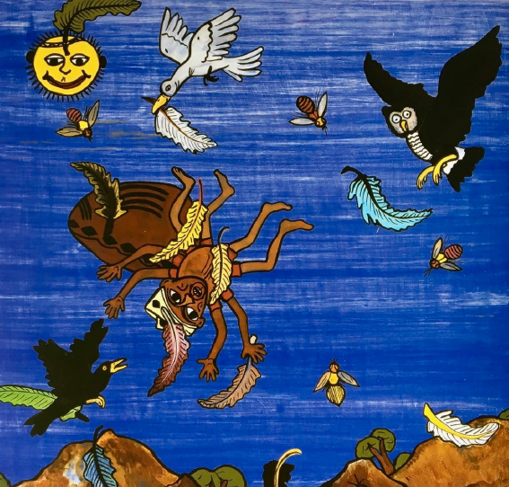  - Listen to the reading of the story of The Great Kapok Tree: https://www.youtube.com/watch?v=J1Teb-_jTyI What do you like about the story? What don’t you like? Have you noticed any patterns in the story?  - Write a letter to the man in the story to persuade him not to cut down the tree. Remember to use persuasive devices such as modal verbs, rhetorical questions and emotive language.  - Research the animals that live in the rainforest and the effects of deforestation so you can add facts to your letter.  - Write a poem about the rainforest. Think about describing what is there: include the smells and the sounds. It would be great to see some alliteration and similes too.  Ananse and the Pot of Wisdom  Ananse is a very special spider, well known for his wit and wisdom. He lives, like other spiders, in corners and on ceilings. Everybody knew that Ananse was wise, for he boasted loud and clear. In his high-pitched voice he laughed at fools and spoke louder than everyone else.  One very sunny day, Sky God called Ananse up to the skies to have a chat. Sky God said in a quiet voice, "Could you do some work for me? Go about the earth and collect all wisdom for  me. When you have brought it up to me, I will name you the Sage of All Time."  Ananse hid a smile. "That's easy, sir," he said. "I will be back in three days with the wisdom of the world."  Now, Ananse, as selfish as he was, had already travelled the length and breadth of the earth and collected every shred of wisdom. He kept it all in a giant pot in his secret hiding place.  The next day, he started out to take the pot full of wisdom to Sky God way up in the skies. It was a huge pot and very heavy. As Ananse tugged it behind him, he was more than filled with pride. To get up to the skies where Sky God lived, you had to climb a tall coconut tree that grew beyond the clouds right up into the heavens. Ananse strapped the pot tightly to his back and made his way slowly up the tree A great crowd was gathered below, waving and cheering him on. He pressed on, never mind his aching muscles. He had an appointment in heaven, and he was going to make it there.  Below, the crowd let out a cheer. It was a great moment for Ananse and,  as pride filled his chest, he raised all his arms in a victory wave.  It was a shocking moment when he plummeted down to earth. He hit the ground with a bang and the pot broke in a million pieces. Wisdom scattered left and right, to the very ends of the earth. Ananse lay there in a heap, sobbing his heart out. Now everyone and every fool had a little bit of wisdom. He could not claim that all wisdom was his alone.  Then Sky God whispered in his ear, "I gave you eight arms, Ananse. If you really had all wisdom, you would not have waved them all."
Reading | - Keep reading! Aim to read a range of text types such as stories, diaries, fact files and newspapers. ‘The World Junior’ is a good magazine for children who are interested in the news, animals, science and sport.  - Use a dictionary to look up the meaning of any words you don’t understand and keep a record of these definitions so you can look over them again.  - Perhaps you could write a letter to the author about their book or you could write a book review for a friend.  - Listen to Miss Fitzpatrick reading Harry Potter and the Philosopher’s Stone https://www.youtube.com/playlist?list=PLhGn0c9jpOLdcsA7LX-IfeZ8nyvTHsT4J New videos will be added regularly.
Maths – | - Create your own number line counting in tenths like the one below. Please show these as fractions, as well as decimals. Practise counting up and down in tenths.  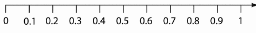  - Create your own place value grid to support you with dividing by 10 and 100. You’ll see an example below. Remember you need to move all your digits one space to the right when dividing by 10 and two spaces to the right when dividing by 100. Don’t forget your decimal point between the ones and the tenths.  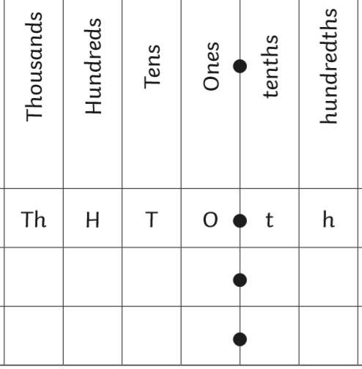  - Make your own snakes and ladders game with a set of questions to determine whether you can move up the snake. Write your questions based around fractions and decimals.  - Ask an adult to write down a range of decimals for you (e.g. 0.3, 0.28, 0.5). Can you order these from smallest to largest? Can you work out the difference between two of them?  - Find a recipe for something you would like to bake. Work with an adult, to measure out the ingredients accurately. We would love to see pictures of your bakes.  - Revise your knowledge of money. Do you know the value of each coin? Can you convert between pounds and pence? Work out the total of your pocket money. How much would you need to get to the next whole pound?  - Use receipts from food shops to work out how much change you would get from £10 for individual items. From your total food bill, work out how much change you would get from £100.  - Watch our videos for support on these tasks. https://www.youtube.com/playlist?list=PLhGn0c9jpOLftXG5pm5Bwl6jRTB3siadi  These will be added to daily and will model how to approach these.  - Keep up with ttrockstars at www.ttrockstars.com  - Have a go at the White Rose Maths lessons. They are going to be continuing with decimals so this support with the work we are setting on purple mash. https://whiterosemaths.com/homelearning/year-4/
Theme – Grow with the Flow | - Create a poster of a plant explaining the role of each part (roots, stem, flower, leaf).  - Dissect a plant to see what it looks like inside. Can you find out what the parts inside the flower are called?  - Find out about life cycle of flowering plants, including pollination, seed formation and seed dispersal. How do these processes take place? Could you write an information text about these?  - Plan and carry out an experiment to find out where the best place to grow seeds are (sunflower seeds work well). You could have a small pot in different areas of your house e.g. garden, on the windowsill, in a cupboard. Make sure it is a fair test by giving them all the same amount of water and soil.  - Create a poster to show ways we can save water e.g. have a shower, instead of a bath or turn the tap off whilst cleaning your teeth.  - Research the life of Claude Monet and write a biography about his life.  - Explore the technique of pointillism by Georges Seurat. Below are two examples of his work. Recreate one or both of these using paint and a cotton bud to help you create the dots.  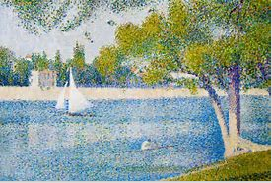  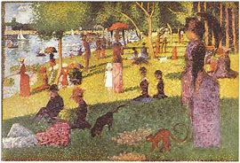
Keeping active | Here are some useful links to keep your children active:  - www.gonoodle.com – guided dance, mindfulness and brainercise activities  - PE with Joe Wicks at 9am on youtube  - imoves – They offer activities for parents and teachers to keep children active - www.imoves.com/imovement-signup  - Get Set 4 PE – They will be setting daily activity tasks on twitter for every day that schools are closed – go to www.twitter.com and search for @GetSet4PE
Other skills | - Go on www.duolingo.com or download the duolingo app to practise your German.

Year 5
We are using Purple Mash to set many tasks for the children, give them a chance to show off their hard work to their peers and to communicate with them. It would be beneficial if they could access this too during this period of home learning.
Writing – | Think about your target bookmarks and improving your writing stamina. We know lots about how to write good introductions, noun phrases, modals, power of three, many different types of punctuation ( . , ! ? : ; - ), paragraphing and linking these, higher level vocabulary, emotive language, descriptions, atmosphere, ‘show me, not tell me’.  - Keep going with the diary about your day to day routine; what have you got up to? What have you learnt? What have you enjoyed? Set yourself a daily goal to achieve the next day.  - You are a scientist who has discovered a brand new material buried in your garden. Write a report about what you have found and what it can be made into or used for.  - Create a diagram of your dream room and what it would contain, this could be your current room with some added features or a completely new design. It needs to include clear labels for everything inside the room.  - Write a new ending for an original story, this could be from any story of your choice. Examples of this could be; the big bad wolf and the three little pigs build a house together to live in, Cinderella’s foot does not fit in the glass slipper.  - If you have completed any craft, art, or even Lego activities, write up a set of instructions and a method so others can create it themselves.
Reading – | With book choices, check out the book list at book trust (see separate list). Mr Turner and Mrs Hunter will be reading some of these books so would love to hear about what you have enjoyed.  - Keep going with the book reviews! Write a book review of a new book you have read, including; a title, the author, genre, target audience, summary, review comments and star rating.  - Create a profile all about a place or setting in your favourite story, for example; Hogwarts, the Wonka Chocolate Factory. What makes this setting so interesting? What does it look like? Why do you like it?  - Practise some of the spellings below! You can use these to create your own dictionaries, use them in sentences or even attempt sentences which use as many of these as possible!  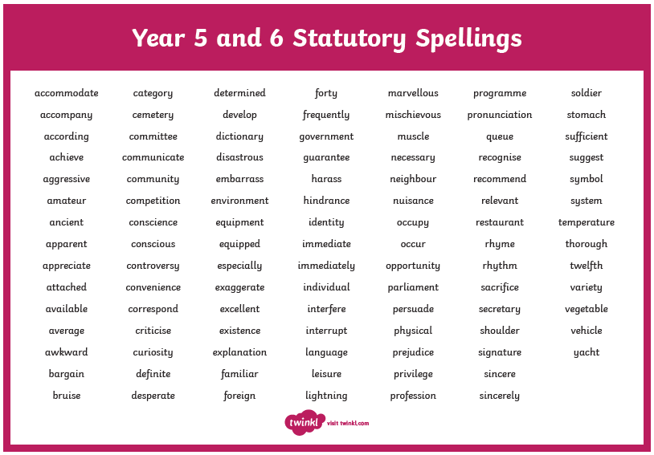
Maths – | Websites and apps: TT Rock Stars, PiXL Times Tables, numbots.  Lots of lessons on https://whiterosemaths.com/homelearning/  - Continuing with your measuring and conversion learning, we are going to do a measuring scavenger hunt, go around your house and find lots of objects to measure. Can you convert them into different measurements? Which objects are bigger/smaller? How much bigger is the object?  - We have learnt about Roman numerals and how they are structured. Can you create a diagram of your road with all the house numbers in Roman numerals?  - Keep going with your 4 basic operations. If you use a dice (or other kind of random number generator) you can make questions for yourself based around: multiplying numbers by 2-digits, dividing by numbers up to 12 with remainders/decimals, adding and subtracting in decimals.  - We have done a lot of work on our multiplying. Using column method, arrays and grid methods to create some interesting designs. This could include using different colours for different numbers, or pictures in your array.  - Make up a time table of your day, using times. Time how long it takes you to do things and if you go over on one activity, what effect this would have on later activities.
Theme – | Science websites:  https://thekidshouldseethis.com/  https://www.natgeokids.com/uk/  Other good websites for home-learning include:  https://www.bbc.co.uk/bitesize/levels/zbr9wmn  https://www.stem.org.uk/home-learning/primary  https://www.hamilton-trust.org.uk/blog/learning-home-packs/  https://classroomsecrets.co.uk/free-home-learning-packs/  - Science: If you have been out in the garden and helping with caring for your plants, what have you noticed? Are they healthy? Are some parts of your garden better for growing than others?  - Science: Plant biography: Write about one of the plants that is growing in your garden. What do you know about it? What colour is it? How tall is it?  - Science: Nature Scavenger hunt: What can you find around your garden or an area close by to you?  - Art: Using the materials you scavenged, can you make these into a piece of art? Could they become a person or figure on the ground?  - Art: learn how to sketch and draw cartoons. You could theme this around your favourite TV show, book or other favourites. https://www.youtube.com/watch?v=7TXEZ4tP06c  - Music: We have all been listening to a lot of music in our homes to help pass the time. What have you been listening to? Why do you like those songs? How do they make you feel?  - If you haven’t had a go at the Fitzwilliam museum activities please continue to use this link: https://www.fitzmuseum.cam.ac.uk/lookthinkdo/about  - I would love to hear about your favourite historical period, what do you find interesting about this period? What famous people lived during this time? Were there any major events that took place? Write a face file all about this period.  - Geography: All about your city/town/village. Since you have learnt all about your home and road, now let us expand our learning to the city or town or village we live in. What main features/buildings are there? Where are you located in your hometown? What do you like about where you live?

Computer Based Work:
Please note that we are giving out these website addresses in good faith and that children’s use of the internet should be monitored by an adult within the home at all times.
A separate ‘additional information’ list has also been sent to you. Please refer to that for more details on some of the school learning platforms.
https://www.purplemash.com/login/ | In Years 1-5 class teachers have set a range of work that can be completed on PurpleMash. Once your child saves and submits their work, teachers can then respond with feedback. If your child does not have their login, please contact their classroom teacher by emailing the office.
https://classroomsecrets.co.uk/free-home-learning-packs/ | Home learning packs for all year groups.
https://primarystarseducation.co.uk/covid-19-year-1/ | Year 1 home learning pack.
https://primarystarseducation.co.uk/covid-19-year-2/ | Year 2 home learning pack.
https://whiterosemaths.com/homelearning/ | Maths revision / home learning.
https://ttrockstars.com/ | TT Rockstars – website to practise times tables. Year 2 – 5 have login details for this.
https://thekidshouldseethis.com/ | Curious videos to enhance children’s knowledge of science.
https://www.natgeokids.com/uk/ | Activities and quizzes relating to science and nature.
https://scratch.mit.edu/explore/projects/games/ | Computer programming tool for children in KS2 or above.
https://www.bbc.co.uk/bitesize/levels/z3g4d2p | BBC activities for KS1 and Early Years.
https://www.bbc.co.uk/bitesize/levels/zbr9wmn | BBC activities for KS2.
https://blockly.games/?lang=en | Simplistic website for basic computer programming.
https://www.dkfindout.com/uk/ | Research website for children.
https://www.twinkl.co.uk/resources/extra-subjects-parents/school-closures-category-free-resources-parents/school-closures-free-resources-parents | Twinkl has a whole range of resources for parents to download.
https://play.numbots.com/?#/account/school-login-type | Maths game.
Child friendly search engines:
https://www.kiddle.co/
https://wackysafe.com/
https://www.alarms.org/kidrex/
https://www.safesearchkids.com/

Additional Reading:
Being off school offers children an ideal opportunity to read. Please see https://home.oxfordowl.co.uk/books/free-ebooks/ for access to free eBooks.

Recommended book lists and story-based websites:
0 - 8 year olds
https://www.booktrust.org.uk/booklists/1/100-best-0-5/
https://www.booktrust.org.uk/booklists/1/100-best-books-6-8/
https://www.storyplace.org/

9 – 11 year olds
https://www.booktrust.org.uk/booklists/1/100-best-books-9-11/

General
https://www.storynory.com/
http://www.professorgarfield.org/pgf_mrsp.html
http://en.childrenslibrary.org/
https://freekidsbooks.org/

