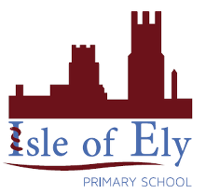

Learning, growing, achieving together

An Active Learning Trust Academy

PSHE Policy
July 2014

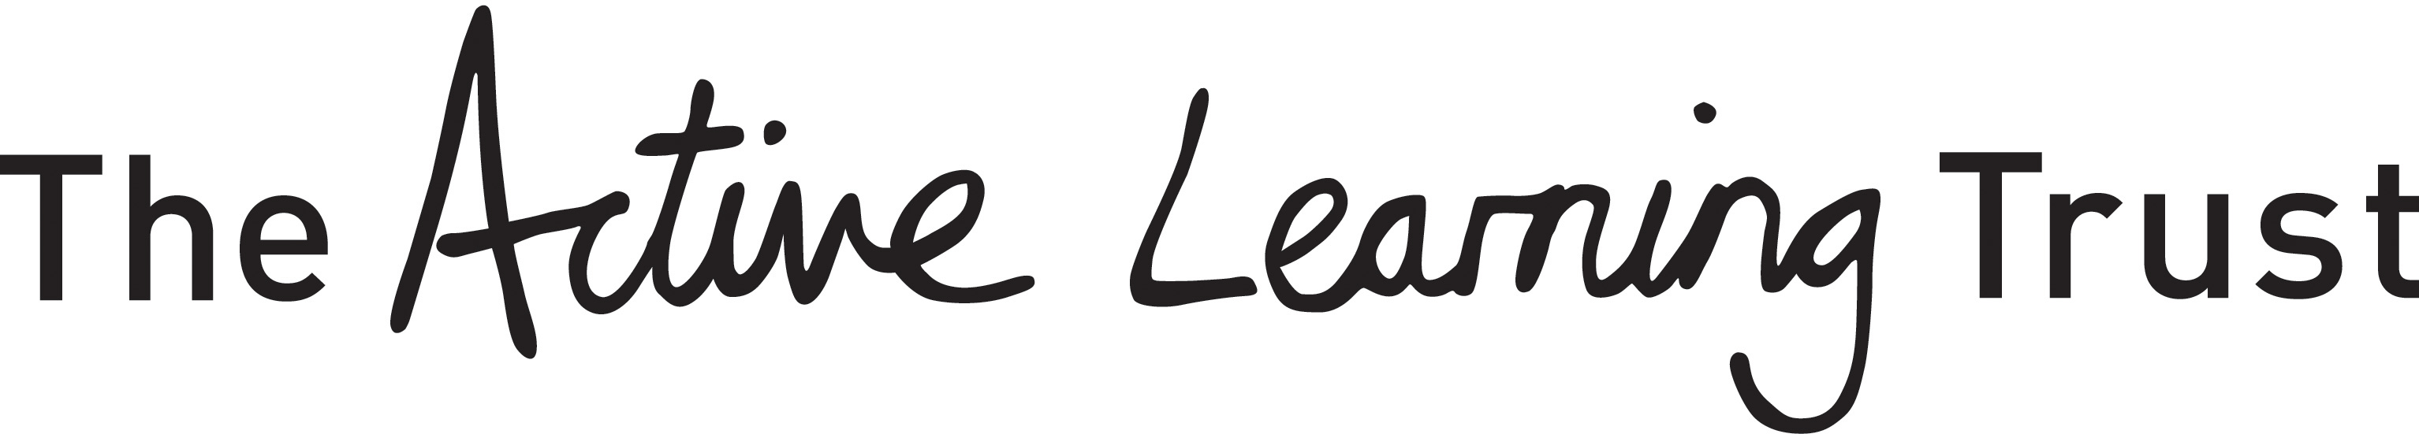

Isle of Ely Primary School

Policy for Personal, Social and Health Education and Citizenship
This policy was created in July 2014 and will be next reviewed in the summer of 2017.

Introduction
This policy is drawn up after consultation with staff and governors and with reference to current national and county guidance, including National Curriculum non-statutory framework for PSHE and Citizenship, QCA guidance, SRE Guidance July 2000, PSHE in Practice 2004 and Every Child Matters.
Isle of Ely Primary School aims to help every pupil develop into a happy and confident learner. The effective teaching of PSHE and Citizenship enables and encourages children to become healthy, independent and responsible members of a diverse, multi-cultural society and to play a positive role in contributing to the life of the School and the wider community. Through our teaching, we help children to develop their sense of self-worth and to value others, to know about their rights and responsibilities and about how our society is organised and governed.

Aims
Our aims in teaching PSHE and Citizenship are to enable the children to:

▪ Develop self-confidence and self-esteem and make informed choices regarding personal and social issues
▪ Understand what makes for a good relationship with others
▪ Have respect for others, appreciating and valuing differences between people
▪ Develop good relationships with other members of the school and the wider community
▪ Be independent and responsible members of the School community
▪ Know and understand what constitutes a healthy lifestyle
▪ Be aware of personal safety issues
▪ Be positive and active members of a democratic society
▪ Understand why laws are needed for society to function
▪ Recognise the interdependence of their role in society, locally, nationally and internationally
▪ Understand and have a view on issues relating to discrimination on the grounds of race, gender, religion or disability.

Framework for PSHE and Citizenship
Early Years Foundation Stage pupils are taught PSHE and Citizenship as an integral part of the topic work covered during the year. We relate the PSHE and Citizenship aspects of the children’s work to the objectives set out in the Early Learning Goals. Therefore, our teaching matches the aims of developing a child’s personal, emotional and social development as set out in the Early Learning Goals. We also support Citizenship education in the Reception class when we teach ‘how to develop a child’s knowledge and understanding of the world.’
Pupils in KS1 and KS2 study topics through our Creative Curriculum, with headings that link to and build upon .

Teaching and Learning
The curriculum consists of five key themes of Health, Relationships, Citizenship, World of work and Sustainable Development which have been broken down and incorporated into a Whole School Plan that takes the form of a programme to accommodate the age classes in KS1 and KS2. Greater weighting is given to Health, Relationships and Citizenship than is given to World of Work and Sustainable Development.

Currently, class teachers plan blocks of work following the medium term plan, using resources available in school, online resources and web sites and contributions and visits from representatives of outside agencies. In KS1 and KS2 there is an average of 1 hour per week taught time. Teachers use a mix of teaching styles as appropriate to the activity and emphasis is placed on active learning. Lessons can include discussions, practical work, role play, research, receiving visitors and class work following a visiting speaker. Time is also allowed for reflection, evaluation of activities and self-assessment. There are many opportunities for learning outside the taught time, such as circle time, Class and School Council meetings, Healthy Week activities, fundraising projects, inter-class activities, Federation activities and links with the wider community.

Ground Rules
Ground rules are set, in consultation between the pupils and the teacher, to ensure all pupils feel comfortable and safe and are able to communicate effectively during PSHE sessions and Circle Times. In KS1 these ground rules may state simply that each pupil listens to others, values others’ comments and does not use personal names when discussing sensitive situations. Older pupils may include an agreement on what kind of language is appropriate.

Confidentiality
Confidentiality is addressed when agreeing ground rules, to promote a safe learning environment and also to minimise the risk of inappropriate or unplanned disclosure in the classroom. However there are implications of disclosure for child protection and all staff are aware of the procedures in the event of a child protection issue arising. Staff and adults working with children should make it clear to pupils that they cannot promise total confidentiality and must not ask the child leading questions or try to investigate any issues themselves. They should contact the Head teacher or other named Child Protection staff member if an issue arises.
Resources
Teachers are free to use their own materials to support lessons, to use materials available online and to use web sites in class when appropriate. Materials available in school include:
▪ Telling Tales Resource books and Teacher’s notes EY – Y6
▪ Folens Resource books Y3-Y6
▪ SEAL resources – photos, posters and guidance booklets.
▪ Posters on a variety of topics e.g. safety and health
▪ Videos, booklets and other materials covering specific subjects inc bullying
▪ Websites, especially CEOP’s ‘Think u Know’ which covers internet safety.

Pupils with Special Needs
We aim to encourage all pupils to reach their full potential through the provision of varied opportunities. Where appropriate the curriculum may be adapted for children with special needs, for example, adaptation of reading materials, or adult support during role play activities.

ICT
Opportunities for the use of ICT and cross-curricular links are built into the planning, delivery and assessment of this subject. Safe use of ICT is taught at all stages.

Evaluation and Assessment
Teachers assess the children’s work in PSHE and Citizenship both by making informal judgements as they observe them during lessons and by carrying out formal assessments of work measured by the Foundation Stage Profile and against the specific learning objectives set out in the National Curriculum.
Pupils will be given opportunities to evaluate activities, to reflect on their own learning and to assess their own progress.

Achievement
Pupils will have regular opportunities to celebrate their achievements and those of their peers through Celebration Assemblies, class discussions and the weekly newsletter.

The Role of the PSHE and Citizenship Co-ordinator
▪ To raise awareness amongst all staff of their contribution to the pupils’ personal and social development and agree the overall aims, objectives and priorities of the School
▪ To provide guidance and support in implementing National Curriculum, and to support assessment and evaluation by staff and by pupils themselves
▪ To monitor and evaluate the programme, in consultation with staff, and to review and update as required
▪ To liase with the subject Governor and keep him/her updated on developments within the subject
▪ To review the policy regularly

▪ To keep up to date with new developments and initiatives by attending courses and feeding back relevant information to colleagues
▪ To encourage, organise, assist or lead INSET
▪ To purchase, organise and maintain teaching resources

Other related policies
▪ Sex and Relationship Education
▪ Drugs Education
▪ Drugs Related Incidents
▪ Child Protection/Safeguarding Children
▪ Behaviour
▪ Health and Safety
▪ Anti-Bullying

Written: B Surtees

Review Date: June 2017

