Ideas for Books to Buy or Borrow Based On Books You’ve Enjoyed
If your children have worked their way through all the books in the house, or maybe have a birthday coming up and you need ideas, here are links to books they may enjoy based on current favourites.
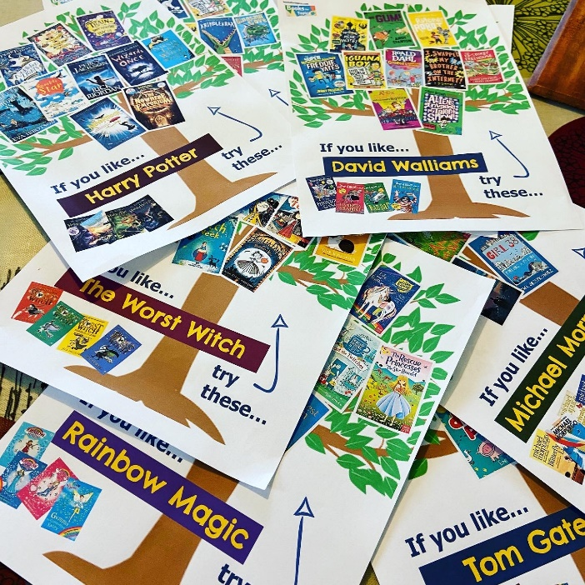
Click on the name of an author or series they have particularly enjoyed reading and you will see ideas for other books they may enjoy. This is a great way of broadening their reading without pushing them too far from their comfort zone and is especially helpful for children who are resistant to change.

If you like Beast Quest, try these…
If you like David Walliams, try these…
If you like Harry Potter, try these…
If you like Horrible Histories, try these…
If you like Horrid Henry, try these…
If you like Jacqueline Wilson, try these…
If you like Julia Donaldson, try these…
If you like Michael Morpurgo, try these…
If you like Rainbow Magic, try these…
If you like Roald Dahl, try these…
If you like Supertato, try these…
If you like The Famous Five, try these…
If you like The Worst Witch, try these…
If you like Tom Gates, try these…
If you like Diary of a Wimpy Kid, try these…

