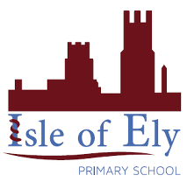
Isle of Ely Primary School
School Prospectus
2019 - 2020
Learning, Growing and Achieving Together

Bryony Surtees
Headteacher

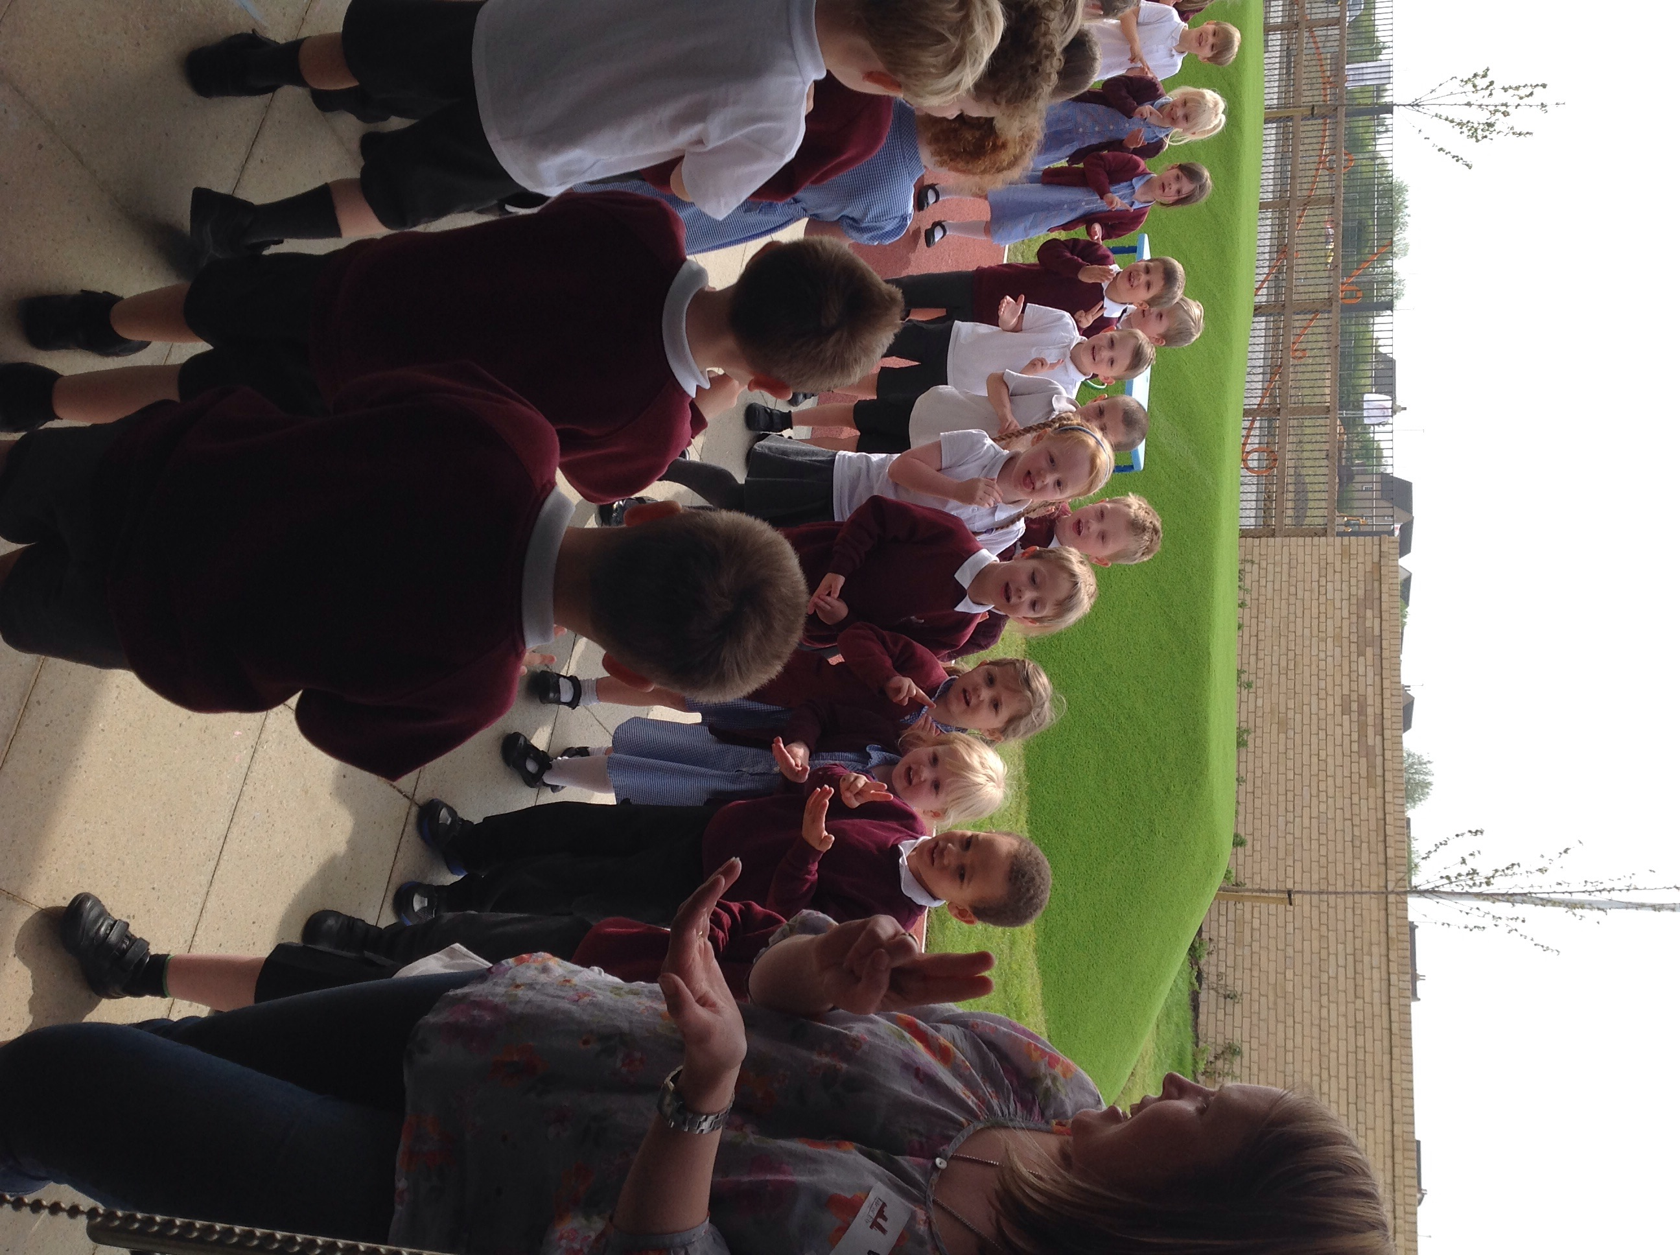

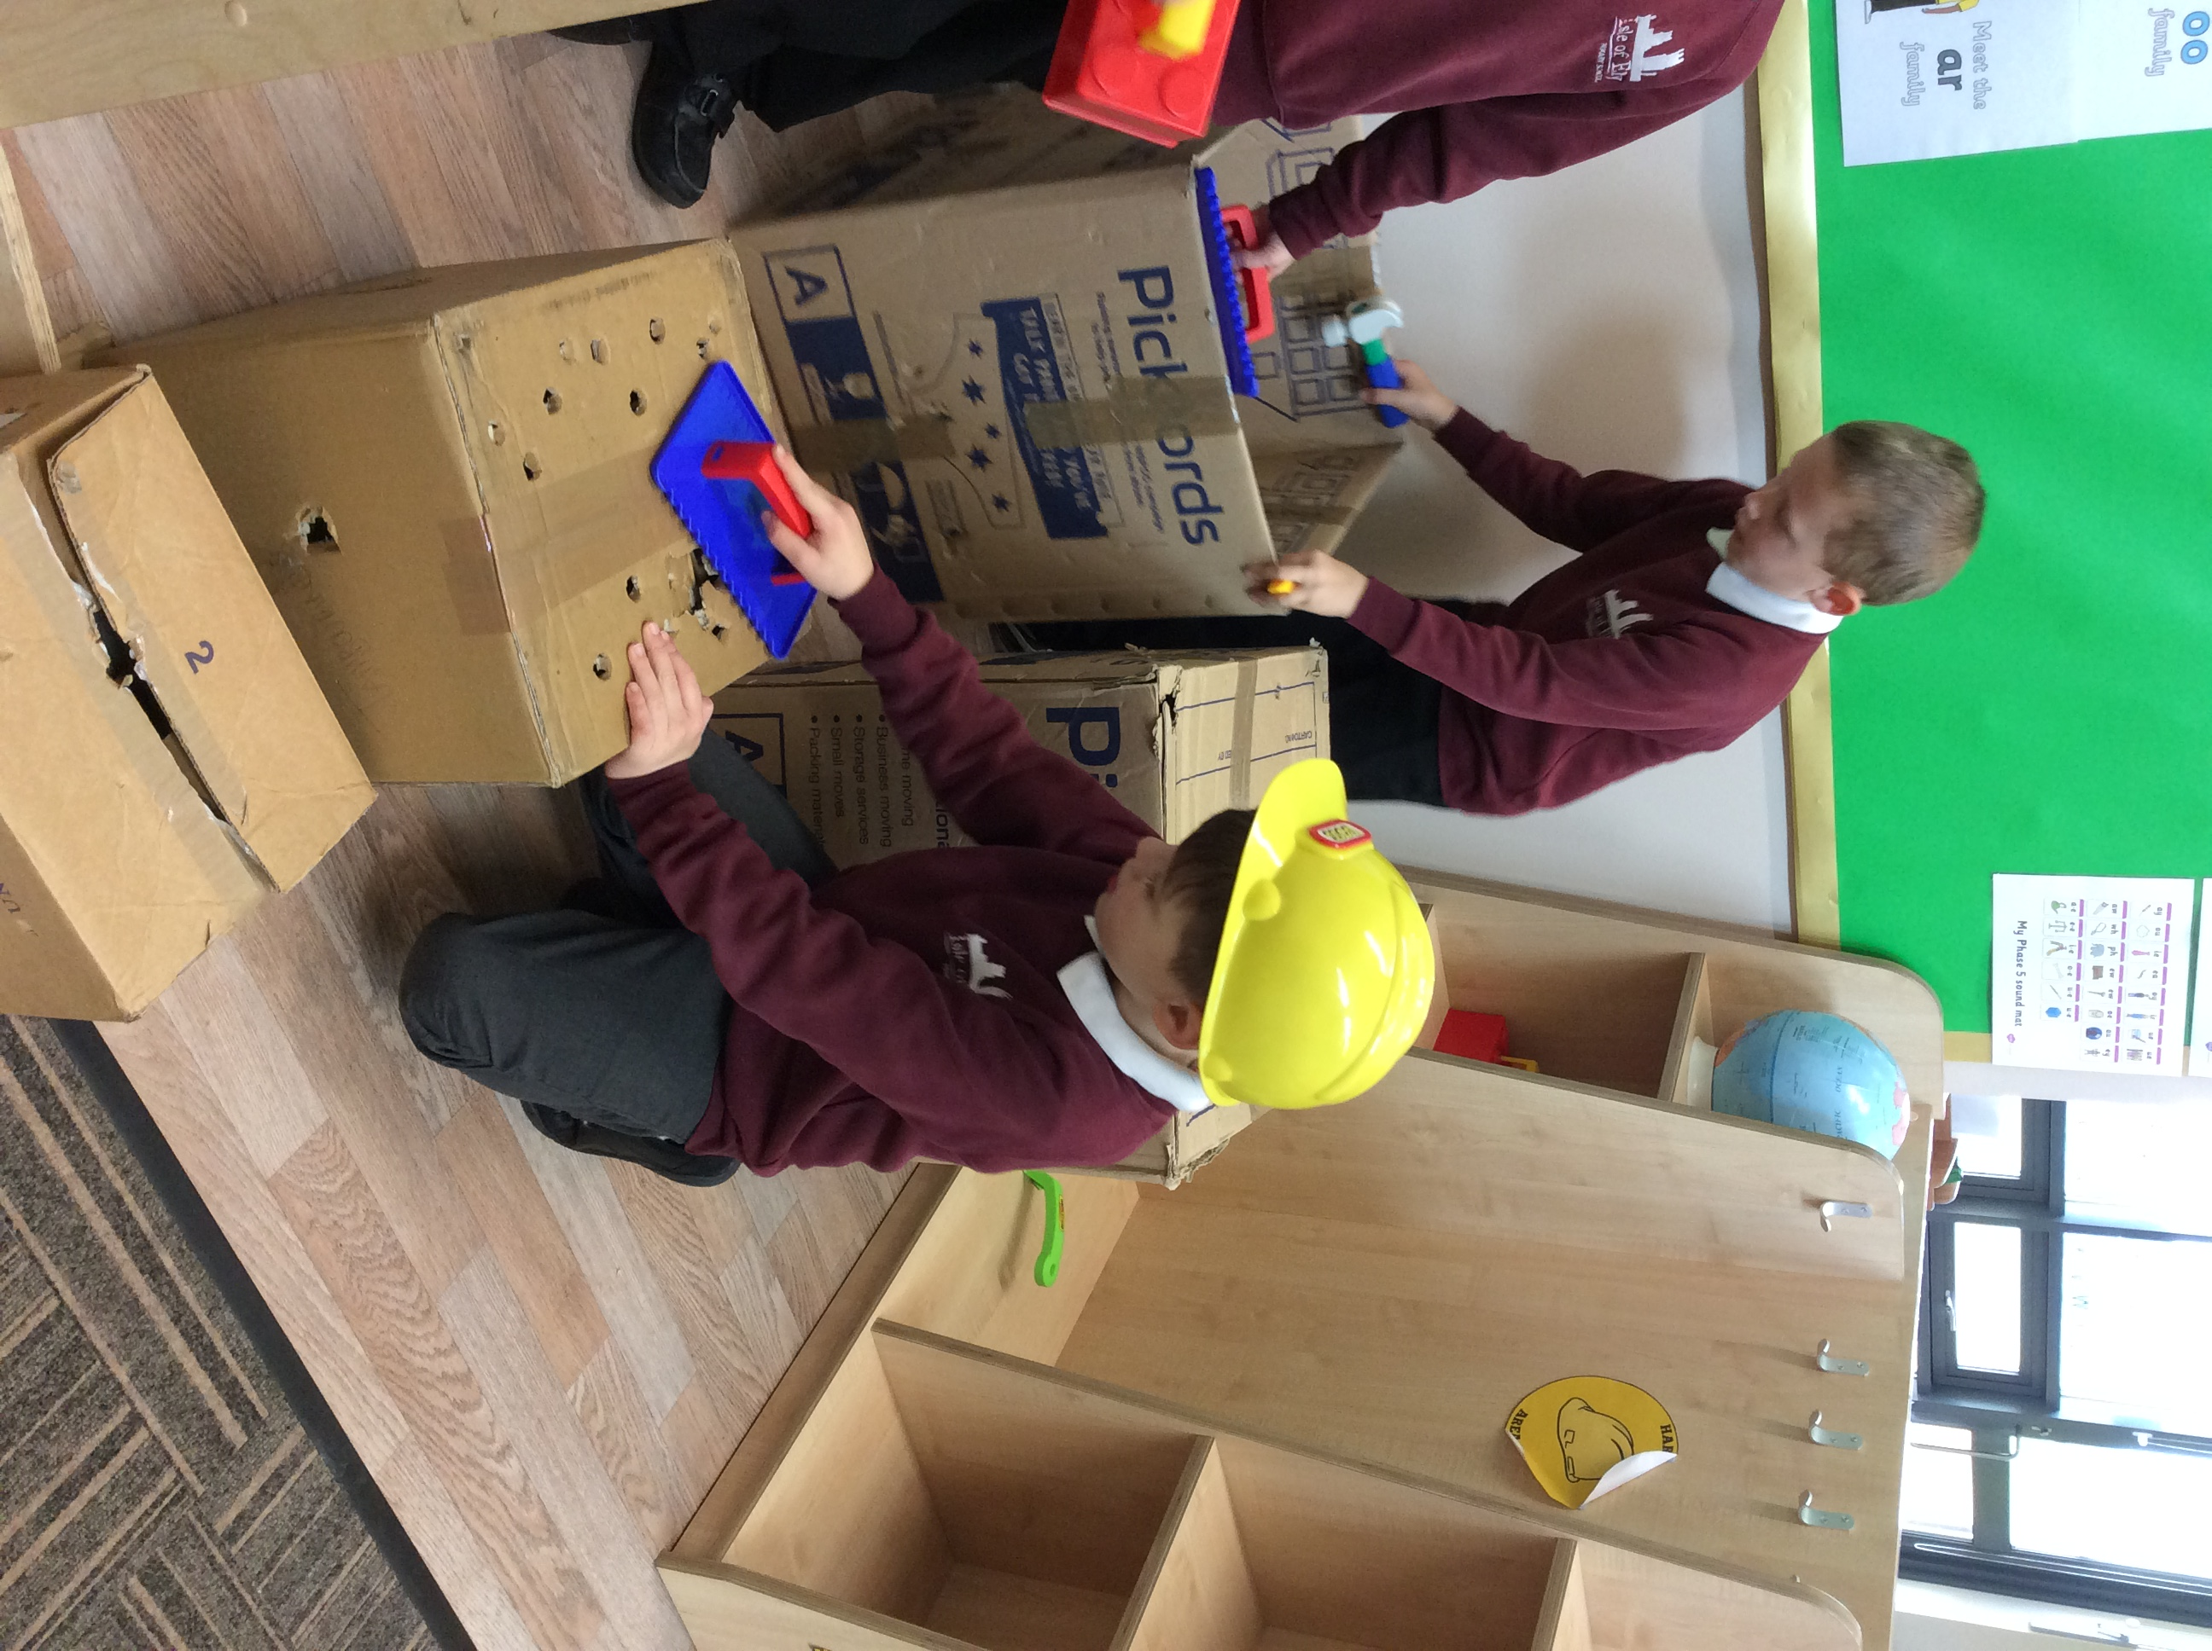

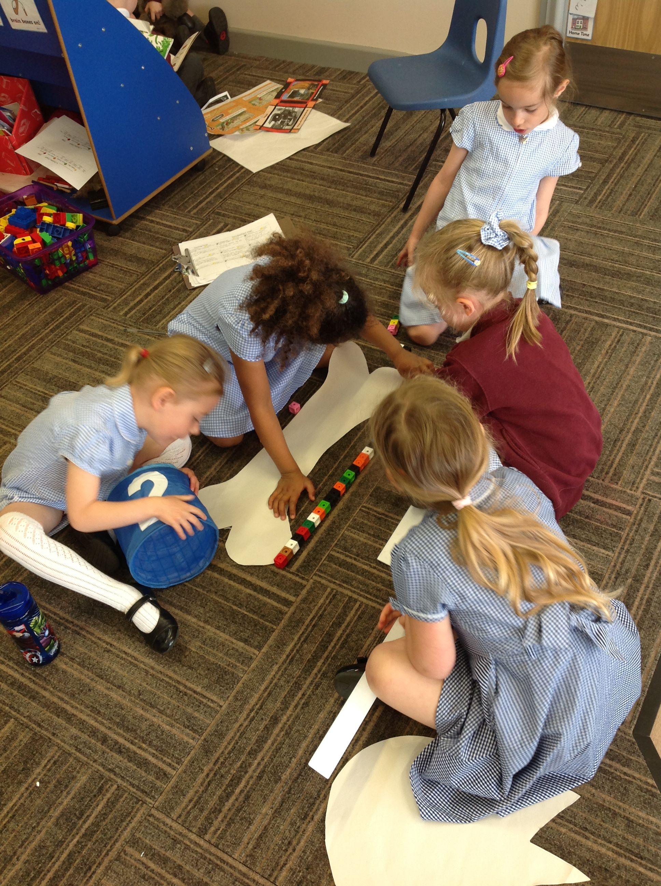

Table of Contents

Welcome letter 2
Whole School Aims 3
Who’s Who at Isle of Ely Primary School 4
Governors of Isle of Ely Primary School 5
Organisation of Education 6
Entry to School 7
The School Curriculum 8
Extra Curricular Activities 14
Special Needs, Including Gifted and Talented 15
Pastoral Care and Discipline 17
Uniform 21
Home-school Links 22
Absence 24
School Meals 25
Child Protection 26
Charging, Remissions and Complaints 27

An Active Learning Trust Academy

Isle of Ely Primary School
School Road, CB6 2FG
Tel: 01223 612818
head@isleofelyprimary.org

Head teacher: Mrs Bryony Surtees
_____________________________________________________________________

Dear Parents and Carers,

The governors and staff at Isle of Ely Primary School extend a very warm welcome to you and your child.

Isle of Ely Primary School is a fun, caring and stimulating learning environment. Our children are enthusiastic and lively, they enjoy the learning atmosphere of the school, but they are aware that we have high expectations and aspirations for them.

We wish to work in partnership with you, to make you feel welcome and part of our team.

Our Prospectus will tell you a little about our school, how we learn and develop, and what we are all working to achieve.

To arrange a visit please contact Chloe Amory or Mary Hook, our Admin Assistants, in the school office.

Yours faithfully,

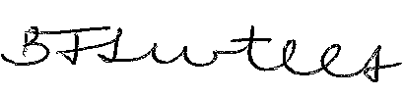

Mrs Bryony Surtees
Head teacher

2

Isle of Ely Primary School – Whole School Aims

We at Isle of Ely School aim to develop happy and confident learners for the future by:

- Providing a safe and happy learning environment
- Fostering a love of learning and a desire to do well
- Helping to promote tolerance, understanding, respect and a sense of responsibility to others, our community and the wider world
- Providing a rich and diverse curriculum which meets the needs and individual differences of the children
- Helping all pupils to understand their own learning styles by developing knowledge, understanding and enthusiasm for learning
- Developing co-operative working relationships between all pupils, staff, governors and parents
- Providing equal opportunities for all

Most importantly!
We remember that children are the centre of our focus, and that they provide, along with the staff, parents and wider neighbourhood, a whole school community worthy of everyone’s education and support.

3
Who’s Who at Isle of Ely Primary School

The school is fortunate to have high quality teaching and non-teaching staff who work extremely hard to create an atmosphere of high expectation, co-operation and fun, which is so important in a small school.

Teaching Staff
Mrs Bryony Surtees Head Teacher
Mrs Laura Fielding Deputy Head Teacher (maternity leave)
Miss Sam Chapman Interim Deputy Head Teacher
Mrs Natalie Godfrey KS1 Lead
Ms Sarah Ryan EYFS Lead
Mrs Carlene Chambers Ladybird (Reception) Class Teacher
Miss Letitia Newman Butterfly (Reception) Class Teacher
Miss Libby Cross Bumblebee (Year 1) Class Teacher
Miss Katie Falconer Dragonfly (Year 1) Class Teacher
Miss Natalie Lewis Spider (Year 2) Class Teacher
Mr Ricky Sinfield Caterpillar (Year 2) Class Teacher
Miss Christine Burnford SENDco and Earwig (Year 3) Class Teacher
Mrs Gemma Berrill Wasp (Year 3) Class Teacher
Mrs Milena Mickleburgh Wasp (Year 3) Trainee Teacher
Miss Emma Fitzpatrick Moth (Year 4) Class Teacher
Miss Pelin Orakci KS2 Lead and Grasshopper (Year 4) Class Teacher
Mr Matthew Turner Mayfly (Year 5) Class Teacher
Mrs Annie Hunter Ant (Year 5) Class Teacher
Miss Kate Bryan Cover Teacher

Administration

Mrs Elizabeth Wright Business Manager
Mrs Mary Hook Admin Assistant
Mrs Chloe Amory Admin Assistant
Mrs Amy Gorrie Admin Assistant

Teaching Assistants
Mrs Joanna Golding

Mrs Alison Butterfield
Mrs Claire Lloyd
Mrs Natascia Newman
Ms Kelly Stoneman
Mrs Beth Wilshin
Mrs Claire Harrison
Mrs Hannah DelGrazia
Mrs Karen Ellis
Mrs Samantha Lambert
Miss Cheryl Bass
Mrs Hayley Ashman
Mrs Bea Kiss
Miss Michelle Reitinger
Mrs Victoria Fowler

4

Little Elvers’ Nursery Teaching Assistants
Mrs Gemma Pavitt
Mrs Alison Butterfield
Miss Lisa Stacey
Mrs Heather Brooks
Mrs Kelly Notley

Head of Kitchen
Caterlink

Site Staff
Mr Stuart Aldridge
Mr John Frampton

Governors of Isle of Ely Primary School

Chair
Mrs Marion Lloyd (Chair of Governors)
Mrs Stephanie Peachey (Trust Governor)
Mr Stephen Dove (Trust Governor)
Mr Allan Sanderson (Trust Governor)
Mr David Monk (Parent Governor)
Mr Tim Gingell (Parent Governor)
Mrs Annabel Charles (Trust Governor)

5
Organisation of Education

Foundation Stage - Reception
Key Stage 1 - Year 1 – Year 2
Key Stage 2 - Year 3 – Year 6

Our school will cater for all children from 4-11 covering the Foundation stage and National Curriculum Years 1-6.

Classes stay together for the whole academic year and the class teachers are responsible for curriculum work within the class. All classes will be supported by well-trained support staff.

Within the classes, children work individually, as a whole class or in small groups, according to ability or the subject being studied.

The Daily Routine

7.30am – 8.30am Breakfast Club
8.25am Gates Open
8.30am Registration
8.45am Morning sessions begin
11.30pm Lunch
12.30pm Afternoon sessions begin
3pm End of the day
3pm – 6pm After School Club

6
Entry to School

All children can attend school full-time in the September following their fourth birthday.

You must apply for a school place if your child will be five between 1 September 2019 and 31 August 2020. This means they will have been born between 1 September 2014 and 31 August 2015.

The closing date for applications is Tuesday 15th January 2019. This closing date is very important.

Children will join either Butterfly or Ladybird Class, which is made up of the 60 Early Years admissions.

Early Years children follow the Early Years Foundation Stage Curriculum (EYFS), which helps to develop essential learning skills. There are seven areas of learning and development that shape our curriculum. All areas of learning and development are important and inter-connected. Three areas are particularly crucial for igniting children’s curiosity and enthusiasm for learning, and for building their capacity to learn, form relationships and thrive. These three areas, the prime areas, are:

- Communication and Language
- Physical Development
- Personal, Social and Emotional Development

We also support children in four specific areas, through which the three prime areas are strengthened and applied. The specific areas are:

- Literacy
- Mathematics
- Understanding the World
- Expressive Arts and design

You will find Butterfly and Ladybird Classes very busy places. Children pursue their learning through carefully planned practical activities and play. Children may be working in groups, as a class or individually.

At the end of Foundation Stage, children are assessed against statements of achievements.

Admissions

The County Council is responsible for admissions to the school. Full details of policy and procedures are set out in the ‘Admissions to Schools in Cambridgeshire 2019-2020’ booklet.

7
The School Curriculum (Years 1 -6)

Isle of Ely Primary School is an Academy and the curriculum is for ‘your’ child. Although we use the National Curriculum as a baseline and a starting point, our curriculum exceeds the requirements of the National Curriculum and it is enriched with the use of the outside space and community.

The curriculum for both Key Stages includes: English, Numeracy, Science, Geography, History, Religious Education, Music, Art, Physical Education, Design and Technology, Information & Communication Technology and Personal, Social and Health Education. A modern foreign language is taught in KS2.

At Isle of Ely Primary School we feel passionately about providing a curriculum that stimulates and motivates all children, ensuring that all pupils achieve their very best. Subjects are taught through a cross-curricular approach using Big Questions, which allows pupils to link their learning. Creativity and thinking skills feature highly in the planning, with innovative approaches to teaching and learning being employed.

As well as the formal curriculum, emphasis is placed on developing individuals into well-rounded personalities. We are keen to develop and celebrate all aspects of a child’s development in and out of school. We try to know the children well and hope to identify individual strengths and problems; we can then encourage them in those strengths and support them in areas of difficulty.

Positive attitudes and good behaviour are an integral part of learning and we encourage a happy, quiet and busy atmosphere in which children can learn. We encourage children to take pride in their work, to have high expectations, to be considerate to everyone in the school and to respect and care for property.

Subjects

ART
Art is used as a vehicle for expression at Isle of Ely and the children are taught a wide range of activities including painting, drawing, printing, textiles, model making, clay work and collage and study a wide range of artists and their work. Children are encouraged to experiment with, and explore, different techniques and media to develop these skills. The environment provides a great stimulus for expression and skills development.

8
DESIGN & TECHNOLOGY
Children are taught the skills of designing and making from the Foundation Stage. All children are taught to create their own models and designs and are taught to work to design specifications, testing and evaluating their own and others’ work. The children undertake a number of design projects each year.

HISTORY AND GEOGRAPHY

History and Geography are often approached through topic work and may be combined with other subject areas. History lessons enable the children to acquire knowledge about historical periods or events, and to know how to find out about the past by using historical sources. It helps them to understand the present in the light of the past. Geography helps the children to make sense of their surroundings and the world through the study of places, the human and physical processes which shape them, and the people who live in them.

COMPUTING
Computing is an integral part of the whole curriculum and the children are encouraged to use it widely and regularly in its various forms. The school keeps ICT resources under review looking at the latest technology and will invest in these resources in line with available funding.

The children will learn word processing, using the Internet and e-mail, data handling, manipulating data, simulations, control and measuring using information technology. Every class has an interactive whiteboard

The internet is used as a great teaching tool and resource through supervised access. All children and parents are advised of our Acceptable Use and Internet policies and sign an agreement. Access to the Internet will enable pupils to explore thousands of libraries, databases and bulletin boards, while exchanging messages with other Internet users throughout the world. We are part of a system operated by Cambridgeshire County Council, which offers protection to the user by creating a ‘firewall’ around any unsuitable material. It is only fair to point out however, that
9
this is not a completely fail-safe system and some material that appears on the Internet might contain items that are illegal, defamatory, inaccurate or potentially offensive to some people. We also have an Internet based Virtual Learning Environment which the children can access at school and at home. Whilst in use at school, this too uses the filtering system, but parents should monitor use at home.

ENGLISH
The National Curriculum forms the basis for planning in English which is taught daily in Key Stages 1 and 2. Opportunities for using literacy skills in all other areas of the curriculum are fully exploited. Our cross-curricular approach to teaching and learning ensures pupils practise and define their literacy skills in all learning situations.

SPEAKING AND LISTENING

These are the first language skills learned by children. We teach a range of speaking and listening skills to develop confidence, accuracy and the ability to express ideas, opinions and feelings. Speaking and listening paves the way to successful understanding of all areas of the curriculum. ‘Talk for Writing’ features highly at our school and children will experience a wide range of speaking and listening activities on a regular basis to help higher quality written work. Drama and role play are used throughout the school.

READING
Promoting a love of reading features highly in our school, as we believe that an enjoyment and love of books is a key feature to future satisfaction in life. Hence, from the first day of school your child is encouraged to value and love books and as parents you are encouraged to share your child's reading and to use their Reading Diary to help build their confidence and enjoyment. Reading can take on many forms, books, comics, posters, instructions, packets etc and the wider use should be encouraged alongside the books provided by school. Phonics is taught throughout the school on a daily basis.

WRITING
Children will be taught writing skills that will be developed and refined in all subject areas. Accurate spelling, grammar and a high level of presentation are always encouraged, with the school’s chief objective to encourage creativity in written work. To this aim, the children will be introduced to the principles of VCOP (Vocabulary, Connective, Openers and Punctuation), four generic target areas where children can improve their work. Children will have the opportunity to learn about and write in fiction, non-fiction and poetry contexts, with links made to their
10
current topics. Children learn spelling patterns and are encouraged to take greater responsibility for their own learning of spellings in the older years.

MUSIC

Music is an important part of our school curriculum. We aim to provide opportunities for singing, playing, composing and performing in our class session, as well as listening to and appraising the music, of others. Enjoyment of music is the key! For those who wish to learn an instrument, we offer violin and keyboard tuition to children who have shown a commitment, and peripatetic music teachers take these lessons; we do however, ask parents to make a contribution towards the cost of these sessions. Children work towards musical performances in all key stages.

MATHS
Maths is taught every day. We provide a broad based and relevant numeracy curriculum appropriate to individual needs. We place high value on problem-solving and real-life mathematics and thus provide children with lots of hands-on practical learning. Mathematical concepts are developed through many subjects in the curriculum. The children will develop skills and knowledge in number work, problem solving, measuring, shape and space and data handling. An emphasis is placed on developing mental arithmetic skills. The school has also implemented ’Big Maths’. It is based upon the principle that there are 4 core skills that lie at the heart of numeracy. These core skills form the platform for virtually all other maths skills and are affectionately known as CLIC, Counting, Learn its, It's nothing new! and Calculations . Because it is so important for all children to make progress in all 4 core skills, 'Big Maths' involves teaching through the CLIC phases every day in a fun, engaging and lively manner.

PERSONAL, SOCIAL, HEALTH AND ECONOMIC EDUCATION
Personal, Social and Health Education is taught throughout the school. The curriculum is organised under 5 main themes; Health, Relationships, World of Work, Sustainable Development and Citizenship and wherever possible, links are made with other areas of the curriculum.

Under the umbrella of citizenship, we are developing a School Council. All members of the school community are encouraged to have a voice and meetings are held fortnightly. In addition, each class sets aside a weekly slot for ‘Circle Time’ when necessary, where children are encouraged to talk about issues and listen to others.

11

SEX AND RELATIONSHIPS EDUCATION
The aim is to develop confident, responsible children with a sound understanding of their own bodies, who are capable of forming loving relationships and have high self-esteem in all aspects of school life. At the end of Key Stage 2, our Sex and Relationships education program carefully and sensitively explains to children the changes in their bodies that will come with puberty, and should enable them to anticipate and be ready for these changes.

DRUG EDUCATION
Our drugs education program aims to raise awareness of the importance of personal health by informing and educating the children about the dangers of drugs and substance misuse so that they are able to make informed choices. Through PSHE topics we aim to create a climate where children feel able to discuss drugs’ issues openly and where self-esteem and respect for one’s body is fostered.

RELIGIOUS EDUCATION AND COLLECTIVE WORSHIP
In Cambridgeshire all schools follow the Agreed Syllabus for Religious Education – ‘R.E. in the Basic Curriculum’


The Education Act 1998 states that R.E should reflect religious traditions in Great Britain. Therefore, whilst the majority of our topics have a Christian basis, pupils also study aspects of the other main religious faiths of the world.

Weekly R.E lessons are planned in termly or half termly blocks and cover such topics as Books and Stories, Signs and Symbols, Celebration and Rules for Living.

ASSEMBLY (ACT OF WORSHIP)
Arrangements for the act of collective worship and for religious education are made by the school in accordance with the Cambridgeshire County Council Syllabus and it is consistent with the requirements of the 1944 Education Act and the Education Reform Act 1988.

There is a daily 15 minutes assembly, taken by teachers or members of faith communities and local church leaders.

Parents may, if they wish, withdraw their children from worship and from R.E lessons and such requests should be made to the Executive Head teacher in writing. A member of staff will supervise these children, during this time.
12

SCIENCE
We emphasise scientific values to encourage and develop a child’s naturally enquiring mind. This work includes careful observation, classification and measuring, devising and designing fair tests and evaluating results. Children are encouraged to find out about themselves and their environment through practical investigations.

SPORTING AIMS & PROVISION FOR SPORT
In P.E. we cover a wide range of activities to develop the children’s understanding of the importance of good health, exercise, movement and body control, through the use of a variety of equipment and apparatus in the school hall, on the playground and outside areas. Activities covered include gymnastics, games, swimming, athletics, dance and adventurous activities.

13

Extra Curricular Activities

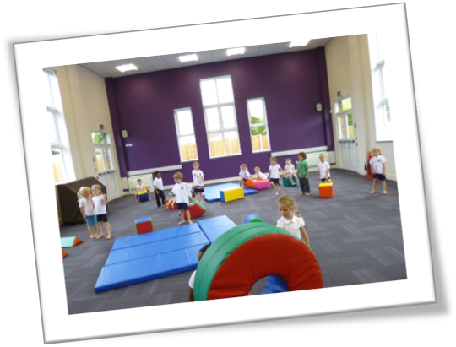
Children will have the opportunity to take part in extra curricular activities which vary during the year to provide a range of opportunities. They will take place during lunchtimes and after school.

Activities may include:

- Football
- Dance
- Mad Science
- French
- Forest School
- Photography

14

Special Needs, including Gifted and Talented:

Some children during their time at Isle of Ely School will need ‘support’ in some areas of the curriculum. Children who have difficulties are identified as soon as possible and supported through One Page Profiles and intervention strategies, often working with experienced classroom assistants. The DFE code of Practice underpins our SEN Policy and is available to parents, from the school office.

Similarly, some children may demonstrate a talent or appear gifted in certain areas. Through early identification, careful planning and working together with parents/carers and outside agencies we aim to ensure gifts are celebrated and talents developed.

Our aims are as follows:
- To provide appropriate learning situations that will best meet the individual needs of children with Special Educational Needs.
- To provide access to the full curriculum at an appropriate level.
- To identify and assess needs as early as possible in order to support the child.
- To involve parents and children as much as possible in the identification and assessment process of Special Needs provision

The school’s Special Education Needs and Disabilities Coordinator is Miss Burnford.

Pupils with Disability

The school has facilities that increase and assist access to the school by pupils who are disabled. The full Accessibility Plan can be obtained from the school office.

External support is also received from a range of different agencies including Educational Welfare Officer, Speech Therapist, Educational Psychologist, Health and Social Services etc.

Individual Difference and Equal Opportunities

We want children to develop their own unique skills and we provide and look for opportunities for children to acquire and develop their talents within the curriculum.

All children are afforded equal opportunities and access to the whole curriculum. The curriculum provides practical as well as formal methods of teaching as appropriate. Children are encouraged to become increasingly independent by working on a wide range of practical tasks throughout the curriculum. Children will be involved in class, group and individual activities according to their needs and the nature of the activity.

15

Home Learning

Whilst we value extra-curricular activities and home life, the benefit of regular home learning is also appreciated; it extends a child’s learning, provides an opportunity for parents to share in school work and helps a child to develop independence and organisational skills. All children are expected to share and read books at home every day if possible. In addition, we follow Government guidelines on homework as follows:

Year 5 & 6 – 2.5 hours weekly
Years 3 & 4 – 1.5 hours weekly
Years 1 & 2 – 1 hour weekly

Home learning tasks will involve talk homework, sound and spelling investigations, number bonds or tables, maths games, an element of research or, in the case of the older children, more formal homework tasks.

Please note that there maybe the odd occasion when home learning is not given out in a particular week – Christmas etc.

If a child is experiencing problems with organising home learning or a specific tasks, it is important that the class teacher is contacted so that any difficulties can be sorted out.

16

Pastoral Care and Discipline

Our aim is that your child is happy in school within a positive learning environment. The organisation of the school is designed to help children develop self-discipline, empathy and respect for others. We expect good behaviour at all times within and outside school. We believe this leads to a positive learning environment. At Isle of Ely Primary School we do not tolerate bullying or racial harassment.

The desired behaviour is promoted through a variety of strategies, with the emphasis being placed on positive behaviour. The children are expected to be polite and thoughtful towards others and adhere to the school’s rules.

THE PRINCIPLES FOR BEHAVIOUR IN THE SCHOOL AND THE SCHOOL RULES

The School’s Golden Rules for behaviour in the school have been agreed by the whole school community. They are:

1. We are gentle
We don’t hurt anyone
2. We are kind and helpful
We don’t hurt anyone’s feelings
3. We listen
We don’t interrupt
4. We are honest
We don’t cover up the truth
5. We work hard
We don’t waste our own or others time
6. We look after property
We don’t waste or damage things

Developed by Jenny Mosley

17

WHAT CHILDREN CAN EXPECT OF ADULTS

We believe that excellent teaching and learning promotes positive behavior; all teaching is underpinned by the school’s Teaching and Learning Policy.

Adults promise to:
- Listen to children
- Help children learn
- Keep children safe
- Show children respect

- Children with additional needs
Children whose additional needs mean they are not able follow the school behaviour policy will have individual behaviour plans which will outline individual needs and strategies which allow them to access school life.

The Rainbow Rules:
The School’s Rainbow Rules for behaviour in the school have been agreed by the whole school community. They are:

- We have kind hands and feet
- We use kind words
- We are helpful
- We are honest
- We are respectful

Rainbows:
Children will move up the Rainbow for good work or trying hard throughout the day which will be collected at the end of the day. As they accumulate the number of rainbows, the children will receive a certificate for working their way through the rainbow. 10 stickers = Red, 25 = Orange, 40 = Yellow, 55 = Green, 70 = Blue, 85 = Indigo, 100 = Violet, 150 = Bronze, 200 = Silver, 250 = Gold, 300 = Platinum and the child from each class with the most rainbows at the end of the year will receive the pot of gold.
If the children do not follow the Rainbow Rules they can move below the sun to the clouds. When a child is not following the Rainbow Rules they will be given a warning each time and then move down to the clouds where they will get the following consequences:
Cloud 1 | Miss 2 minutes of play
Cloud 2 | Miss 5 minutes of play
Cloud 3 | Miss 10 minutes of play
If a child has repaired they will have the opportunity to move back up the clouds to the sun and they can earn their play time back.

18
If a child reaches cloud 3, they are sent to a peer teacher, and if there is no improvement, adults will continue to follow the steps in the behavior flow chart.
Reaching the Shooting Star:
Each day a child is able to reach the shooting star for outstanding work or behaviour and for demonstrating outstanding learning behaviours. These children are given a shooting star sticker to show their parents.
Celebration Assembly:
Children will receive their rainbow certificates during the assembly. Class teachers will nominate one child per week who has demonstrated excellent learning behaviours and they will receive Headteacher’s sticker and certificate.
House points:
Each child will be allocated a house which they will represent. The houses are: Air, Water, Fire and Earth. The children can earn house points for outstanding work and excellent behaviour. These will be given out as tokens which will be printed on the relevant paper. Each class will have a box where these can be collected and counted on a weekly basis. Children can also receive house points by competing in inter-house competitions such as spelling bee, music competition and Sports day.
Class rewards:
At the teacher’s discretion the teacher can reward the children for making good choices and working hard.
Behaviour flow chart:
If a child is not following the Rainbow Rules adults must follow the behaviour flow chart. This should be displayed in every classroom.

19
Verbal warning
Move down the cloud and repay time at play where the child will reflect and repair
Send to peer teacher with work to be completed
Send to key stage lead
3 x to Key stage lead there will be a meeting with parents, class teacher and Key stage lead
Send to Deputy Headteacher/ Headteacher
3 x to leadership there will be a meeting with parents, class teacher, Key stage lead and Deputy Headteacher/ Headteacher
Not following the Rainbow rules
Any incidents of serious violence where someone is or could be seriously hurt.
Parents will be informed and child will be either internally or externally excluded on a case by case basis to be decided by Deputy Headteacher/ Headteacher.
Child gets to cloud 3 with no improvement

Anti-Bullying
We are fortunate not to have experienced many problems with bullying, but we do take a serious view on this matter. Parents will always be informed of any bullying issues. We rely on parents to inform us as early as possible if they ever have a concern with regard to bullying. We take a very proactive approach to this issue and like to deal with bullying on the first day it occurs wherever possible.
Uniform

There is a compulsory uniform which we expect children to wear from entry into our school. The school uniform provider is www.yourschooluniform.com
Day-to-day uniform
Sweatshirts/ Cardigans/ Jumpers
Plain Burgundy or plain burgundy with school logo
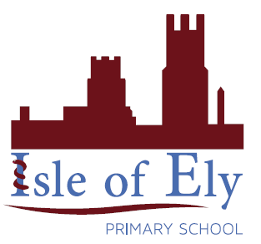
Hoodies for outside use only
Polo shirt/ Blouse/ Shirt
Plain white or white with school logo
Skirts/ trousers/ pinafore dresses
Plain grey or black
No denim
Summer dresses
Burgundy or blue and white check
Socks and tights
Plain burgundy, grey or black
No leggings
Shoes
Sensible shoes/trainers which will support your child’s feet outside and inside. No strappy sandals or open backed sandals.
Dark blue or black. No bright colours or flashing lights.
Tie
KS2 children wear a school tie.

PE and Forest School kit
Plain colours only, no logos other than the school’s, no football shirts. Please send your child’s PE kit in a named PE bag.
T-shirt/ polo shirt
White
Sweat shirt/ hoodie
Burgundy (both items can be purchased via the website with the school’s logo)
Shorts (inside and outside) and jogging bottoms (outside if cold)
Black
No leggings
Leotards (For gymnastics only)
Burgundy or black
Foot wear
Trainers or pumps which must be in addition to school shoes.
Forest school
Wellies, warm clothing, waterproof coats

21
Please note
- For Heath and Safety requirements as well as maintaining high standards of tidiness, children are required to have long hair tied back at all times
- Small stud earrings may be worn by pupils with pierced ears but no other jewellery is acceptable. Watches are acceptable.
- Earrings must be taken out for PE

Home-school links

Prospective Parents
The Head teacher or Deputy Head is glad to show interested parents around the school and to give additional information. Please contact the school’s Admin team, and they will be happy to make an appointment for you.

Parents in School

Parents are very welcome to join us in school on many occasions. There are popular annual events as well as termly events. Sports Day is always popular with parents, as is our annual Christmas decoration morning. Occasionally, we hold meetings to display/explain some part of the school curriculum. Classes also invite parents to their class assemblies and then into part of a lesson. Parents are always welcome to come and help in school, whether regularly or just periodically, subject to a Criminal Record check. Cooking, using the computer, painting, listening to reading or just talking to children, are all useful jobs and we welcome parental involvement.

Consultation with Parents

We have a formal Parents’ Evening in the autumn and spring term, which teachers really do expect every parent to attend. It is most important that children know their parents are interested in their schoolwork and value their achievements. In the summer term, we hold an Open Day when parents and visitors are welcome to spend some time with us sharing in the children’s achievements.

The children also write a learning journey which we send home at the end of the autumn and spring terms. This highlights their achievements for the term and any targets they are working towards. At the end of the summer term, the teachers write reports.

Medicine
If your child is unwell the best place for them is to stay at home. Please inform us by phone if your child is unwell and will not be attending school. In the case of diarrhoea or sickness a child should stay away from school for 48 hours after the last episode.
22
If your child is taking medicine that has to be administered during the school day, you may come to the school by agreement with the Executive Head teacher in order to administer it yourself. We are unable to administer medicine to children except in those situations where children have long term individual medical plans.

Home-School Agreement

In line with National Policy we have a Home-School Agreement, which outlines the responsibilities of parents, pupils and staff. All parties are required to sign this when their child starts school, and it will be reviewed annually.

23

Absence

Daily attendance at school is a legal requirement. Please notify us by phone call or e-mail if your child is to be absent. We need to be informed on a daily basis of continued absence. There will be times when children will need to be away through ill health or emergencies but we do ask that wherever possible, appointments/holidays etc. are taken outside school time.

If we are not notified, the School will phone parents to find out why a child is absent.

Taking Holidays During Term Time

In line with tighter Government regulations, the Head teacher will not grant leave of absence for a holiday taken during term time other than in the most exceptional circumstances. Any absences without the permission of the Head teacher will be marked as ‘an unauthorised absence’. Any unauthorised absences of three days or more will be referred to our Education Welfare Officer and a penalty notice may be served.

Your child’s attendance will also be included in the Annual School Report.

Education Pupil Attendance Records (Regulations 1991)

Our published admissions number is 60 children per year group.

24

School Meals


Excellent meals are cooked on the premises and the children have a choice with a vegetarian option. Please let us know if your child cannot eat certain foods. All children in Reception and Key Stage 1 will receive a universal free school meal which will be provided by CCS. Please book your meal choices half termly.

Packed Lunches

All lunches are provided for the children by our Caterlink – as an alternative to a hot lunch, a pack lunch is provided. Children in Key Stage 2, can bring their own lunches. Please be aware we are a nut free school.

Water

We encourage the children to bring in their own water bottle as they are able to drink throughout the day.

25

Child Protection

The School works in partnership with parents to support children in every way possible. However, schools have a clear responsibility to ensure that they work together with other agencies to safeguard and promote the welfare of all the children.

As a result, if concerns are raised within the school, or a child or parent reports a situation involving possible abuse, we would not be able to guarantee confidentiality. Such information would have to be referred on to Social Services. This is in line with Government and Cambridgeshire policy.

The ‘Designated Safeguarding Leader’ is:
Bryony Surtees – Headteacher
The deputy designated teachers are:
Laura Fielding – Deputy Head (maternity leave)
Natalie Godfrey – KS1 Lead
Pelin Orakci – KS2 Lead
The Safeguarding Governor is:
Marion Lloyd

Permission from parents is sought before any photograph is published in newspapers or promotional material.

26

Charging

The Governing Body recognises the valuable contribution that the wide range of additional activities, including clubs, trips and residential experiences can make towards pupils’ personal and social education. Their aim is to promote and provide such activities both as part of a broad and balanced curriculum and as additional optional activities. The Governing Body reserves the right to make a charge in certain circumstances for activities organised by the school.

Remissions

Where the parents of pupils are in receipt of Child Tax Credits, the Governing Body will invite those parents to apply in confidence for the remission of charges in part or in full.

Complaints Procedure

We hope that you will maintain a regular contact with the school and with your child’s teacher. In doing so points of concern can be discussed and dealt with as they arise. Recent legislation provides for complaints to be dealt with:

- By discussion with the Executive Head teacher,
- In writing to the Governors,
- In writing to the Active Learning Trust – details available from the school office.

School Documents:

All policy documents are available for parents to see from the School Office by prior arrangement.

27

