Issue number: 6
Weekly Primary Newsletter
Friday 23rd October 2020
2020

Issue number: 1
Our school values: Respect. Honesty. Responsibility. Equality. Resilience.

Message from the Headteacher
I know that this has been an extremely challenging half-term for children, parents and staff, and I would like to say a huge thank you for all your help in settling the children back into school. The children have been amazing: they have shown fantastic resilience in making up for the lost learning time and are making great progress in every subject.
Like many schools across Barking and Dagenham – and the country as a whole – we have seen our first positive cases of Covid-19 this half-term. While I know this is worrying for us all, I have been so impressed by how the children in year 3 – encouraged by their parents - kept working while in isolation at home.

The year 3 teachers used Class Dojo to set work and to communicate with parents and children during the self-isolation. This fabulous tool is available to parents across the school to send and receive messages from their teacher. If you haven’t yet used Class Dojo, please ensure that you activate the link and set this up. Please let your class teacher or the school office know if you’re not sure how to do this.

I strongly believe that good communication with parents and carers is vital to children’s education at all times, and even more so with the current social distancing. We have therefore made improvements to the school website, launched a school Facebook and Twitter account, and also introduced MySchoolApp so you can get regular updates on your phone on the news from the school. You can also talk to a member of the school’s senior leadership team at the school gates either before or after school.

Although we sadly won’t be able to invite you into the school for Parents’ Evening this term, class teachers will be contacting all of you during the week beginning 9th November to discuss your children’s progress.

Despite the challenge of Covid-19, you can see from this newsletter that there has still been lots going on across the school this half-term. The staff here are determined that your children should continue to have a range of exciting and engaging educational experiences.

Please note that the children return after half-term on Tuesday 3rd November (Monday 2nd November is a teacher training day). In the meantime, I wish you all a relaxing half-term holiday – and look forward to a time when the current restrictions will be behind us.

Best wishes, Joe Wilson.



Thank you again for your great support for the school.

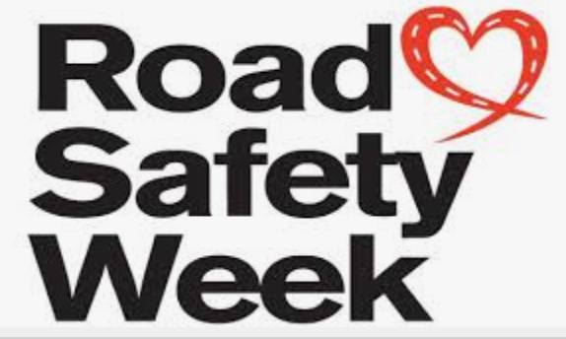

Hot Dinners
After half-term we will be starting to re-introduce hot dinners. Reception children will have a hot dinner every day, while the other year groups will have a hot dinner on alternating weeks. The dining hall will be cleaned after each year group has had its lunch.

The dates for next half-term are set out below:

Week commencing | Hot Dinners | Packed lunch
3rd to 6th November | Years 1, 3 and 5 | Years 2, 4 and 6
9th to 13th November | Years 2, 4 and 6 | Years 1, 3 and 5
16th to 20th November | Years 1, 3 and 5 | Years 2, 4 and 6
23rd to 27th November | Years 2, 4 and 6 | Years 1, 3 and 5
30th November to 4th December | Years 1, 3 and 5 | Years 2, 4 and 6
7th to 11th December | Years 2, 4 and 6 | Years 1, 3 and 5
14th to 18th December | Years 1, 3 and 5 | Years 2, 4 and 6

The arrangements for free school meals and school dinner payment through ParentPay remain the same.

Road Safety Week
Next Saturday night we will be setting the clocks back an hour as summertime ends. Road traffic collisions increase by 20% in the fortnight after the time change. Sadly, some of those collisions will involve child pedestrians and cyclists. Children under 16 are one of the most vulnerable groups of road users.
The latest available government statistics show that 58% of children who die or are seriously injured in a road collision are involved in incidents between 3 and 7pm. From next Sunday, much of those will happen in darkness.
This week has therefore been Road Safety Week at James Cambell, the children have been learning how to travel to school safely and how to cross the road safely. They have also been designing posters reminding adults to park carefully outside our school.

Please park safely 
We would kindly ask parents to avoid parking on corners, double yellow lines and the white zig zags to protect our children. Park and stride instead –park a couple of streets away and walk your child to school.

This is important to keep our children safe – and to stop you from getting a parking ticket (parking enforcement officers will be making regular checks before and after school).

Year 5 children develop their cycling skills
A group of year 5 children participated in the Bikeability programme, run by Van Dome Cycles, on Thursday 1st October. The children enjoyed gaining practical skills in bike handling and understanding how to ride safely on the roads.

Unfortunately, the second day of the programme had to be postponed because of heavy rain, but we will be re-organising it for later this year.


Rainbow Day
The children said a big thank you to the NHS and key workers by wearing bright rainbow colours to school on 1st October. They enjoyed a special rainbow menu for lunch and received a surprise rainbow gift. A fun day was had by all!

The school received extra money from the Government for every child who had a school meal on that day. We are using this money to improve your child's education.

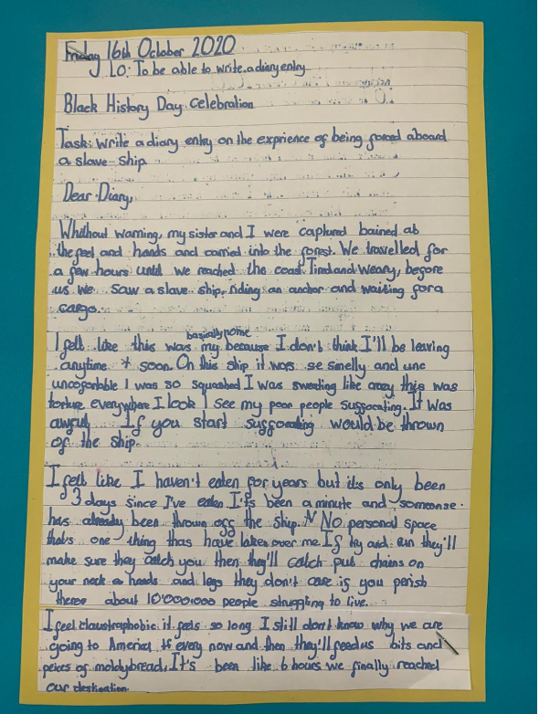
Times Table Rockstars! 
This week the children in KS2 battled against each other on the Times Table Rockstars website. The winning class was able to come to school in non-uniform this Friday and earn some extra playtime.
Please encourage your child to keep practising times tables at home. Next time they could be part of the winning class!

Reception’s Rainbow Fish Storyteller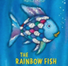
An amazing storyteller visited Reception on 6th October and took the children on an imaginary trip below the sea to find the rainbow fish. The children loved listening to the storyteller telling the story of how the rainbow fish learnt to share.
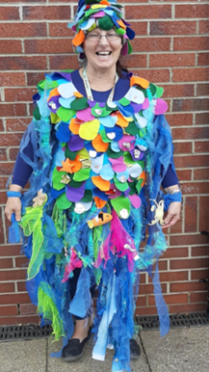
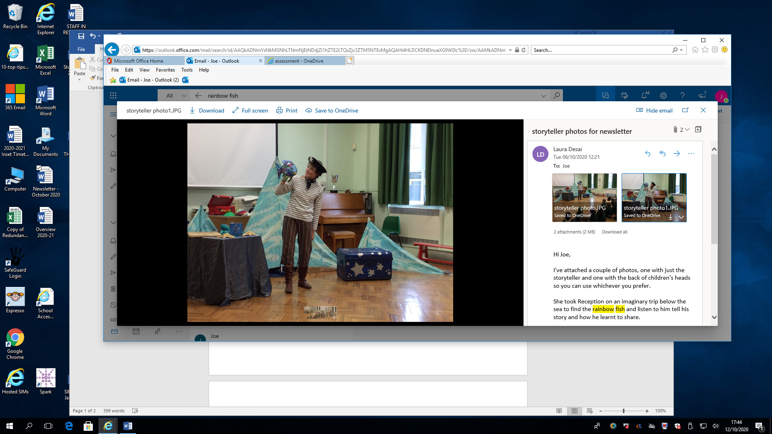

The children were also given a special rainbow fish shiny scale to take home with them. Later in the week, the Reception children had a visit from Mrs Rainbow Fish herself - also known as Mrs Mulqueen!

Black History
October is Black History month. This is an annual celebration of achievements by black people and is an opportunity for children to learn more about important themes and events in black history.

Children across the school learnt about different aspects of Black History. In years 1 and 2 children found out all about the life of Barack Obama, while years 3 and 4 learnt about The Windrush. The theme in years 5 and 6 was the Transatlantic slave route and the children produced some very thoughtful writing on the life of slaves.

A diary of a captured slave as imagined by a child in Key Stage 2

Lost Property 
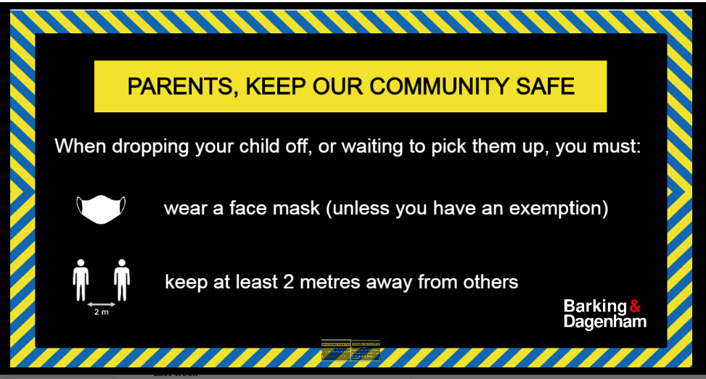
Please could you put name tags in your children’s uniform, coats and PE kits – or mark them clearly with a pen. We will then be able to return any lost clothes to your child easily.
If there is no name tag, then please ask at the main reception whether it has been found. We keep lost property for three weeks, after which it will be either reused or disposed of.
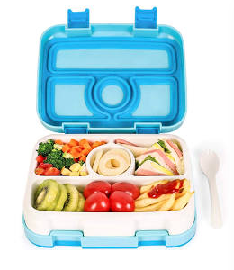
Packed Lunches
School dinners are available to all children. However, you may also choose to provide your child with a packed lunch.
If you do provide your child with a packed lunch, please make sure it’s healthy and balanced.
A healthy balanced packed lunch should contain all the major food groups:
- A starchy carbohydrate (e.g bread, pitta or wrap)
- A portion of meat or dairy (e.g chicken, egg or cheese)
- A portion of vegetables (e.g carrot sticks, lettuce, sweetcorn)
- Fruit (e.g apple, banana, orange)
- A drink of water
Please avoid sweets, lollies and sugary drinks. You should also avoid nuts because some children may have allergies.
‘Barkingbash’ Family Cricket Programme

James Cambell Primary School has been lucky enough to receive funding from Essex Cricket for year groups 3 and 5. This funding is to inspire and promote more children in Barking and Dagenham to play Cricket. With this, we are inviting all families to join the #BARKINGBASH ‘Family Cricket Program’
What will you get for taking part in the programme?
1: A free cricket bat and ball for your family to keep (you should already have this)
2: 8 weekly online cricket activity sessions for your family, you will join in at home using your smart phone, tablet, or laptop
3: A cricket activity booklet to give you ideas of games to play with your new equipment
4: 8 weekly online wellbeing sessions for your family, on topics such as healthy eating and keeping active, you will join in at home using your smart phone, tablet, or laptop
5: A certificate to show you have completed the programme
6: The chance to win cricket goodies if you take part in the whole programme
How do I join?
You must make sure that you register with us to take part in the programme.
You can join in three ways, either:
1: Preferred way: Go online to this link www.surveymonkey.co.uk/r/BarkingBash and complete the quick questionnaire, OR
2: Fill in the answers on the back of this letter, take a photo of it and email to Claire.smith@essexcricket.org.uk, OR
3: Send an email to Claire.smith@essexcricket.org.uk and she will email you back with the questionnaire to complete online.
Keep our school community safe
Thank you for supporting the safety measures we have in place at James Cambell. We must all work together to stop the spread of coronavirus, keep each other safe and avoid another lockdown.

Here are a few reminders:
Visiting our school site
When dropping your child off, or waiting to pick them up, you must:
· wear a face mask (unless you are exempt from wearing one)
· keep a safe distance (ideally 2 metres) away from others
Self-isolation
Do not send your child to school if:
· they are showing coronavirus (COVID-19) symptoms
· someone in their household is showing symptoms
Please also self-isolate yourself and your family for the advised amount of time if you have just returned from a country on the Government’s quarantine list.
Tests 
Arrange a test only if you or your child develops symptoms and please inform us of the results.

