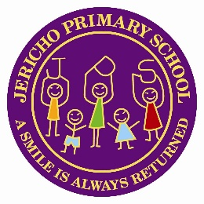

### JERICHO PRIMARY SCHOOL

**Headteacher : Mr James Blackwell**

[**www.jericho.cumbria.sch.uk**](http://www.jericho.cumbria.sch.uk)

April 2025

Dear Applicant,

**Welcome to Jericho – where a smile is always returned!**

**Achievement – Nurture and Respect – Adventure - Creativity**

Jericho Primary School is a fantastic place to be. Thank you for looking at our advert and thank you for considering to share your talents with our community.

Our children are amazing! They are characters who come together to make our school a vibrant community. Laughter is never far away and we value kindness, humour and challenge to help us achieve trusting relationships with all of our children.

Our children need challenge! Our values are placed firmly in helping our children achieve the very best that they can achieve. To do this we place the love of learning in all that we do. We want our children to know more and understand more each and every time that we teach.

The community we serve is based in Whitehaven. Whitehaven is a small town on the west coast of Cumbria. Most of our parents work within the local area and fully support the school and our aims.

We are **an expanding schoo**l having increased our roll to 432 children. We have moved into our new purpose built school where each classroom has state of the art IT facilities along with a great new learning environment for our children to learn in.

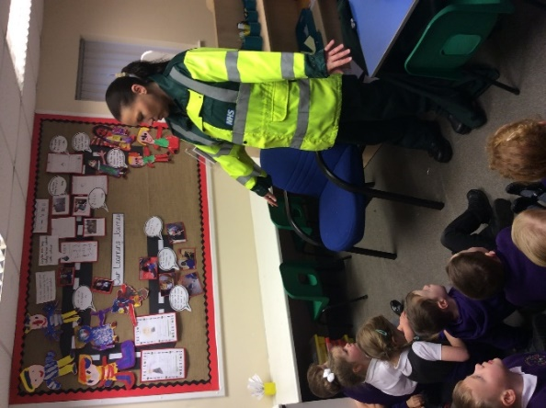We have a dedicated, hard working team led by our Head Teacher. We are supportive yet challenging and have placed good teaching at the heart of what we do. We have a clear vision for our future. We are working on our curriculum which brings together literacy running through discrete subjects. We have strong community links and plan to use these to support our curriculum work and to produce an exciting and engaging curriculum that has knowledge and skills at its heart.

In November 2023, Ofsted visited the school and continued to recognise the school as a good school. We were delighted with the outcome and have continued to build on our strengths and have strong systems in place for curriculum and assessment. We have a firm commitment that every child will read no matter what by the time they leave our KS1 classes.

We are committed to high standards and believe that all our children should leave our school being successful readers, writers and mathematicians along with having a deep knowledge of every curriculum subject. This will help ensure they have the best possible start to their lives.

We want to be an outstanding school for our community with high standards of achievement. Teaching and our profession is challenging yet rewarding. For this reason, it is vital that not only do we select the candidates, but the candidates select Jericho. We are looking for people who share our vision and understand the hard work needed to realise this.

We are first and foremost looking to appoint a candidate who will embrace our values: Achievement, Nurture and Respect, Adventure and Creativity.

About the role:

We have an opportunity for a job share class teacher for September 2025 in our ‘outstandingly happy school’. This is a fixed term post. We have a degree of flexibility within the staff team. We are therefore inviting applications interested in teaching in EYFS, KS1 or KS2 to apply. Please state your preference in your application. As this is a job share post, we require someone who can work on a Monday for this post.

We offer a full induction package that includes support from our Assistant Heads along with personalised learning plans to support you with the next stage of your career.

We are particularly interested in finding out about your skills and talents. We especially want to hear from anyone that can/or who is willing to lead a subject across the school. If you are an ECT – tell us how you would you like to see your career developing.

**Important please read carefully:**

**Procedures for filling out your application:**

When completing the application form, we ask that you do not complete Section 4 in the application form. Instead, please write your supporting information as a statement and attach this separately in your email. In this statement you need to provide supporting information referencing content of the job description and the person specification but please also **outline your educational philosophy as well as showing your knowledge and understanding of teaching and learning.**

Please ensure that you mark your application form clearly with the post that you are applying for.

We understand that applying for positions in this timeframe may be difficult but please do try and come and visit our school our school. There are many ways to find out about our work. A starting point could be to explore our Facebook page <https://www.facebook.com/Jerichoprimaryschool/> and website.

Completed application forms should be returned via email only, marked for the attention of the Headteacher and sent back to our School Business Manager – Karen Hannah – k.hannah@jericho.cumbria.sch.uk

Good luck and we look forward to welcoming you to Jericho Primary School.

Warmest Regards,

James Blackwell

Headteacher