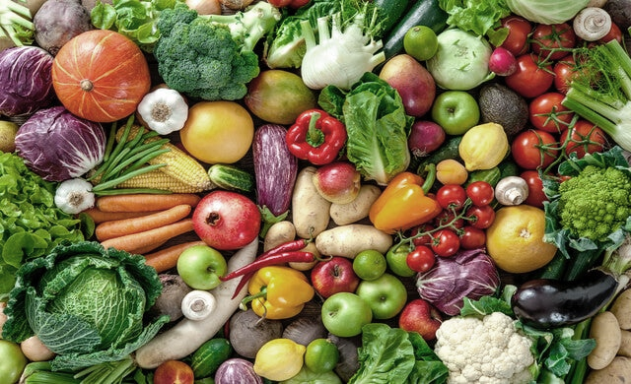

**All Day Breakfast**

**Salmon Nibbles**

**Jacket Potato Served With Tuna Mayonnaise, Baked Beans Or Cheese**

**Baked Beans**

**Bread**

**Raspberry sponge Dessert**

**Rice Pudding & Sultanas**

**Australian Crunch**

**Fish Fingers**

**Macaroni Cheese**

**Jacket Potato Served With Tuna Mayonnaise, Baked Beans Or Cheese.**

**Chips, Baked Beans, Garden peas & Tomato Ketchup**

**Chocolate Cookies & Strawberry Milkshake**

**Minced Beef Pie**

**Tomato Pasta**

**Jacket Potato Served With Tuna Mayonnaise, Baked Beans Or Cheese.**

**Diced Potato/Mash**

**Sweetcorn**

**Cheese & Crackers**

**Gingerbread Biscuits**

**Pepperoni or Cheese Pizza**

**Chicken Goujons**

**Jacket Potato Served With Tuna Mayonnaise, Baked Beans Or Cheese.**

**Oven Baked Wedges, Peas Or**

**Wholewheat Spaghetti Hoops**

**Vanilla Or Chocolate**

**Icecream**

**Week 2 – Jan 2024**

**Tuesday**

**Thursday**

**Additional menu choices**

**offered each day**

**Wednesday**

**Roast Chicken & Yorkshire Pudding**

**Sausage (Veggie choice available)**

**Jacket Potato Served With Tuna Mayonnaise, Baked Beans Or Cheese.**

**Mash Potato, Carrots, Broccoli & Gravy**

**Chocolate Cake**

**Bread Roll filled with Tuna Mayonnaise/Cheese/Ham/Jam**

**Salad Bar**

**Pasta**

**Fruit Bar – Seasonal Prepared Fruit**

**Fruit Bowl**

**Fruit Yoghurt**

**Friday**

**Monday**

**Please contact the school and speak with the Kitchen Manager, Gill Wayman should you need information about allergens.**