Pupil premium strategy statement – Jericho Primary School
This statement details our school’s use of pupil premium (and recovery premium) funding to help improve the attainment of our disadvantaged pupils.
It outlines our pupil premium strategy, how we intend to spend the funding in this academic year and the outcomes for disadvantaged pupils last academic year.

School overview
Detail | Data
Number of pupils in school | 416 (43 Pupil Premium)
Proportion (%) of pupil premium eligible pupils | 10%
Academic year/years that our current pupil premium strategy plan covers (3 year plans are recommended) | 2023-2026
Date this statement was published
Date on which it will be reviewed
Statement authorised by | J Blackwell / G Gregg
Pupil premium lead | L Ball
Governor / Trustee lead | L Savage

Funding overview
Detail | Amount
Pupil premium funding allocation this academic year | £62562
Recovery premium funding allocation this academic year | £ 6325
Pupil premium (and recovery premium*) funding carried forward from previous years (enter £0 if not applicable)  *Recovery premium received in academic year 2021 to 2022 can be carried forward to academic year 2022 to 2023. Recovery premium received in academic year 2022 to 2023 cannot be carried forward to 2023 to 2024. | £0
Total budget for this academic year  If your school is an academy in a trust that pools this funding, state the amount available to your school this academic year | £68887  School Contribution: £994

Part A: Pupil premium strategy plan

Statement of intent
Our intent is that all pupils, irrespective of their background or the challenges they face, make good progress and achieve their potential across all subject areas. The focus of our pupil premium strategy is to support disadvantaged pupils to achieve that goal, including progress for those who are already high attainers.
We will consider the challenges faced by vulnerable pupils, such as those who require external support from a range of agencies and professionals. The outline we have in this statement is also intended to support needs, regardless of disadvantaged or not.
High-quality teaching is at the center of our curriculum, with a focus on areas in which disadvantaged pupils require the most support. This is proven to have the greatest impact on closing the disadvantage attainment gap and at the same time will benefit the non-disadvantaged pupils in our school. Implicit in the intended outcomes detailed below, is the intention that non-disadvantaged pupils’ attainment will be sustained and improved alongside progress for their disadvantaged peers.
Our strategy is also integral to wider school plans for education recovery, notably in its targeted support and use of wider support.
Our approach will be responsive to common challenges and individual needs, rooted in robust diagnostic assessment, not assumptions about the impact of disadvantage. The approaches we have adopted complement each other to help pupils excel. To ensure they are effective we will:
- Ensure disadvantaged pupils are challenged in the work that they’re set and we will act early to
intervene at the point need is identified.
- Use small steps in progress documents to ensure we can monitor progress made for those who are
working towards their year group objectives or below.
- Adopt a whole school approach in which all staff take responsibility for disadvantaged pupils’ outcomes and raise expectations of what they can achieve.

Challenges
This details the key challenges to achievement that we have identified among our disadvantaged pupils.
Challenge number | Detail of challenge
1 | Assessments, observations, and discussions indicate that oral language skills and vocabulary practice is yet to be embedded in EYFS. Further work to continue in order to close the vocabulary and oral language gap across the early years.
2 | Regular assessments, observations, and discussions with pupils suggest disadvantaged pupils generally have greater difficulties acquiring the fluency required in reading to enable them to make progress once they have completed the RWI phonics scheme. Specific focus is to be given to fluency practice in EYFS, year 1 and 2.
3 | Our assessments and observations indicate that the wellbeing of many of our disadvantaged pupils has been impacted by their early experiences prior to beginning school during the Covid 19 pandemic. Our findings are supported by national studies and current research.
5 | Spaced retrieval practice is not yet embedded across all subjects across the whole school.
6 | Our assessments show that children are still behind in their writing. This has resulted in significant knowledge gaps leading to pupils falling further behind age-related expectations, in writing across the key stages. There were no pupil premium children at greater depth in writing at the end of the academic year 22-23.
7 | Our assessments show that whilst we have made significant gains in children catching up in their mathematical knowledge, children still lag behind in reasoning and problem solving. Implementation of a new lesson design is in its infancy therefore impact has yet to be seen.
8 | Our assessments (including wellbeing survey), observations and discussions with pupils and families have identified social and emotional issues for many pupils, notably due to post pandemic issues, online safety and cyber bullying, and a lack of enrichment and wider opportunities. These challenges particularly affect disadvantaged pupils, including their opportunities for character development and access to a varied range of activities.

Intended outcomes
This explains the outcomes we are aiming for by the end of our current strategy plan, and how we will measure whether they have been achieved.
Intended outcome | Success criteria
Embedded oral language skills and vocabulary among disadvantaged pupils. | Assessments and observations indicate significantly improved oral language among disadvantaged pupils. Improvement in language screening scores for nursery and reception children. Evident in the use of vocabulary across the curriculum subjects, including engagement in lessons, book scrutiny and ongoing formative assessment.
Improved level of fluency among pupils in EYFS, year one and two. | KS1 phonics outcomes in 2022/23 show that more than 90% of disadvantaged pupils met the expected standard. Internal data will show rapid progress where intervention has taken place- regular monitoring will demonstrate this.
Improvement in percentage of ARE data for children in EYFS, year 1 and 2 across core curriculum subjects. | A higher percentage of children are assessed by triangulated data to be working at ARE in maths, writing and reading.
To narrow gaps for all identified ‘catch up’ children across core curriculum subjects. | Those identified as having fallen behind catch up and data demonstrates that they are back on track with their progress.
To improve the ARE/ GD percentage in writing across the whole school. | There is a higher proportion of children assessed at ARE or GD by the end of the academic year.
To improve the teaching and therefore the outcomes of Reasoning and Problem Solving in the Mathematics Curriculum. | Increased ability of pupils to use and apply number facts and calculations in problem solving and reason with understanding.  Increased outcomes at the end of KS2 for all pupils in R and PS.  Increased reasoning and problem solving scores in all summative assessments over time.
To embed consistently effective retrieval practice throughout the curriculum | Pupil voice and assessments show that pupil are retaining in detail the key knowledge as outlined in the school’s curriculum from a range of previously taught content. This is reflected in their work.

Activity in this academic year
This details how we intend to spend our pupil premium (and recovery premium) funding this academic year to address the challenges listed above.

Teaching (for example, CPD, recruitment and retention)
Budgeted cost: 30894
Activity | Evidence that supports this approach | Challenge number(s) addressed
Fluency CPD | https://d2tic4wvo1iusb.cloudfront.net/production/eef-guidance-reports/literacy-early-years/Reading_Fluency_Resource_1.0.pdf?v=1694513940 | 2
Fluency practice to be implemented into reading sessions- EYFS, Y1 and 2 | https://d2tic4wvo1iusb.cloudfront.net/production/eef-guidance-reports/literacy-early-years/Reading_Fluency_Resource_1.0.pdf?v=1694513940 | 2
Purchase of standardised and diagnostic assessments and trackers. | Standardised tests can provide reliable insights into the specific strengths and weaknesses of each pupil to help ensure they receive the correct additional support through interventions or teacher instruction  Standardised tests | Assessing and Monitoring Pupil Progress | Education Endowment Foundation | EEF | 1,2,3 and 4
Continued increased staffing level to ensure all classes in school have support from both a teacher and teaching assistant. 1 per class is EYFS and KS1. One per year group in KS2. | Supporting best use of teaching assistants by adopting the principles and recommendations made by the EEF  EEF: Making the best use of Teaching Assistants Guidance Report. | 1,2,3,4 and 7
New lesson design CPD and implementation in writing. Coaching to improve writing for teaching staff by literacy lead. Devising a whole school editing writing system. | https://educationendowmentfoundation.org.uk/education-evidence/guidance-reports/literacy-ks2?utm_source=/education-evidence/guidance-reports/literacy-ks2&utm_medium=search&utm_campaign=site_search&search_term=liter | 5 and 7
Maths reasoning and problem solving leads in each year group. CPD to be attended and rolled out within year group team. | https://educationendowmentfoundation.org.uk/education-evidence/guidance-reports/maths-ks-2-3?utm_source=/education-evidence/guidance-reports/maths-ks-2-3&utm_medium=search&utm_campaign=site_search&search_term=Mathematics | 6
EYFS oracy CPD sessions  CPD for all staff in the EYFS ‘High quality interactions- the shREC approach. | https://d2tic4wvo1iusb.cloudfront.net/production/eef-guidance-reports/literacy-early-years/Supporting_oral_language_development_2021-08-18-154019_ehqs.pdf?v=1694513940 | 1

Targeted academic support (for example, tutoring, one-to-one support, structured interventions)
Budgeted cost: £ 33698
Activity | Evidence that supports this approach | Challenge number(s) addressed
NELI intervention and language screener to identify those with oral language and vocabulary gaps at baseline in EYFS. | Language screener to identify children entering school with language skills lower than the expected standard. EKLAN language programme recommended by the DFE to improve early language  https://assets.publishing.service.gov.uk/government  /uploads/system/uploads/attachment_data/file/  219627/DFE-RR247-BCRP13.pdf | 1
Fluency intervention | https://d2tic4wvo1iusb.cloudfront.net/production/eef-guidance-reports/literacy-early-years/Preparing_Literacy_Poster.pdf?v=1694496661  Where targeted support is required to enable children to make rapid progress, the EEF research recommendations suggest high quality targeted approaches such as NELI be used to accelerate progress.  https://d2tic4wvo1iusb.cloudfront.net/production/eef-guidance-reports/literacy-early-years/Reading_Fluency_Resource_1.0.pdf?v=1694513940 | 2
Increase in staffing levels to ensure high quality targeted intervention can be delivered to support those identified as needing to ‘catch up’ or PP. | The EEF research recommends developing effective strategies and diagnosing the challenges for children who are identified as pp or need to ‘catch up’. Ensuring adequate staff to deliver focused intervention is a strategy to narrow gaps.  https://educationendowmentfoundation.org.uk/guidance-for-teachers/using-pupil-premium | 1,2,3,4 and 7

Wider strategies (for example, related to attendance, behaviour, wellbeing)
Budgeted cost: £ 5289
Activity | Evidence that supports this approach | Challenge number(s) addressed
Whole staff training on behaviour management and anti-bullying approaches with the aim of developing our school ethos and improving behaviour across school. | Both targeted interventions and universal approaches can have positive overall effects:  Behaviour interventions | EEF (educationendowmentfoundation.org.uk) | 5
Embedding principles of good practice set out in the DfE’s Improving School Attendance advice.  This will involve training and release time for staff to develop and implement new procedures and appointing attendance/support officers to improve attendance. | The DfE guidance has been informed by engagement with schools that have significantly reduced levels of absence and persistent absence. | 6
Contingency fund for acute issues. | Based on our experiences and those of similar schools to ours, we have identified a need to set a small amount of funding aside to respond quickly to needs that have not yet been identified. | All
Coaching for staff from the lead in school coach. Release time and cover required for the staff taking part. Teaching staff completing coaching qualifications with leadership edge to further provide a coaching offer. | https://www.headteacher-update.com/content/best-practice/instructional-coaching-what-it-is-how-it-works-and-why-it-matters/ | All

Total budgeted cost: £ 65881

Part B: Review of the previous academic year

Outcomes for disadvantaged pupils
This details the impact that our pupil premium activity had on pupils in the 2022-2023 academic year.
We have analysed the performance of our school’s disadvantaged pupils during the 2022/23 academic year using key stage 1 and 2 performance data, phonics check results and our own internal assessments. These included standardised assessments were used as an end as well as using small step triangulation of the curriculum to measure the progress made by disadvantaged pupils.
To help us gauge the performance of our disadvantaged pupils we compared our results to those for disadvantaged and non-disadvantaged pupils at a national and regional level (although these comparisons are to be considered with caution given the caveats stated above). We also looked at these comparisons using pre-pandemic scores for 2019, in order to assess how the performance of our disadvantaged pupils has changed during this period.
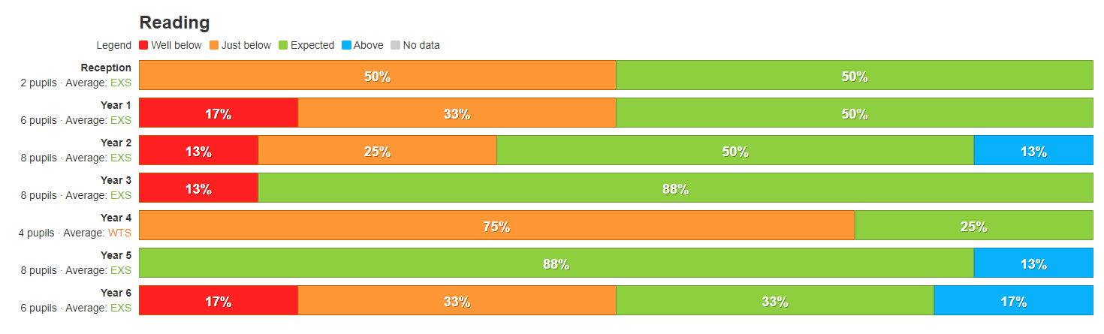
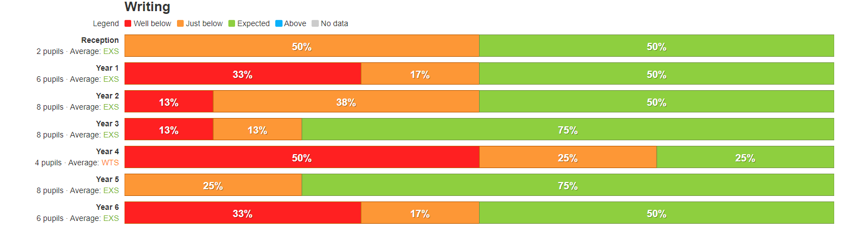
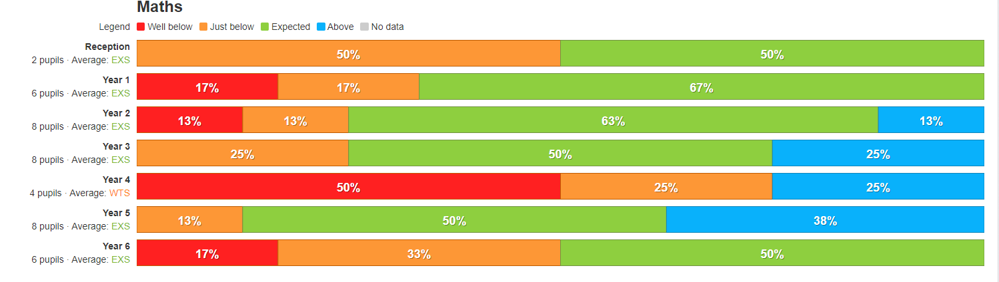

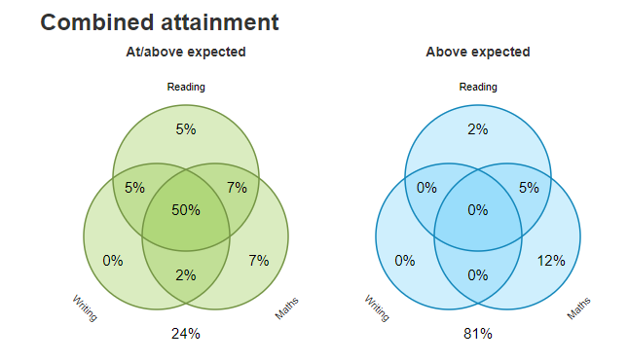

The attainment gap between our disadvantaged pupils and non-disadvantaged pupils varies within our school. This is due to the relatively low percentage of disadvantaged children. 1/3 of disadvantaged children are also identified as SEND. In addition to this, the small percentages of children within each year group who are eligible for pupil premium has impact on the comparison data. Therefore, teachers carry out individual assessments of pupils where there are concern in relation to attainment and progress and act by intervening at the earliest possible point.
Our observations and assessments demonstrated that pupil behaviour improved last year, but challenges in relation to wellbeing and mental health remain significantly higher than before the pandemic. The impact on disadvantaged pupils has been particularly acute. We did however gain significant recognition in our mental health work gaining the united against bullying ‘Anti-bullying school status’ and will continue to develop our personal development offer for all pupils.
We have reviewed our strategy plan and made changes to how we intend to use some of our budget this academic year, as set out in the activity in This Academic Year section above. The Further Information section below provides more details about our planning, implementation, and evaluation processes.

Further information
In addition to ensure that pupil premium children can access educational visits, we have provided supplements to costs for visits. We have families who struggle with transport to enable the children to attend school on time and regularly. We have provided additional support by organising and financing the cost of private taxis to eliminate barriers to children accessing school. In addition we have paid for families to attend breakfast and afterschool clubs to support their social development and access to a range of differing clubs and activities.
Our pupil premium strategy will be supplemented by additional activity that is not being funded by pupil premium or recovery premium. That will include:
- To improve the curriculum sequencing and implementation of the writing curriculum.
- Subject leaders to check and refine subject curriculum plans in Art, Music, MFL, RE and PE -ensuring clear sequencing and knowledge end points.
- Improve maths outcomes by develop reasoning and problem solving
- Develop consistently highly effective retrieval practice.
- To develop moderation systems to ensure that assessments are consistent across school.
- To embed behaviour procedures and policies and further embed our ‘Outstanding Happy School’ work so that this drives positivity across the school
- Review and develop spiritual, moral, social and cultural enrichment opportunities for children.
- To continue to support Subject Leaders to develop robust development plans.
- To implement revised knowledge curriculum ensuring it is delivered through engaging provision and high quality play.
- offering a wide range of high-quality extracurricular activities to boost wellbeing, behaviour, attendance, and aspiration. Activities will focus on building life skills such as confidence, resilience, and socialising. Disadvantaged pupils will be encouraged and supported to participate.
Planning, implementation, and evaluation
In planning our new pupil premium strategy, we evaluated why activity undertaken in previous years had not had the degree of impact that we had expected. We also commissioned a pupil premium review to get an external perspective.
We triangulated evidence from multiple sources of data including assessments, engagement in class book scrutiny, conversations with parents, students and teachers in order to identify the challenges faced by disadvantaged pupils.
We looked at a number of reports, studies and research papers about effective use of pupil premium, the impact of disadvantage on education outcomes and how to address challenges to learning presented by socio-economic disadvantage. We also looked at studies about the impact of the pandemic on disadvantaged pupils.
We used the EEF’s implementation guidance to help us develop our strategy, particularly the ‘explore’ phase to help us diagnose specific pupil needs and work out which activities and approaches are likely to work in our school. We will continue to use it through the implementation of activities.
We have put a robust evaluation framework in place for the duration of our three-year approach and will adjust our plan over time to secure better outcomes for pupils.
We work closely with a local project – WELL. Who have support us through training and developing a research based approach to school improvement. This is based on the EEF – Putting the Evidence to Work approach.
Our work is monitored and evaluated by the Full Governing Body who undertake a range of monitoring strategies across the school year.

