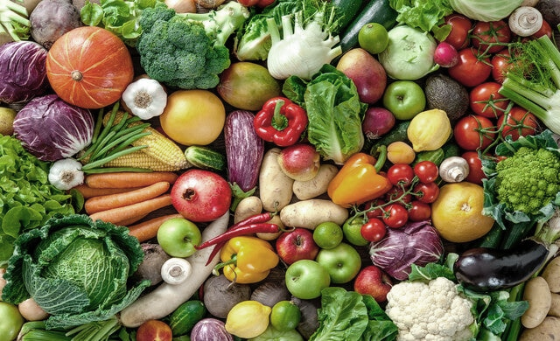

Wednesday

**Fish Fingers**

**Chicken Goujons**

**Jacket Potato Served With Tuna Mayonnaise, Baked Beans Or Cheese.**

**Chips**

**Baked Beans ,Garden Peas**

**Tomato Ketchup**

**Chocolate Cookie & Strawberry Milkshake**

**Week 1 Jan – spring Term 2024**

**Tuesday**

**Thursday**

**Additional menu choices**

**offered each day**

**Roast Chicken & Yorkshire Pudding**

**Toad In The Hole**

**Jacket Potato Served With Tuna Mayonnaise, Baked Beans Or Cheese.**

**Mashed Potato,Broccoli,Carrots & Gravy.**

**Jelly & Fruit**

**Cheese & Biscuits**

**Creamed Potatoes, Broccoli, Carrots, Salad Bar**

**Iced Sponge Cake with Sprinkles**

**Yoghurt**

**Bread Roll filled with Tuna Mayonnaise/Cheese/Ham/Jam**

**Salad Bar**

**Pasta**

**Fruit Bar – Seasonal Prepared Fruit.**

**Assorted Fruit Yoghurt**

**Fruit Bowl**

**Friday**

**Monday**

**Please contact the school and speak with the Kitchen Manager, Gill Wayman should you need information about allergens**

**All Day Breakfast**

**Salmon Nibbles**

**Hash Brown & Baked Beans**

**Jacket Potato Served With Tuna Mayonnaise, Baked Beans Or Cheese**

**Cheese & Biscuits**

**Chocolate Brownie**

**Pasta, Potato Slices, Baked Beans (V GF), Sweetcorn & Salad Bar (V GF)**

**Pepperoni Or Cheese Pizza**

**Quorn Nuggets**

**Jacket Potato Served With Tuna Mayonnaise, Baked Beans Or Cheese**

**Seasoned Potato Wedges**

**Wholewheat Spaghetti Hoops**

**Baked Beans**

**Chocolate or Vanilla Ice Cream**

**Macaroni Cheese**

**Meatballs in a Tomato sauce**

**Jacket Potato Served With Tuna Mayonnaise, Baked Beans Or Cheese**

**Garlic Bread**

**Spaghetti**

**Peas**

**Sprinkle Cake**