Jericho Primary School -Calculation Policy – Addition – Year 1
Mental Calculations | Read, write and interpret mathematical statements using symbols +, -, =  - - Represent and use number bonds and related addition facts within 20  - Children know that working systematically helps them to find all  - the possible number bonds to 20.  - - Add one digit and two-digit numbers up to 20, including zero.  - When adding numbers children should explore aggregation and augmentation.  - Children explore addition by counting on from a given number and know that addition is commutative and that it is more efficient to start from the largest number.  - Children know the importance of ten ones equalling one ten.  - - Solve one-step problems using concrete objects and pictorial representations, and missing number problems such as: ___ + 9 = 11  - - Given a number, identify (and use the language) one more
Written calculation | Read, write and interpret mathematical statements using symbols +, -, =  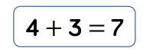  - Represent and use number bonds and related addition facts within 20.  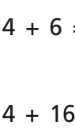  - Add one digit and two-digit numbers up to 20, including zero.  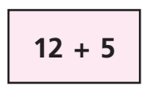  - Solve one-step problems using concrete objects and pictorial representations, and missing number problems such as: ____ + 9 = 11  - Given a number, identify (and use the language) one more
Representations  to support calculations | Golden Nugget representations:  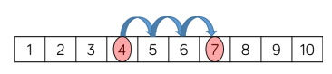  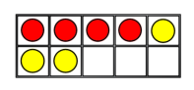  Other representations:  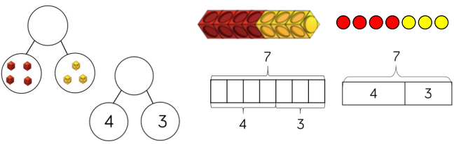  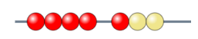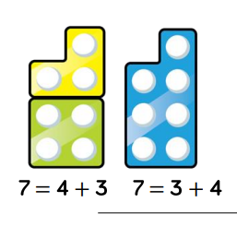
Jericho Primary School -Calculation Policy – Addition – Year 2
Mental Calculations | Add numbers using concrete objects, pictorial representations, and mentally, including:  - - a two-digit number and ones to 100  - Children should know that ten ones equals one ten and to count on from the larger number  - - a two-digit number and tens  - - two, two-digit numbers to 100  - - adding three one-digit numbers  - Children should find number bonds to 10 or doubles for efficiency  - Recall and use addition and subtraction facts to 20 facts fluently, and derive and use related facts up to 100.
Written calculation | Add numbers using concrete objects, pictorial representations, and mentally, including:  - - a two-digit number and ones  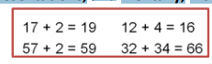  - - a two-digit number and tens  - - two, two-digit numbers crossing 10  Introduce the expanded method of the column method to prepare for  formal written methods with larger numbers  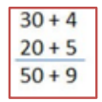 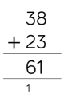 introduce column method when children are secure with pictorial and expanded method.  - - adding three one-digit numbers  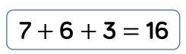  - Demonstrate the commutative law of addition  - - Re-partition numbers  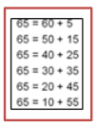  - - Use a hundred square  - Check calculations using inverse and by adding numbers in different order using fact families  -Solve missing number problems
Representations  to support calculations | Golden Nugget representations:  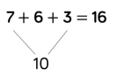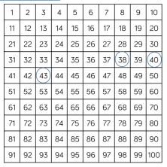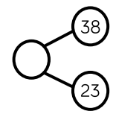  Other representations:  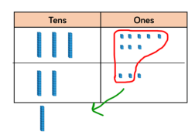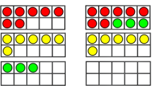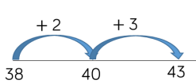  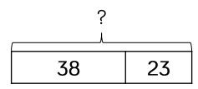  Bar models are useful for finding missing numbers.
Jericho Primary School -Calculation Policy – Addition – Year 3
Mental Calculations | Add numbers mentally, including:  - -a three-digit number and ones  - -a three-digit number and tens  - -a three-digit number and hundreds  - -Partition all numbers and recombine,  - start with TU + TU then HTU + TU  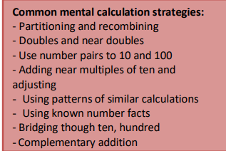
Written calculation | Add numbers with up to three digits, using formal written (columnar) methods  - Add to three digit numbers using physical and abstract representations (e.g. Base 10, place value counters, empty number lines)  - Children know that the column method is the usually most efficient method and move onto abstract method when exchanging concept is embedded.  - Children are taught to exchange appropriately.  - Children to place exchanged ten or hundred underneath the answer line as shown.  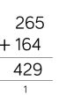  - Estimate the answer to a calculation and use inverse operations to check answers.  - Solve problems, including missing number problems, using number facts, place  value, and more complex addition.
Representations  to support calculations | Golden Nugget representations:  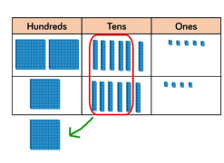  Other representations:  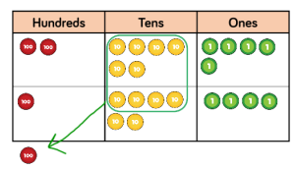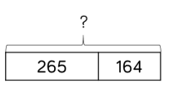  Bar models are useful for finding missing numbers.
Jericho Primary School -Calculation Policy – Addition – Year 4
Mental Calculations | Practise mental methods with increasingly large numbers.  - Consolidate partitioning and re-partitioning  - 550 + 370 = 550 + 300 + 70  - = 850 + 70  - = 920  - Use compensation for adding too much/little and adjusting  - Use Base 10, place value counters, empty number lines etc.
Written calculation | Add and subtract numbers with up to 4 digits using the formal written methods of columnar where appropriate.  - Children know that the column method is the usually most efficient method. Children are taught to exchange appropriately.  - Children to place exchanged ten or hundred underneath the answer line as shown.  - Include decimal addition for money. 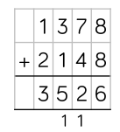  - Estimate and use inverse operations to check answers to a calculation.  - Solve addition two-step problems in contexts, deciding which operations and methods to use and why.
Representations  to support calculations | Golden Nugget representations:  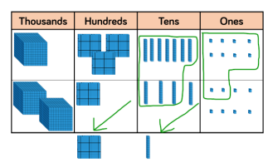  Other representations:  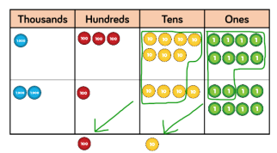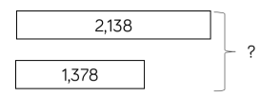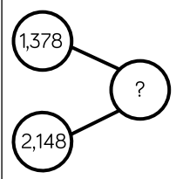  Bar models are useful for finding missing numbers/inverse operations.

Jericho Primary School -Calculation Policy – Addition – Year 5
Mental Calculations | Practise mental methods with increasingly large numbers.  - Eg 12 462 + 2300 = 14 762)  - Use compensation for adding too much/little and adjusting  - Use Base 10, place value counters, empty number lines etc.
Written calculation | Add and subtract numbers with more than 4 digits using the formal written methods of columnar where appropriate.  - Children know that the column method is the usually most efficient method. Children are taught to exchange appropriately.  - Children to place exchanged ten, hundred or thousand underneath the answer line as shown.  - Include decimal addition  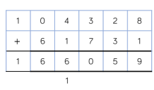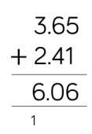  - use rounding to check answers to calculations and determine, in the context of a problem, levels of accuracy.  - Solve addition two-step problems in contexts, deciding which operations and methods to use and why.
Representations  to support calculations | Golden Nugget representations:  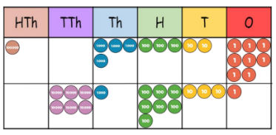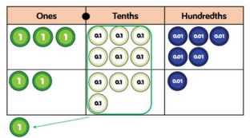  Other representations:  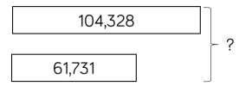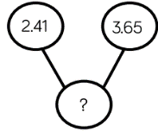  Bar models are useful for finding missing numbers/inverse operations.

Jericho Primary School -Calculation Policy – Addition – Year 6
Mental Calculations | ▪Perform mental calculations, including with mixed operations and large numbers  - Children use representation of choice.  - Consolidate partitioning and re-partitioning.  - Use compensation for adding too much/little and adjusting
Written calculation | Add larger numbers with more than 5 digits using the formal written methods of columnar where appropriate.  - Children know that the column method is the usually most efficient method. Children are taught to exchange appropriately.  - Children to place exchanged ten, hundred or thousand etc underneath the answer line as shown.  - Include decimal addition  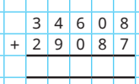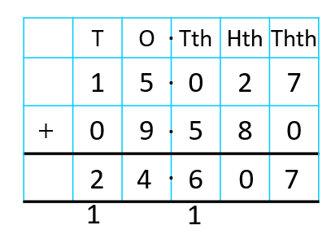  - Use their knowledge of the order of operations to carry out calculations involving the  - four operations  - Solve addition multi-step problems in contexts, deciding which operations and methods to use and why.
Representations  to support calculations | Golden Nugget representations:  Other representations:  Bar models are useful for finding missing numbers/inverse operations.

