Jericho Primary School -Calculation Policy – Division – Year 1
Mental Calculations | Solve one-step problems involving multiplication and division, by calculating the answer using concrete objects, pictorial representations and arrays with the support of the teacher.  - Count in multiples of twos, fives and tens with equipment, songs, rhythms and including by rote.  - Counting 2s e.g. counting socks,shoes, animal legs...  - Counting in 5 s e.g. counting fingers, fingers in gloves, toes …  - Counting in 10s e.g. counting fingers, toes...  - Halves up to 20.  - Write as a number pattern(e.g. 5, 10, 15...; 2, 4, 6...; 10, 20, 30...)
Written calculation | Solve one-step problems involving multiplication and division, by calculating the answer using concrete objects, pictorial representations and arrays with the support of the teacher.  - Children should experiment with the concept of grouping and sharing in a range of contexts.  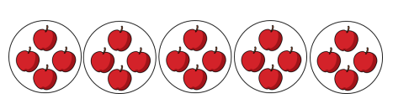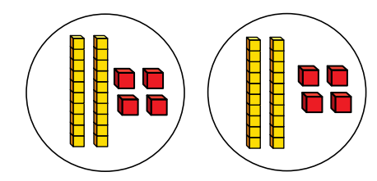  - It would be beneficial if children could see the relationships between multiplication and division.  - Children could be introduced to the concept of division as repeated subtraction eg 15 – 5 - 5 - 5 = 0
Representations  to support calculations | Golden Nugget representations:  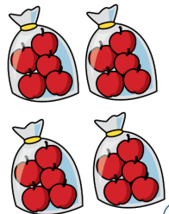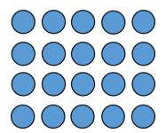  Other representations:  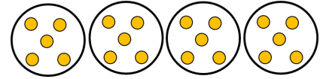
Jericho Primary School -Calculation Policy – Division – Year 2
Mental Calculations | Recall and use multiplication and division facts for the 2, 5 and 10 multiplication tables, connecting the 2, 5 and 10 multiplication tables to each  other.  -Connect the 10 multiplication table to place value.  - Use a variety of language to describe multiplication and  division.  -Apply halving of numbers up to 20 to halving larger  numbers.
Written calculation | Calculate mathematical statements for multiplication and division within the multiplication tables and write them using the multiplication (×), division (÷) and equals(=)signs.  - Begin to use other multiplication tables and recall facts to perform written calculations.  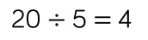  - Solve problems involving multiplication and division, using materials, arrays, repeated subtraction, mental methods, and multiplication and division facts, including problems in contexts.  - 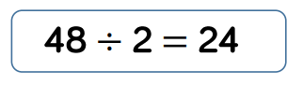  - 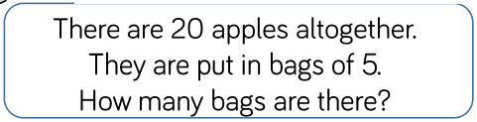
Representations  to support calculations | Golden Nugget representations:  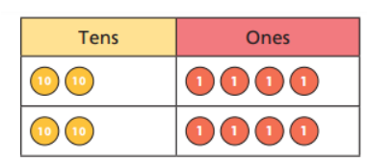  Other representations:  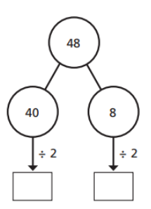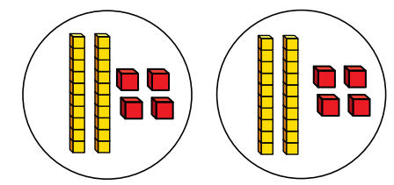

Jericho Primary School -Calculation Policy – Division – Year 3
Mental Calculations | Recall and use multiplication and division facts for the 3, 4 and 8 multiplication tables (and 2, 5 and 10 multiplication tables from Y2).  -Use halving to connect 2, 4 and 8 multiplication tables.  -Develop efficient mental methods using commutativity and  associativity.  -Derive related multiplication and division facts.  -Calculate mathematical statements for division using the multiplication tables that they know, including for twodigit numbers times one-digit numbers, using mental methods.  -Partitioning: divide the tens first and then divide the units, e.g. = 96 ÷ 3 = 90 ÷ 3 = 30 and 6 ÷ 3 = 2 so answer is 32.  -Children can apply these skills to solve spoken word problems too, include missing number statements e.g. 560 ÷ ___= 70
Written calculation | Write and calculate mathematical statements for multiplication using the multiplication tables that they know, including for two-digit numbers times one-digit numbers, progressing to formal written methods.  - Estimate before calculating.  - Ensure written methods build on/relate to mental methods.  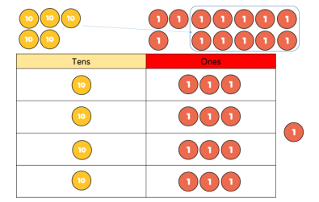  Focus on tens and ones method with and without remainders.
Representations  to support calculations | Golden Nugget representations:  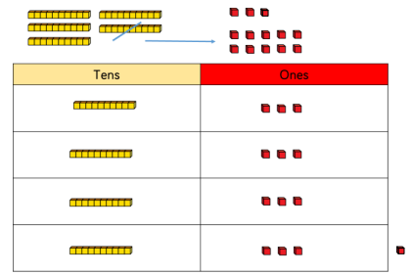  Other representations:  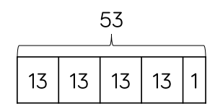

Jericho Primary School -Calculation Policy – Division – Year 4
Mental Calculations | Recall multiplication and division facts for multiplication tables up to 12 x 12.  - Use place value, known and derived facts to multiply and divide mentally, including: multiplying by 0 and 1; dividing by 1; multiplying together three numbers.  - Recognise and use factor pairs and commutativity in mental calculations.  - Practise mental methods and extend this to three-digit numbers to derive facts, (for example 600 ÷ 3 = 200 can be derived from 6 ÷ 3 = 2).
Written calculation | Divide two-digit and three-digit numbers by a one-digit number using formal written layout.  - All children need to be able to use the bus stop method for short division.  - Estimate before calculating.  - Ensure written methods build on/relate to mental methods.  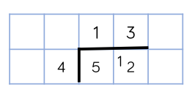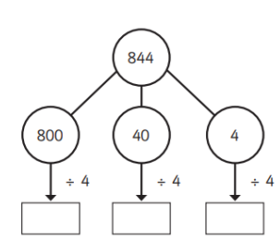  - By the end of Year 4, children need to have encountered remainders in a number of contexts.
Representations  to support calculations | Golden Nugget representations:  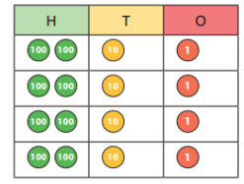  Other representations:  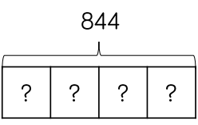

Jericho Primary School -Calculation Policy – Division – Year 5
Mental Calculations | Multiply and divide numbers mentally drawing upon known facts  - Multiply and divide whole numbers and those involving decimals by 10, 100 & 1000.  - Recognise and use square & cube numbers (& notation).  - Use factors and multiples as connected ideas: 48 is a multiple of 6 and 6 is a  factor of 48.  - Find all factor pairs of a number and common factors of two numbers.  - Know and use the vocabulary of prime numbers, prime factors and composite (non-prime) numbers.  - Establish whether a number up to 100 is prime and recall prime numbers up to 19.  - Multiply and divide whole numbers and those involving decimals by 10, 100 and 1000.
Written calculation | Divide numbers up to 4 digits by a one- or two-digit number using a formal written method, including short division and interpret remainders appropriately for the context.  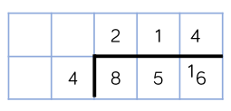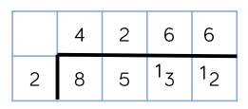  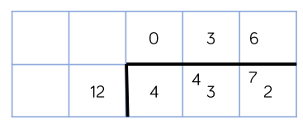
Representations  to support calculations | Golden Nugget representations:  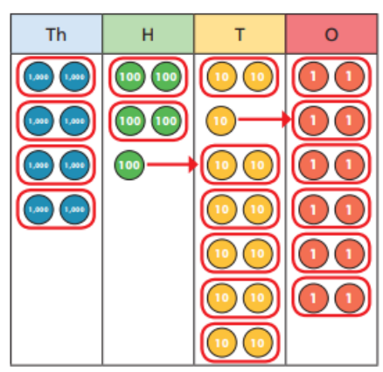  Other representations:  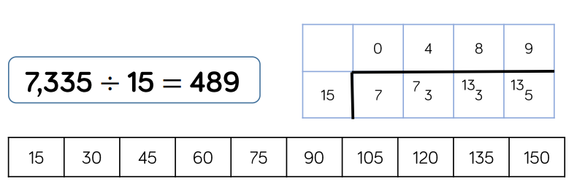

Jericho Primary School -Calculation Policy – Division – Year 6
Mental Calculations | Perform mental calculations, including with mixed operations and large numbers.  - identify common factors, common multiples and prime numbers  - use their knowledge of the order of operations to carry out calculations involving the four operations
Written calculation | Divide numbers up to 4 digits by a one- or two-digit number using a formal written method, including long division for two-digit numbers and interpret remainders as whole number remainders, fractions, or by rounding, as appropriate for the context.  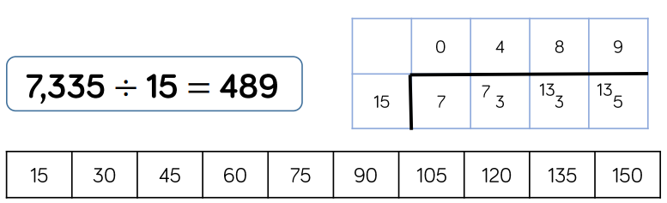  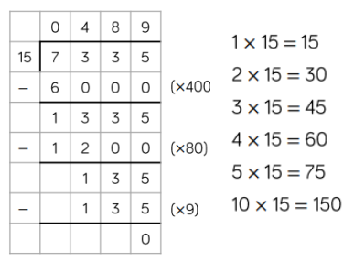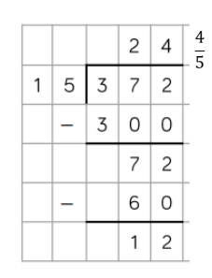
Representations  to support calculations | Golden Nugget representations:  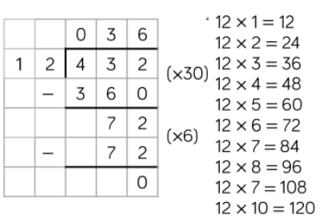  Other representations:  