Jericho Primary School -Calculation Policy – Multiplication – Year 1
Mental Calculations | Solve one-step problems involving multiplication and division, by calculating the answer using concrete objects, pictorial representations and arrays with the support of the teacher.  - Count in multiples of twos, fives and tens with equipment, songs, rhythms and including by rote.  - Counting 2s e.g. counting socks,shoes, animal legs...  - Counting in 5 s e.g. counting fingers, fingers in gloves, toes …  - Counting in 10s e.g. counting fingers, toes...  - Doubles up to 10.  - Recognising odd and even numbers  - Write as a number pattern(e.g. 5, 10, 15...; 2, 4, 6...; 10, 20, 30...)
Written calculation | Solve one-step problems involving multiplication and division, by calculating the answer using concrete objects, pictorial representations and arrays with the support of the teacher.  - There is no statutory requirement for written multiplication in Year 1 but it would be beneficial for children to record it as repeated addition eg 2+2+2+2 = 8 etc.  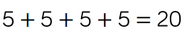  - It would be beneficial if children could see the relationships between arrays, number patterns and counting in 2’s, 5’s and 10’s.
Representations  to support calculations | Golden Nugget representations:  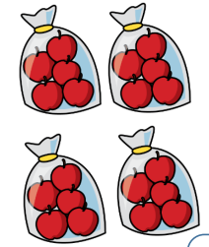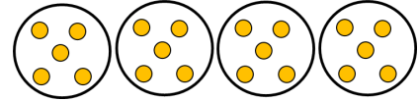  Other representations:  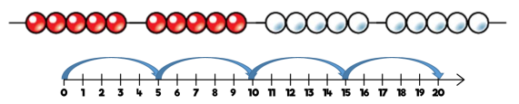
Jericho Primary School -Calculation Policy – Multiplication – Year 2
Mental Calculations | Recall and use multiplication and division facts for the 2, 5 and 10 multiplication tables, connecting the 2, 5 and 10 multiplication tables to each  other.  -Connect the 10 multiplication table to place value.  - Recognise odd and even numbers.  - Show that multiplication of two numbers can be done in  any order (commutative).  - Use a variety of language to describe multiplication and  division.  -Apply doubling of numbers up to ten to doubling larger  numbers.
Written calculation | Calculate mathematical statements for multiplication and division within the multiplication tables and write them using the multiplication (×), division (÷) and equals(=)signs.  - Begin to use other multiplication tables and recall facts to perform written calculations.  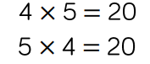  - Use a range of materials and contexts … including arrays and repeated addition.  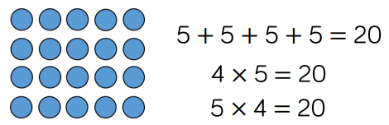
Representations  to support calculations | Golden Nugget representations:  Other representations:  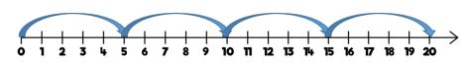  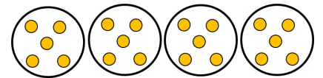

Jericho Primary School -Calculation Policy – Multiplication – Year 3
Mental Calculations | Recall and use multiplication and division facts for the 3, 4 and 8 multiplication tables (and 2, 5 and 10 multiplication tables from Y2).  -Use doubling to connect 2, 4 and 8 multiplication tables.  -Develop efficient mental methods using commutativity and  associativity.  -Derive related multiplication and division facts.  -Calculate mathematical statements for multiplication using the multiplication tables that they know, including for twodigit numbers times one-digit numbers, using mental methods.  -Partitioning: multiply the tens first and then multiply the units, e.g. 57 x 6 = (50 x 6) + (7 x 6) = 300 + 42 = 342  -Children can apply these skills to solve spoken word problems too, include missing number statements e.g. 8 x ___= 56
Written calculation | Write and calculate mathematical statements for multiplication using the multiplication tables that they know, including for two-digit numbers times one-digit numbers, progressing to formal written methods.  - Estimate before calculating.  - Ensure written methods build on/relate to mental methods.  - Solve missing number problems,including positive integer scaling problems.  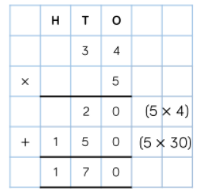
Representations  to support calculations | Golden Nugget representations:  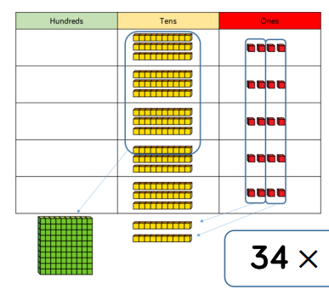  Other representations:  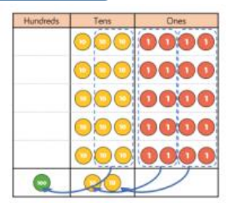  Bar models support finding a missing number.

Jericho Primary School -Calculation Policy – Multiplication – Year 4
Mental Calculations | Recall multiplication and division facts for multiplication tables up to 12 x 12.  - Use place value, known and derived facts to multiply and divide mentally, including: multiplying by 0 and 1; dividing by 1; multiplying together three numbers.  - Recognise and use factor pairs and commutativity in mental calculations.  - Practise mental methods and extend this to three-digit numbers to derive facts, (for example 600 ÷ 3 = 200 can be derived from 2 x 3 = 6).
Written calculation | Multiply two-digit and three-digit numbers by a one-digit number using formal written layout.  - Estimate before calculating.  - Ensure written methods build on/relate to mental methods.  - Introduce alongside grid and expanded column methods.  - Exchanged digits sit below the answer line like column addition.  - Solve problems, including scaling and harder correspondence problems.  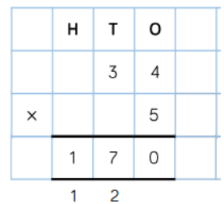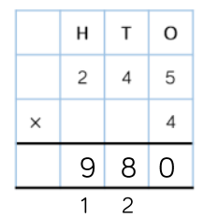
Representations  to support calculations | Golden Nugget representations:  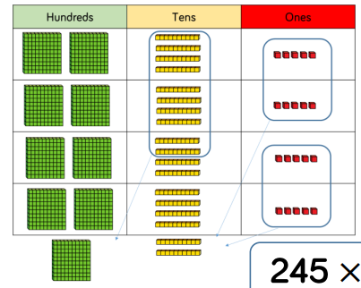  Other representations:  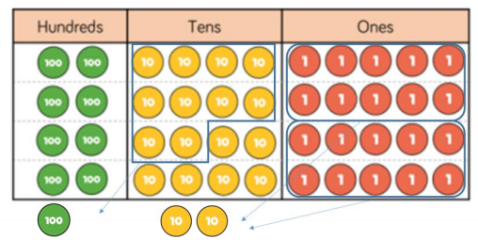

Jericho Primary School -Calculation Policy – Multiplication – Year 5
Mental Calculations | Multiply and divide numbers mentally drawing upon known facts  - Multiply and divide whole numbers and those involving decimals by 10, 100 & 1000.  - Recognise and use square & cube numbers (& notation).  - Use factors and multiples as connected ideas: 48 is a multiple of 6 and 6 is a  factor of 48.  - Find all factor pairs of a number and common factors of two numbers.  - Know and use the vocabulary of prime numbers, prime factors and composite (non-prime) numbers.  - Establish whether a number up to 100 is prime and recall prime numbers up to 19.  - Multiply and divide whole numbers and those involving decimals by 10, 100 and 1000.
Written calculation | Multiply numbers up to 4 digits by a one- or two-digit number using a formal written method, including long multiplication for two-digit numbers.  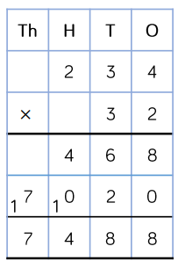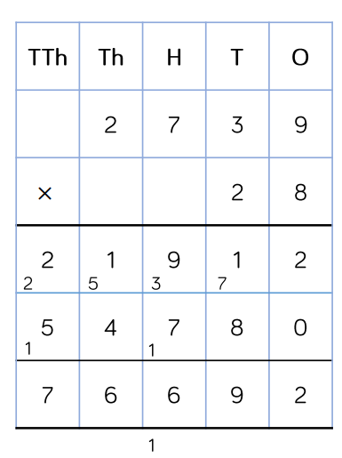  - Exchanged digits sit below/on the answer line. See example above.  - Children must be secure in the understanding and vocabulary of multiplying by 10,100,1000 using 0 as a place holder (No eggs!)  - Continue to develop children’s understanding of the multiplication of a decimal number (alongside its whole number equivalent).
Representations  to support calculations | Golden Nugget representations:  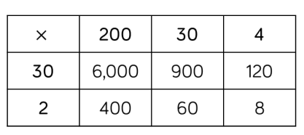  Other representations:  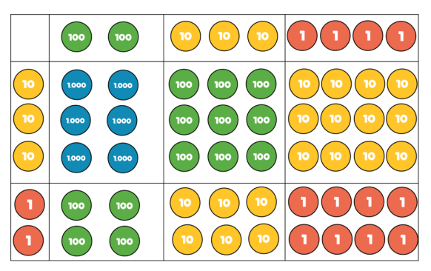

Jericho Primary School -Calculation Policy – Multiplication – Year 6
Mental Calculations | Perform mental calculations, including with mixed operations and large numbers.  - identify common factors, common multiples and prime numbers  - use their knowledge of the order of operations to carry out calculations involving the four operations
Written calculation | Multiply numbers up to 4 digits by a one- or two-digit number using a formal written method, including long multiplication for two-digit numbers.  - Understand that standard written multiplication method involves a number of partial products e.g. 36 × 24 is made up of four partial products 30 × 20, 30 × 4, 6 × 20, 6 × 4. Use manipulatives to support structure of the algorithm especially place value  - Exchanged digits sit below/on the answer line. See example above.  - Children must be secure in the understanding and vocabulary of multiplying by 10,100,1000 using 0 as a place holder (No eggs!)  Multiply one-digit numbers with up to two decimal places by whole numbers  - Continue to develop children’s understanding of the multiplication of a decimal number (alongside its whole number equivalent).  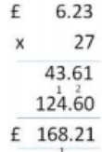
Representations  to support calculations | Golden Nugget representations:  Other representations:

