Jericho Primary School -Calculation Policy – Subtraction – Year 1
Mental Calculations | Read, write and interpret mathematical statements using symbols +, -, =  - - Represent and use number bonds and related subtraction facts within 20  - Children know that working systematically helps them to find all  - the possible number bonds to 20.  - - Subtract one digit and two-digit numbers up to 20, including zero.  - Children explore subtraction by counting back from a given number.  - Children know the importance of ten ones equalling one ten.  - - Solve one-step problems using concrete objects and pictorial representations, and missing number problems such as: ___ - 9 = 11  - - Given a number, identify (and use the language) one less
Written calculation | -Read, write and interpret mathematical statements using symbols +, -, =  - Represent and use number bonds and related subtraction facts within 20.  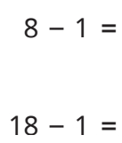  - Subtract one digit and two-digit numbers up to 20, including zero.  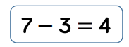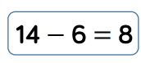  - Solve one-step problems using concrete objects and pictorial representations, and missing number problems such as: ____ - 9 = 11  _ Know fact families to 20  - Given a number, identify (and use the language) one less
Representations  to support calculations | Golden Nugget representations:  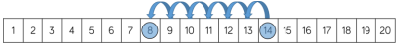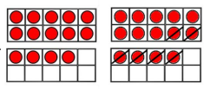  Other representations:  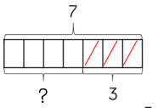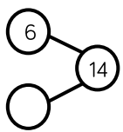
Jericho Primary School -Calculation Policy – Subtraction – Year 2
Mental Calculations | Subtract numbers using concrete objects, pictorial representations, and mentally, including:  - - a two-digit number and ones to 100  - Children should know that ten ones equals one ten and to count back from the larger number  - - a two-digit number and tens  - - two, two-digit numbers to 100  - - adding three one-digit numbers  - Children should find number bonds to 10 or doubles for efficiency.  - Recall and use and subtraction facts to 20 facts fluently, and derive and use related facts up to 100.
Written calculation | Subtract numbers using concrete objects, pictorial representations, abstract representations and mentally, including:  - - a two-digit number and ones  57 -8=  - - a two-digit number and tens  63 – 30 =  - - two, two-digit numbers crossing 10  Introduce the expanded method of the column method to prepare for  formal written methods with larger numbers  70 + 6  -40 + 3  _____  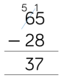 only use the column method with exchanging if children are confident completing with Base 10 and the expanded method.  - Re-partition numbers  - Use a hundred square  - Check calculations using inverse and by subtracting numbers in different order
Representations  to support calculations | Golden Nugget representations:  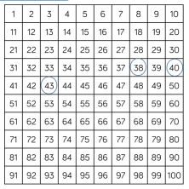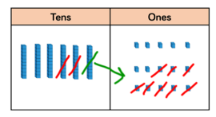  Other representations:  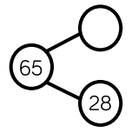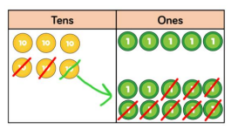  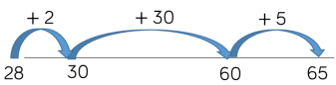  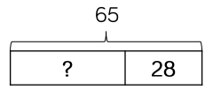bar models are useful for finding missing numbers.

Jericho Primary School -Calculation Policy – Subtraction – Year 3
Mental Calculations | Subtract numbers mentally, including:  - -a three-digit number and ones  - -a three-digit number and tens  - -a three-digit number and hundreds  - -Partition all numbers and recombine,  - start with TU - TU then HTU - TU  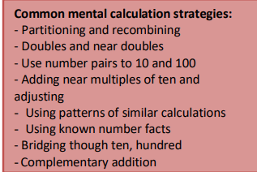
Written calculation | Subtract numbers with up to three digits, using formal written (columnar) methods  - Subtract to three digit numbers using physical and abstract representations (e.g. Base 10, place value counters, empty number lines)  - Children know that the column method is the usually most efficient method and move onto abstract method when exchanging concept is embedded.  - Children are taught to exchange appropriately.  - Children to exchange from the next place value column and recombine.  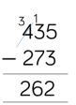  - Estimate the answer to a calculation and use inverse operations to check answers.  - Solve problems, including missing number problems, using number facts, place  value, and more complex subtraction.
Representations  to support calculations | Golden Nugget representations:  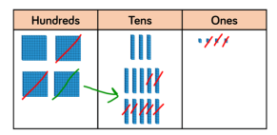  Other representations:  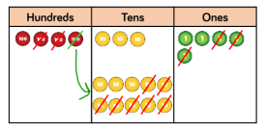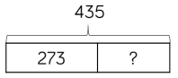  Bar models are useful for finding missing numbers.

Jericho Primary School -Calculation Policy – Subtraction – Year 4
Mental Calculations | Practise mental methods with increasingly large numbers.  - Consolidate partitioning and re-partitioning  - 550 - 320 = 550 - 300 - 20  - = 250 - 20  - = 230  - Use compensation for subtracting too much/little and adjusting  - Use Base 10, place value counters, empty number lines etc.
Written calculation | Subtract numbers with up to 4 digits using the formal written methods of columnar where appropriate.  - Children know that the column method is the usually most efficient method. Children are taught to exchange and recombine appropriately.  - Children to place exchanged value as shown.  - Include decimal subtraction for money.  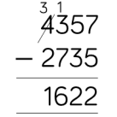  - Estimate and use inverse operations to check answers to a calculation.  - Solve subtraction two-step problems in contexts, deciding which operations and methods to use and why.
Representations  to support calculations | Golden Nugget representations:  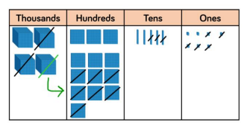  Other representations:  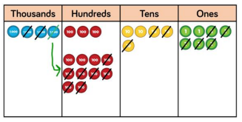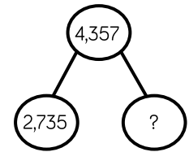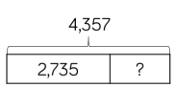  Bar models are useful for finding missing numbers/inverse operations.

Jericho Primary School -Calculation Policy – Subtraction – Year 5
Mental Calculations | Practise mental methods with increasingly large numbers.  - Eg 12 462 – 2300 = 10 162)  - Use compensation for subtracting too much/little and adjusting  - Use Base 10, place value counters, empty number lines etc.
Written calculation | Subtract numbers with more than 4 digits using the formal written methods of columnar where appropriate.  - Children know that the column method is the usually most efficient method. Children are taught to exchange and recombine appropriately.  - Children to place exchanged value as shown.  - Include decimal subtraction  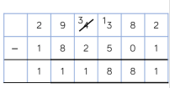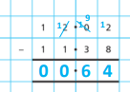  - use rounding to check answers to calculations and determine, in the context of a problem, levels of accuracy.  - Solve subtraction two-step problems in contexts, deciding which operations and methods to use and why.
Representations  to support calculations | Golden Nugget representations:  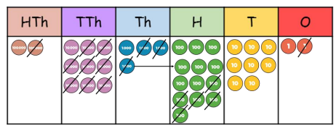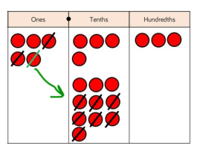  Other representations:  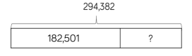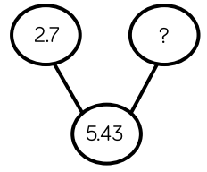  Bar models are useful for finding missing numbers/inverse operations.

Jericho Primary School -Calculation Policy – Subtraction – Year 6
Mental Calculations | Perform mental calculations, including with mixed operations and large numbers  - Children use representation of choice.  - Consolidate partitioning and re-partitioning.  - Use compensation for subtracting too much/little and adjusting
Written calculation | Add larger numbers with more than 5 digits using the formal written methods of columnar where appropriate.  - Children know that the column method is the usually most efficient method. Children are taught to exchange and recombine appropriately.  - Children to place exchanged value as shown.  - Include decimal subtraction.  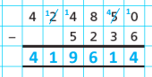  - Use their knowledge of the order of operations to carry out calculations involving the  - four operations.  - Solve subtraction multi-step problems in contexts, deciding which operations and methods to use and why.
Representations  to support calculations | Golden Nugget representations:  Other representations:  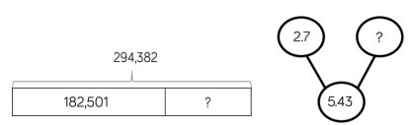  Bar models are useful for finding missing numbers/inverse operations.

