John Clifford School Passport
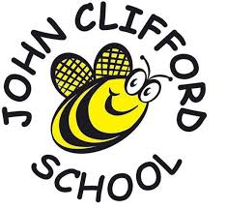
This year I am going to be in Year 4

My Class is Clover Class
My Teacher in Clover Class is


Mr Standen
The Teaching Assistant working in Year 4 is
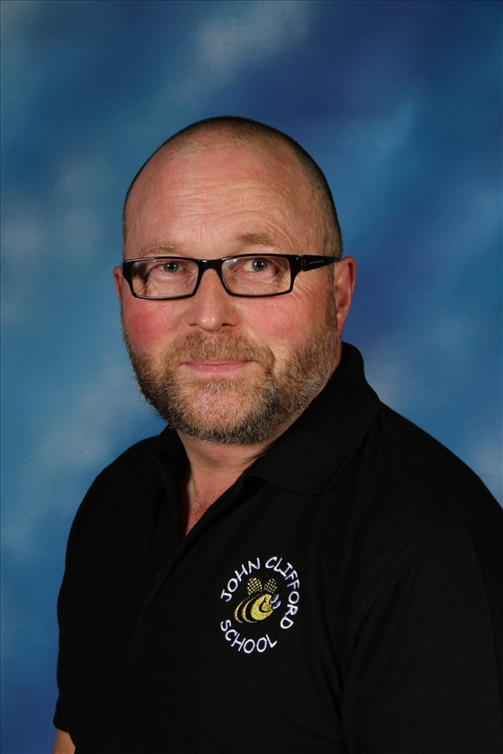

Mr Barber
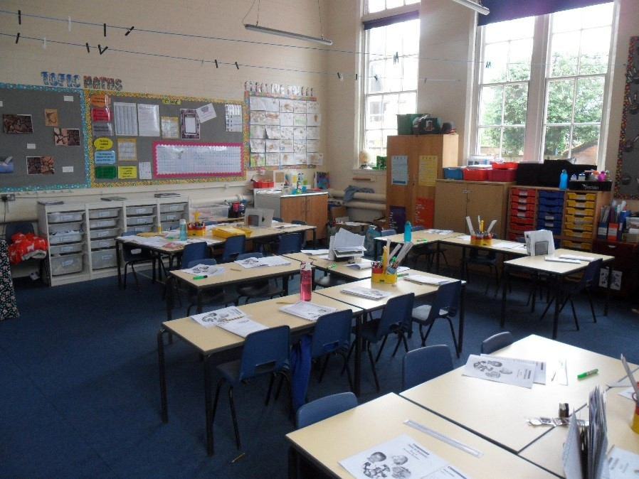
My Year 4 Classroom – Clover

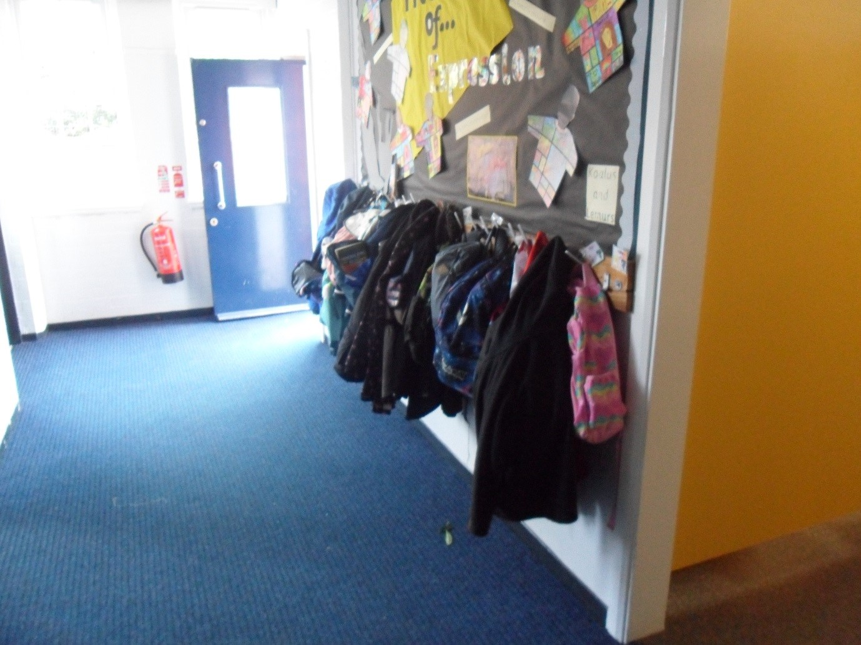
My Cloakroom

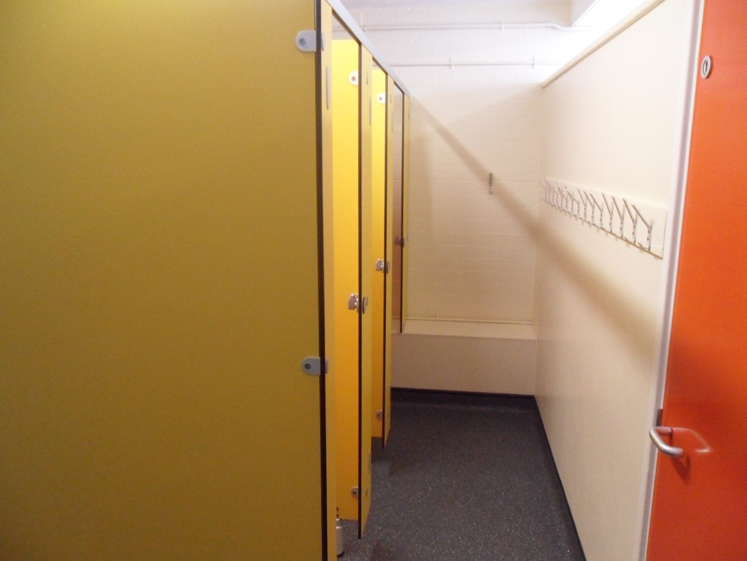
The toilets I will use.

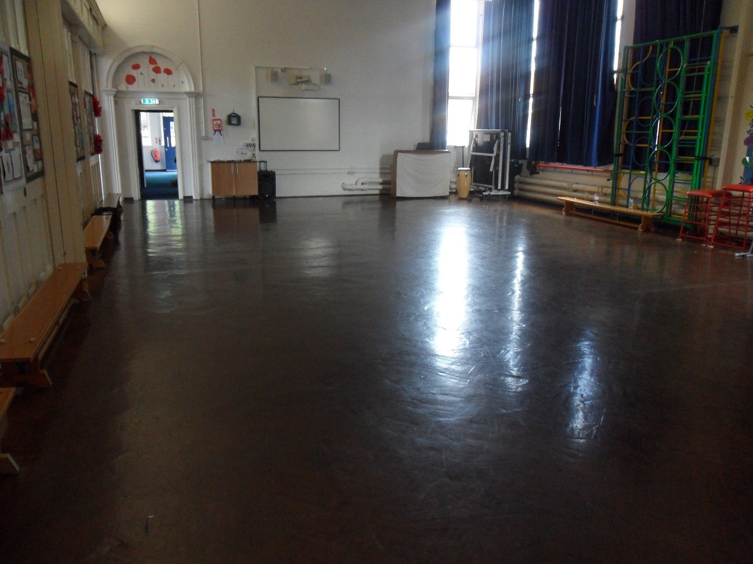
The Junior Hall

