Subitising – recognising “how many” just from a quick look!  Fledglings – Autumn 1 – 26/27  Counting up and counting back- 5 little ducks, 10 green bottles, 5 little speckled frogs – you tube has great versions  Number songs:  How Many Fingers? | Kids Songs | Super Simple Songs thus one is my favourite and the children are enjoying finding their fingers and toes | Phonics and signing  S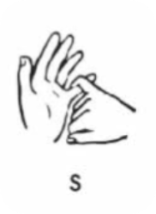 A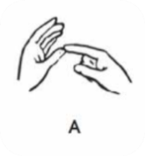T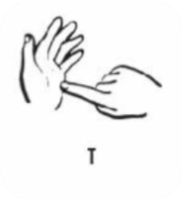  Visit the Makaton website for videos of the alphabet signs and letter related vocabulary. www.makaton.org  Check out our morning song and learn the words and signs at home together:  The ‘Good Morning Song’ With British Makaton #motivationalmakaton #makaton #inclusion #goodmorning | This half term our topic is “All About Me”  Find out all about Elmer and Gerald!  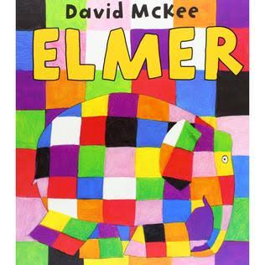  Elmer Interactive Simplified Story  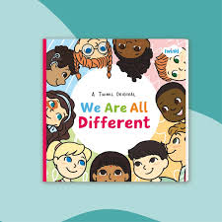  We Are All Different | Twinkl Originals Children's Book Reading - YouTube  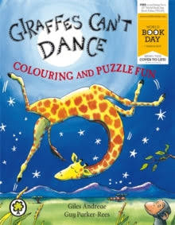
Maths at home
- Count up’s and countdowns to mark the transitions in the day
- Count anything and everything
- Practice “a quick look” for 1,2 or 3 things.
- Numbers 1-3 in the home and out about
- If your child knows these numbers, “use bigger numbers!”
- Count your steps, jumps, sausages, shoes….anything at all!
Check these out: Liquid Listening | Musical Hydrotherapy
Sensory Circuits: How to sensory circuits for beginners tutorial
We do these too!
 | Literacy at home | Topic at home
 | - Check out “Bounce Patrol” Letter songs on you tube  - Point out items in daily life that start with the letter sound  - Learn some signs for important words in your child’s life  - Practice writing the letter or some sentences | - Read or watch the stories  - Look at Pinterest for Elmer craft ideas  - Act them out  - Have fun  - Build a jungle role play or have a dance competition  - How different are the members of your family?

