# Agreements

To confirm you’ve read and agree to the John Grant School / Home Agreement please click the **Data Collection** option on the left menu bar in My Child At School (MCAS).

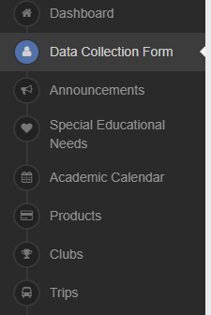

You will then see **Documents** at the top of the page. Here you can download the agreement and tick for confirm.

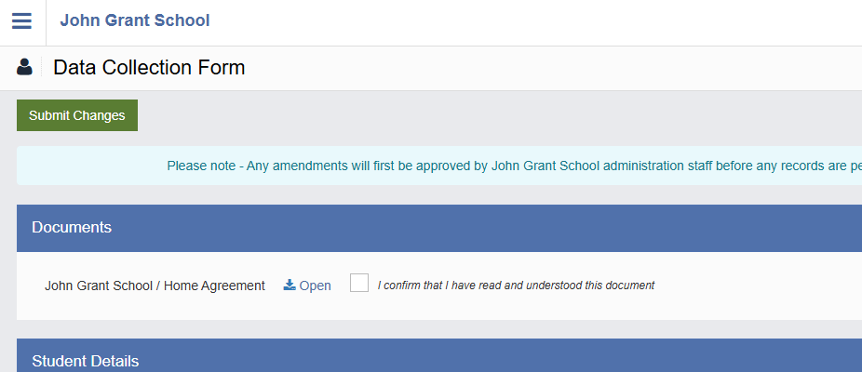

# Consents

You can use this guide to view or give **Parental Consent** in the desktop version of**MCAS (MyChildAtSchool)**

The **Parental Consent**option is accessible only from the left **Menu** **Bar** on the MCAS Dashboard

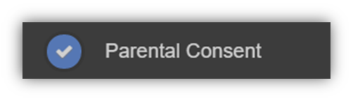

It displays the **Parental Consent**options for the Student. Tick the buttons to give Consent for information or images of the Student to be used within each of the options.

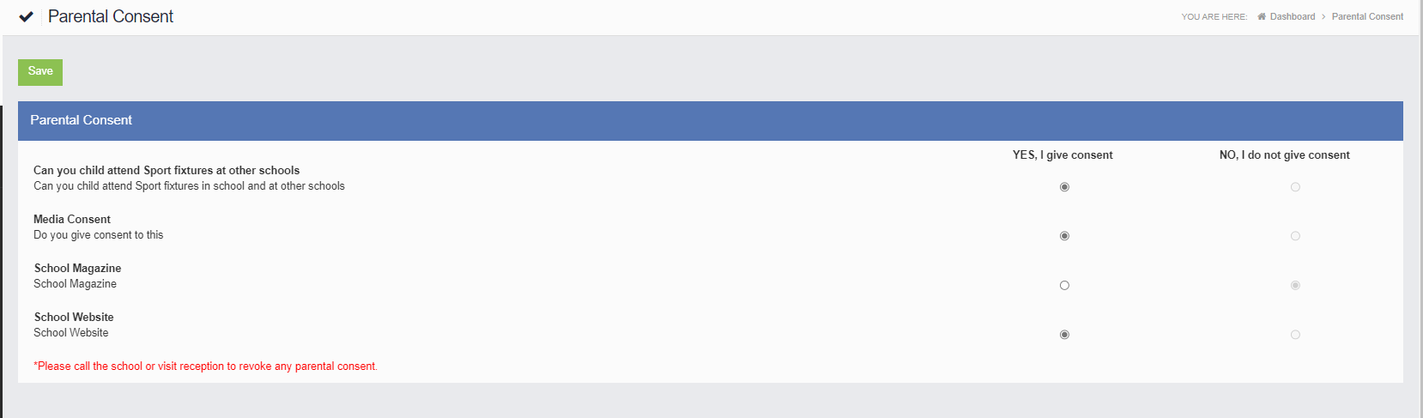

To revoke consent please contact [office@johngrant.norfolk.sch.uk](mailto:office@johngrant.norfolk.sch.uk)