**How to view and add Dinner Money in MCAS**

From your MCAS Dashboard the **Dinner Money**option is accessible as a Widget.

The Widget displays the current Credit Balance Summary and gives the option to top-up the Balance.

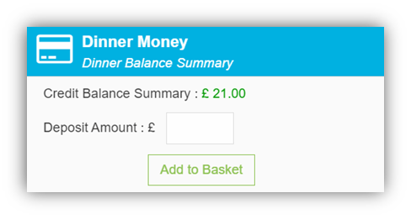

To do this enter the amount in the **Deposit** **Amount** box and click the **Add to Basket** button. The **Shopping** **Basket** (trolley) icon on the top bar will now display that you have 1 item in the Basket, click here to open the Basket and view the contents, the item can be removed by clicking on the **X** to the right.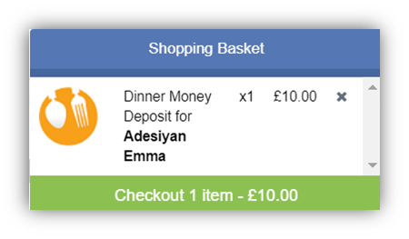 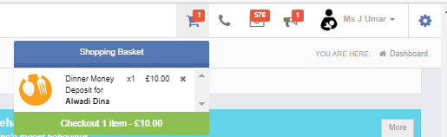

To continue click on the green **Checkout** bar which will open the Shopping Basket.

Here you can click the **Continue** **Shopping** button to open the **School** **Shop** and add more items, click the **Clear** **Basket** button to empty the Basket or the **Checkout** button to continue and make your payment.

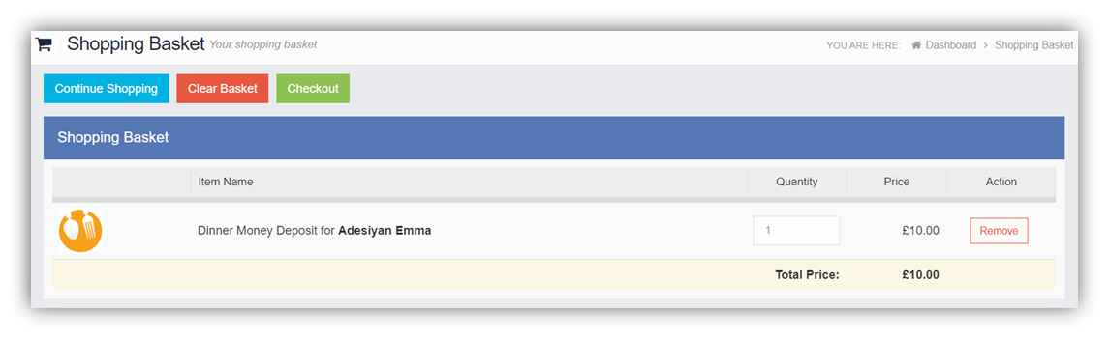

Enter your **Payment** **Details** on the following page, once verified and paid a Confirmation message will be given and the **Credit** **Balance** **Summary** updated on the Widget.

