**Hub of Hope**

The Hub of Hope is the UK's largest and most comprehensive directory of community mental health services, so you can find help when you need it, wherever you are.

When you click on their web site, you will see the front page below, with a wide range of “resources” and if you then click on “Get Support”, under which you can search within your own particular postcode.

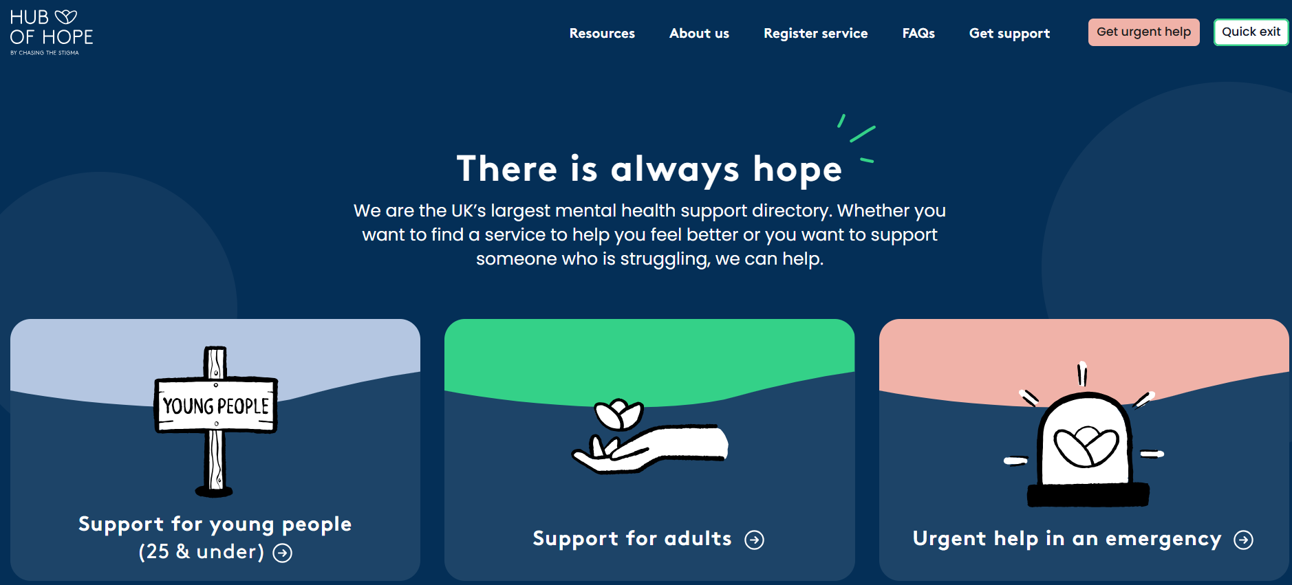

Hub of Hope is the only directory of its kind in the UK that brings local, national, peer, community, charity, private and NHS mental health support services together in one place.

Access to mental health support should never come with barriers and be free to all.

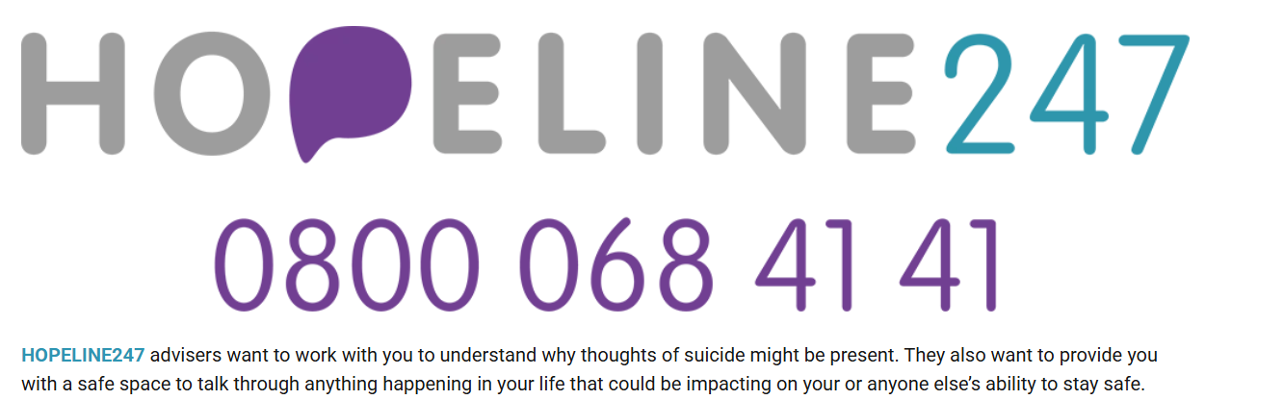

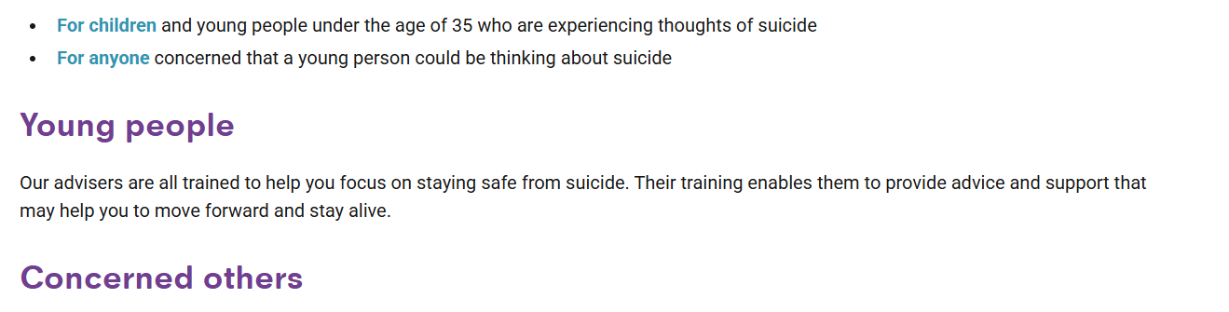 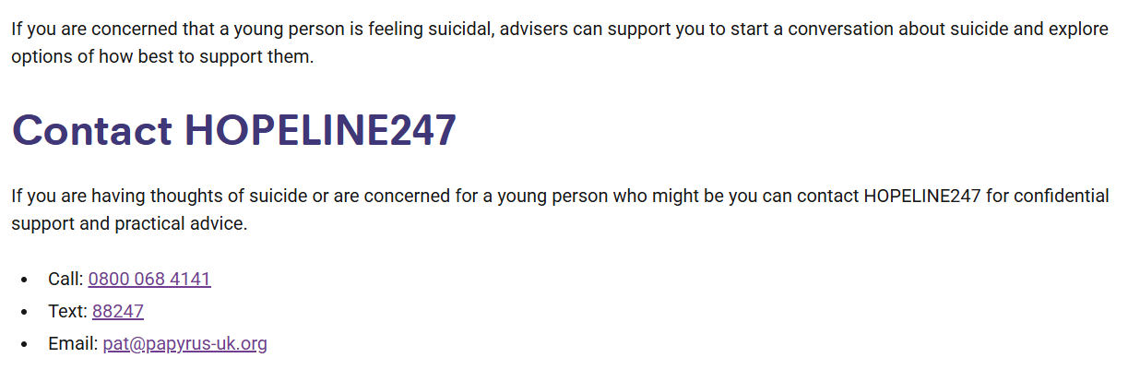

[giveusashout.org/get-help/](https://giveusashout.org/get-help/)

