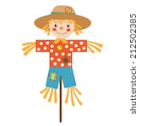  This ½ term in Kingfisher/Cormorant Class our focus/Topic is ‘Walking through Autumn.  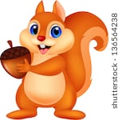 | 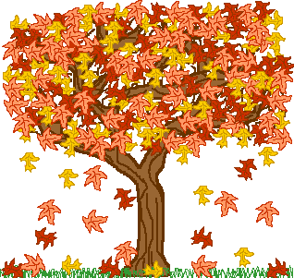  Autumn 2026
We will be learning about | Please help me at home by
English  Phonics – early sounds and familiar words.  Different sensory stories with props to support the text. Learning about different Autumn things, i.e. colours of Autumn, activities for Autumn, animals in Autumn, food in Autumn time etc. We will explore different Autumn objects, i.e. leaves, conkers - the sounds they make etc, We will go on an Autumn hunt outside to explore what nature is like in Autumn time and also lots of writing and mark-making(fine/gross motor skills). We are going to learn about scarecrows and making our own scare crows for our display. Our English story is called ‘Don’t hog the hedgehog’. | Take me on an Autumn hunt to the park so I can collect leaves, pine cones, sticks etc to play with and bring into my class.  Help me to copy-write my name or the first letter of my name, using different sensory materials, i.e. soil, sand, spices etc.  Watch Autumn songs with me on YouTube.  When possible, write in my contact book what I did on the weekend so I can share my news with my friends.
Maths  Counting to 5 and 10. Autumn/Magic Counting songs and rhymes.  Objects that are big/small, hard and soft, short and long, thick and thin.  Patterns using Autumn and magical colours, shapes and numbers.  Ordering and sequencing numbers 1 and 2. | Count with me or sing with me familiar nursery rhymes.  Talk to me about the day of the week / month and Autumn season. Show me outside our house what Autumn looks like. Dress me up with appropriate clothes for Autumn, i.e. raincoat, wellies, umbrella etc. and you can dress me up as a scarecrow etc.
Science  Messy Play.  Sensory integrated activities. Topic related activities, i.e. making an Autumn sensory tray with leaves, soil, pinecones, conkers etc or a magical tray with coloured sand, sparklers, slime etc. Exploring different Autumn smells, different tastes and textures. | Help me to make my own sensory tray. We can make jelly together (orange, yellow and red) and put different Autumn objects in it for me to explore.  Doing messy activities with me, i.e. playing with leaves, sand etc.
ICT  Looking up on the computer about Autumn things and listening to different Autumn noises. We will also look at and learn about different animals you can see in Autumn time, i.e. squirrels, foxes, etc and explore their habits, hibernation etc.  Interact with different switch-operated objects and toys.  Using different electronic devices to make something happen, i.e. switch-operated toys, light-up objects, noisy toys.  Using the touchscreen or mouse to create an image. | Help me to find objects that make a noise, light up, cause and effect i.e. in a shop.  Help me to turn the radio, tv etc on/off.  Watch Autumn inspired clips on YouTube with me.
Art  Lots of different textures, materials and fabrics.  Mark-making/drawing. Focusing on my early writing skills, using different utensils, finger exercises.  Creating lovely Autumn pictures and objects.  Using different utensils to create pictures.  Explore different tools for making pictures. | Any art related activities. Making Autumn pictures. You can ‘Google’ for Autumn templates, print them off and I can colour them in or decorate them.
Sensory Activities  Music Therapy.  Tac Pac  Sensology (Discover all my senses)  Sensory Art/Sensory cooking.  Sensory and dark room.  Sensory integrated activities.  All my activities will be based around my sensory curriculum. | Talk to me about my day as you will see on my timetable what I have been doing. My staff will also write in my home/school contact book if I have done special sensory activities.  You can do messy play with me at home, water or sand play.
PE  Group games.  Turn taking.  Rebound Therapy.  Swimming/Hydro pool - try to propel myself forwards by kicking my legs. Walking independently in the pool.  Sensory circuit activities in the hall, which will include basic concepts, i.e. walking, running, skipping, marching, jumping, balancing etc. | If the opportunity arises practise kicking legs to move forwards. You can also support me with my balancing; kicking and catching a ball. You can help me to practise basic movements, i.e. forwards, backwards, turn around, stretch, crouch run, hop, jump etc.
RE  Celebrations in class and in school, i.e. birthdays, assemblies.  Star charts. | My staff will write in my school/home contact book if I have done something very special so you can celebrate with me.
PSHE  Personal well-being and personal care.  Learning to feed myself and to hold my own cup when I have a drink. Participate in personal care. | Help me complete these activities at home. Encourage me to ‘help’ with my personal care, i.e. dressing, brushing my hair/teeth etc.
If there is anything you think we might find useful at home about our topics, please send it in or let us know in the home school book. | Please let us know if there is anything new your child has learned at home. From swimming awards, to saying their first words, to using the toilet, to trying new food.  We’d love to celebrate at school too.
Here are a few templates you can use with me if you want:

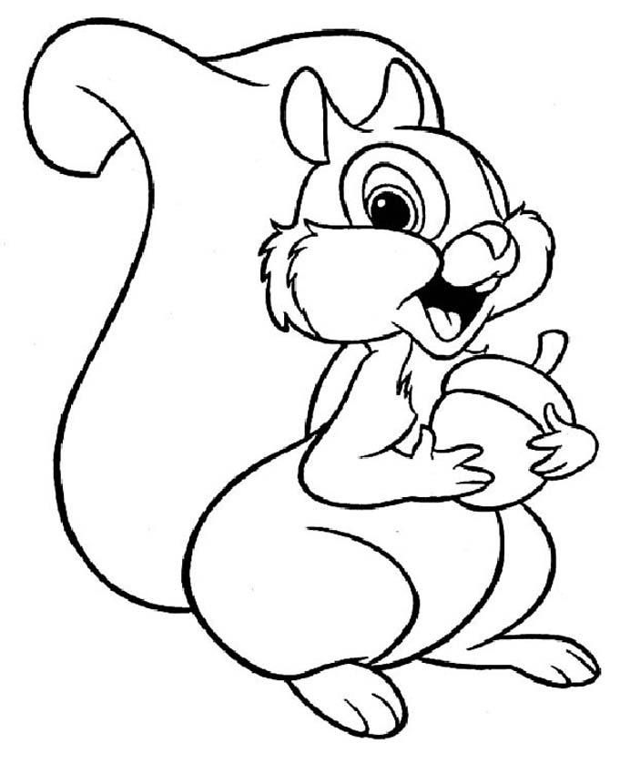
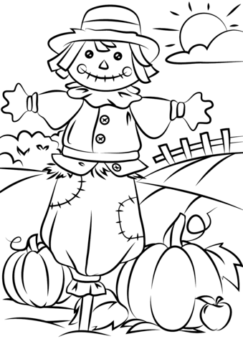

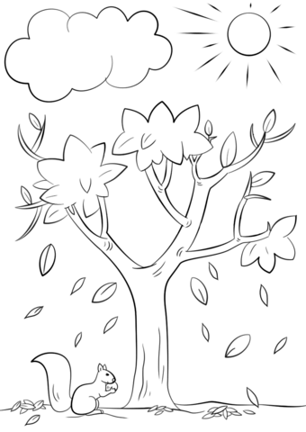

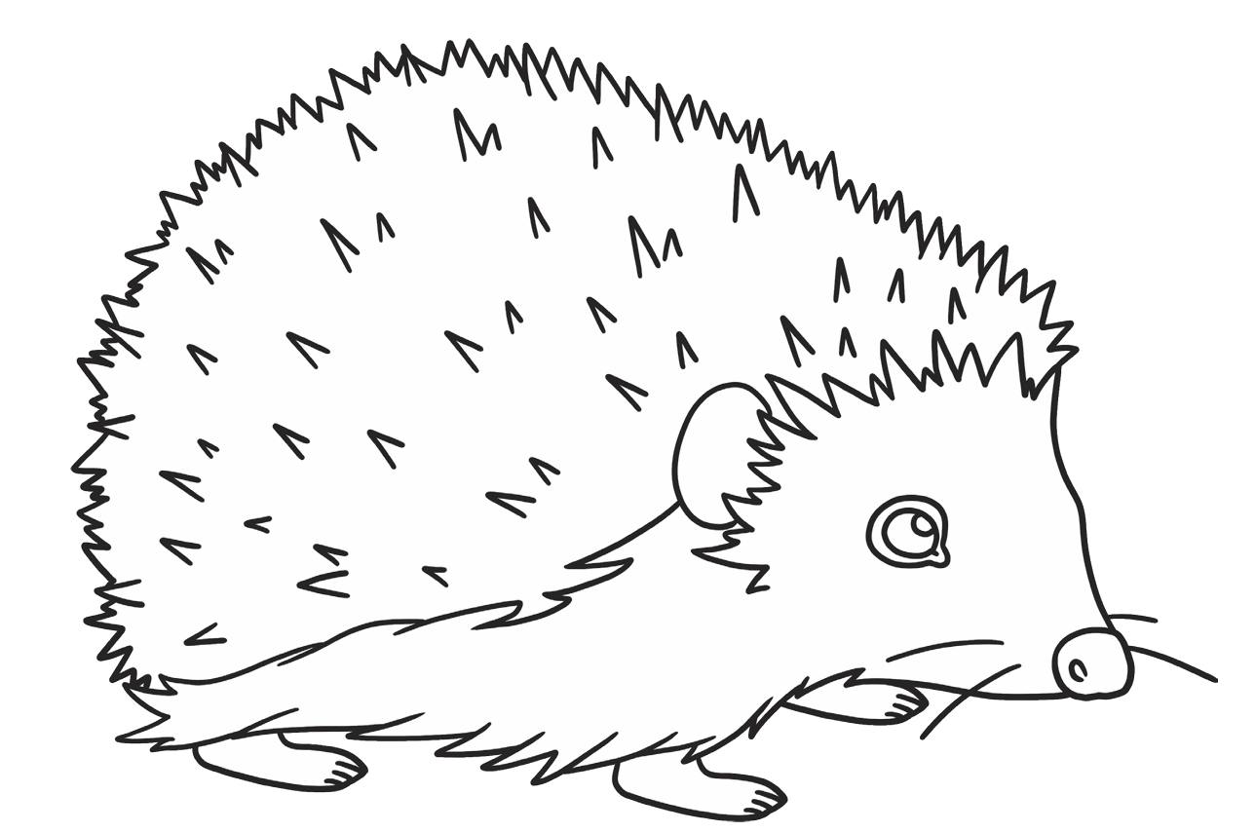
Useful websites:
English:
- Don't Hog the Hedge! | Twinkl Originals - Children's Book Reading | Twinkl Kids Tv
- Happy Hedgehog! | Fun Nursery Rhymes and Kids Songs | Toon Bops
- Seasons Song for Kids ♫ Autumn Leaves are Falling Down ♫ Fall Kids Song ♫ by The Learning Station

Maths:
- Mr Tumble's Autumn Song | Golden Golden | Mr Tumble and Friends
- Five Little Leaves 🍂 | Autumn Counting Song for Kids | Fun Nursery Rhyme
- Fall and Autumn Counting Song for Kids - How Many Leaves? - ELF Learning

ICT:
- What is Autumn? | Signs of Autumn for Kids 🍂
- Autumn Is Coming | Autumn Story for Kids | Kindergarten
- Autumn Animals in English for Kids | Vocabulary and Fun Animal Facts
- Autumn Animals Song for Kids | Autumn & Fall Nursery Rhymes for Preschool

- If there is anything about Autumn I really enjoy, please let my staff know so they can repeat it in school with me and maybe share with my friends.

