**My Child At School - Sign Up Guide**

**Click or visit** [**https://www.mychildatschool.com/**](https://www.mychildatschool.com/)

Once at the **Parent Login**screen you should follow these steps:

* Click on the **Sign Up**link in the Parent Login screen.
* Enter the **school’s Postcode:** NR30 5QW or **School ID**: 11953
* Select the school from the list in the dropdown.
* Click **Continue**.
* Enter your email address (this must be the same as the email address you provided the school).
* Click **Sign Up**.

You will see the message *‘To complete your registration, we have sent an email to the email address you provided. Please access your email and follow the steps to create your password’*.



You will receive an email from **MyChildAtSchool** with a link to a **one time passcode**.

* Click on the **link** for the one time passcode.
* Enter the one time passcode.
* Click **Verify**.

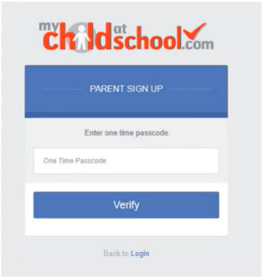

As soon as the **one time passcode** has been verified, you will be prompted to create a **password**.

* **Enter Password.**
* **Confirm Password.**
* Click **Create Password**.

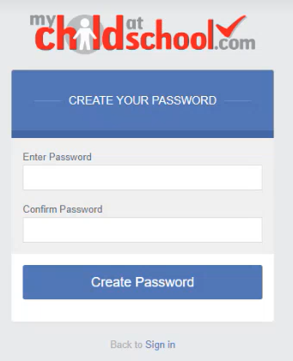

Once the password has been created, you can login from within the web browser at [**www.mychildatschool.com**](http://www.mychildatschool.com/), or access the **MyChildAtSchool** mobile phone app, this will open the **Parent Login** screen.

**Note**: If you receive the ‘*Email address invalid’* message, please contact the school to confirm you are using the same email address as we have registered for you.