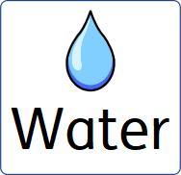

Autumn 2026
This term in Owl class we will be learning about the topic of “Water”.

We will be learning about | Please help me at home by
English  Reading  Handwriting and punctuation  Communication | You can support your child's learning by taking a trip to your local library (Local library services - GOV.UK) to explore, read and listen to books about the sea, rivers and lakes including the animals whom call this there home. Reading together and talking about the pictures and characters is a great way to develop language and a love of books.  Challenge: Can you help your child create their own story about an animal that lives in the sea? They could draw pictures to go with their story or tell it aloud for you to write down.  As part of our learning in class, all children are beginning to learn Makaton to provide additional opportunities for communication. You can support this at home by exploring the free videos from Singing Hands, which introduce Makaton signs alongside familiar songs to help strengthen language and communication skills.
Maths  Place value (counting and number recognition) | This term, we are focusing on developing your child's understanding of place value and number language. We will be using key vocabulary such as more, less, one more, one less, and the same.  You can support your child's learning at home by using this language during everyday activities. For example, when you're shopping, encourage your child to help collect items and use phrases such as, "Can you find one more apple?" or "Which basket has more?"  You can also use these terms during play and daily routines with things your child enjoys, such as blocks, books, biscuits, toy cars, or when playing on the swings. For example:  - "Can I have one more biscuit?"  - "Do these towers have the same number of blocks?"  - "Which pile has more cars?"  - "Can you find one less book?"  - "Shall we have one more turn on the swings"  Using this mathematical language regularly in everyday situations will help to build your child's confidence and understanding of early number concepts.
Science (after half-term)  Floating and sinking, properties of materials, rubbish and recycling. | You can support your child's learning at home by creating your own ice sculpture. Fill a balloon or rubber glove with water and add a few drops of food colouring if you would like coloured ice. Place it in the freezer overnight. Once frozen, carefully remove the balloon or glove to reveal your unique ice sculpture.  Encourage your child to observe and talk about what they notice. How has the water changed? What does the ice feel like? What happens as it begins to melt? You could even freeze water in different containers and compare the shapes that are made.  What can be recycled and what can’t – can I sort their own recycling and put in the correct bins?
Design Technology  Our focus is Creative Water Play – Pool Noodle Boats  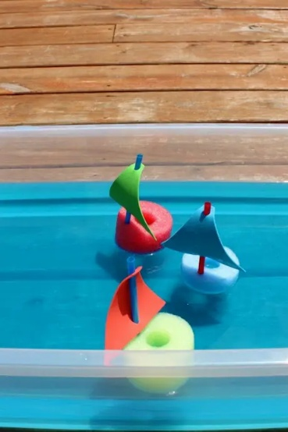 | Why not have a go at making your own pool noodle boats for some fun water play?  These simple boats are great for encouraging creativity, problem-solving and imaginative play. Your child can race the boats by blowing on them, float them in the bath or a water tray, give them names, or even investigate which materials make them float or sink.  What you'll need:  - Foam sheets  - An old pool noodle  - Straws  - A hole punch  - Scissors (adult use/supervision)  How to make them:  - Cut small triangles from the foam sheets to create the sails.  - Punch two holes in each sail and thread a straw through to make the mast.  - Cut the pool noodle into small sections to create the boat bases.  - Carefully push the straw into the pool noodle, and your boat is ready to sail!  Encourage your child to talk about what they notice as they play. Which boat goes the fastest? Which one floats the longest? Can they make a story about where their boat is travelling? These simple conversations help to develop language, creativity and early scientific thinking.
Art (before half-term) and Design Technology (after half-term)  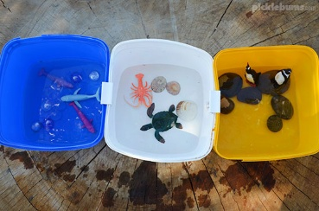  This term, we will be exploring water discovery through creative play and art activities. | You can support your child's learning at home by creating your own ocean small world. All you need is a container, some plastic sea creatures and a few natural materials. You could add sand to the bottom, along with stones, rocks, leaves or seaweed to create an underwater habitat.  Encourage your child to explore, imagine and talk about the different sea creatures and their environment. They might enjoy making up stories, sorting the animals or recreating scenes from their favourite sea-themed books. This type of creative play helps to develop imagination, language and an understanding of the natural world.
Geography (before half-term) and History (after half-term)  This term, we will be learning about the water cycle and exploring how water moves around our planet through evaporation, condensation and precipitation. | You can support your child's learning at home by singing the Water Cycle Song together. A fun version is available on Twinkl, and there is also an interactive version on GoNoodle that encourages children to sing, dance and remember the different stages of the water cycle through movement.  Can they spot the different stages of the water cycle and talk about what happens to water as it travels from the sea, into the clouds and back to the ground. Singing and repeating the key vocabulary.
Food Technology  In class we have a fruit or vegetable of the week, all are encouraged to explore and maybe find a new food they enjoy. | Encourage your child to try, touch, smell or taste a new food. At first this can be tricky but even expressing a dislike or no towards food is communication.
PE  This term we will be taking part in basketball and co-ordination. | On a nice day explore the park, can they create their own circuit. Do they enjoy riding their bikes? Getting out and exploring for 10 minutes a day can boost self-regulation and help support physical fitness.
RE (after half-term)  Religious celebrations, such as Christmas, Hannukah and Diwali | Talk to me about the Christmas story, Hannukah (4th to 12th) and Diwali (8th November) when they appear on the news
PSHE  Water in the community (firefighters, lifeguards), using water to keep us healthy | Discuss about people who help us, focusing on those who keep us safe in the water and the role of a firefighter and what they do to help.

