
Seagulls Class Autumn Newsletter


In maths we will be learning about place value. We will be using numicon and embedded maths play and interaction to secure our knowledge and understanding.
In English we are focusing on developing our listening, communication and writing skills. We will be employing the use of Makaton signing, colourful semantics and symbols to support our communication and listening.
Our topic lessons will be focussed on exploring our identity and how we see the world around us. We will be using lots of different tools in Art and looking at different ways to represent ourselves and our families.
Our Topic for this half term is All about me!
We will explore this through learning about families and ourselves.
Encourage us to talk about our families using pictures.
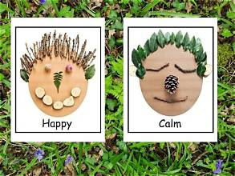

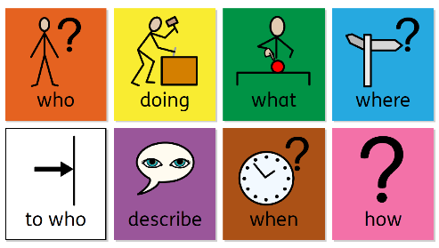


Below you’ll find some helpful links with information and activities you can use at home to support your childs learning
Makaton
Official Makaton Charity
🔗 https://makaton.org
The official source for learning signs, symbols, training, and free resources for families. They offer workshops specifically suitable for parents and carers. [makaton.org], [makaton.org]
Makaton YouTube Channel
🔗 https://www.youtube.com/@MakatonCharity
Great for learning signs through songs, stories, and themed vocabularies. Regular free content that children enjoy. [makaton.org]
CBeebies Something Special
🔗 https://www.bbc.co.uk/cbeebies/shows/something-special
Mr Tumble uses Makaton signs throughout the programme, making it a fun way for children and families to learn together.
Attention Autism / Bucket Time
Attention Autism Ltd (Gina Davies)
🔗 https://attentionautism.co.uk
The official website for the Attention Autism programme. Includes information, training opportunities, and guidance for families. The programme was developed by speech and language therapist Gina Davies to build attention, engagement and communication skills. [attentiona...tism.co.uk], [attentiona...tism.co.uk]
Gina Davies YouTube Channel
🔗 https://www.youtube.com/results?search_query=Gina+Davies+Attention+Autism
Videos demonstrating Bucket Time activities and Attention Autism principles. Recommended by many schools and speech therapists. [wtt.org.uk]
A Bucket Full of Ideas
🔗 https://stpatricksliverpool.co.uk/wp-content/uploads/2021/01/Ideas-and-tips-for-attention-autism-activities.pdf
A free booklet packed with home Bucket Time ideas, attention-building activities, and practical guidance for parents. [stpatricks...pool.co.uk]
Attention Autism Support Booklet
🔗 https://www.wtt.org.uk/attachments/download.asp?file=310&type=pdf
Explains the stages of Attention Autism and provides activity suggestions and video links. [wtt.org.uk]
Colourful Semantics
Parent Guide to Colourful Semantics
🔗 https://www.twinkl.co.uk/resource/colourful-semantics-how-to-guide-for-parents-t-e-1746267866
A simple guide explaining how parents can use colour coding to support sentence building, storytelling and language development at home. [twinkl.com.au], [twinkl.nl]
Colourful Semantics Information Guide
🔗 https:// www.twinkl.co.uk/parenting-wiki/colourful-semantics
Explains the colour system and why it helps children understand sentence structure and develop expressive language. [twinkl.co.uk]
Twinkl Colourful Semantics Resources
🔗 https://www.twinkl.co.uk/resources/speech-language-and-communication-areas-of-need-primary-send-inclusion-teaching-resources/expressive-language-salt-inclusion-key-stage-1-year-1-year-2/colourful-semantics-speech-and-communication-salt-inclusion-teaching-resources
Free and subscription-based printable activities, sentence strips, visual supports, and picture cards. [twinkl.co.uk]
Widgit Colourful Semantics Pack
🔗 https://www.widgit.com/resources/literacy-language/language-development/colourful-semantics-pack/index.htm
Downloadable resources and symbol-supported materials based on the Colourful Semantics approach developed by Alison Bryan. [widgit.com]

General SEN Communication Resources
BBC Tiny Happy People
🔗 https://www.bbc.co.uk/tiny-happy-people
Excellent videos and activities supporting communication, language and interaction skills.
ICAN Children's Communication Charity
🔗 https://ican.org.uk
Advice, activities and resources for supporting speech, language and communication needs.
Speech and Language UK
🔗 https://speechandlanguage.org.uk
Parent-friendly information, activity ideas and guidance for children with speech and language difficulties.

Easy Home Activities
- Use Makaton signs during everyday routines (snack time, dressing, bath time).
- Do a 5-minute Bucket Time activity daily using exciting toys, bubbles, torches or wind-up toys.
- Use Colourful Semantics colours when describing pictures:
  - Who?
  - Doing what?
  - What?
  - Where?
This consistency between home and school can really support communication development and confidence.

