Monday 11th January 2021

Dear Parents and Carers,

Re: Key Stage 1 and 2 SATs Cancelled

I hope you are all staying safe and healthy and that your children are managing to access remote learning at home.

As you may have heard on the news, the 2021 national curriculum assessments, including key stage 1 and 2 tests (SATs) and teacher assessments have been cancelled. This does not mean that learning has been cancelled. SATs are only used to assess the children against the age-related expectations as set out by the National Curriculum. We are still teaching this curriculum, albeit remotely via Seesaw. Learning of the skills and knowledge within national curriculum is vital in order to prepare the children for future years in school.

For our Year 6 children, the learning in primary school, including in their final year with us, sets the foundations of their learning in high school. If they do not complete the Year 6 curriculum in some form, there will be gaps when they get to Year 7 and beyond. Therefore, it is vital that you encourage your children to log into Seesaw every day and to complete the learning to the best of their ability. For our Year 2 children, key stage 1 learning sets them up for the next phase of primary school and provides the basic skills that they need to achieve and progress throughout key stage 2 (Years 3 – 6). Again, I cannot stress enough the importance of children completing their Seesaw activities and logging on to the live meets with their teachers during this period of closure.

We know that we cannot replicate classroom teaching online perfectly. However, our teachers are all working extremely hard in order to ensure that your children are provided with remote education which is making a significant contribution to enabling your children to continue to learn and progress, and to mitigate any widening of attainment gaps.

If you are having any difficulties in logging on to Seesaw, please contact the school as soon as you can so that we can help. I understand that home schooling is difficult but we are here to help. We will be contacting families of any children not accessing the learning to provide support where we can so please talk to us.

Yours sincerely,

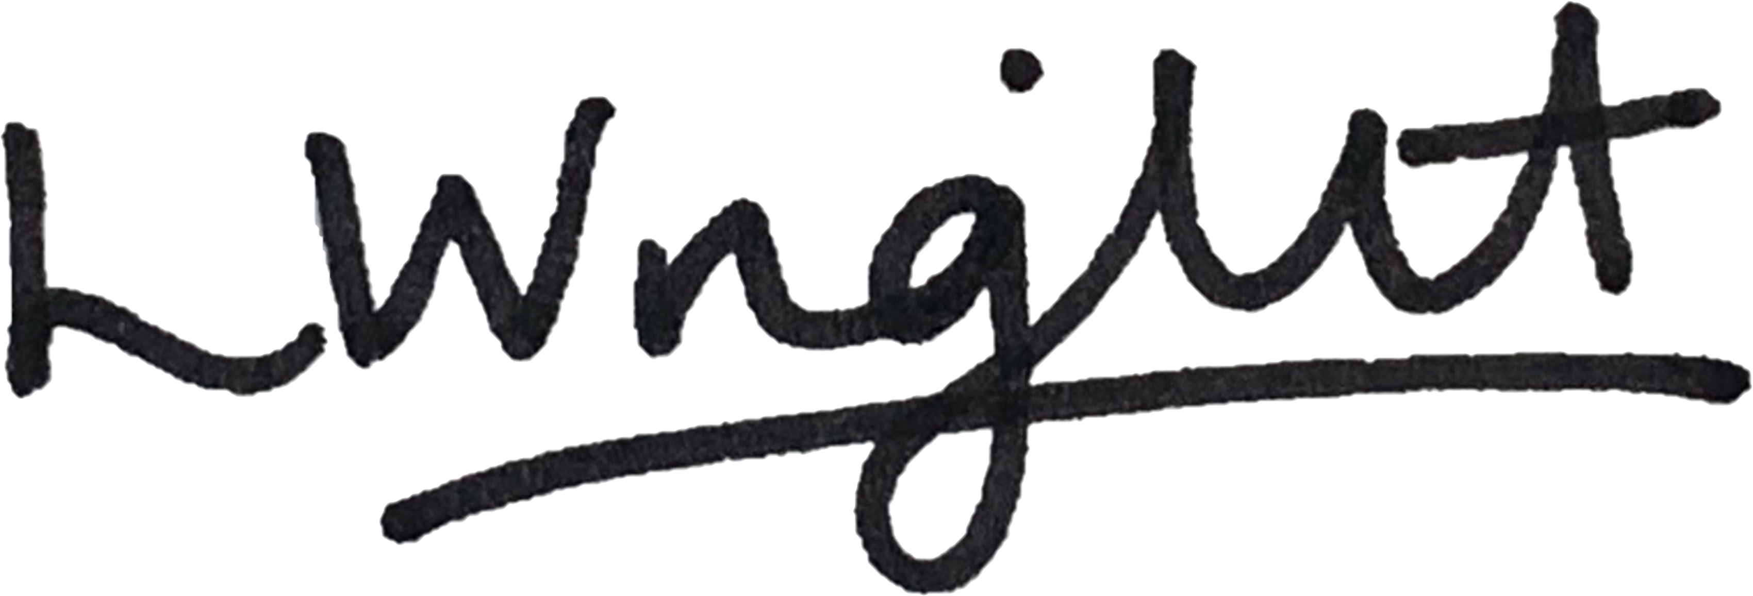

Ms. Leah Wright
Head Teacher

