Tuesday 5th January 2021
Dear Parents and Carers,

Re: National Lockdown

As you will now know, last night, the Prime Minister once more announced a national lockdown. This means that primary and secondary schools are now closed for most children, only remaining partially open only for vulnerable children and the children of critical workers. All other children will learn online until at least February half term.
John Perryn children will continue to use the online platform Seesaw to complete their daily learning. Teachers are working hard to ensure that the children have access to high quality learning for three to four hours a day. Teachers are also uploading welcome videos every morning and have begun live sessions so that your children can see and talk to them on a daily basis. Please contact the school as a matter of urgency if you are unable to access this for any reason. If your child does not complete the online learning, they will be marked as absent and their attendance will be affected. School staff will also contact you to find out why learning is not being completed. We understand that home schooling is extremely difficult so please get in touch with us if you have any issues – communication is key.
For those children entitled to free school meals, we have sent a text to each of you with a survey regarding the collection of weekly food parcels. Again, if you have not received this survey or you are unable to collect, please contact the school.
Although teachers are desperate to have full classrooms again, it does appear that limiting the number of households mixing in schools is the safest option with the current rates of infection so high. You will be the first to know when we are told that we can open to the rest of the school again and we all look forward to that day.
Until then, please stay safe and follow the rules set out by the government https://www.gov.uk/guidance/national-lockdown-stay-at-home. We all have a huge part to play in controlling the virus and protecting our communities. The more we can do to limit the spread, the sooner we can all be together again and return to normality.
Yours sincerely,

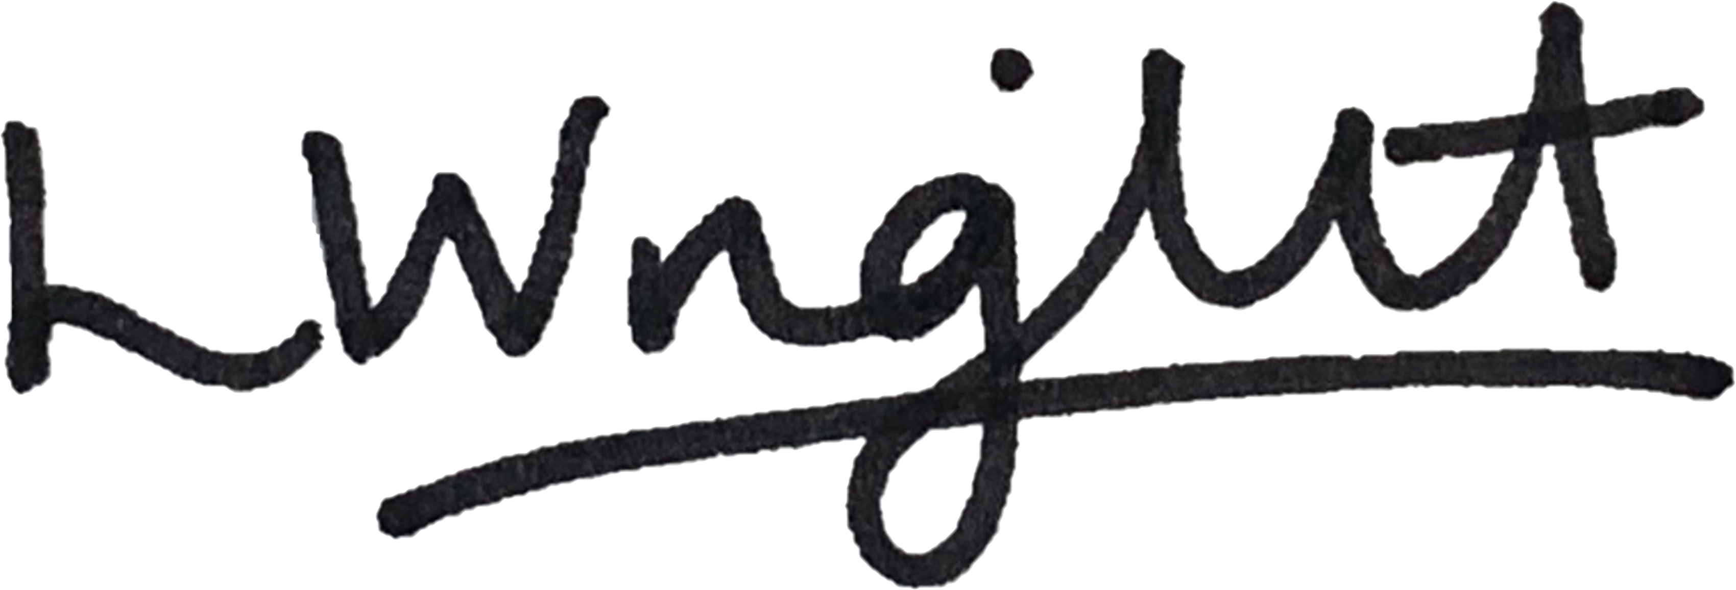

Ms. Leah Wright
Head Teacher

