Governor profile
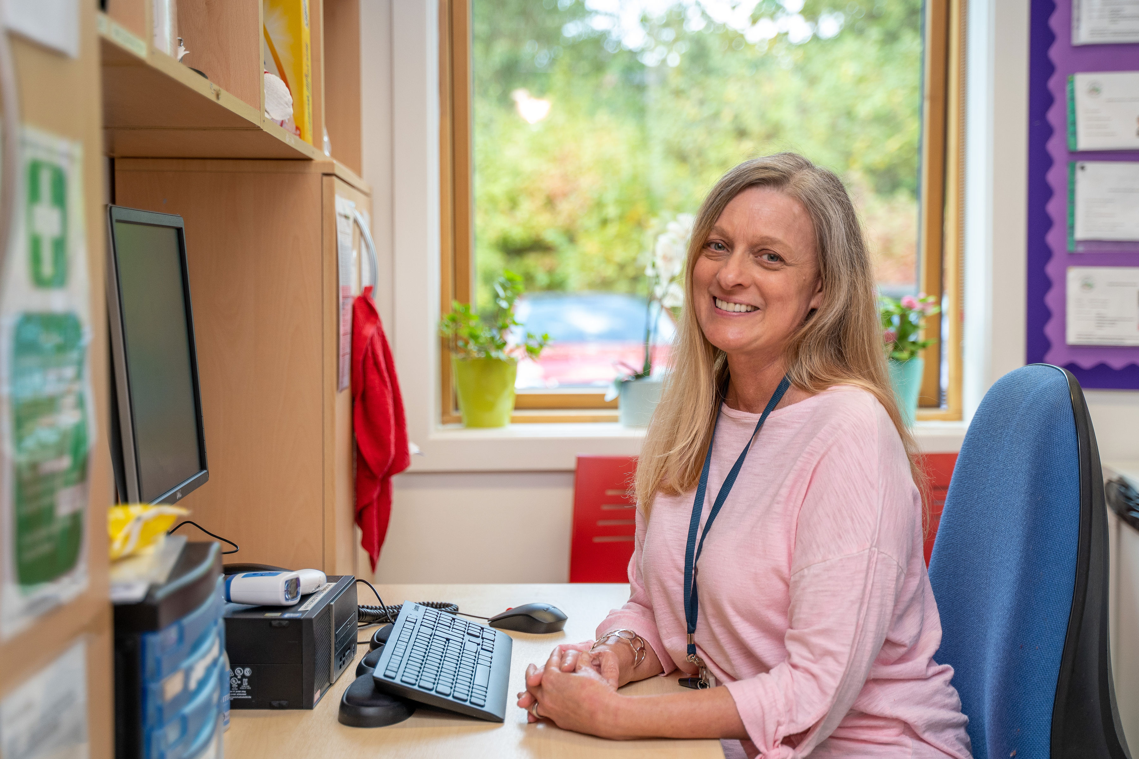

Name | Helen Richards
Category of governor | Staff Governor
Term of office | 1 Feb 2019 to 31 Jan 2023
Work | Helen is a dedicated member of staff, having been involved with the school for eleven years, and now works as SEN Teaching assistant, assisting the SENCo and working with SEN children across the school.
Governance experience | First appointed on 2 Feb 2015
Hobbies and interests | Gardening, going to art galleries and going to cinema.
Links to the school/area | Helen lives in Acton and so has close links with the area.
Why did you become a governor? | I saw an opportunity to help make a difference, not only for children in school now, but for children in years to come.

