Governor profile
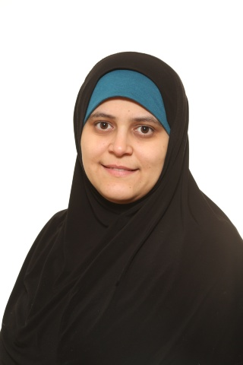

Name | HOUDA SIDANI
Category of governor | Parent Governor
Term of office | 26 Mar 2018 to 25 Mar 2022
Work | Housewife
Governance experience | 2 YEARS.
Hobbies and interests | Enjoy walking and cycling
Links to the school/area | My son is currently studying at John Perryn School.
Why did you become a governor? | I have been at the school for 2 years standing as a parent governor. I wanted to provide the best quality of education for our children and provide the best care where needed. This will also be an opportunity to choose and employ the best qualified teachers for our children’s education as well as monitoring the headteacher’s plans for the school in order to provide the best possible outcome. I chose John Perryn to help make it always AIM HIGHER.

