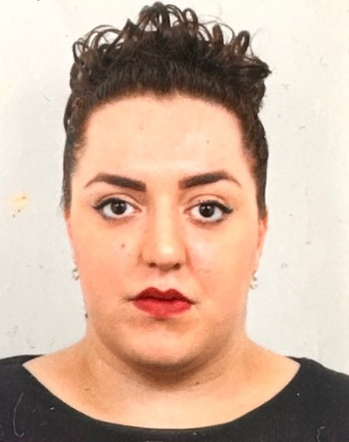
Governor profile

Name | Maryam Milani
Category of governor | Co-Opted Governor
Term of office | 12 November 2022 – 11 November 2026
Work | I have been working within education sector for 10 years. I am currently a teacher of design at Southbank International School.
Governance experience | New Governor
Hobbies and interests | When time allows me, I enjoy reading and traveling. I absolutely love art, design and watching a good movie.
Links to the school/area | No direct links
Why did you become a governor? | Having grown up with a single mother in a council state, I have seen first-hand how crucial education is and the opportunities which one can get by having the right education. I chose a career in education as I knew I could help and inspire students to believe in themselves. Being a governor allows me to give something back to my community as well as being able to make a difference.

