Wednesday 24th February 2021

Dear Parents and Carers,

Re: Return to school on 8th March 2021

I am sure that, by now, you have heard the news that all children will be returning to school for face to face teaching from Monday 8th March 2021. Whilst we are all delighted that we have a date for the children’s return, I am in no doubt that some parents will have reservations or concerns about the reopening of all schools whilst infection rates remain high although it is also good to note that they are going down in Ealing. I am writing to you today to reassure you that we will, of course, continue to do everything within our power to keep the children, staff and our community as safe as possible.

Does my child have to return to school?

- Yes, from 8th March, school attendance will be mandatory for all pupils with the usual rules and duties around school attendance in place from this date.
- Our expectation is the regular attendance of all children at school, unless there is a reason for self-isolation within the household, which is communicated to school via the office.
- We will continue to stagger the start and end of the school day to minimise the number of people on site at any one time. Please do stick to the times as closely as possible to keep everyone safe.
- Reception, Year 2, Year 4 and Year 6 should arrive at 8.45 a.m. and be collected at 3.15 p.m. Year 1, Year 3 and Year 5 should arrive at 9 a.m. and should be collected at 3.30 p.m. Please ensure that your child attends school on time so that they do not miss any vital teaching and learning at the start of the day. Children arriving after these times will be marked late on the registers.
What measures do we have in place to reduce risks?
- Since January, schools have been involved in a national effort to test staff for Covid-19. Rapid testing will continue to remain a vital part of the Government’s plan to supress the virus. This sort of testing means that asymptomatic people, who might otherwise continue to attend schools, are identified and self-isolate.
- Twice-weekly asymptomatic testing is already taking place at John Perryn while staff continue to work with the children attending school throughout lockdown. This will continue until we are told by the government that testing is no longer necessary.
- The system of controls, set out by the government, supports us to assess risk and implement measures to mitigate risk, including ventilating rooms by opening windows and doors, enhanced cleaning schedules and use of bubbles to keep children from mixing. We will continue to do everything we can to adhere to these measures as it is vital that they are implemented well and consistently.
- We will continue to ask parents to wear face coverings when on the school site, even those who have been vaccinated as they could still carry the virus.
- All staff will continue to wear face coverings at the beginning and end of each day as well as when social distancing is not possible and in communal areas.
- All children will continue to be encouraged to follow the ‘Catch it, bin it, kill it’ approach as well as completing regular hand washing and use of sanitiser.
- I will be updating our school risk assessment this week and you will be able to view the most up to date version on the school website.
As head teacher, I am confident that we are doing all that we can to reduce the risk of transmission of the virus within our school community. However, as always, should you have any further ideas or recommendations, please do get in touch as soon as possible via the school office. Also, if you have any concerns or questions about the reopening, do not hesitate to get in touch with the school. If a member of the senior leadership team is not available at the time, please leave a message with the office and we will call you back as soon as we can.
We really cannot wait to welcome the children back to school, we know that this is the best place for them academically and socially, and I am sure you will look forward to a break from home schooling too.
Please do get in touch with any questions.

Yours sincerely,

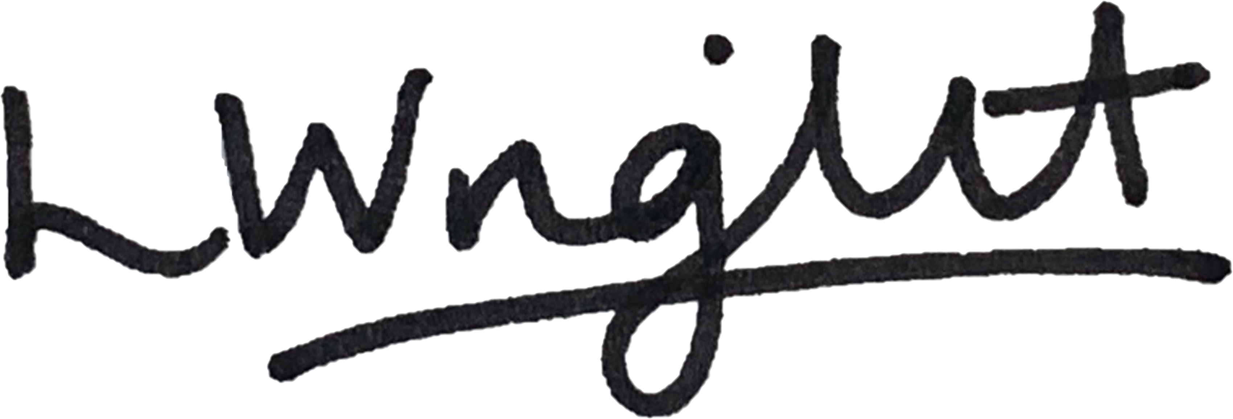

Ms. Leah Wright
Head Teacher

