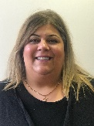
Androulla Charalambous
Better Start Area Manager
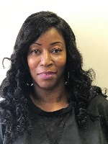
Jackie Baker
Senior Administrator
Noyanna Wade- Williams
Administrator

Ridgley River- Jedd Administrator
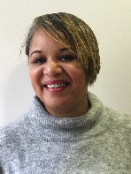
Alison Patten
Deputy Manager for Better Start Services
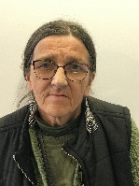
Kathy Powers
Better Start Worker
Sabrina Phipps
Deputy Manager for Early Years Services

Michelle Belgrave
Senior Early years and Family Practitioner
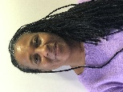
Lynda Ellis
Early years and Family Practitioner
Elaine Parsons
Better Start Worker
Keisha Chambers
Better Start Worker
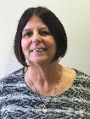
Margaret Grant
Better Start Worker

