FIRE SAFETY
MANAGEMENT POLICY

JUBILEE SCHOOL AND CHILDRENS CENTRE

Reviewed Annually

CONTENTS

Section | Page
Fire Safety Management Policy – Introduction  Fire Safety Statement  Fire Management System  Fire Management Responsibilities:  - Head Teacher  - Head Fire Warden  - Premises Officer  - School Secretary  - Teachers  - Fire Wardens  Hirers and Extended School Providers  Fire Management Organisational Chart  Staff Acknowledgement section  Appendix  - Emergency Evacuation Policy  - Fire Risk Assessment | 3  3  3  4  5  5  6  7  7  8  8  9  10  11  12

FIRE SAFETY MANAGEMENT POLICY

The fire safety order specifically requires a fire risk assessment to be carried out and to be suitably reviewed. This has been completed for the premises and is reviewed annually or when there is a significant change, which ever occurs first.

In addition, it is expected that the school will put in place a management system / policy and procedures to deal with fire safety and prevention.

The fire safety management policy sets out the objectives in respect of fire prevention and emphasises the school’s commitment to fire safety.

The school aims to have proactive liaison with the local fire and rescue service including effective arrangements for notifying the fire and rescue service of changes to the occupancy, periods of abnormal occupancy, fire growth characteristics and other relevant factors. The arrangements allow for routine meetings with the fire and rescue service and additional meetings where a change in the building or its occupancy is proposed.

FIRE SAFETY STATEMENT

The schools primary focus is for the safety of its children, employees and visitors, to that end the fire safety management of the school is based around “life safety”. The school has put procedures in place to protect records but this is not the primary focus.

The school aims to provide an environment which is safe and which promotes fire prevention at all times. To suitably manage the fire risk within the school environment the management has designated responsible people with specific tasks.

The school Governors and Head Teacher are ultimately the recognised responsible people. In practice responsibility for fire safety is delegated to the Head Teacher who manages the school and its fire safety on a day to day basis. The Head Teacher has specific areas of responsibility but has delegated defined duties to support staff. Please see fire management responsibilities and the organisation chart for details.

FIRE MANAGEMENT SYSTEM

There is a clear fire management system in place to ensure that the school suitably manages the fire risk. The system seeks to anticipate and proactively identify the impact of any proposed changes. The management of the school identify any alternative protection and management measures that will be required as a result and ensures that they are implemented.

The staffing level provided is specifically appropriate to the fire safety requirements of a secondary school. It includes sufficient trained personnel to ensure that all occupants are assisted or supported, to make their way out of the building effectively in an emergency.
The training ensures that there are sufficient numbers of staff trained in all aspects of fire prevention, fire protection and evacuation procedures and able to use the appropriate extinguishing equipment (and media), so as to provide full coverage of the building, with provision for contingencies, sickness or holiday absences.

Planning

The most recent fire risk assessment was completed on 27th August 2020 and will be reviewed annually or when there is a significant change, which ever occurs first.

The implementation of corrective actions is ongoing following each risk assessment review with priority given to the highest risks. Where budget restraints delay implementation, risk management strategies will be put in place to reduce the risk.

The planning system is proactive and takes into account a wide range of possible emergencies and incidents. These are likely to include planning for logistical issues such as the provision of shelter, communications, transport, the weather, time of day, time of week, time of year (holidays, etc.) and traffic related issues, as well as scenarios such as power failures or floods.

Organisation

The Head Teacher is responsible for ensuring that all control measures identified in the fire risk assessment are in place and that further improvement actions are completed so far as is reasonably practicable.

The Head Teacher will assign an appropriate member of his team the responsibility to complete each improvement action.

The premises officer complete fire management tasks. This includes maintenance and testing of fire safety systems. Some of these duties are contracted to suitably qualified engineers.

Fire wardens have been designated and are suitably trained in their fire evacuation duties. Fire drills are completed once every half term. All staff receive fire safety awareness training annually.

FIRE MANAGEMENT RESPONSIBILITIES

The school communications system is able to ensure that all of those involved, or potentially involved, in an incident are informed rapidly and effectively, of relevant information. In addition the systems make use of alternative formats as necessary, with contingency plans for when systems fail.

The following are the defined responsibilities for those working within the school who have been assigned specific duties.

HEAD TEACHER

The Head Teacher is empowered to ensure that legislative requirements are met; and that testing, maintenance or repairs are initiated as required. Such powers are supported by the necessary, sufficient and appropriate resources, including funds.

The Head Teacher is responsible for ensuring:

- The school has a fire safety management policy and that such a policy is reviewed annually

- That a Fire Risk Assessment is completed and reviewed annually

- Staff are notified of the significant findings of the fire risk assessment

- Recommended actions derived from the fire risk assessment are completed

- The maintenance / testing of all fire fighting systems and equipment are completed and recorded in the fire log book

- That the school emergency plan and evacuation procedures are regularly reviewed

- The school has a major incident evacuation plan which may include agreements with local providers and additional training for staff

- All pupils, employees, visitors and others who use the building are made aware of the fire safety precautions and the fire evacuation procedures

- The provision of fire awareness training to all staff

- The provision of fire warden training for designated staff

- That an emergency fire drill is undertaken every term

- The preparation of specific personal emergency evacuation plans for staff and/or pupils with special needs and or disability

- The provision of suitable fire safety systems i.e. fire alarm, automatic detection and emergency lighting

- The provision of suitable fire safety equipment such as fire doors, fire signs and fire fighting equipment

- Any fire prevention officer’s recommendations and or enforcement notices are complied with.

HEAD FIRE WARDEN

Head Fire Warden (this may be the Head Teacher) is responsible for:

- Collecting all of the area and classroom information from Teachers and Fire Wardens

- Controlling the assembly point

- Ensuring that fire and rescue service access gates are opened

- During a practice noting escape times and general observations for improvement

- Liaising with the fire and rescue service to ensure that all relevant information is communicated effectively

- Providing the fire and rescue service with a detailed (laminated) plan of the building

- Ensuring that no one re-enters the building until deemed safe to do so by the fire and rescue service

- Implementing the major incident site evacuation plan if required.

PREMISES OFFICER

The Premises officer is responsible for controlling work, maintaining safety systems and maintenance. A system has been developed proactively with clear lines of responsibility; a permit system; logging and audit processes and routine checking and supervision.

The maintenance system is one where there is dynamic monitoring of the fire safety systems, and the equipment is always kept fully functional when the building is in use.

The Premises officer is responsible for:

- The formal maintenance and regular testing of the fire alarm

- The formal maintenance and regular testing of the emergency lighting

- The formal maintenance and organising of testing for the automatic detection system

- The maintenance and inspection of the fire fighting equipment

- The maintenance of exit/escape routes and signage

- The completion and upkeep of the school fire log

- Supervision of contractors undertaking hot work and cold work

- Ensuring that fire compartmentation is sound and that any fire engineering solutions are suitably maintained

- Reporting any hazards (which can not be dealt with) to the Head Teacher

- Ensuring that access can be gained at all times to the electric and gas shut off devices

- Ensuring that fire critical plant such as gas boilers are annually serviced in line with the schools planned preventative maintenance regime

- Ensuring that electrical equipment is suitably maintained and that fixed electrical wiring is inspected at least every five years in line with the schools planned preventative maintenance regime

- Ensuring that fire fighter equipment is maintained and accessible i.e. fire hydrants and dry risers.

School Officer Manager

The School Officer Manager is responsible for:

- Calling the fire and rescue service to ensure that they have been notified of the alarm

- Ensuring that classroom registers are always available and are taken to the assembly point in the event of an evacuation

- Ensuring that visitors and contractors are signed into the building and are notified as to the evacuation procedures

- Where appropriate escorting visitors and contractors from the building

- Collecting information such as contact details of parents

- Taking such information to the assembly point for use in a major incident / site evacuation.

TEACHERS

The Teachers are responsible for:

- Acting as fire wardens when evacuating their class from the school

- Ensuring that their particular classrooms are kept free of hazards which may block escape routes

- Ensuring that all electrical equipment used within the classroom have been suitably maintained

- Reporting any hazards (which can not be dealt with) to the Premises officer

- Ensuring that new pupils are suitably trained in evacuation procedures

- Ensuring that pupils who attend class with a prohibitive injury are assessed and that a personal emergency evacuation plan is put in place

- Following school evacuation procedures including reporting to the head fire warden with the results of the register check

- Controlling their class at the assembly point, ensuring that no pupil re-enters the building until the head fire warden announces that the school is safe

- If required, being aware and trained in the major incident evacuation plan which may require escorting the class away from the premises to a safe site

- Taking part in any fire safety training provided by the school.

FIRE WARDENS

The Fire Wardens / Support Staff (given responsibility) are responsible for:

- Ensuring that their designated areas are clear before leaving the building

- Closing all fire doors (not on automatic closers) before leaving their area

- Taking an active day to day role in fire prevention and hazard spotting

- Reporting fire safety issues such as missing fire extinguishers

- Ensuring that fire escape routes/stairs and fire exits are not blocked

- Reporting any hazards (which can not be dealt with) to the Premises officer

- Reporting to the Head fire warden at the assembly point to notify them of the occupancy status of their area

- Assisting the head fire warden in securing the building and ensuring that no one re-enters the premises until it is deemed safe to do so by the fire and rescue service.

HIRERS and EXTENDED SCHOOL PROVIDERS

All hirers and contracted users of the premises will receive written details of the fire procedure as part of the hire arrangements. Hirers of the building are required to adhere to the fire procedures at all times and take such measures as are necessary to ensure the safety of those children/persons for whom they have responsibility.

FIRE MANAGEMENT ORGANISATIONAL CHART
KEY

School fire safety management

Denotes lines of communication only

SCHOOL
Judicium Education
Health and Safety Consultants

School Governors

Head Teacher

Head Fire Warden
SBM

Premises officer

Teachers
Fire Wardens

School Office Manager

Pupils
Contractors and Visitors

FIRE SAFETY MANAGEMENT POLICY

Member of Staff Acknowledgement

All members of staff with fire safety responsibilities (all staff) should be issued a copy of the policy and be required to sign the staff acknowledgement slip.

I have read the school Fire safety management policy and agree to follow the procedures outlined in the policy.

Employees Position:

Employees Name:

Employees Signature:

Date of Signature:

APPENDIX

SCHOOL

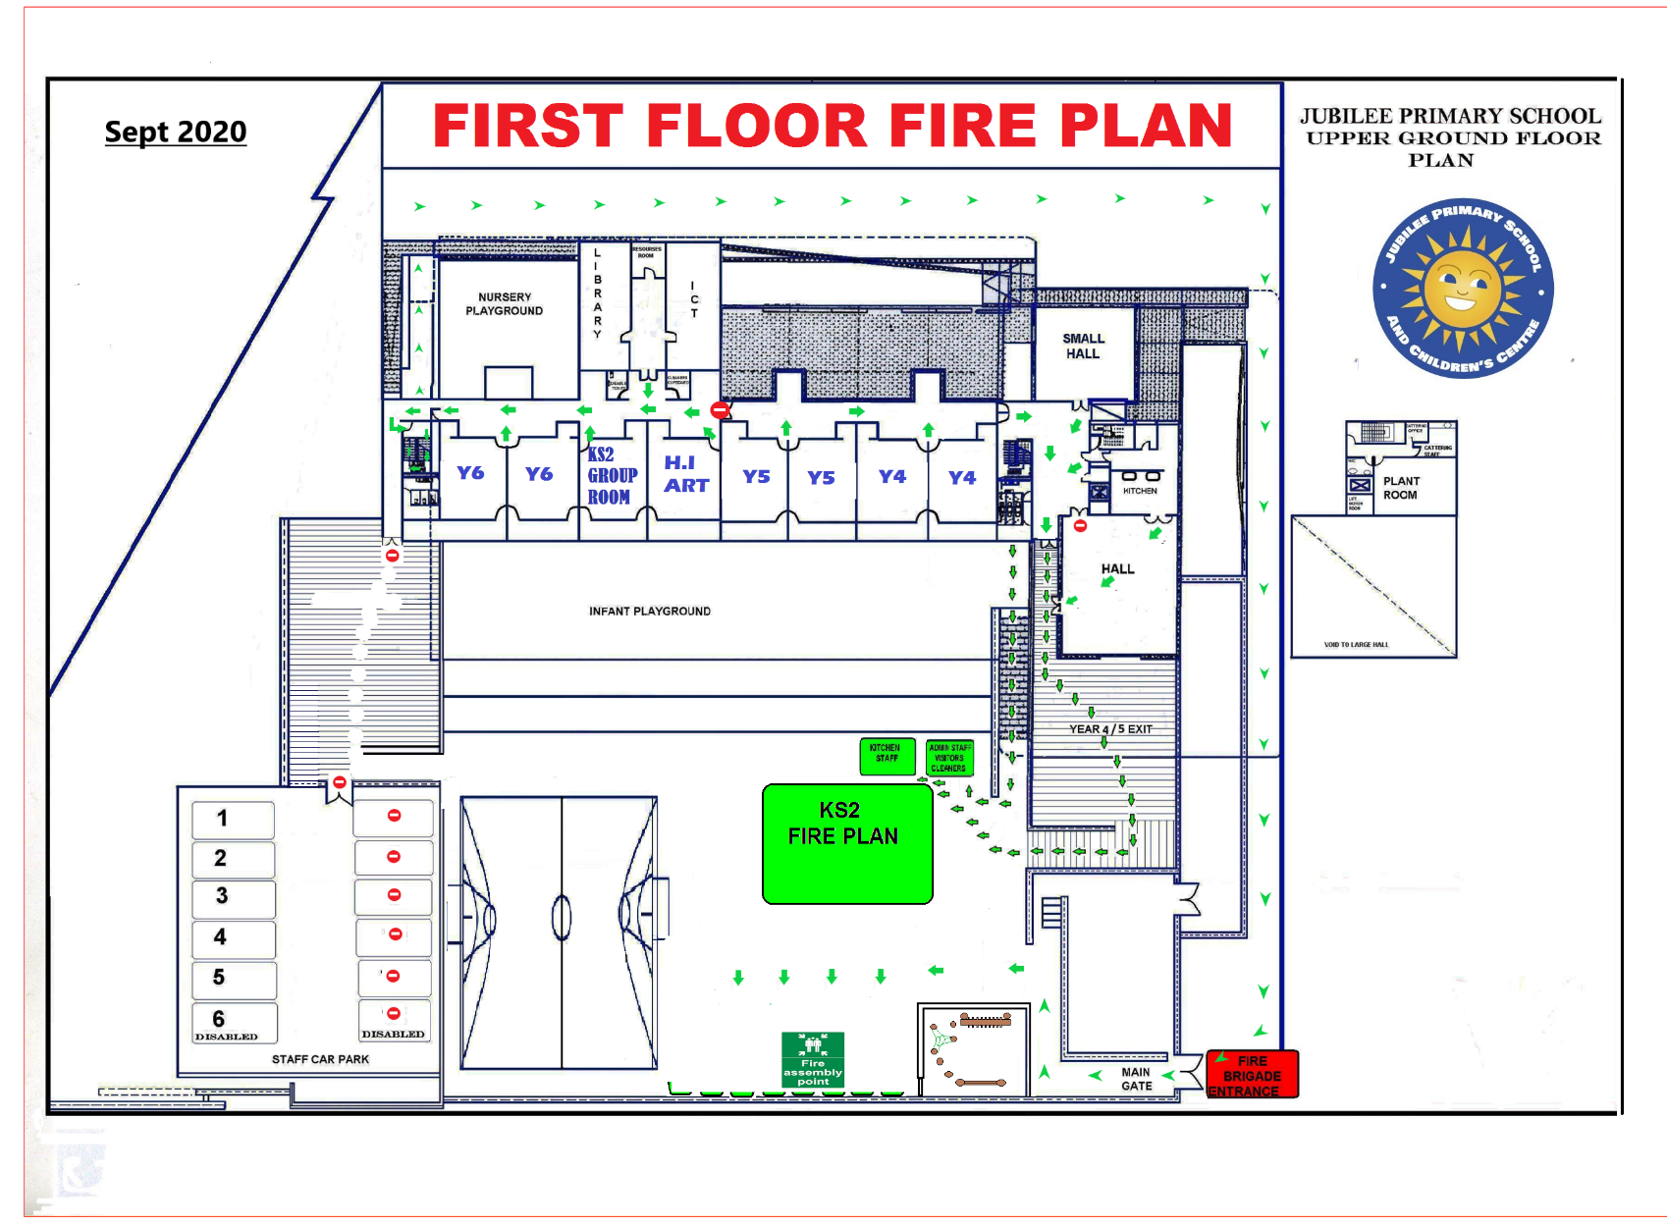

FIRE RISK ASSESSMENT

Jubilee Primary School
Tulse Hill, London, SW2 2JE

27th August 2020

CONTENTS

FIRE RISK ASSESSMENT OVERVIEW:

Introduction | Methodology of assessment  Detail of assessment  Client and building information | 3  4  5
Summary | Executive Summary  Evidence Table  Overall Fire Risk Rating | 7  10  12
Action plan | Risk Assessment Action Plan | 13
FIRE RISK ASSESSMENT REPORT:

Section 1 | Fire Systems and Management | 21
Section 2 | Identify Fire Hazards | 34
Section 3 | Identify the location of people at significant risk in case of fire | 2
Section 4 | Evaluate the risks | 64
Section 5 | Record of the findings and actions taken | 75
Section 6 | Keep assessments under review | 78
Appendices | Photographic Evidence | 79

Jubilee Primary School

Fire Risk Assessment

In accordance with

The Regulatory Reform (Fire Safety) Order 2005

Methodology

The fire risk assessment is prepared in accordance with the Regulatory Reform (Fire Safety) Order 2005 (RRO) and applies the risk profiling and management level assessments of British Standard BS9999. This fire risk assessment also considerers the guidance and recommendations set out within BB100: Design for fire safety in schools and government publications including, Fire risk assessment: educational premises, which provides guidance on how to comply with fire safety law, fire risk assessment and identify the general fire precautions that must be in place.

BB100 Provides fire safety design guidance for schools in England and Wales. All new building work is subject to approval under the Building Regulations, which are standards for design, construction and alterations, BB100 is a design guide which shows clearly how the requirements for life safety, contained in the Building Regulations, can be met in the design of a new school or an extension. The principles followed within BB100 are based on identifying and assessing the risks presented in the different areas of a school and, where necessary, taking action to reduce them. The guidance is aimed at designers, fire engineers, building control and fire safety officers. However, head teachers, governors, teaching staff and facilities and maintenance staff will find it of interest and support their responsibilities as Responsible Persons.

If the school is reported to have been built to the British Standard BS9999, the fire risk assessor will apply the standard to ensure the school is achieving and maintaining the level of standards set out.

The assessment will cover all required sections recommended under the guidance relating to the RRO. The consultant will principally use set criteria and will assess the risks seen within the building against recognised control measures. If unique control measures have been implemented by the client, these will be considered and addressed within the assessment.

HM Government publication ‘Fire Risk Assessment – Educational Premises’ and British Standard ‘Code of Practice for Fire Safety in the Design, Management and Use of Buildings BS 9999:2017’ both require the reader to categorise the risk within their premises prior to applying the requirements of the guidance documents.

The principles of BS9999 are used to assess the overall risk profile of the building. Such an assessment aims to assign a management level required to suitably and sufficiently manage the identified risks apparent within the building.

Once identified the consultant will assess whether the current management levels and procedures require updating or enhancement. Recommendations will be given as to how this can be achieved.

Detail of Assessment

The purpose of the fire risk assessment is to protect as far as possible the “life safety” of the buildings occupants. This is the principal aim of the fire risk assessment. The occupiers or owners of the building may be required by their insurance company to address property protection and business continuity. This will be considered but will not form a detailed section within the report. As a result of protecting life it is likely that property protection will be addressed to a reasonably significant degree.

The contents of the fire risk assessment and attached action plan are based on the areas and/or the activities shown to the consultant during the visit. Judicium Consulting Ltd cannot be held liable for any areas or activities not shown to the consultant at the time of the fire risk assessment.

The assessment of building structure i.e. fire compartments, has been completed on a sample basis and should not be considered as a detailed structural assessment. If this is needed the services of a suitable building surveyor should be commissioned. After conducting a sample approach to the integrity of the existing compartmentation the consultant will recommend action in relation to their findings. This does not mean that all compartmentation is sound. The occupier should consider the results carefully and may well wish to conduct a structural survey even if the consultant finds no evidence of damage to compartmentation.

Guidance

All of the actions listed on the Action Plan are considered necessary to meet the statutory duty imposed on the responsible person(s), it must be recognised that everything cannot be completed at once. It should be borne in mind that, although they appear less important than other higher priority items that might take longer to complete, easily achievable improvements should not be unnecessarily delayed and dealt with in strict rotation.

It is recommended that the recommendations should be implemented in order to reduce the risk to, or maintain the risk at tolerable level.

Client and Building Information

Address: | Tulse Hill, London, SW2 2JE
Type of Workplace: | Primary School for pupils aged 3 to 11 years.
Occupancy: | Building  Ground Floor  First Floor  Second Floor  Main Hall  Small Hall | Employees  30  30  6  -  - | Students  230  160  0  -  - | Maximum no. persons present  250  200  6  450  90
Special Populations:  - Disabled Occupants:  - Sleeping occupants:  - Occupants in remote areas: | Building / Floor  All  0  0 | Employees  0  0  0 | Students  15  0  0 | Maximum no. persons present  15  0  0
Jubilee Primary School has a specialist hearing Impairment unit in addition to an inclusive pupil group with varied levels of SEN provisions and support services. It has been confirmed that combined group plans are in place where specific assistance is required above the overarching evacuation plans.

Building Fire History:  The Risk Assessment  Carried out by:  Client officer consulted:  Previous Assessment Date:  Date of Assessment: | None reported.  Sarah Crouch, CMIOSH  Senior Health and Safety Consultant  Brad Ekman, School Business Manager  Juan Suarez, Premises Officer  22nd January 2018 – Elliswhittam Ltd  27th August 2020

Risk Profile:  Occupancy Characteristic: A  Fire Growth Rate: 2 | Profile Assigned: A2
 | Management Level Required: 1

Executive Summary

This is an “executive summary” of the full report contained in the following sections. The objective of the Fire Risk Assessment was to evaluate the existing fire safety arrangements for the premises and to make recommendations for improvement.

Jubilee Primary School is an inclusive local authority school with a hearing impairment provision that operates from a three-story building that has a number of extensions and alterations over the preceding 10 years. The school also has a connected Children’s Centre. The Children’s Center is subject to a separate fire risk assessment for the new building in place.

The School Management Team have some existing fire management arrangements in place regarding preventative maintenance and emergency evacuation plans. The primary school has undergone significant operational change that includes changes to the management responsibilities and physical alterations to the buildings.

The following high priority actions were identified and are detailed within the attached action plan:
- Ensure the existing evacuation plans are reviewed to clarify the proposed temporary alternative evacuation route from the first floor classrooms

- Ensure a fire drill is carried out to provide training on the new temporary evacuation routes

- The school should review of the existing assembly point in the lower playground area is reviewed to provide greater distance from the school building

- Ensure Personal Emergency Evacuation Plans (PEEP) are completed for any staff or pupil who requires assistance evacuating.

- Ensure arrangements are implemented to assist those who cannot self-evacuate from the first floor of the building when the lift cannot be used or the lower playground assembly point which as one exit route via stairs.

- Clarification should be sought regarding the fire strategy and design of the building to confirm where constructed Refuge Points

- Ensure beacons/Visual Alarm Devices (VADs) are in working order and additional devices are installed in classrooms, escape routes, toilets and other areas of isolation where occupants with hearing impairments will be located.

- Ensure that the evacuation procedure is revised to include specific details for the Hearing Impairment group.

- Ensure all staff are provided with fire safety training. A fire safety module is available on the Judicium e-learning system provided.

- Ensure that nominated fire wardens are provided with suitable training to formalise their additional responsibilities. A fire warden module is available on the Judicium e-learning system provided

- Ensure the stored waste and combustible materials are cleared from under the wooden stairs leading from the first floor kitchen area

- Ensure the fridge and microwave located in the escape route leading from the first floor kitchen area up to the plant room are removed

- Inspect all doors and carry out remedial works to ensure they are compliant fire doors

- Ensure that the double fire doors previously removed from the Year 2 corridor are reinstated to create suitable compartmentation breaks within the escape route corridor.

- Ensure suitable separation is in place between the server cabinet and the escape route from management offices.

- Ensure the kitchen gas supply and interlock system are subject to annual service by a competent Gas Safe Engineer with certification retained on file for audit purposes.

- Ensure the kitchen extraction ventilation system and fan equipment is subject to a TR19 standard deep clean and mechanical service with certification retained on file for audit purposes.

- It is recommended that a wet chemical fire extinguisher is suitably located within the kitchen for oil/fat-based fires.

- Ensure the central gas supply and associated equipment is serviced by a gas safe engineer and certification is retained on file for audit purposes.

- Ensure the main hall occupancy is managed to a maximum of 360 occupants at any one time due to the fire escape capacity available.

- Ensure the small hall occupancy is managed to a maximum of 60 occupants at any one time due to the single fire exit point from the room.

- Ensure suitable external lighting is in place on the escape routes leading from the main hall area out to the MUGA upper assembly point.

- Ensure the existing fire alarm system is subject to service and maintenance by a competent engineer and certification for services are retained on file for audit purposes.

- Ensure the damaged call point in the Reception Class area is repaired and returned to use.

- The school should consider additional automatic smoke and fire detection across the school building to ensure all staff and pupils have early warning to allow quick escape.
An L2 Category system is recommended to provide suitable detection in accordance with BS5839 Pt 1 and as recommended by BB100. All escape routes, circulation areas, rooms leading directly onto escape routes and high-risk areas (plant rooms, kitchen areas, staff room, server cabinet areas, etc) are covered by automatic fire detection.

Responsible Person

The responsible person for fire safety within the school is Tom Prestwich. Head Teacher. In order to achieve the required fire safety management standards, the responsible person is assisted by the School Business Manager, Premises Officer and appointed Judicium Consultant.

The responsible person(s) have a duty under the Regulatory Reform (Fire Safety) Order 2005 (RRO) to carry out a fire risk assessment of the premises and review it regularly, inform staff and representative about the risks identified, put in place and maintain appropriate fire safety measures, plan for an emergency and provide staff with information, fire safety instruction and training.

This fire risk assessment was carried out on the 27th August 2020 and is a reflection of the fire management provisions and fire safety measures in place at the time of assessment. The responsible person(s) must ensure that fire safety management standards are maintained at all times, and where necessary, further control measures are implemented as appropriate. The responsible person(s) should refer to the fire risk assessment action plan section of this report.

Limitations of assessment

The ceiling voids, loft space and cavity areas were not accessed during the assessment. No destructive, intrusive testing, inspection of passive fire protection was carried out.

This fire risk assessment was completed outside normal term time working hours when teaching staff and pupils were not present. Therefore, the management of the building, its fire safety provisions and any regard for the maintenance of a safe working environment could not be fully assessed. Such matters as wedged open fire doors, overloaded multiple adaptors or similar should be reviewed on a regular basis when the building is occupied and general recommendations concerning such areas in the action plan should be applied.

Evidence Table

This ‘Evidence Table’ details the servicing / inspection requirements of all plant and equipment installed within the school. Further information on servicing and inspection requirements can be found within the following sections of the report and action plan. The fire risk assessment action plan should be referred to where the school / academy is non-compliant, as identified within the table below.

Record details  (Required records) | Evidence  (Records in place, Yes/No, NA) | Date  (Date of implementation, last review or completion or N/A – if date not required) | Service Company  (N/A if not applicable) | Compliant  (Yes/No, NA)
Fire safety manual | No | N/A | N/A | No
Fire safety log book | Yes | 2020 | In-house | Yes
Fire Safety Policy | Yes | 2020 | In-house | No
Evidence of hot work permits | No | N/A | N/A | No
Fire / emergency evacuation plan | Yes | 2020 | In-house | No
Evidence of evacuation drills | Yes | 26/03/2020 | N/A | No
Personal emergency evacuation plans (PEEPs) | No | N/A | N/A | No
Fire safety training | No | N/A | N/A | No
Fire warden training | No | N/A | N/A | No
Fire extinguisher training | No | N/A | N/A | No
Portable electrical appliances testing (PAT) | Yes | October 2019 | UK Safety Ltd | Yes
5 yearly fixed electrical installation | Yes | December 2019 | O2 Light Ltd | Yes
A satisfactory condition reported | Yes | December 2019 | O2 Light | Yes
Evidence of any remedial work completed | No | N/A | N/A | No
Fire door inspections | No | N/A | N/A | No
Kitchen extraction system – Deep clean | No | N/A | N/A | No
Kitchen equipment maintenance | No | N/A | N/A | No
Gas Boilers – Gas Safe certificate | No | N/A | N/A | No
Main Kitchen gas service – certificate | Yes | February 2019 | KCS Bromley Ltd | No
Gas shut off devices – certificate | Yes | February 2019 | KCS Ltd | No
Pressure system, written scheme | No | N/A | N/A | No
Lightning conductor annual inspection | No | N/A | N/A | No
Premises inspections (Housekeeping, escape routes) | No | N/A | N/A | No
Emergency light service | Yes | New Install – 2020 | TBC | No
Evidence of monthly testing | Yes | 2020 | Log book | Yes
Fire alarm service and inspection | Yes | 2018 | Chubb Ltd | No
Evidence of weekly tests | Yes | 2020 | Log book | Yes
Fire extinguisher service | Yes | August 2020 | TVF Ltd | Yes
Evidence of in-house inspections | Yes | Ongoing | Log Book | Yes
Business Continuity plan | No | N/A | N/A | No

THE OVERALL FIRE RISK IS:

The overall fire risk is medium for these premises. All risks identified need to be reduced to an acceptable level as soon as practically possible. Required further actions have been identified in the assessment and copied into the action plan below. The school should address the actions with the highest priority first in order to suitably manage the fire risk.

The following table shows a brief description of each risk level in order to communicate the importance that the consultant has put on each required action:

ACTION  PRIORITY LEVEL | DESCRIPTION
Very High | Occupation/use of the premises, or part of it, should not be continued until the risk level has been reduced. The identified hazard MUST be rectified before use of that area resumes.
High | It is recommended that occupation/use of the area at risk should be suspended, or exceptional monitoring and prevention measures implemented, until the risk has been reduced. Considerable resources may have to be allocated to reduce the risk. Where the risk involves existing occupation or use, the problem should be remedied within three months.
Medium | Efforts should be made to reduce the risk, but the costs of prevention may determine what is practical. Risk reduction measures should normally be implemented within three to six months, depending on the number of people exposed to the hazard.
Low | No further preventative action is necessary, but consideration should be given to cost-effective solutions, or improvements that impose minimal or no additional cost burden. Monitoring is required to ensure that the controls are maintained.

The action plan identifies target dates for completion of all required actions. These dates are a guide relating to the above risk descriptions. Ideally all actions will be completed as soon as possible. The final two columns on the action plan are for client use and should be used to assign responsibility and mark when actions have been completed.

FIRE RISK ASSESSMENT
ACTION PLAN

The plan collates all of the recommendations derived from the fire risk assessment. The School can use this plan to ensure all recommended actions are noted, dated when completed and highlighted if they are not acted upon. The action plan includes the date, which the consultant has concluded should be attributed to a recommendation relating to the action priority level. The fire risk assessment should be reviewed annually or sooner if there is a significant change.

No. | Action Priority | Recommendation | Target  Date For Completion | For Client Use |  | Comments
 |  |  |  | Person Responsible | Date Completed
 | HIGH | Ensure the existing evacuation plans are reviewed to clarify the proposed temporary alternative evacuation route from the first floor classrooms, library and ICT space whilst first floor decking works are completed and updated building plans are displayed in relevant areas. | November 2020 | SBM created plans  PM to put up notices on floor | 03/09/2020  16/09/2020 | New fire evacuation plans have been put up around the building and new exit routes have been explained to all staff on inset day 03/09/2020  The new fire evacuation plan is on page 11 of this document.  School will update fire evacuation plan once roofing/ decking works complete in October 2020
 | HIGH | Ensure a fire drill is carried out to provide training on the new temporary evacuation routes for all occupants, with particular focus on the first-floor occupants and how they will integrate at assembly points with the other groups. | November 2020 | Headteacher | TBC by Oct half term | Taking into account the updated fire evacuation The school will upscale its Fire Drills to take place every 6 weeks until the decking works are complete
 | HIGH | The school should review of the existing assembly point in the lower playground area is reviewed to provide greater distance from the school building and additional, accessible exit routes to a place of ultimate safety. The Judicium consultant can assist with revised plans and reviewing proposed changes. | November 2020 | Local Authority |  | The school has been made aware by Judicium that the assembly point for the lower playground is not fit for purpose due to the proximity of the building to the assembly point in the lower playground. Furthermore whilst there are steps leading up to KS2 playground assembly point. Site evacuation may not be possible in the event that the stairs to the KS2 playground are impeded due to fire and proximity to building, as this is the only evacuation route from the lower playground to evacuate the site in an emergency  Recommendation is a new ramp is built between the 2 playgrounds to help support lower playground evacuate to the KS 2 playground safely without any restrictions and or risk of route being impeded
 | HIGH | Ensure Personal Emergency Evacuation Plans (PEEP) are completed for any staff or pupil who requires assistance evacuating. This should include those with permanent mobility or behavioural needs affecting evacuation and temporary situations such as a broken leg with crutches. (A template PEEP has been provided to assist) | November 2020 | Head  SLT  SBM  Premises Team  Staff | - September 2020  - 23/10/2020  - 23/10/2020  - 30/10/2020 | - The School has now created a folder with PEEP’s.  - We are in the process of completing PEEP’s for pupils who are identified as needing one.  - We are also compiling a list of any staff that may also need a PEEP.  - The premises team have been assigned training on the e-training portal to complete by the end of October half term
 | HIGH | Ensure arrangements are implemented to assist those who cannot self-evacuate from the first floor of the building when the lift cannot be used or the lower playground assembly point which as one exit route via stairs. Evacuation equipment such as evacuation chairs that are suitable for the stairs of each location are recommended. | November 2020 | SBM & Premises Team | 23/10/2020 | Prices have been sort from suppliers for evacuation chairs. Est. £1,561  Additional costs for staff training of evac chairs will need to form part of overall costs  1 x Train the Trainer Session for up to 6 delegates £895 + VAT
 | HIGH | Clarification should be sought regarding the fire strategy and design of the building to confirm where constructed Refuge Points are that provide additional fire protection to occupants who must wait for assistance. The existing evacuation procedure refers to ‘Safe Area’ but does not define what or where these locations are. | November 2020 | Local Authority | Due date 26.06.2018 | The school’s previous FRA 2018 confirms the need to Consider increasing compartmentation to reduce compartment size. Any alteration should be completed to comply with Building regulations ADB.  The school does not meet BS476  This item was listed on building survey 26.06.2017 under item 2.4 and was highlighted to Lambeth as priority 1
 | HIGH | Ensure beacons/Visual Alarm Devices (VADs) are in working order and additional devices are installed in classrooms, escape routes, toilets and other areas of isolation where occupants with hearing impairments will be located.  Due to the specialist nature of the inclusive teaching at the school and the hearing impairment groups supported on site, visual devices to alert that the fire alarm has been activated are essential. | November 2020 | Local Authority |  | The number of VAD’s is not adequate for the reason that we have no VAD in blind spots around the building such examples would be toilets and could potentially put lives at risk if they are not to see the VAD active due to there not being one in the location of occupancy
 | HIGH | Ensure that the evacuation procedure is revised to include specific details for the Hearing Impairment group. Whilst an individual PEEP may not be required for every pupil within the group, a collective plan should be recorded to detail how the staff ensure all pupils evacuate safely and are supported. | November 2020 | Teaching staff, Fire Marshals, SLT, Premises Team | Group PEEP’s completed by October half term. | Peep training is currently in progress but as highlighted in point 7. Adequate VAD are needed to help staff help those with hearing impairments evacuate safely
 | HIGH | Ensure all staff are provided with fire safety training. A fire safety module is available on the Judicium e-learning system provided. | November 2020 | Premises Team  Fire Marshalls | October half term | Staff are being setup on training portal and will be sent link to complete fire training online by October half term
 | HIGH | Ensure that nominated fire wardens are provided with suitable training to formalise their additional responsibilities. A fire warden module is available on the Judicium e-learning system provided. | November 2020 | Fire Marshalls | 24/09/2020 | Premises officer has completed the Judicium online training and CPD certificate is in folder
 | HIGH | Ensure the stored waste and combustible materials are cleared from under the wooden stairs leading from the first floor kitchen area up to the plant room. This area should continue to be monitored to ensure no storage is permitted under the stairs on the escape route at any time.  See photo 1 | November 2020 | Completed By Premises Team | Sept 2020 | Items were moved by the premises team and regular sites walks are in place to note such hazards. Kitchen staff have been informed not leave anything under or near the wooden stairs
 | HIGH | Ensure the fridge and microwave located in the escape route leading from the first floor kitchen area up to the plant room are removed and electrical equipment is not permitted in the escape stairwell at any time.  See photo 2 | November 2020 | Completed By Premises Team | Sept 2020 | Items were moved by the premises team and regular sites walks are in place to note such hazards. Kitchen staff have been informed not leave anything under or near the wooden stairs
 | HIGH | Inspect all doors and carry out remedial works to ensure they are compliant fire doors which:  - close effectively with a mechanical closer  - provide a suitable fire break  - have intumescent strips/smoke seals installed  - Are undamaged.  - Gaps should not exceed 3-4mm. Issues were noted around the hall entrance doors.  A fire door survey by a competent contractor may assist with this process where significant wear or door certification information is not available. | November 2020 | Local authority competent contractor |  | - The 2017 building survey listed and costed these works under section 2.4  - these works under  - The FRA 2018 has noted: The gap between fire doors and frames should be no larger than 3mm. Arrange for repair of the following door(s) I.e. reception, RHS, Y6LL, Speech and Therapy, 5 JP, SLT do not fiction properly. Emergency lighting need to be verified on monthly bases.  Consider increasing compartmentation to reduce compartment size. Any alteration should be completed to comply with Building regulations ADB.  Breaches of compartmentation were noted in cleaning cupboard, server and printer areas. These breaches should be fire stopped with a suitable material complying with BS476 to achieve a minimum of 30 minutes fire resistance.  Repair fire partitions to achieve a minimum of 30 mins fire resistance to BS476 and ensure that they extend to the underside of the floor above to compartment effectively.
 | HIGH | Ensure that the double fire doors previously removed from the Year 2 corridor are reinstated to create suitable compartmentation breaks within the escape route corridor. | November 2020 | Local Authority  competent contractor  independent fully accredited NSI BAFE SP203 pt 1 Third Party Certificated Company. |  | Doors were removed as part of the school & children centre expansion project and were never reinstated by the contractor. New survey for doors is required due to new children centre  Standards (BS 5839pt 1:2013  BS 7273 pt 4:2015  the Actuation of release mechanisms for doors. BS 7273 pt 4:2007 may be applicable depending on the date of installation
 | HIGH | Ensure suitable separation is in place between the server cabinet and the escape route from management offices.  It is recommended that the service cabinet is relocated away from the escape corridor. Where this is not possible, enclosure within a suitably fire rated and ventilated cupboard can be considered.  The existing arrangement provides not fire rated divisions between the server and the corridor allowing for the spread of smoke and fire along the escape route. | November 2020 | Headteacher, SBM  PM | TBC | The school has had the work surveyed and is awaiting quotations. The work is timely and costly due the fibre and data cabling to be relocated to new location. Costs also include crating partition for new location between Headteacher office and the SBM office with air con for new server room
 | HIGH | Ensure the kitchen gas supply and interlock system are subject to annual service by a competent Gas Safe Engineer with certification retained on file for audit purposes. | November 2020 | Premises Team  Competent contractor |  | The school has had its service by the gas safe engineer and are awaiting certification
 | HIGH | Ensure the kitchen extraction ventilation system and fan equipment is subject to a TR19 standard deep clean and mechanical service with certification retained on file for audit purposes. | November 2020 | Premises  Indepth hygiene services | 24th July 2020
 | HIGH | It is recommended that a wet chemical fire extinguisher is suitably located within the kitchen for oil/fat-based fires. | November 2020 | Juan and TVF to complete | October half term | The school has had its annual service of fire extinguishers and we have contacted the company for a quotation based on recommendation from this FRA
 | HIGH | Ensure the central gas supply and associated equipment is serviced by a gas safe engineer and certification is retained on file for audit purposes. | November 2020 | Local authority Atlas Boiler and premises  Chubb Fire Security | September 2020 | The school cannot complete this without the following works to be completed to the main panel in the pump house, due to the fire alarm not being wired into the gas safety shut off valve
 | HIGH | Ensure the main hall occupancy is managed to a maximum of 360 occupants at any one time due to the fire escape capacity available. | November 2020 | SLT / Premises team to ensure signs and information for staff | October Half term | Signs are being produced and will be displayed in the halls
 | HIGH | Ensure the small hall occupancy is managed to a maximum of 60 occupants at any one time due to the single fire exit point from the room. | November 2020 | SLT / Premises team to ensure signs and information for staff | October Half term | Signs are being produced and will be displayed in the halls
 | HIGH | Ensure suitable external lighting is in place on the escape routes leading from the main hall area out to the MUGA upper assembly point. | November 2020 | Local Authority |  | Condition survey 2017  Items 3.6 & 3.8  FRA 2018  Works have not been completed and still requires action from Lambeth
 | HIGH | Ensure the existing fire alarm system is subject to service and maintenance by a competent engineer and certification for services are retained on file for audit purposes. | November 2020 | Fire Folder Chub Fire services | September 2020 | We can confirm the works have taken place and the service record is filed in the fire folder
 | HIGH | Ensure the damaged call point in the Reception Class area is repaired and returned to use. | November 2020 | Premises | September 2020 | The repairs were delayed due to the leaks from the roof above where the decking works are taking place.  This item has now been completed
 | HIGH | The school should consider additional automatic smoke and fire detection across the school building to ensure all staff and pupils have early warning to allow quick escape.  An L2 Category system is recommended to provide suitable detection in accordance with BS5839 Pt 1 and as recommended by BB100. All escape routes, circulation areas, rooms leading directly onto escape routes and high-risk areas (plant rooms, kitchen areas, staff room, server cabinet areas, etc) are covered by automatic fire detection.  Automatic fire detection should be provided to the void areas under the building if they are of 800 mm or more in height. Where the voids are less than 800 mm in height, but the fire or smoke can spread between rooms and compartments before detection, automatic fire detection should be provided.  Ensure documentation is obtained for all works carried out on the fire alarm systems and held within the fire safety manual. | November 2020 | Local Authority |  | Please see documents attached  ..\H&S Compliance Folder 2020-21\Copy of 811336 Jubilee Condition Summary.xlsx
 | MEDIUM | The school should obtain copies of fire strategy and building commissioning documentation to clarify the intended use of the site areas and construction details, including compartmentalisation or fire stopping. | March 2021 | Headteacher, SBM/ Local authority, H&S committee | September | The school does not have a copy of the last fire strategy, The school is requesting from the LA the final survey from 2017 and the original quotations for the survey of works to be reviewed by the H&S committee
 | MEDIUM | The School should ensure the following information is held within the fire safety manual:  - Fire safety policy  - Monitoring and audit plans  - Fire Logbook  - Maintenance logs and procedures  - Evacuation Plan  - Personal Emergency Evacuation Plans (PEEP)  - Building compartmentation and hazardous storage plans  - Fire Strategy Documentation  - Fire systems testing information  - Results of fire drills  - Staff training records  - System failure and fault records  - Contingency plans  - The fire risk assessment | March 2021 | Headteacher, SBM, H&S committee | September 2020 and ongoing | The school has all the documents in the fire safety manual and are in the process of aligning it to the recommended filing system by Judicium
 | MEDIUM | It is recommended that the existing fire policy is revised to expand on staff fire management roles and responsibilities to ensure all staff roles are clearly defined. A template policy document has been provided to assist with the inclusion of an organisational chart. | March 2021 | H&S Committee  Headteacher | Autumn Term 2020 | This document includes the draft of the policy to be ratified by governors at the next meeting
 | MEDIUM | Ensure a policy and process is in place to appoint competent contractors and suitably manage contractor work carried out on site. Particular focus should be given to higher risk work including hot works or work at height that require permit to work arrangements.  A template policy has been provided for consideration. | March 2021 | Premises, SBM | September 2020 | The school has now adopted the template from Judicium and we have records of Hot Works permits and RAMS
 | MEDIUM | Ensure a suitable number of staff, in addition to the Premises Officer, are trained on how to operate the fire alarm panel and associated systems. | March 2021 | Office Staff/ Premises Team  Children Centre  EYFS | Autumn Term 2020 | Training is to be provided to persons listed. Until such time we have shown them how to push a break glass panel
 | MEDIUM | Ensure the identified C3 (Improvement Required) category electrical remedial works detailed in the Electrical Installation Condition Report are completed and certification of the completed works are retained on file for audit purposes. | March 2021 | Premises Team | Spring 2021
 | MEDIUM | It is recommended that a review is carried out of cable management within the school to remove extension leads that are used for long term power solution and wall sockets are provided where required.  See photo 3 for reference. | March 2021 | Classroom checklist by Staff and checked by premises team | Completed every half term | We have adopted the Judicium template and are planning to carry this out once every 6 weeks. Action from those checklists will be completed before the next classroom check
 | MEDIUM | Ensure wall displays in corridors are contained within fire rated noticeboards and fire doors are kept free of any materials or signs. Examples were noted across the first floor corridor and associated classroom doors.  See photo 4. | March 2021 | Premises Team | October Half term | Fire rated boards have been procured and have recently been delivered. These are planned to be put up over October Half term
 | MEDIUM | Ensure a process is in place for visually check all fire doors within the building periodically for damage or wear. Such visual inspections should be recorded in the fire logbook. | March 2021 | Premises Team  Local Authority |  | FRA 2020  Competent contractor is required to advise on the state of doors since the 2017 survey
 | MEDIUM | It is recommended that a compartmentation survey is commissioned by a competent contractor to identify breaches in fire stopping that will promote the spread of smoke and fire. Using the results of the survey, the school should ensure identified gaps around pipes and services that pass-through wall and ceiling areas are fire stopped with suitable fire rated materials | March 2021 | Local Authority |  | Condition survey 2017
 | MEDIUM | It is recommended that construction and building design information is obtained to clarify if a lighting protection system is in place.  If a system is not currently installed, it is recommended that a competent contractor is appointed to complete a survey to ascertain if such a system is required for the extended building. | March 2021 | Local Authority competent Contractor |  | This item was listed as a priority 1 on the building conditions survey 2017 under section 3.8, no work was carried out by the LA
 | MEDIUM | To ensure safe evacuation, the double fire exit doors leading from the main hall space to the external decking pathway requires repair to ensure:  - A working push bar is present  - The exit doors are of good condition and safe  - The hinges are repaired to function correctly | March 2021 | Local Authority competent Contractor |  | This item was listed as a priority 1 on the building conditions survey 2017 under section 1.4, no work was carried out by the LA
 | MEDIUM | It is recommended that recorded periodic site inspections are completed for the school building to include checks of all escape routes. A template premises inspection sheet is available from the client website at www.judiciumeducation.com | March 2021 | SBM/ Premises Team | September 2020 | Competed when updated the evacuation plan for September 2020
 | MEDIUM | It is recommended that changes in floor level, including step edges and ramp edges are highlighted in a contrasting colour. | March 2021 | Premises Team | September 2020
 | MEDIUM | Ensure that each final exit point and manual call point has suitable fire action notices displayed. | March 2021 | Premises Team | September 2020
 | MEDIUM | Ensure that the year 2 classroom fire exits have suitable fire exit directional signage. | March 2021 | Premises Team | September 2020
 | MEDIUM | Ensure the missing extinguisher in year 2 class is replaced on the empty mounting hook. | March 2021 | Premises Team | September 2020 | This is a legacy item and the fire extinguisher holder is to be removed as no classroom at this location has fire extinguishers
 |  | It is recommended that procedures are put in place to ensure firefighting equipment is checked frequently, weekly where possible, and recorded to monitor for damage or missing units. | March 2021 | Premises Team Weekly checks | SBM/ Head Termly H&S walk | This will form part of H&S walks carried out termly
 | MEDIUM | The school should ensure that a business continuity plan for the school is in place to detail the emergency procedures, management responsibilities and protocols put in place to response to events such as flooding, fire, prolonged loss of power or pandemic responses. | March 2021 | SBM Headteacher | Autumn Term | Currently in development due to COVID 19 risk assessment
 | LOW | It is recommended that the school reviews the PAT testing schedule in place to avoid bulk annual testing to:  - Put all electrical equipment in an asset register  - Assign a suitable PAT testing frequency schedule for each piece of equipment (See HSE guidance document HSG107)  - Assign a date for visual inspections at a greater frequency than the Physical PAT test  Ensure that staff are prevented from bringing in electrical equipment from home. | August 2021
 | LOW | It is recommended that a copy of the fire risk assessment is made available to all staff. | August 2021

FIRE RISK ASSESSMENT REPORT

Section 1 - Fire Systems and Management

QUESTION | RECOGNISED CONTROL MEASURES  (Are they in place or applicable) |  | IN PLACE?  (“X” or “√”or N/A)
1. Is there an existing fire safety manual in place?  NO | - A fire safety manual is a requirement of building regulation 38 and should detail the way fire systems are managed and the way the building is designed to resist fire. A fire safety manual is in place? |  | X
ADDITIONAL CONTROL MEASURES IN PLACE / CONSULTANT OBSERVATIONS | RISK LEVEL  (Very High, High, Medium or Low)  (See risk assessment guide for details) | ACTION REQUIRED  (Copied into attached action plan)
It has been confirmed that some fire management related documentation is retained by the Premises Manager but some essential information requires collating to ensure it is accessible.  This includes the fire strategy and fire management documentation relating to the construction and extension works carried out across the site over recent years.  This information is required to clarify how the extended building and specific areas area designed to be managed and where specialist management arrangements are required. | MEDIUM | The school should obtain copies of fire strategy and building commissioning documentation to clarify the intended use of the site areas and construction details, including compartmentalisation or fire stopping.  The School should ensure the following information is held within the fire safety manual:  - Fire safety policy  - Monitoring and audit plans  - Fire Logbook  - Maintenance logs and procedures  - Evacuation Plan  - Personal Emergency Evacuation Plans (PEEP)  - Building compartmentation and hazardous storage plans  - Fire Strategy Documentation  - Fire systems testing information  - Results of fire drills  - Staff training records  - System failure and fault records  - Contingency plans  - The fire risk assessment

QUESTION | RECOGNISED CONTROL MEASURES  (Are they in place or applicable) |  | IN PLACE?  (“X” or “√”or N/A)
- Is a fire management structure in place?  YES | - A fire management chart identifying the fire management structure is in place?  - A structure is in place and understood which clearly identifies the responsible person?  - Is the required management level in place in accordance with BS9999 and the assessment of the consultant? |  | X  √  X
ADDITIONAL CONTROL MEASURES IN PLACE / CONSULTANT OBSERVATIONS | RISK LEVEL  (Very High, High, Medium or Low)  (See risk assessment guide for details) | ACTION REQUIRED  (Copied into attached action plan)
A fire management structure is in place as part of the existing fire management policy but it does not currently contain suitable information to clarify the fire management responsibilities of all staff involved at the school. | MEDIUM | It is recommended that the existing fire policy is revised to expand on staff fire management roles and responsibilities to ensure all staff roles are clearly defined. A template policy document has been provided to assist with the inclusion of an organisational chart.

QUESTION | RECOGNISED CONTROL MEASURES  (Are they in place or applicable) |  | IN PLACE?  (“X” or “√”or N/A)
- Is a building plan in place detailing compartmentation?  NO | - There is a plan of the building in place identifying all compartment walls, ceilings and floors (normally marked in red)?  - The plan details building construction materials? |  | X  X
ADDITIONAL CONTROL MEASURES IN PLACE / CONSULTANT OBSERVATIONS | RISK LEVEL  (Very High, High, Medium or Low)  (See risk assessment guide for details) | ACTION REQUIRED  (Copied into attached action plan)
Building plans detailing construction materials, methods or intended use are not currently available for varying areas of the school. | MEDIUM | See recommendation for question 1

QUESTION | RECOGNISED CONTROL MEASURES  (Are they in place or applicable) |  | IN PLACE?  (“X” or “√”or N/A)
- Does the building design incorporate any specific fire engineering solutions?  NO | - The fire safety manager has detailed plans and information with regards to any specific fire engineering solutions?  - Contractor’s work is on a permit to work system only in order to specifically control work on any fire engineering solutions?  - A competent / qualified fire engineer is consulted when the use of the building is changed?  - Details of fire engineering solutions are understood and passed on to any effected tenants / facilities managers? |  | X  X  X  X
ADDITIONAL CONTROL MEASURES IN PLACE / CONSULTANT OBSERVATIONS | RISK LEVEL  (Very High, High, Medium or Low)  (See risk assessment guide for details) | ACTION REQUIRED  (Copied into attached action plan)
Specific fire engineering solutions were not identified during the assessment, but it should be noted that areas above ceiling level or below floor level were not accessed. Due to construction information and fire strategy documentation not being available it could not be confirmed if the building contains engineering solutions. | MEDIUM | See recommendation for question 1

QUESTION | RECOGNISED CONTROL MEASURES  (Are they in place or applicable) |  | IN PLACE?  (“X” or “√”or N/A)
5. Is the work of contractors suitably controlled?  NO | - A “Hot works” permit to work system is in place?  - The work of contractors is supervised and inspected to ensure that the integrity of fire compartment walls, doors and ceilings are not compromised?  - Contractors are informed / issued with a copy of the evacuation plan?  - Contractors are escorted from the building during evacuation? |  | X  X  √  √
ADDITIONAL CONTROL MEASURES IN PLACE / CONSULTANT OBSERVATIONS | RISK LEVEL  (Very High, High, Medium or Low)  (See risk assessment guide for details) | ACTION REQUIRED  (Copied into attached action plan)
It could not be confirmed that a managing contractor’s policy is in place to ensure competent contractors are appointed and higher risk works, including hot works introducing sparks or flames, have additional control measure such as a permit to work system. | MEDIUM | Ensure a policy and process is in place to appoint competent contractors and suitably manage contractor work carried out on site. Particular focus should be given to higher risk work including hot works or work at height that require permit to work arrangements.  A template policy has been provided for consideration.

QUESTION | RECOGNISED CONTROL MEASURES  (Are they in place or applicable) |  | IN PLACE?  (“X” or “√”or N/A)
- Is there a fire / emergency evacuation action plan?  YES | - The school has an emergency plan that is displayed within staff areas and on evacuation routes?  - The school has compiled a building plan showing nearest and alternative exits from all areas?  - There is a clear procedure for contacting the Fire Service (or other emergency service) with nominated personnel?  - Building plans are suitably displayed?  - Employees are suitably trained in the evacuation plan during school induction?  - Evacuation practices are completed at least once a year?  - There is a clearly signed evacuation assembly point? |  | √  √  √  X  X  √  √
ADDITIONAL CONTROL MEASURES IN PLACE / CONSULTANT OBSERVATIONS | RISK LEVEL  (Very High, High, Medium or Low)  (See risk assessment guide for details) | ACTION REQUIRED  (Copied into attached action plan)
It has been confirmed that the existing fire evacuation plan requires review due to two main areas.  The first relates to a temporary closure of an escape route due to decking installation work on an external area leading from the first floor to the rear car park. It has been identified that the proposed works cannot take place whilst providing continued access to building occupants and so alternative routes are required.  It is currently proposed that occupants from the first floor of the building split for Year 5 and 4 classroom occupants to use the escape route stairs adjacent to the small hall and year 6, ICT, library and KS1 group room occupants exit through the escape stairs adjacent to the closed ‘Year 6 final first floor exit point’.  A revised plan and training for the staff and pupils concerned will need to be implemented to ensure all occupants are clear on the revised plans.  The second area requiring review relates to the capacity and proximity to the school building of the infant playground as a suitable assembly point.  The current arrangements do not take occupants to a place of ultimate safety as the lower playground area is close to the school building and has a single, staired exit route that is within 2 meters of the school building.  With the additional need for potentially half of the first floor occupants to evacuate to the lower playground in the new term, this increases the number of groups filling the space and being required to use the single stairs leading to the upper MUGA area as a place of ultimate safety should a building fire compromise the lower playground space.  It is recommended that the existing assembly points are reviewed to assess the practicalities of alternative assembly point locations, potentially expanding the upper playground areas, to ensure greater distance between the school building and assembly points.  Please see question 7 for specific recommendations relating to accessible escape route and assisting occupants who cannot self-evacuate. | HIGH | Ensure the existing evacuation plans are reviewed to clarify the proposed temporary alternative evacuation route from the first floor classrooms, library and ICT space whilst first floor decking works are completed and updated building plans are displayed in relevant areas.  Ensure a fire drill is carried out to provide training on the new temporary evacuation routes for all occupants, with particular focus on the first-floor occupants and how they will integrate at assembly points with the other groups.  The school should review of the existing assembly point in the lower playground area is reviewed to provide greater distance from the school building and additional, accessible exit routes to a place of ultimate safety. The Judicium consultant can assist with revised plans and reviewing proposed changes.

QUESTION | RECOGNISED CONTROL MEASURES  (Are they in place or applicable) |  | IN PLACE?  (“X” or “√”or N/A)
- Have plans been made and rehearsed regarding assisting disabled staff and visitors to evacuate the premises?  YES | - The school has Personal Emergency Evacuation Plans (PEEPs) in place for all disabled students / employees?  - Procedures are in place to accommodate and evacuate disabled visitors?  - Procedures are in place to accommodate and evacuate temporarily injured students / employees?  - Suitable systems are in place to communicate a fire alarm to disabled employees and visitors i.e. Visual alarms?  - The premises are compliant with the Equalities Act and as such have been designed to safely evacuate and accommodate disabled people? |  | X  √  X  X  X
ADDITIONAL CONTROL MEASURES IN PLACE / CONSULTANT OBSERVATIONS | RISK LEVEL  (Very High, High, Medium or Low)  (See risk assessment guide for details) | ACTION REQUIRED  (Copied into attached action plan)
The school has an existing evacuation procedure that includes a section for occupants with mobility problems but relies on the direct assistance from the fire brigade for direct rescue. The school should have procedures in place to allow quick and direct evacuation of all occupants across the building, the Fire Brigade should be requested to assist with standard evacuation.  The existing plan does not cover sufficient detail for temporary needs or hearing impairments or other assistance needs including behavioural issues.  It is recommended that the evacuation plan is reviewed to include the following aspects:  - Personal Emergency Evacuation Plans (PEEP) are completed for any staff or pupil who requires assistance evacuating, this should include those with permanent needs such as mobility or behavioural issues affecting evacuation and temporary situations such as a broken leg with crutches. (A template PEEP has been provided to assist)  - Arrangements are implemented to assist those who cannot self-evacuate from the first floor of the building when the lift cannot be used or the lower playground assembly point which as one exit route via stairs. Evacuation equipment such as evacuation chairs that are suitable for the stairs of each location are recommended.  - Clarification is sought regarding the fire strategy and design of the building to confirm where constructed Refuge Points are that provide additional fire protection to occupants who have to wait for assistance, these locations were not clear during the assessment.  - Beacons/Visual Alarm Devices (VADs) were noted in some areas of the building but not all. Due to the specialist nature of the inclusive teaching at the school and the hearing impairment groups supported on site, visual devices to alert that the fire alarm has been activated are essential. It is recommended that visual devices/beacons are installed in classrooms, escape routes, toilets and other areas of isolation where occupants with hearing impairments will be located.  - Hearing Impairment groups are not currently mentioned within the evacuation plan. Whilst an individual PEEP may not be required for every pupil within the group, a collective plan should be recorded to detail how the staff ensure all pupils evacuate safely and are supported. | HIGH | Ensure Personal Emergency Evacuation Plans (PEEP) are completed for any staff or pupil who requires assistance evacuating. This should include those with permanent mobility or behavioural needs affecting evacuation and temporary situations such as a broken leg with crutches. (A template PEEP has been provided to assist)  Ensure arrangements are implemented to assist those who cannot self-evacuate from the first floor of the building when the lift cannot be used or the lower playground assembly point which as one exit route via stairs. Evacuation equipment such as evacuation chairs that are suitable for the stairs of each location are recommended.  Clarification should be sought regarding the fire strategy and design of the building to confirm where constructed Refuge Points are that provide additional fire protection to occupants who must wait for assistance. The existing evacuation procedure refers to ‘Safe Area’ but does not define what or where these locations are.  Ensure beacons/Visual Alarm Devices (VADs) are in working order and additional devices are installed in classrooms, escape routes, toilets and other areas of isolation where occupants with hearing impairments will be located.  Due to the specialist nature of the inclusive teaching at the school and the hearing impairment groups supported on site, visual devices to alert that the fire alarm has been activated are essential.  Ensure that the evacuation procedure is revised to include specific details for the Hearing Impairment group. Whilst an individual PEEP may not be required for every pupil within the group, a collective plan should be recorded to detail how the staff ensure all pupils evacuate safely and are supported.  See recommendations for question 1 and 6

QUESTION | RECOGNISED CONTROL MEASURES  (Are they in place or applicable) |  | IN PLACE?  (“X” or “√”or N/A)
- Have employees been trained in how to call the Fire Brigade, the use of fire extinguishers and basic fire prevention?  NO | - Employees have received fire prevention and fire extinguisher training?  - Employees have been trained in procedures to follow if they discover a fire?  - Employee fire training completed during school induction and refreshed once a year? |  | X  √  X
ADDITIONAL CONTROL MEASURES IN PLACE / CONSULTANT OBSERVATIONS | RISK LEVEL  (Very High, High, Medium or Low)  (See risk assessment guide for details) | ACTION REQUIRED  (Copied into attached action plan)
It could not be confirmed at the time of assessment that staff have been provided with fire safety training which is required.  In addition, due to the proposed revisions to the evacuation plan, further fire drills are essential to ensure new plans are fully understood by staff and pupils. | HIGH | Ensure all staff are provided with fire safety training. A fire safety module is available on the Judicium e-learning system provided.  See recommendations for question 6

QUESTION | RECOGNISED CONTROL MEASURES  (Are they in place or applicable) |  | IN PLACE?  (“X” or “√”or N/A)
- Are there a suitable number of trained fire wardens?  NO | - Fire wardens and deputies are in place ensuring that each area is suitably covered during an evacuation?  - A head fire warden is in place to liaise with the fire officer?  - Suitable employees are trained in the function and reading of the fire panel and associated systems? |  | √  √  X
ADDITIONAL CONTROL MEASURES IN PLACE / CONSULTANT OBSERVATIONS | RISK LEVEL  (Very High, High, Medium or Low)  (See risk assessment guide for details) | ACTION REQUIRED  (Copied into attached action plan)
It could not be confirmed during the assessment if nominated Fire Wardens (Marshalls) have been provided with suitable training to formalise their additional responsibilities.  The school should ensure that all fire wardens are provided with training for their role and a clear structure of responsibilities in an emergency situation is in place. | HIGH  MEDIUM | Ensure that nominated fire wardens are provided with suitable training to formalise their additional responsibilities. A fire warden module is available on the Judicium e-learning system provided.  Ensure a suitable number of staff, in addition to the Premises Officer, are trained on how to operate the fire alarm panel and associated systems.  See recommendations for question 2.

QUESTION | RECOGNISED CONTROL MEASURES  (Are they in place or applicable) |  | IN PLACE?  (“X” or “√”or N/A)
10. Is the head fire warden or health and safety / facilities manager suitably trained in fire management (do they have the information required to facilitate the fire officer)?  NO | - The head fire warden has the relevant building information such as:  - Fire fighter access / entry points?  - Location of fire fighter lifts and disabled refuge points?  - The position of chemical stores?  - What chemicals are stored?  - The position of electrical / gas service rooms?  - The position of plants rooms?  - The location of fire hydrants (external)?  - The location of dry & wet risers?  - An overall plan of the building (ideally laminated)?  - An overall site plan displaying fire alarm “Zones” is displayed adjacent to the fire alarm panel? |  | √  X  X  X  √  √  X  N/A  X  √
ADDITIONAL CONTROL MEASURES IN PLACE / CONSULTANT OBSERVATIONS | RISK LEVEL  (Very High, High, Medium or Low)  (See risk assessment guide for details) | ACTION REQUIRED  (Copied into attached action plan)
The Head Teacher and Premises Officer take lead roles during evacuation situations. It was confirmed that information required to assist the fire service in regard to stored chemicals, building plans and refuge points locations are not currently available. | MEDIUM | See recommendation for question 1

QUESTION | RECOGNISED CONTROL MEASURES  (Are they in place or applicable) |  | IN PLACE?  (“X” or “√”or N/A)
11. Is access to essential emergency service’s fire fighting equipment maintained?  N/A | - Access to fire hydrants is maintained and regularly inspected?  - Access to dry risers is maintained and regularly inspected?  - Access to wet risers is maintained and regularly inspected?  - Access to fire fighter lifts is maintained and regularly inspected? |  | N/A  N/A  N/A  N/A
ADDITIONAL CONTROL MEASURES IN PLACE / CONSULTANT OBSERVATIONS | RISK LEVEL  (Very High, High, Medium or Low)  (See risk assessment guide for details) | ACTION REQUIRED  (Copied into attached action plan)
Emergency Service equipment was not observed on site. | LOW | N/A

QUESTION | RECOGNISED CONTROL MEASURES  (Are they in place or applicable) |  | IN PLACE?  (“X” or “√”or N/A)
12. Are fire fighter services maintained?  N/A | - Fire hydrants are suitably maintained and serviced?  - Dry risers are visually inspected on a 6-monthy basis?  - Dry risers are serviced on an annual basis?  - Wet risers are visually inspected on a 6-monthy basis?  - Wet risers are serviced on an annual basis?  - Fire fighter lifts are suitably maintained and serviced? |  | N/A  N/A  N/A  N/A  N/A  N/A
ADDITIONAL CONTROL MEASURES IN PLACE / CONSULTANT OBSERVATIONS | RISK LEVEL  (Very High, High, Medium or Low)  (See risk assessment guide for details) | ACTION REQUIRED  (Copied into attached action plan)
N/A | LOW | N/A

Section 2 - Identify Fire Hazards

QUESTION | RECOGNISED CONTROL MEASURES  (Are they in place or applicable) |  | IN PLACE?  (“X” or “√”or N/A)
13. Is there a system for controlling the amounts of combustible materials, flammable liquids and gases that are kept in the workplace?  NO | - The school has a suitable procurement process in place restricting large amounts of combustible materials, flammable liquids and gases being stored in the workplace?  - Arrangements for the disposal of waste are adequate preventing build up?  - The fire load in the building is suitably controlled so as to minimise fire growth rate? |  | √  √  X
ADDITIONAL CONTROL MEASURES IN PLACE / CONSULTANT OBSERVATIONS | RISK LEVEL  (Very High, High, Medium or Low)  (See risk assessment guide for details) | ACTION REQUIRED  (Copied into attached action plan)
The school does not have a formal process in place for managing the amount of combustible materials or associate equipment stored in the workplace.  The Premises Officer ensures that waste is cleared from all areas of the school on a daily basis and secure storage is in place for routine collections by the waste contractor. | LOW | N/A

QUESTION | RECOGNISED CONTROL MEASURES  (Are they in place or applicable) |  | IN PLACE?  (“X” or “√”or N/A)
14. Is the system operating effectively?  NO | - The systems of procurement and waste collection are suitable for the school?  - No issues have been reported or observed? |  | √  X
ADDITIONAL CONTROL MEASURES IN PLACE / CONSULTANT OBSERVATIONS | RISK LEVEL  (Very High, High, Medium or Low)  (See risk assessment guide for details) | ACTION REQUIRED  (Copied into attached action plan)
Combustible items and stored equipment were noted under the wooden stairs leading from the first-floor kitchen area up to the 2nd floor plant room.  Combustible materials were stored directly under the stairwell increasing the fire loading in the escape route and a fridge unit and microwave are currently in use creating a high risk of fire. | HIGH | Ensure the stored waste and combustible materials are cleared from under the wooden stairs leading from the first floor kitchen area up to the plant room. This area should continue to be monitored to ensure no storage is permitted under the stairs on the escape route at any time.  See photo 1  Ensure the fridge and microwave located in the escape route leading from the first floor kitchen area up to the plant room are removed and electrical equipment is not permitted in the escape stairwell at any time.  See photo 2

QUESTION | RECOGNISED CONTROL MEASURES  (Are they in place or applicable) |  | IN PLACE?  (“X” or “√”or N/A)
15. Are all combustible materials, flammable liquids and gases stored safely and in a safe location?  YES | - Flammable liquid stores or cabinets are in place?  - Flammable liquid stores are kept locked?  - All flammable liquids are stored appropriately?  - Flammable liquid stores are suitably signed?  - Gas cylinders are chained / secured in place to prevent falling?  - Where appropriate Gas cylinders are stored in locked cages in external areas?  - Reactive Gas cylinders kept separated?  - Reactive chemicals are store separately?  - Internal storage rooms are suitably compartmentalised from the rest of the building?  - Gas shut off controls are in place and operational?  - Plant rooms (electrical switch rooms, boiler rooms) are free of combustible materials and flammable liquids?  - Server rooms are free of combustible materials and flammable liquids? |  | √  √  √  √  N/A  N/A  N/A  N/A  √  √  √  √
ADDITIONAL CONTROL MEASURES IN PLACE / CONSULTANT OBSERVATIONS | RISK LEVEL  (Very High, High, Medium or Low)  (See risk assessment guide for details) | ACTION REQUIRED  (Copied into attached action plan)
Storage of flammable materials/substances is suitably managed by the Premises Officer. A separate premises and cleaning store is in place which is secured for restricted access. | LOW | N/A

QUESTION | RECOGNISED CONTROL MEASURES  (Are they in place or applicable) |  | IN PLACE?  (“X” or “√”or N/A)
16. Are there any processes that produce radiated, convective or conductive heat; Sparks; Gases/fumes/vapours?  YES | - Hot work permits are in place?  - Work activities are well organised to reduce any risk from hot works?  - Employees involved in hot works are suitably trained in safe working procedures?  - Flammable liquids and gases are stored away from possible sources of ignition?  - Sources of combustion / fuel are stored away from sources of heat/ignition?  - Contractors can only complete hot works with a signed hot works permit in place including a suitable risk assessment / method statement? |  | X  X  N/A  √  √  X
ADDITIONAL CONTROL MEASURES IN PLACE / CONSULTANT OBSERVATIONS | RISK LEVEL  (Very High, High, Medium or Low)  (See risk assessment guide for details) | ACTION REQUIRED  (Copied into attached action plan)
Contractors may be required to carry out flat roof works or hot works relating to gas installations in the future. It was confirmed that a permit to work system to control contractor work that introduces new fire risks to the school is not currently in place. | MEDIUM | See recommendation for question 5

QUESTION | RECOGNISED CONTROL MEASURES  (Are they in place or applicable) |  | IN PLACE?  (“X” or “√”or N/A)
17. Are there Gas and Electrical shut off device / controls in place?  YES | - Gas shut off devices are in place in gas critical areas?  - A central gas shut off device is in place?  - Electrical shut off devices are in place in critical areas?  - A central electrical shut off device is in place?  - Suitable / affected staff are trained in shut off controls / procedures? |  | √  √  √  √  √
ADDITIONAL CONTROL MEASURES IN PLACE / CONSULTANT OBSERVATIONS | RISK LEVEL  (Very High, High, Medium or Low)  (See risk assessment guide for details) | ACTION REQUIRED  (Copied into attached action plan)
It was confirmed that shut off devices are in place, which includes a gas interlocked system within the kitchen area.  Kitchen staff and the premises officer are trained in the use of shut off devices. | LOW | N/A

QUESTION | RECOGNISED CONTROL MEASURES  (Are they in place or applicable) |  | IN PLACE?  (“X” or “√”or N/A)
18. Is all portable electrical equipment in a satisfactory condition inspected regularly and fitted with the correct rated fuses?  YES | - Portable electrical equipment is PAT tested in line with HSE recommendations?  - An electrical equipment asset register is in place detailing PAT testing schedules?  - Employees are trained to complete visual checks of electrical equipment before use?  - Formal visual inspections are completed by a competent person at recommended intervals?  - Employees are trained not to use portable electrical equipment that has not been suitably maintained?  - Employees are trained not to use and to report any damage to electrical equipment?  - There is appropriate means of protection for portable electrical equipment; e.g. fusing, RCD’s – is there evidence of testing? |  | X  √  √  X  √  √  √
ADDITIONAL CONTROL MEASURES IN PLACE / CONSULTANT OBSERVATIONS | RISK LEVEL  (Very High, High, Medium or Low)  (See risk assessment guide for details) | ACTION REQUIRED  (Copied into attached action plan)
It has been confirmed that the PAT testing was completed for the school in October 2019. Currently arrangements are in place for all appliances to be tested on an annual basis and visual checks are not formerly carried out between testing anniversaries.  The current Health and Safety Executive guidance for PAT testing recommends a programmed approach is used to give different types of appliances appropriate testing periods in relation to their use, their location and the type of equipment being used.  Blanket annual testing is recommended to be avoided where possible to allow for static equipment that carries a low risk of damage or wear to be tested over longer periods than high use equipment that is prone to damage that should be tested annually. | LOW | It is recommended that the school reviews the PAT testing schedule in place to avoid bulk annual testing to:  - Put all electrical equipment in an asset register  - Assign a suitable PAT testing frequency schedule for each piece of equipment (See HSE guidance document HSG107)  - Assign a date for visual inspections at a greater frequency than the Physical PAT test  - Ensure that staff are prevented from bringing in electrical equipment from home.

QUESTION | RECOGNISED CONTROL MEASURES  (Are they in place or applicable) |  | IN PLACE?  (“X” or “√”or N/A)
19. Are portable/radiant heaters used?  NO | - Portable or radiant heaters are not used?  - Portable or radiant heaters are used and safe procedures are in  Place ensuring that they are switched off when the room is not occupied?  - Portable or radiant heaters are not positioned in confined spaces or under desks?  - Portable or radiant heaters are kept away from combustible materials and flammable substances?  - Portable or radiant heaters are suitably maintained? |  | √  N/A  N/A  N/A  N/A
ADDITIONAL CONTROL MEASURES IN PLACE / CONSULTANT OBSERVATIONS | RISK LEVEL  (Very High, High, Medium or Low)  (See risk assessment guide for details) | ACTION REQUIRED  (Copied into attached action plan)
N/A | LOW | N/A

QUESTION | RECOGNISED CONTROL MEASURES  (Are they in place or applicable) |  | IN PLACE?  (“X” or “√”or N/A)
20. Is the wiring of the electrical installation inspected periodically by a competent person?  YES | - The fixed wiring installation is inspected at intervals specified in BS 7671:2018 (18th Edition Wiring Regulations) e.g. Leisure complexes every three years, swimming pools annually offices and schools at least every five years etc.?  - A fixed wiring installation certificate is in place?  - All testing, installations, repairs and alterations are completed by a suitably qualified competent electrical contractor registered with the ECA or NICEIC? |  | √  √  √
ADDITIONAL CONTROL MEASURES IN PLACE / CONSULTANT OBSERVATIONS | RISK LEVEL  (Very High, High, Medium or Low)  (See risk assessment guide for details) | ACTION REQUIRED  (Copied into attached action plan)
It has been confirmed that a five year fixed wiring inspection report was completed in February 2020 and four C3 (Improvement Required) remedial works were identified. It could not be confirmed at the time of assessment if the works have been completed and certification should be obtained from the appointed contractor upon completion to be retained on file for audit purposes. | MEDIUM | Ensure the identified C3 (Improvement Required) category electrical remedial works detailed in the Electrical Installation Condition Report are completed and certification of the completed works are retained on file for audit purposes.

QUESTION | RECOGNISED CONTROL MEASURES  (Are they in place or applicable) |  | IN PLACE?  (“X” or “√”or N/A)
- Are light bulbs or fittings near to combustible materials?  NO | - Clear space is maintained between storage items and light fittings / bulbs?  - Lights in storerooms are turned off when rooms are not in use?  - The condition of light fittings and bulbs is monitored? |  | √  √  √
ADDITIONAL CONTROL MEASURES IN PLACE / CONSULTANT OBSERVATIONS | RISK LEVEL  (Very High, High, Medium or Low)  (See risk assessment guide for details) | ACTION REQUIRED  (Copied into attached action plan)
N/A | LOW | N/A

QUESTION | RECOGNISED CONTROL MEASURES  (Are they in place or applicable) |  | IN PLACE?  (“X” or “√”or N/A)
22. Is the use of extension leads and multi point adapters appropriate and kept to a minimum?  NO | - Where possible extension leads are replaced with additional fixed sockets?  - Extension leads are not used in unsuitable environments such as kitchens?  - Sockets are not overloaded?  - Multi-plug / block adaptors are not used?  - Extension leads are not plugged in to other extension leads “daisy chained”?  - Extension leads are included within the PAT testing regime and area separately listed on the electrical equipment asset register? |  | X  √  √  √  √  √
ADDITIONAL CONTROL MEASURES IN PLACE / CONSULTANT OBSERVATIONS | RISK LEVEL  (Very High, High, Medium or Low)  (See risk assessment guide for details) | ACTION REQUIRED  (Copied into attached action plan)
The majority of cable managed was assessed to be suitable and appropriate wall sockets are available in most areas of the school. Some examples of extension leads being used as long term power solutions in classrooms and it is recommended that a review of such extension cables are reviewed to ensure suitable sockets are available. | MEDIUM | It is recommended that a review is carried out of cable management within the school to remove extension leads that are used for long term power solution and wall sockets are provided where required.  See photo 3 for reference.

QUESTION | RECOGNISED CONTROL MEASURES  (Are they in place or applicable) |  | IN PLACE?  (“X” or “√”or N/A)
23. Are flexes run in safe places where they will not be damaged?  YES | - Cables are suitably contained in cable tidying solutions?  - Cables and extension leads under workstations are raised from the ground to prevent damage from employee’s chairs and feet?  - Where it can be avoided cables do not run across walkways or access routes?  - If unavoidable cables that cross walkways or access routes are protected from damage by suitable cable covers?  - Cables running in high risk areas or serving high voltage equipment are protected by suitable armoured cabling?  - Employees are trained to report the identification of damaged cabling to the appropriate person?  - Employees are trained not to use equipment that is served by damaged cabling?  - Cables do not run over or against hot pipes or radiators? |  | √  X  √  √  √  √  √  √
ADDITIONAL CONTROL MEASURES IN PLACE / CONSULTANT OBSERVATIONS | RISK LEVEL  (Very High, High, Medium or Low)  (See risk assessment guide for details) | ACTION REQUIRED  (Copied into attached action plan)
Some extension leads are in use that could be damaged and required review in classroom spaces. | MEDIUM | See recommendation for question 22

QUESTION | RECOGNISED CONTROL MEASURES  (Are they in place or applicable) |  | IN PLACE?  (“X” or “√”or N/A)
24. Is the upholstery of furniture in good condition and are display materials suitable?  YES | - Upholstered furniture, curtains, drapes and other soft furnishings are fire retardant, or have been treated with a proprietary fire-retardant treatment designed to enhance their performance?  - Damage or old furniture is replaced / removed?  - Display materials (including artificial and dried foliage), scenery and stands are fire retardant or have been suitably treated? |  | √  √  X
ADDITIONAL CONTROL MEASURES IN PLACE / CONSULTANT OBSERVATIONS | RISK LEVEL  (Very High, High, Medium or Low)  (See risk assessment guide for details) | ACTION REQUIRED  (Copied into attached action plan)
It was assessed that the majority of display materials across the school were suitably managed. It has to be taken into account that the assessment was completed before the start of term and additional displays are likely to be hung that require future management.  A small number of displays were noted to increase outside of a noticeboard area or across fire doors that should be free from display that require management. E.g. The first-floor corridor adjacent to the ICT area. | MEDIUM | Ensure wall displays in corridors are contained within fire rated noticeboards and fire doors are kept free of any materials or signs. Examples were noted across the first floor corridor and associated classroom doors.  See photo 4.

QUESTION | RECOGNISED CONTROL MEASURES  (Are they in place or applicable) |  | IN PLACE?  (“X” or “√”or N/A)
25. Is the premises free from rubbish and combustible waste materials?  YES | - Combustible waste is removed from the workplace on a daily basis?  - Combustible waste is suitably collected and stored away from escape routes and exit doors?  - Waste is collected from site on a regular basis in order that it does not build up to unsuitable levels? |  | √  √  √
ADDITIONAL CONTROL MEASURES IN PLACE / CONSULTANT OBSERVATIONS | RISK LEVEL  (Very High, High, Medium or Low)  (See risk assessment guide for details) | ACTION REQUIRED  (Copied into attached action plan)
The Premises Officer confirmed that waste is cleared from all rooms on a daily basis and secure storage is in place in the rear car park area for regular contractor collections. | LOW | N/A

QUESTION | RECOGNISED CONTROL MEASURES  (Are they in place or applicable) |  | IN PLACE?  (“X” or “√”or N/A)
26. Is there a designated smoking area provided with adequate ashtrays?  NO | - The premises are a smoke free environment?  - Smoking is allowed on site in external areas designed for that purpose?  - Ashtrays are provided in smoking areas (external)?  - Ashtrays and smoking areas are positioned away from the building and away from external escape routes?  - Ashtrays are emptied on a regular basis?  - No smoking signs are displayed? |  | √  X  X  X  X  X
ADDITIONAL CONTROL MEASURES IN PLACE / CONSULTANT OBSERVATIONS | RISK LEVEL  (Very High, High, Medium or Low)  (See risk assessment guide for details) | ACTION REQUIRED  (Copied into attached action plan)
The school is a no smoking site. | LOW | N/A

QUESTION | RECOGNISED CONTROL MEASURES  (Are they in place or applicable) |  | IN PLACE?  (“X” or “√”or N/A)
- Have suitable measures been taken to protect against arson?  YES | - Access to the building is controlled through secure entrance keys, access codes or swipe card entry?  - Visitors are only permitted into the building once accompanied by an employee?  - Access to potential fire starting areas is controlled by secure suite keys i.e. plant rooms, stationary stores?  - External waste bins are located in secure areas away from the main building?  - External waste bins have lockable lids?  - Combustible waste such as cardboard or wooden pallets is stored away from the building and is removed at suitable intervals?  - CCTV is in place monitoring all high risk areas?  - The building is protected by a comprehensive intruder alarm system?  - The building is locked when not in use?  - Internal doors are locked and closed when the building is closed to minimise accessibility and fire spread?  - Vandalism or small “accidental fires” are reported and culprits monitored? |  | √  √  √  √  √  √  √  √  √  √
ADDITIONAL CONTROL MEASURES IN PLACE / CONSULTANT OBSERVATIONS | RISK LEVEL  (Very High, High, Medium or Low)  (See risk assessment guide for details) | ACTION REQUIRED  (Copied into attached action plan)
Good security arrangements are in place to manage access to the site and maintain perimeter fencing.  Visitors are signed in upon arrival and accompanied around site as required.  Waste storage is secure and away from boundary fences.  CCTV is in place for all site entrance points. | LOW | N/A

QUESTION | RECOGNISED CONTROL MEASURES  (Are they in place or applicable) |  | IN PLACE?  (“X” or “√”or N/A)
28. Have measures been taken to ensure that smoke and flame cannot spread from one compartment to another?  NO | - There is a plan of the building in place which identifies all  Compartment walls, ceilings and floors (normally marked in red)?  - The work of contractors is supervised and inspected to ensure that the integrity of fire compartment walls, doors and ceilings are not compromised?  - Areas with suspended ceilings are separated from escape routes (corridors, stairways) with fire resisting partitions?  - Fire resisting partitions continue to the main structure of the building i.e. there is no gap in the ceiling void through which fire could spread?  - There are no voids, cable ducts or any holes or openings that would allow the spread of smoke or fire?  - Suitably rated fire doors are installed?  - Fire doors have working self-closers?  - Fire doors are kept shut or are fitted with suitable door release mechanisms?  - Fire doors are routinely inspected to ensure they maintain a suitable fire break?  - Fire doors include intumescent strips and smoke seals? |  | X  X  Unknown  Unknown  X  X  X  X  X  X
ADDITIONAL CONTROL MEASURES IN PLACE / CONSULTANT OBSERVATIONS | RISK LEVEL  (Very High, High, Medium or Low)  (See risk assessment guide for details) | ACTION REQUIRED  (Copied into attached action plan)
There were several aspects of fire stopping that require review within the school.  The plans for construction and compartmentation within the various additions to the school building are not available and should be obtained from the local authority to clarify the compartmentation that is in place, or required, to prevent the spread of smoke and fire.  If the original compartmentation plans cannot be obtained in a timely manner, it is recommended that a compartmentation survey is commissioned from a competent contractor to identify what is already in place and if any additional fire stopping is required.  A number of fire doors were noted to be in poor condition or completely removed from escape routes which has created gaps within existing protection for the evacuation routes. Specific examples include:  - Classroom doors for Year 2 that were previously external doors are now internal doors leading to an escape route corridor and do not offer fire resistance to prevent fire or smoke spreading to the corridor area.  - A double set of fire doors have been removed from escape route corridor outside of the year 2 classrooms following the conversation works to enclose the previously external area. The corridor that has been created now measures 49 meters without a compartmentation break. The fire doors should be reinstated to ensure suitable divisions are within the escape route to create compartments of safety for occupants when evacuating.  - Fire doors were noted to have gaps of over 3mm due to wear, caught on floor to prevent self-closing devices to work and painted intumescent strips that require replacement.  - Fire door leading from first floor kitchen and first floor cleaners cupboard/electrical cupboard is without working closer  - Pipe and service access points across the building are not fire stopped, the first floor cleaners cupboard with electrical equipment and ground floor corridors where new fire rated plasterboard has been installed.  - The server cabinet adjacent to the Deputy Heads office is not enclosed within fire rated protection and on escape route corridor. | HIGH  MEDIUM | Inspect all doors and carry out remedial works to ensure they are compliant fire doors which:  - close effectively with a mechanical closer  - provide a suitable fire break  - have intumescent strips/smoke seals installed  - are undamaged.  - Gaps should not exceed 3-4mm. Issues were noted around the hall entrance doors.  A fire door survey by a competent contractor may assist with this process where significant wear or door certification information is not available.  Ensure that the double fire doors previously removed from the Year 2 corridor are reinstated to create suitable compartmentation breaks within the escape route corridor.  Ensure suitable separation is in place between the server cabinet and the escape route from management offices.  It is recommended that the service cabinet is relocated away from the escape corridor. Where this is not possible, enclosure within a suitably fire rated and ventilated cupboard can be considered.  The existing arrangement provides not fire rated divisions between the server and the corridor allowing for the spread of smoke and fire along the escape route.  Ensure a process is in place for visually check all fire doors within the building periodically for damage or wear. Such visual inspections should be recorded in the fire logbook.  It is recommended that a compartmentation survey is commissioned by a competent contractor to identify breaches in fire stopping that will promote the spread of smoke and fire. Using the results of the survey, the school should ensure identified gaps around pipes and services that pass-through wall and ceiling areas are fire stopped with suitable fire rated materials  See recommendation for questions 1  See photos 5-8

QUESTION | RECOGNISED CONTROL MEASURES  (Are they in place or applicable) |  | IN PLACE?  (“X” or “√”or N/A)
29. Does work involve a source of heat? (welding, cooking, scientific tests involving heat)?  YES | - Cooking / Kitchens activities are well controlled; staff are trained in fire procedures and safety controls?  - Kitchen hobs are fitted with fire suppression systems?  - Hobs are fitted with extraction hoods and ducting?  - Extraction systems and ducting are subject to suitable cleaning regimes?  - All kitchen appliances are maintained and serviced in line with manufacturers guidelines?  - An appropriate maintenance regime is in place in relation to usage?  - Electrical and Gas shut off devices are in place?  - All staff are trained in the safety procedures applicable for using the Electrical and Gas shut off devices?  - Suitable extinguishing media is in place such as; Wet chemical extinguishers and fire blankets? |  | √  X  √  X  √  √  √  √  X
ADDITIONAL CONTROL MEASURES IN PLACE / CONSULTANT OBSERVATIONS | RISK LEVEL  (Very High, High, Medium or Low)  (See risk assessment guide for details) | ACTION REQUIRED  (Copied into attached action plan)
The kitchen area is well maintained and kitchen staff are managed contractors.  It has been confirmed that a current TR19 extraction system cleaning certificate is not in place and is required.  The gas supply is fitted with an interlock system to the kitchen extraction system but it was confirmed that that last gas service was completed in February 2019 with a contractor currently being appointed to reservice the system in the autumn term.  A wet chemical extinguisher could not be located within the kitchen area and with the presence of frying and a bratt-pan style equipment this is considered necessary. | HIGH | Ensure the kitchen gas supply and interlock system are subject to annual service by a competent Gas Safe Engineer with certification retained on file for audit purposes.  Ensure the kitchen extraction ventilation system and fan equipment is subject to a TR19 standard deep clean and mechanical service with certification retained on file for audit purposes.  It is recommended that a wet chemical fire extinguisher is suitably located within the kitchen for oil/fat-based fires.

QUESTION | RECOGNISED CONTROL MEASURES  (Are they in place or applicable) |  | IN PLACE?  (“X” or “√”or N/A)
- Are Gas supply lines and appliances inspected on an annual basis by a suitably qualified engineer?  NO | - A Gas Safe Registered Engineer completes a suitable inspection on an annual basis?  - Inspection and testing certificates are in place? |  | X  X
ADDITIONAL CONTROL MEASURES IN PLACE / CONSULTANT OBSERVATIONS | RISK LEVEL  (Very High, High, Medium or Low)  (See risk assessment guide for details) | ACTION REQUIRED  (Copied into attached action plan)
It could not be confirmed that the main gas supply and the kitchen supply have been suitably serviced within the last 12 months. | HIGH | Ensure the central gas supply and associated equipment is serviced by a gas safe engineer and certification is retained on file for audit purposes.  See recommendation for question 29.

QUESTION | RECOGNISED CONTROL MEASURES  (Are they in place or applicable) |  | IN PLACE?  (“X” or “√”or N/A)
31. Are there any other ignition sources or other combustible items posing a significant risk?  NO | - All ignition sources and combustible materials posing a significant are well controlled or have been addressed in the preceding questions?  - The building has a Lightning Conductor installed? |  | √  Unknown
ADDITIONAL CONTROL MEASURES IN PLACE / CONSULTANT OBSERVATIONS | RISK LEVEL  (Very High, High, Medium or Low)  (See risk assessment guide for details) | ACTION REQUIRED  (Copied into attached action plan)
It could not be clarified during the assessment if a lightning protection system is installed and construction information for the building was not available. | MEDIUM | It is recommended that construction and building design information is obtained to clarify if a lighting protection system is in place.  If a system is not currently installed, it is recommended that a competent contractor is appointed to complete a survey to ascertain if such a system is required for the extended building.

Section 3 - Identify the location of people at significant risk in case of fire

QUESTION | RECOGNISED CONTROL MEASURES  (Are they in place or applicable) |  | IN PLACE?  (“X” or “√”or N/A)
32. Are there a sufficient number of exits of suitable width for the people present?  NO | - The width of exit doors and corridors has been assessed and is suitable for the numbers of people present within all areas?  - The number of occupants is suitable for the design of the area?  - Plans / evacuation procedures are in place which ensure that occupants exit from their nearest / designated exit (rather than all through the main entrance)?  - External escape stairs are suitably constructed; of suitable dimension and are protected by fire rated windows and doors? |  | X  X  √  N/A
ADDITIONAL CONTROL MEASURES IN PLACE / CONSULTANT OBSERVATIONS | RISK LEVEL  (Very High, High, Medium or Low)  (See risk assessment guide for details) | ACTION REQUIRED  (Copied into attached action plan)
Due to fire strategy documentation for the building not being available during the assessment, it could not be confirmed if specific fire management arrangements are in place for areas of assembly.  Suitable exits are in place for the general areas of the school and teaching spaces.  The main hall has a stated capacity of 450 people with two nominated exit points. It should be noted that a large double sliding door is installed into the main hall but such door design cannot be allocated as fire exit points.  The two exit points measure 2070mm and 1850mm respectively. When calculating the escape capacity of an area, the assessor is required to discount the largest exit. Taking this into consideration the exit capacity for the main hall is calculated at 360 people.  It was also noted that the double external fire exit doors from the Main Hall are in a state of disrepair and pose a risk to occupants. The glazing is damaged, the body of the doors are damaged to expose splinters and the hinges on one side are damaged causing screws to protrude at ankle height.  The small hall has a stated capacity of 90 people. The hall has one single exit point and so should not exceed a maximum occupancy of 60 people to ensure suitable escape capacity is maintained.  It has been confirmed that as the fire strategy information is not currently available for the construction and intended use of the building. The above elements can be reviewed upon receipt of the fire strategy should additional fire management information be provided. | HIGH  MEDIUM | Ensure the main hall occupancy is managed to a maximum of 360 occupants at any one time due to the fire escape capacity available.  Ensure the small hall occupancy is managed to a maximum of 60 occupants at any one time due to the single fire exit point from the room.  To ensure safe evacuation, the double fire exit doors leading from the main hall space to the external decking pathway requires repair to ensure:  - A working push bar is present  - The exit doors are of good condition and safe  - The hinges are repaired to function correctly

QUESTION | RECOGNISED CONTROL MEASURES  (Are they in place or applicable) |  | IN PLACE?  (“X” or “√”or N/A)
33. Do the final exits lead to a place of safety?  NO | - Final exits open onto a path leading away from the building and to safety?  - Final exits which lead to car parks or external storage areas are suitably signed to ensure the exit is kept clear i.e. hashed ground markings and keep clear sign on the door?  - External escape routes are suitably lit so as to provide safe passage?  - All occupants have been trained in the external escape route path and are familiar with the evacuation plan? |  | X  N/A  X  X
ADDITIONAL CONTROL MEASURES IN PLACE / CONSULTANT OBSERVATIONS | RISK LEVEL  (Very High, High, Medium or Low)  (See risk assessment guide for details) | ACTION REQUIRED  (Copied into attached action plan)
As clarified in Question 6 of the assessment report, the existing evacuation plan and assembly point do not lead to a place of ultimate safety. The lower playground assembly point is an enclosed space with a single, staired escape route that runs along the wall of the school building.  It has also been confirmed that the external area outside of the main hall space leading to the MUGA upper assembly point does not currently have external lighting which would be required for dark periods in winter months or out of hours use of the hall space. | HIGH | Ensure suitable external lighting is in place on the escape routes leading from the main hall area out to the MUGA upper assembly point.  See recommendation for question 6

QUESTION | RECOGNISED CONTROL MEASURES  (Are they in place or applicable) |  | IN PLACE?  (“X” or “√”or N/A)
34. Are gangways and escape routes free from obstruction?  YES | - Internal and external escape routes are subject to routine documented inspections?  - Escape routes are not used as storage areas?  - Occupants are trained not to leave items in escape routes?  - Contractors are managed to ensure their tools / work materials do not block escape routes? |  | X  √  √  √
ADDITIONAL CONTROL MEASURES IN PLACE / CONSULTANT OBSERVATIONS | RISK LEVEL  (Very High, High, Medium or Low)  (See risk assessment guide for details) | ACTION REQUIRED  (Copied into attached action plan)
Escape routes were observed to be free from obstruction during the assessment. | LOW | N/A

QUESTION | RECOGNISED CONTROL MEASURES  (Are they in place or applicable) |  | IN PLACE?  (“X” or “√”or N/A)
35. Are the escape routes free from tripping hazards and in a good state of repair?  YES | - Internal escape routes are subject to routine maintenance inspections and are kept in a good state of repair?  - External escape routes are subject to routine maintenance inspections and are kept in a good state of repair?  - Permanent tripping hazards in external escape routes such as changes of level are suitably highlighted? |  | √  √  X
ADDITIONAL CONTROL MEASURES IN PLACE / CONSULTANT OBSERVATIONS | RISK LEVEL  (Very High, High, Medium or Low)  (See risk assessment guide for details) | ACTION REQUIRED  (Copied into attached action plan)
It was confirmed that the Premises Officer carries out regular visual checks of all escape routes but these checks are not currently recorded.  It is confirmed that whilst daily checks do not require recording, to evidence the work carried out, a monthly site inspection is completed to create an audit trail.  It is recommended that changes in floor level, including step edges and ramp edges are highlighted in a contrasting colour. | MEDIUM | It is recommended that recorded periodic site inspections are completed for the school building to include checks of all escape routes. A template premises inspection sheet is available from the client website at www.judiciumeducation.com  It is recommended that changes in floor level, including step edges and ramp edges are highlighted in a contrasting colour.

QUESTION | RECOGNISED CONTROL MEASURES  (Are they in place or applicable) |  | IN PLACE?  (“X” or “√”or N/A)
36. Are the final exits unlocked when the premises are in use?  YES | - A procedure is in place to ensure that any security locks / systems on final exits are unlocked when the premises is in use?  - Access control systems which restrict entry are overridden when the evacuation alarm is activated i.e. all final and internal restricted doors open?  - Break glass emergency door opening devices are in place if door restrictions are not overridden? |  | √  √  √
ADDITIONAL CONTROL MEASURES IN PLACE / CONSULTANT OBSERVATIONS | RISK LEVEL  (Very High, High, Medium or Low)  (See risk assessment guide for details) | ACTION REQUIRED  (Copied into attached action plan)
All final exits were unlocked and remain unlocked when the building is occupied. | LOW | N/A

QUESTION | RECOGNISED CONTROL MEASURES  (Are they in place or applicable) |  | IN PLACE?  (“X” or “√”or N/A)
37. Are there devices securing final exits capable of being opened immediately and easily without the use of a key?  NO | - Final exits are fitted with push bars only?  - Final exits are fitted with thumb turn single motion locks?  - Final exits are fitted with push button / break glass opening devices?  - Final exits are not locked with keys? |  | X  √  √  √
ADDITIONAL CONTROL MEASURES IN PLACE / CONSULTANT OBSERVATIONS | RISK LEVEL  (Very High, High, Medium or Low)  (See risk assessment guide for details) | ACTION REQUIRED  (Copied into attached action plan)
The majority of fire exits have suitable single motion opening devices.  The main hall external exit doors have a broken push bar that requires repairs. | MEDIUM | See recommendation for question 32

QUESTION | RECOGNISED CONTROL MEASURES  (Are they in place or applicable) |  | IN PLACE?  (“X” or “√”or N/A)
38. Are all internal fire doors labelled as such and normally kept closed?  NO | - Internal fire doors are labelled “Fire Door Keep Closed”?  - Final Exit doors are labelled “Fire Exit Keep Clear” on the external side?  - Fire doors have working self-closers?  - Fire doors are kept shut or are fitted with suitable door release mechanisms?  - Occupants are not permitted to prop fire doors open? |  | √  √  X  X  X
ADDITIONAL CONTROL MEASURES IN PLACE / CONSULTANT OBSERVATIONS | RISK LEVEL  (Very High, High, Medium or Low)  (See risk assessment guide for details) | ACTION REQUIRED  (Copied into attached action plan)
Some fire doors were noted to have broken or self-closing devices or catching on the floor level. | HIGH | See recommendations for question 28

QUESTION | RECOGNISED CONTROL MEASURES  (Are they in place or applicable) |  | IN PLACE?  (“X” or “√”or N/A)
39. Are the self-closers on fire doors operating correctly?  NO | - All fire doors are fitted with suitable self-closers?  - Self-closers pull the door closed in a suitable period of time?  - Self-closers are fitted correctly and maintained to ensure they are kept in working order?  - Occupants are trained to report damage to self-closers? |  | X  X  X  √
ADDITIONAL CONTROL MEASURES IN PLACE / CONSULTANT OBSERVATIONS | RISK LEVEL  (Very High, High, Medium or Low)  (See risk assessment guide for details) | ACTION REQUIRED  (Copied into attached action plan)
Some fire doors were noted to have broken or missing self-closing devices which require repair. Examples were noted on the first floor cleaners cupboard and the kitchen area. | HIGH | See recommendations for question 28

QUESTION | RECOGNISED CONTROL MEASURES  (Are they in place or applicable) |  | IN PLACE?  (“X” or “√”or N/A)
40. Do the doors on escape routes open in the direction of travel?  YES | - Where possible doors on escape routes open in the direction of travel i.e. push to open?  - Fire doors leading from rooms occupied by more than 60 people open in the direction of travel?  - Suitable size vision panels are in place to prevent doors opening onto stairs or escape routes from striking escapees? |  | √  √  √
ADDITIONAL CONTROL MEASURES IN PLACE / CONSULTANT OBSERVATIONS | RISK LEVEL  (Very High, High, Medium or Low)  (See risk assessment guide for details) | ACTION REQUIRED  (Copied into attached action plan)
N/A | LOW | N/A

QUESTION | RECOGNISED CONTROL MEASURES  (Are they in place or applicable) |  | IN PLACE?  (“X” or “√”or N/A)
41. Are all suitable fire / warning signs in place?  NO | - Escape routes are clearly and correctly signed?  - Fire Extinguishers are suitably signed?  - Electrical intake units or cupboards are suitable signed?  - COSHH cupboards are highlighted with warning signs?  - Gas service rooms and Gas Cylinder storage areas are suitable signed?  - Break glass call points are suitable signed?  - Lifts have “Do not use in Evacuation” signs in place?  - Are fire action notices are displayed prominently throughout the premises?  - Fire evacuation building plans are displayed appropriately throughout the premises? |  | X  √  √  √  √  X  √  X  √
ADDITIONAL CONTROL MEASURES IN PLACE / CONSULTANT OBSERVATIONS | RISK LEVEL  (Very High, High, Medium or Low)  (See risk assessment guide for details) | ACTION REQUIRED  (Copied into attached action plan)
There are areas of the building that do not have consistent signage and require review.  The year 2 classrooms that have alternative exit points following the construction of a corridor over previous external areas now have fire escape doors facing the lower playground that do not have directional escape signage.  A number of manual call points and final exits were noted to be without a fire action notice that include a manual call point sign. | MEDIUM | Ensure that each final exit point and manual call point has suitable fire action notices displayed.  Ensure that the year 2 classroom fire exits have suitable fire exit directional signage.

QUESTION | RECOGNISED CONTROL MEASURES  (Are they in place or applicable) |  | IN PLACE?  (“X” or “√”or N/A)
42. Are escape routes adequately lit?  NO | - Emergency lights are in place covering all areas?  - Emergency lights are in place covering all escape routes and doors?  - Emergency lights are in place on external escape stairs, routes and car parks?  - Escape routes are designed so as to allow natural light to aid escape during daylight evacuation? |  | √  √  X  √
ADDITIONAL CONTROL MEASURES IN PLACE / CONSULTANT OBSERVATIONS | RISK LEVEL  (Very High, High, Medium or Low)  (See risk assessment guide for details) | ACTION REQUIRED  (Copied into attached action plan)
A good level of internal emergency lighting coverage was observed during the assessment. It was noted that the appointed contractor was installing additional emergency lighting units at the time of assessment and it has been confirmed that installation certificates will be obtained for the work upon completion.  It was noted that the external escape route from the main hall area to the upper MUGA assembly point does not have external lighting which is required. | MEDIUM | See recommendation for question 33

QUESTION | RECOGNISED CONTROL MEASURES  (Are they in place or applicable) |  | IN PLACE?  (“X” or “√”or N/A)
43. Where escape lighting is installed is it in working order and maintained regularly?  YES | - Daily visual inspections are completed of all emergency lights?  - Monthly “flick” 5-minute tests are completed for all emergency lights?  - Annual 1 or 3 hour tests are completed for all emergency lights?  - A maintenance contract is in place with a suitably qualified engineer to complete the annual test including replace and testing batteries?  - All tests and maintenance is recorded in the school Fire Log? |  | √  √  √  √  √
ADDITIONAL CONTROL MEASURES IN PLACE / CONSULTANT OBSERVATIONS | RISK LEVEL  (Very High, High, Medium or Low)  (See risk assessment guide for details) | ACTION REQUIRED  (Copied into attached action plan)
It has been confirmed that the appointed contractor completes servicing for the system and an annual run down test was completed in February 2020.  The Premises Officer completes monthly flick tests which are recorded in the fire log book. | LOW | N/A

QUESTION | RECOGNISED CONTROL MEASURES  (Are they in place or applicable) |  | IN PLACE?  (“X” or “√”or N/A)
44. Do employees work in high risk areas or alone in remote areas?  NO | - Employees do not open or close the building alone?  - Employees do not work late alone?  - Employees working in high risk areas always work in at least pairs?  - Shift workers, working out of normal operational hours (evening or night) have been trained in the alternative emergency exits if required?  - Internal and final exits are not locked when employees are working late?  - Employees that are required to work alone have been trained in the use of fire extinguishers?  - Employees working alone have suitable means of calling for assistance if required? |  | X  X  √  N/A  √  √  √
ADDITIONAL CONTROL MEASURES IN PLACE / CONSULTANT OBSERVATIONS | RISK LEVEL  (Very High, High, Medium or Low)  (See risk assessment guide for details) | ACTION REQUIRED  (Copied into attached action plan)
It has been confirmed that lone working arrangements are in place but rarely required and the premises officer liaises with any staff working late. | LOW | N/A

QUESTION | RECOGNISED CONTROL MEASURES  (Are they in place or applicable) |  | IN PLACE?  (“X” or “√”or N/A)
- Does the premises include any features that could promote:  - Rapid spread of fire  - Heat spread  - Smoke spread  Which may affect escape routes?  YES | - All compartmentation is suitably managed and maintained?  - Fire doors are in place with intrumescent strips, smoke seals and self-closers?  - Chemicals are stored appropriately away from escape routes?  - Flammables chemicals, gasses and combustibles are well managed, low in number and stored appropriately?  - The fire load of the building is suitably managed? |  | X  X  √  √  X
ADDITIONAL CONTROL MEASURES IN PLACE / CONSULTANT OBSERVATIONS | RISK LEVEL  (Very High, High, Medium or Low)  (See risk assessment guide for details) | ACTION REQUIRED  (Copied into attached action plan)
Issues have been observed with the fire stopping of intrusive services and fire doors across the building as covered in earlier sections of this report. | HIGH | See recommendations for question 28

QUESTION | RECOGNISED CONTROL MEASURES  (Are they in place or applicable) |  | IN PLACE?  (“X” or “√”or N/A)
46. Are control measures in place to reduce the potential sources of oxygen to a fire?  YES | - There is an Oxygen Reduction system in place in high risk areas such as the server room?  - Windows, doors and other openings not required for ventilation and safe operation of equipment (e.g. gas fired equipment) are closed?  - Oxidising materials are not stored adjacent to any sources of heat or flammable materials?  - The use of Oxygen cylinders is well controlled (Cylinders are secured in place)? |  | X  √  X  X
ADDITIONAL CONTROL MEASURES IN PLACE / CONSULTANT OBSERVATIONS | RISK LEVEL  (Very High, High, Medium or Low)  (See risk assessment guide for details) | ACTION REQUIRED  (Copied into attached action plan)
N/A | LOW | N/A

Section 4 - Evaluate the Risks

QUESTION | RECOGNISED CONTROL MEASURES  (Are they in place or applicable) |  | IN PLACE?  (“X” or “√”or N/A)
47. Do procedures and practices avoid the use of combustible materials or processes that use heat?  NO | - There is no welding, cooking or use of industrial machinery?  - If completed suitable hot works procedures are in place?  - Combustible materials are kept to minimum?  - If extensive the use of combustible materials is suitably controlled by management procedures? |  | X  X  √  X
ADDITIONAL CONTROL MEASURES IN PLACE / CONSULTANT OBSERVATIONS | RISK LEVEL  (Very High, High, Medium or Low)  (See risk assessment guide for details) | ACTION REQUIRED  (Copied into attached action plan)
It has been confirmed that kitchen operations are suitably managed but additional fire fighting equipment is recommended by way of a wet chemical extinguisher.  A hot works permit system is not currently in place for contractor work that could introduce the risk of fire or sparks to the school building which is required. | MEDIUM | See recommendation for question 29

QUESTION | RECOGNISED CONTROL MEASURES  (Are they in place or applicable) |  | IN PLACE?  (“X” or “√”or N/A)
48. Has your insurance company made any special comments regarding fire safety?  NO | - The insurance company has visited the premises and asked the company to put in certain management controls?  - The insurance company has asked for physical control measures such as; keeping waste materials away from the building?  - If applicable, all insurance company requirements have been adhered to? |  | N/A  N/A  N/A
ADDITIONAL CONTROL MEASURES IN PLACE / CONSULTANT OBSERVATIONS | RISK LEVEL  (Very High, High, Medium or Low)  (See risk assessment guide for details) | ACTION REQUIRED  (Copied into attached action plan)
N/A | LOW | N/A

QUESTION | RECOGNISED CONTROL MEASURES  (Are they in place or applicable) |  | IN PLACE?  (“X” or “√”or N/A)
49. Is the fire alarm system in working order?  NO | - The fire alarm system is maintained on service contract by a suitably qualified engineer (quarterly and annually)?  - A competent person is trained within the premises to monitor the fire panel on a daily basis and report any faults to the alarm maintenance company?  - Any faults / maintenance work on the fire alarm is recorded in the Fire Log? |  | X  √  √
ADDITIONAL CONTROL MEASURES IN PLACE / CONSULTANT OBSERVATIONS | RISK LEVEL  (Very High, High, Medium or Low)  (See risk assessment guide for details) | ACTION REQUIRED  (Copied into attached action plan)
It could not be confirmed that the fire alarm system in place has been serviced by a competent engineer at suitable intervals. | HIGH | Ensure the existing fire alarm system is subject to service and maintenance by a competent engineer and certification for services are retained on file for audit purposes.

QUESTION | RECOGNISED CONTROL MEASURES  (Are they in place or applicable) |  | IN PLACE?  (“X” or “√”or N/A)
50. Is the fire alarm tested weekly?  YES | - One detector or call point is activated on a weekly basis?  - The competent person ensures that the fire panel indicates the activation?  - A different detector or call point is activated each week on a rotational basis?  - The competent person ensures that sounders are working effectively?  - Where visual flashing light alarms are installed, they are inspected to ensure they are working? |  | √  √  √  √  √
ADDITIONAL CONTROL MEASURES IN PLACE / CONSULTANT OBSERVATIONS | RISK LEVEL  (Very High, High, Medium or Low)  (See risk assessment guide for details) | ACTION REQUIRED  (Copied into attached action plan)
The premises officer completes rotating manual call point tests that are recorded in the fire log book and existing beacons are visually checked during tests. | LOW | N/A

QUESTION | RECOGNISED CONTROL MEASURES  (Are they in place or applicable) |  | IN PLACE?  (“X” or “√”or N/A)
51. Can the fire alarm be raised without placing anyone in danger?  YES | - Break Glass call points are in place at each final exit and throughout the building if required?  - The premises are small enough that verbal commands are sufficient to sound the alarm? |  | √  X
ADDITIONAL CONTROL MEASURES IN PLACE / CONSULTANT OBSERVATIONS | RISK LEVEL  (Very High, High, Medium or Low)  (See risk assessment guide for details) | ACTION REQUIRED  (Copied into attached action plan)
Manual call points are located at appropriate exit points. | LOW | N/A

QUESTION | RECOGNISED CONTROL MEASURES  (Are they in place or applicable) |  | IN PLACE?  (“X” or “√”or N/A)
52. Are the fire alarm call points clearly visible and unobstructed?  NO | - Break Glass Call points are suitably signed?  - Call points are positioned in suitable positions so that they can be accessed easily?  - All call points are accessible and not blocked? |  | X  √  X
ADDITIONAL CONTROL MEASURES IN PLACE / CONSULTANT OBSERVATIONS | RISK LEVEL  (Very High, High, Medium or Low)  (See risk assessment guide for details) | ACTION REQUIRED  (Copied into attached action plan)
It has been confirmed that fire action notices with manual call point information are not displayed at all exits points which is recommended.  One manual call point in the Reception Class area is currently dislodged from the wall and out of use. | HIGH  MEDIUM | Ensure the damaged call point in the Reception Class area is repaired and returned to use.  See recommendations for question 42

QUESTION | RECOGNISED CONTROL MEASURES  (Are they in place or applicable) |  | IN PLACE?  (“X” or “√”or N/A)
53. Are an adequate number of suitable fire extinguishers provided?  NO  (Delete as appropriate) | - Suitable fire extinguishers are in place at each final exit and throughout the premises?  - In relation to the work being completed there are suitable numbers of fire extinguishers? |  | √  X
ADDITIONAL CONTROL MEASURES IN PLACE / CONSULTANT OBSERVATIONS | RISK LEVEL  (Very High, High, Medium or Low)  (See risk assessment guide for details) | ACTION REQUIRED  (Copied into attached action plan)
As previously noted, the kitchen does not currently have a wet chemical fire extinguisher.  It was noted that an extinguisher has been removed from a year 2 classroom and an empty mount hook was visible. See photo 6 | MEDIUM | Ensure the missing extinguisher in year 2 class is replaced on the empty mounting hook.  See recommendation for question 30

QUESTION | RECOGNISED CONTROL MEASURES  (Are they in place or applicable) |  | IN PLACE?  (“X” or “√”or N/A)
54. Are fire extinguishers and fire blankets located suitably and ready for use?  YES | - Fire extinguishers are located in easily accessible areas and are unobstructed?  - Employees are trained in the location of the extinguishers that they may require?  - Fire blankets are installed in cooking areas if required?  - Fire extinguishers are positioned no more than 1 metre (more than 4kg) from the floor or on suitable stands?  - Fire extinguishers are positioned no more than 1.5 metre (less than 4kg) from the floor or on suitable stands?  - Fire blankets are fixed to the wall at a suitable height and position? |  | √  √  √  √  √  √
ADDITIONAL CONTROL MEASURES IN PLACE / CONSULTANT OBSERVATIONS | RISK LEVEL  (Very High, High, Medium or Low)  (See risk assessment guide for details) | ACTION REQUIRED  (Copied into attached action plan)
N/A | LOW | N/A

QUESTION | RECOGNISED CONTROL MEASURES  (Are they in place or applicable) |  | IN PLACE?  (“X” or “√”or N/A)
55. Are the fire extinguishers serviced annually by a competent person or company?  YES | - A service contract is in place for portable fire extinguishers?  - A service contract is in place for fire blankets?  - A service contract is in place for hose reels?  - All such servicing is up to date and annual services have been completed? |  | √  √  N/A  √
ADDITIONAL CONTROL MEASURES IN PLACE / CONSULTANT OBSERVATIONS | RISK LEVEL  (Very High, High, Medium or Low)  (See risk assessment guide for details) | ACTION REQUIRED  (Copied into attached action plan)
It has been confirmed that the appointed contractor complete the most recent service in August 2020. | LOW | N/A

QUESTION | RECOGNISED CONTROL MEASURES  (Are they in place or applicable) |  | IN PLACE?  (“X” or “√”or N/A)
56. Is a competent person tasked with inspecting extinguishers on a weekly basis?  NO | - Procedures are in place for a competent employee to check all extinguishers on a weekly basis?  - Checks include; that extinguishers are correctly positioned; that they have not been damaged and that they have not been tampered with?  - Any issues with maintenance or missing extinguishers are reported to the responsible person? |  | X  X  √
ADDITIONAL CONTROL MEASURES IN PLACE / CONSULTANT OBSERVATIONS | RISK LEVEL  (Very High, High, Medium or Low)  (See risk assessment guide for details) | ACTION REQUIRED  (Copied into attached action plan)
It has been confirmed that the premises officer completes informal checks of fire fighting equipment but recorded checks are not currently carried out. | MEDIUM | It is recommended that procedures are put in place to ensure fire fighting equipment is checked frequently, weekly where possible, and recorded to monitor for damage or missing units.

QUESTION | RECOGNISED CONTROL MEASURES  (Are they in place or applicable) |  | IN PLACE?  (“X” or “√”or N/A)
57. Is any fixed fire fighting installation or automatic detection system in working order?  YES | - A service contract is in place that includes maintaining and servicing smoke and or heat detectors?  - A service contract is in place to maintain suppression / sprinkler systems?  - Automatic detection or suppression systems were installed by a qualified engineer and incorporate systems suitable rated suitably for the premises, its occupiers and its inherent risks? |  | X  N/A  X
ADDITIONAL CONTROL MEASURES IN PLACE / CONSULTANT OBSERVATIONS | RISK LEVEL  (Very High, High, Medium or Low)  (See risk assessment guide for details) | ACTION REQUIRED  (Copied into attached action plan)
The premises officer stated the system is subject to a service contract. Evidence of servicing and testing by a competent contractor was not available at the time of assessment and is required. | HIGH | See recommendation for question 49

QUESTION | RECOGNISED CONTROL MEASURES  (Are they in place or applicable) |  | IN PLACE?  (“X” or “√”or N/A)
58. Is automatic detection provided where fires may go unnoticed?  NO | - Automatic detection is in place on all escape routes?  - Automatic detection is in place in server rooms?  - Automatic detection is in place in gas and electrical plant rooms?  - Automatic detection is in place in storerooms?  - Automatic detection is in place in kitchen and staff rooms?  - Automatic detection covers all areas of the business? |  | X  X  √  X  X  X
ADDITIONAL CONTROL MEASURES IN PLACE / CONSULTANT OBSERVATIONS | RISK LEVEL  (Very High, High, Medium or Low)  (See risk assessment guide for details) | ACTION REQUIRED  (Copied into attached action plan)
Due to the building being adapted and extended at different periods. The existing automatic detection system has not been expanded with the building in various areas.  During the assessment, detection was noted in the kitchen, plant room, library and one area of corridor escape route on the first floor but the majority of areas do not currently have automatic detection.  Due to the vulnerable nature of many pupils within the school and higher risk areas such electrical cupboards and server cabinets being located directly onto escape routes, additional detection is recommended to ensure an early warning system is in place to allow all occupants to evacuate quickly and safely.  Information is provided below regarding fire alarm system categories intended for the protection of life (category L).  Category L systems are automatic fire detection systems intended for the protection of life and they are divided into the following subcategories of system as follows:  Category L1: Systems installed throughout all areas of the building (including roof spaces) with the aim of providing the earliest possible detection.  Category L2: Systems installed in escape routes, rooms adjoining escape routes and high hazard rooms. These fire alarm systems are identical to an L3 system but with additional detection in an area where there is a high chance of ignition (e.g. kitchen) or where the risk to people is particularly increased (e.g. sleeping risk).  Category L3: This category is designed to give early warning to everyone. Detectors should be placed in all escape routes and all rooms that open onto an escape route. The objective is to warn the occupants of the building early enough to ensure that all are able to exit the building before escape routes become impassable. | HIGH | The school should consider additional automatic smoke and fire detection across the school building to ensure all staff and pupils have early warning to allow quick escape.  An L2 Category system is recommended to provide suitable detection in accordance with BS5839 Pt 1 and as recommended by BB100. All escape routes, circulation areas, rooms leading directly onto escape routes and high-risk areas (plant rooms, kitchen areas, staff room, server cabinet areas, etc) are covered by automatic fire detection.  Automatic fire detection should be provided to the void areas under the building if they are of 800 mm or more in height. Where the voids are less than 800 mm in height, but the fire or smoke can spread between rooms and compartments before detection, automatic fire detection should be provided.  Ensure documentation is obtained for all works carried out on the fire alarm systems and held within the fire safety manual.

QUESTION | RECOGNISED CONTROL MEASURES  (Are they in place or applicable) |  | IN PLACE?  (“X” or “√”or N/A)
59. Can you turn away from a fire and escape?  NO | - There are two means of escape in opposite directions?  - Travel distances to a place of safety are within recommendations?  - There is only one final exit / escape route, however it is well managed and the risk of fire blocking the exit is unlikely?  - Fire extinguishers are provided in order to assist escape if the exit is compromised? |  | X  √  X  √
ADDITIONAL CONTROL MEASURES IN PLACE / CONSULTANT OBSERVATIONS | RISK LEVEL  (Very High, High, Medium or Low)  (See risk assessment guide for details) | ACTION REQUIRED  (Copied into attached action plan)
The corridor for the 2nd floor plant room and staff area has a single escape stair. The stairwell is currently used to store combustible items and has a fridge and microwave in use.  The fire door at the top of the stairwell and at the bottom leading to the kitchen are not operating correctly to close automatically within a reasonable time. | HIGH | See recommendation for question 14 and 28

QUESTION | RECOGNISED CONTROL MEASURES  (Are they in place or applicable) |  | IN PLACE?  (“X” or “√”or N/A)
60. Are corridors/staircases protected where necessary?  NO | - Escape corridors are protected by fire doors, solid and maintained compartments and automatic detection?  - Escape staircases are protected by fire doors, solid and maintained compartments and automatic detection?  - Regular inspections (Daily) of all escape routes including corridors and staircases are completed by a competent person? |  | X  X  √
ADDITIONAL CONTROL MEASURES IN PLACE / CONSULTANT OBSERVATIONS | RISK LEVEL  (Very High, High, Medium or Low)  (See risk assessment guide for details) | ACTION REQUIRED  (Copied into attached action plan)
As detailed within sections 28, fire door and partition fire stopping require remedial works to ensure corridor and stairwell escape routes are suitably protected. | HIGH | See recommendations for question 28

Section 5 - Record of the findings and actions taken

QUESTION | RECOGNISED CONTROL MEASURES  (Are they in place or applicable) |  | IN PLACE?  (“X” or “√”or N/A)
61. If you employ five or more people have you recorded the findings of a fire risk assessment?  YES | - A fire risk assessment has been completed in the past and records are held by the school?  - This is the first fire risk assessment completed for the premises?  - A copy of this fire risk assessment will be held by the school management? |  | √  X  √
ADDITIONAL CONTROL MEASURES IN PLACE / CONSULTANT OBSERVATIONS | RISK LEVEL  (Very High, High, Medium or Low)  (See risk assessment guide for details) | ACTION REQUIRED  (Copied into attached action plan)
The fire risk assessment will be provided with the Senior Management Team and Board of Governors as per previous reports. | LOW | N/A

QUESTION | RECOGNISED CONTROL MEASURES  (Are they in place or applicable) |  | IN PLACE?  (“X” or “√”or N/A)
62. Have you told your staff or their representatives about your findings?  NO | - A copy of the fire risk assessment action plan has been issued to all staff or their representatives?  - All staff have been informed of any significant findings of the risk assessment that may directly affect their safety?  - A copy of the fire risk assessment and the fire evacuation plan has been issued to the parents of all those employees under 18 years old? |  | X  X  N/A
ADDITIONAL CONTROL MEASURES IN PLACE / CONSULTANT OBSERVATIONS | RISK LEVEL  (Very High, High, Medium or Low)  (See risk assessment guide for details) | ACTION REQUIRED  (Copied into attached action plan)
It is recommended that a copy of the assessment is made available to all staff. | LOW | It is recommended that a copy of the fire risk assessment is made available to all staff.

QUESTION | RECOGNISED CONTROL MEASURES  (Are they in place or applicable) |  | IN PLACE?  (“X” or “√”or N/A)
63. If you share a workplace with others do they know about the risks you have identified?  NO | - Tenants of the same premises have been issued with a copy of your fire risk assessment / action plan?  - A health and safety tenants / building committee is in place which deals with issues such as fire risks and successful evacuation? |  | X  X
ADDITIONAL CONTROL MEASURES IN PLACE / CONSULTANT OBSERVATIONS | RISK LEVEL  (Very High, High, Medium or Low)  (See risk assessment guide for details) | ACTION REQUIRED  (Copied into attached action plan)
The school should ensure that Children Centre staff in the adjoining building are made aware of the assessment information. | LOW | See recommendation for question 62

QUESTION | RECOGNISED CONTROL MEASURES  (Are they in place or applicable) |  | IN PLACE?  (“X” or “√”or N/A)
64. If you do not have direct control over the workplace have you made your findings known to the owner or landlord?  N/A | - The landlord / building management company have been issued with a copy of the fire risk assessment / action plan?  - Any identified issues that require their attention have been communicated / highlighted? |  | N/A  N/A
ADDITIONAL CONTROL MEASURES IN PLACE / CONSULTANT OBSERVATIONS | RISK LEVEL  (Very High, High, Medium or Low)  (See risk assessment guide for details) | ACTION REQUIRED  (Copied into attached action plan)
N/A | LOW | N/A

QUESTION | RECOGNISED CONTROL MEASURES  (Are they in place or applicable) |  | IN PLACE?  (“X” or “√”or N/A)
65. Has an emergency plan been drawn up in case of a major fire?  NO | - A serious incident / business continuity plan is in place?  - Procedures are in place to evacuate to a suitable location away from the building?  - Procedures are in place to protect assets in order to maintain operational status?  - Procedures are in place to inform all those who are not at work as to the ongoing plans and short working arrangements (if required)?  - A copy of the major incident / business continuity plan is held on a computer server other than that which may be affected by a fire? |  | X  X  X  X  X
ADDITIONAL CONTROL MEASURES IN PLACE / CONSULTANT OBSERVATIONS | RISK LEVEL  (Very High, High, Medium or Low)  (See risk assessment guide for details) | ACTION REQUIRED  (Copied into attached action plan)
It could not be confirmed that the time of assessment that a business continuity plan for the school is in place to detail the emergency procedures, management responsibilities and protocols put in place to response to events such as flooding, fire, prolonged loss of power or pandemic responses. | MEDIUM | The school should ensure that a business continuity plan for the school is in place to detail the emergency procedures, management responsibilities and protocols put in place to response to events such as flooding, fire, prolonged loss of power or pandemic responses.

Section 6 - Keep assessment under review

QUESTION | RECOGNISED CONTROL MEASURES  (Are they in place or applicable) |  | IN PLACE?  (“X” or “√”or N/A)
66. Has a procedure been established to review the fire risk assessment periodically?  YES | - The fire risk assessment will be reviewed annually or when there is a significant change, which ever comes first?  - The fire risk assessment will be reviewed if a specific activity is to take place which is unusual and so not assessed within the existing fire risk assessment i.e. inviting large numbers of additional people into the building for a meeting or performance?  - The fire risk assessment will be reviewed if a long serving or knowledgeable employee leaves employment i.e. the premises or facilities manager, chemical technician or fire manager? |  | √  √  √
ADDITIONAL CONTROL MEASURES IN PLACE / CONSULTANT OBSERVATIONS | RISK LEVEL  (Very High, High, Medium or Low)  (See risk assessment guide for details) | ACTION REQUIRED  (Copied into attached action plan)
It has been confirmed that the appointed Judicium consultant will review the assessment annually, or sooner should significant operational change occur. | LOW | N/A

PHOTOGRAPHIC EVIDENCE

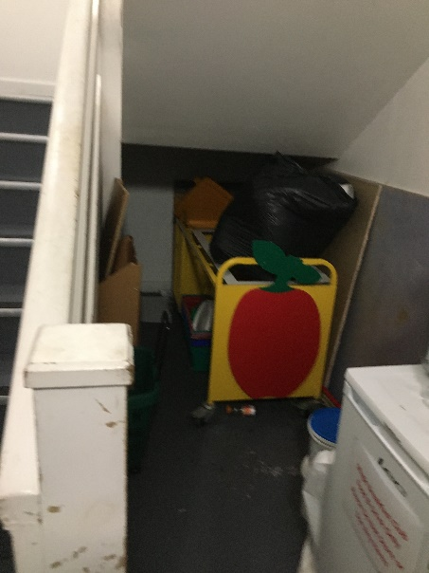 | 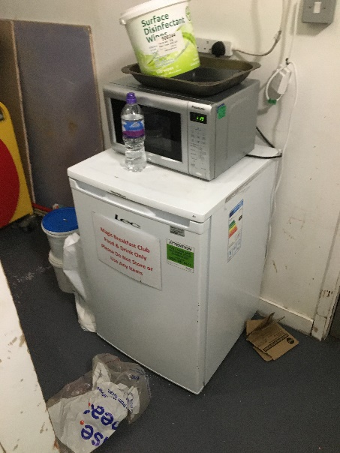 | 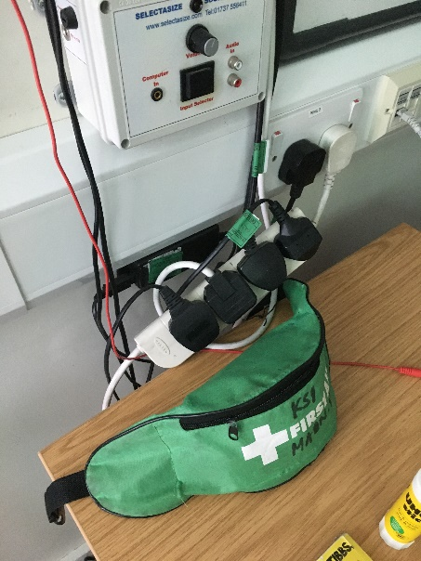
Photo 1 –  Combustible storage under kitchen stairs | Photo 2 – Microwave and fridge in kitchen stairwell | Photo 3 – poor extension cord management | Photo 4 – display materials in escape routes outside of rated notice board areas

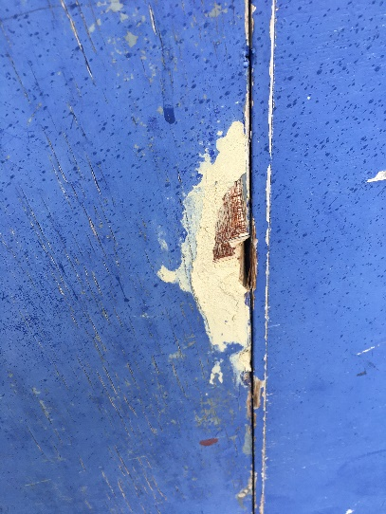 | 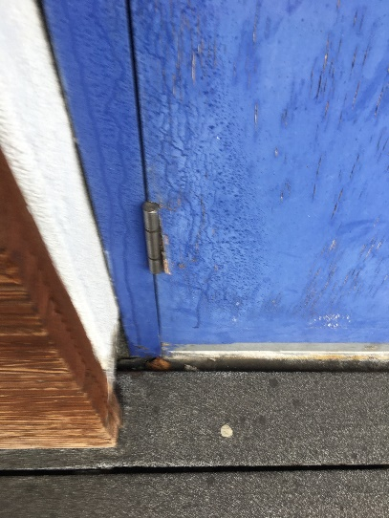 | 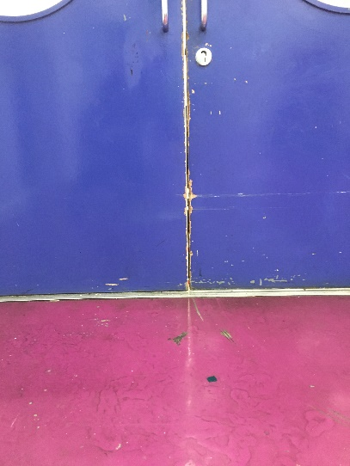 | 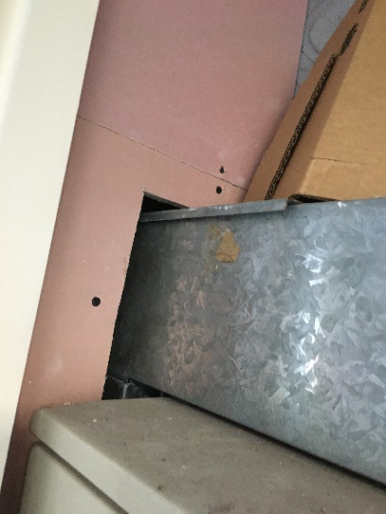
Photo 5 – Damaged fire exit door from main hall | Photo 6 – fire exit hinge damage on main hall exit | Photo 7 – Year 2 corridor fire door with excessive gaps | Photo 8 – fire stopping require for service routes.

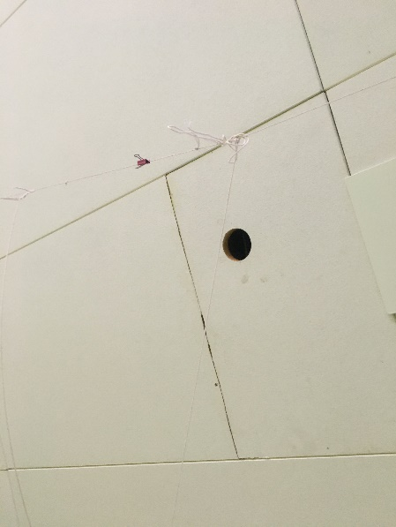 | 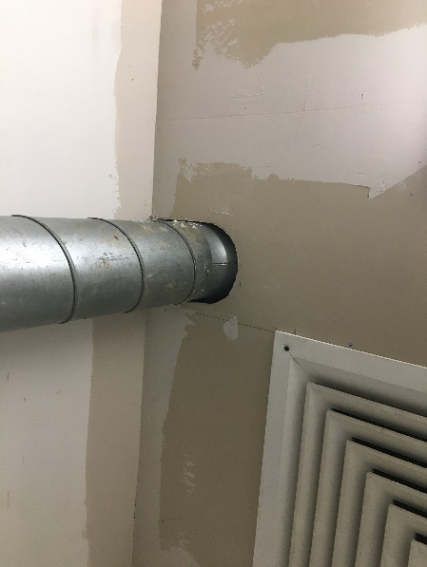 | 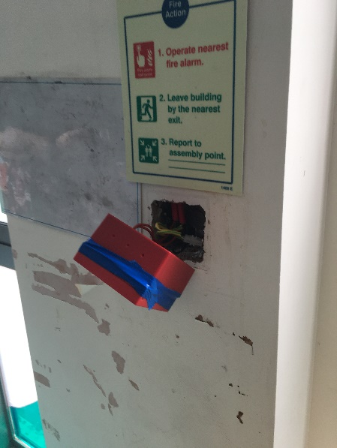 | 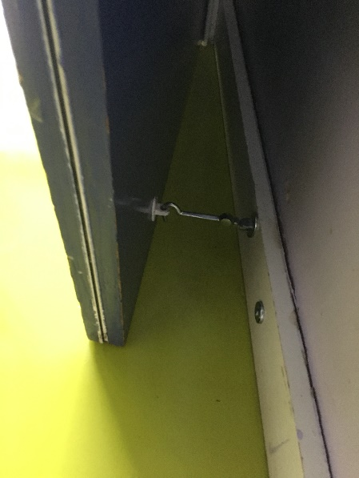
Photo 9 – fire stopping require where projectors have been removed from classrooms | Photo 10 – fire stopping required around services | Photo 11 – manual call point in Reception Class requiring repair | Photo 12 – fire door hooked back and not on self-closer

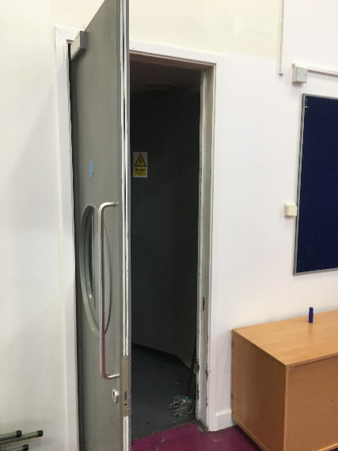 | 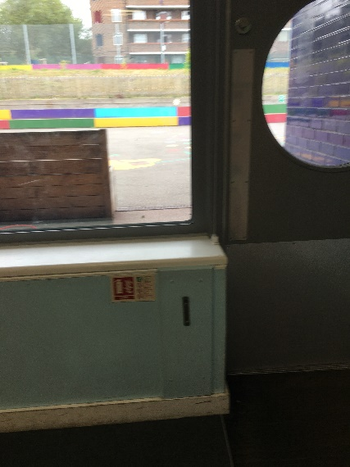 | 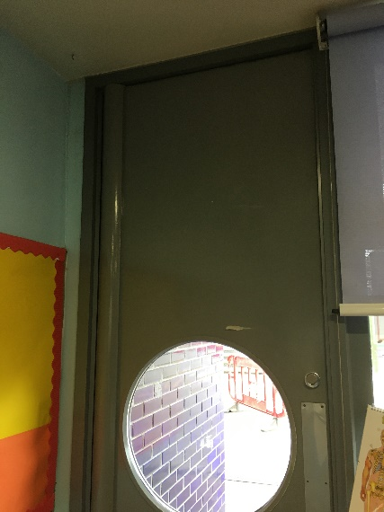
Photo 13 – fire door to kitchen not self-closing | Photo 15 – fire extinguisher in year 2 class missing | Photo 16 – year 2 classroom fire exits not signed

