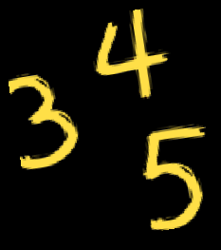
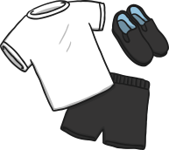
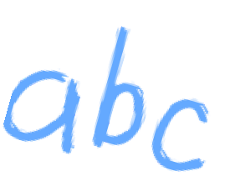
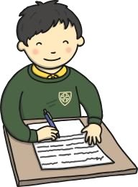
Nebula Newsletter Autumn 1

Welcome
Welcome back! I hope you had a wonderful summer break. My name is Ayisha Salman, and I will be your child's teacher.
Throughout the term, we will focus on establishing routines and supporting emotional regulation through consistent visual systems, such as the Zones of Regulation. We will use single-keyword verbal instructions, paired with a photo, symbol, or BSL sign. This approach is designed to ensure children clearly understand expectations and to minimise anxiety and dysregulation.
Literacy & Phonics  In Literacy, we will use sensory story telling methods, focusing on the stories on “The Groffalo” BY Julia Donaldson and “We are going on a bread hunt” by Michael Rosen. We will discuss the 'who' and 'where' elements of each story to develop comprehension skills. Children will have the opportunity to immerse themselves in these stories and explore them through their senses.  In phonics, we will be learning ‘s’, ‘a’, ‘t’, ‘p’, ‘i’, and ‘n’ sounds from our phonics scheme. | Maths  In Maths, we will be learning about Place Value within 10 and progressing to number bonds to 10. We will use a range of concrete manipulatives to understand that numbers represent quantities before looking at pictorial representations of the numbers.  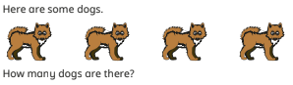
Foundation Subjects
In Science lessons, we will learn about plants, focusing on labelling and naming the different parts of a plant and recognising the difference between trees and smaller plants. In Art, we will explore colours, identify the primary colours, and learn how to create darker and lighter shades by adding black or white paint. During PSHE lessons, we will talk about emotions and feelings. Our Geography topic is “Our School”, and we will learn about the human and physical features of our school.
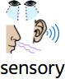
Sensory Integration

This term, students will participate in a variety of sensory activities during carousel time. Activities will include the use of essential oils, paints, water, dry rice, dry pasta, lights, play foam, and gloop. Please ensure your child has a change of clothes in their bag in case they get messy. If your child has any allergies to specific scents or materials, please inform me.

