 | Nursery | Reception | Year 1 | Year 2 | Year 3 | Year 4 | Year 5 | Year 6
Autumn 1 | My Happy Mind – Meet Your Brain  Consent lesson – https://learning.nspcc.org.uk/research-resources/schools/pants-teaching  Online Safety – Circle Time - https://www.youtube.com/watch?v=X0ORbbSUb-A | My Happy Mind – Meet Your Brain  Consent lesson – https://learning.nspcc.org.uk/research-resources/schools/pants-teaching  Online Safety –Online Bullying-LQ1: How can people be unkind online?  https://projectevolve.co.uk/toolkit/resources/content/online-bullying/early-years-7/i-can-describe-ways-that-some-people-can-be-unkind-online/?from=strand | My Happy Mind – Meet Your Brain  Consent lesson – https://learning.nspcc.org.uk/research-resources/schools/pants-teaching  Online Safety - Online Bullying -  LQ1: What is bullying?  https://projectevolve.co.uk/toolkit/resources/content/online-bullying/early-years-7/i-can-explain-what-bullying-is-how-people-may-bully-others-and-how-bullying-can-make-someone-feel/?from=strands | My Happy Mind – Meet Your Brain  Consent lesson – https://learning.nspcc.org.uk/research-resources/schools/pants-teaching  Online Safety - Online Bullying -  LQ1: How should I behave towards others online?  https://projectevolve.co.uk/toolkit/resources/content/online-bullying/7-11/i-can-describe-appropriate-ways-to-behave-towards-other-people-online-and-why-this-is-important/?from=strands | My Happy Mind – Meet Your Brain  Consent lesson – https://learning.nspcc.org.uk/research-resources/schools/pants-teaching  Online Safety - Online Relationships -  LQ1: What does it mean to know someone online and how is this different from knowing someone offline?  https://projectevolve.co.uk/toolkit/resources/content/online-relationships/7-11/i-can-explain-what-it-means-to-know-someone-online-and-why-this-might-be-different-from-knowing-someone-offline/?from=strands | My Happy Mind – Meet Your Brain  Consent lesson – https://learning.nspcc.org.uk/research-resources/schools/pants-teaching  Online Safety -  Online Bullying -  LQ1: How is online bullying different to bullying in the physical world?  https://projectevolve.co.uk/toolkit/resources/content/online-bullying/7-11/i-can-recognise-online-bullying-can-be-different-to-bullying-in-the-physical-world-and-can-describe-some-of-those-differences/?from=strands | My Happy Mind – Meet Your Brain  Consent lesson – https://learning.nspcc.org.uk/research-resources/schools/pants-teaching  Online Safety - Online Bullying -  LQ1: How can I report concerns and access support for online bullying?  https://projectevolve.co.uk/toolkit/resources/content/online-bullying/7-11/i-can-identify-a-range-of-ways-to-report-concerns-and-access-support-both-in-school-and-at-home-about-online-bullying/?from=strands | My Happy Mind – Meet Your Brain  Consent lesson – https://learning.nspcc.org.uk/research-resources/schools/pants-teaching  Online Safety - Online Bullying -  LQ1: How can I capture bullying content as evidence?  https://projectevolve.co.uk/toolkit/resources/content/online-bullying/7-11/i-can-describe-how-to-capture-bullying-content-as-evidence-e-g-screen-grab-url-profile-to-share-with-others-who-can-help-me/?from=strands
Autumn 2 | My Happy Mind – Celebrate  Jigsaw - Healthy Me  L1 - What are parts of my body called?  https://www.youtube.com/watch?v=BwHMMZQGFoM  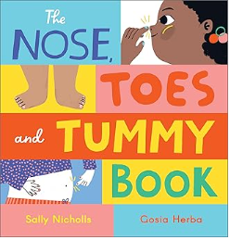  L2 – Why is exercise important for our bodies?  https://www.youtube.com/watch?v=-y5yuLuw7KQ  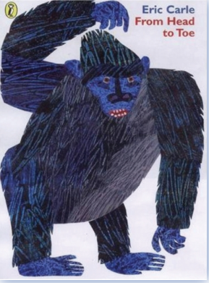  L3: What foods are healthy for me?  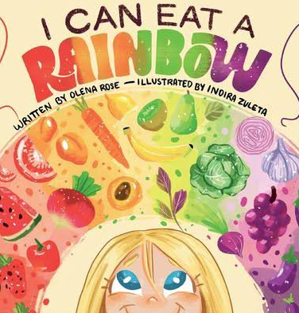  L4: Why is sleep important for my body?  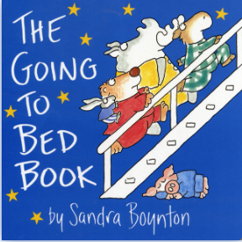  L5: Why is it important to keep clean?  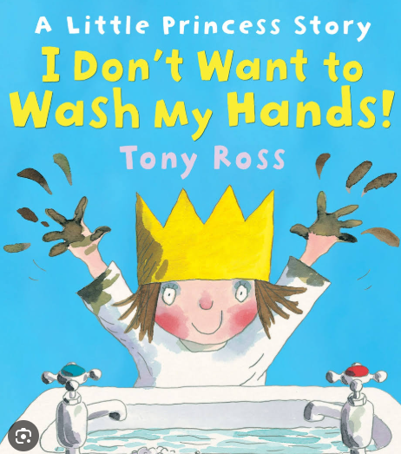  L6: What to do if I get lost or someone talks to me who I do not know? (puppets needed) | My Happy Mind – Celebrate  Jigsaw – Healthy Me  L 1 - How can I keep my body healthy?  L2 – Which foods are healthy and unhealthy for my body?  L3 – What does it mean to be healthy?  L4 – Why is sleep important?  L5 – Why is it important to wash my hands and keep clean?  L6 – What is a stranger and how do I keep myself safe? | My Happy Mind – Celebrate  Jigsaw – Healthy Me  L1- How do I keep myself healthy?  L2 – How can we stay clean, healthy and safe at home?  L3- How can I help myself when I feel poorly?  L4 – How can I stay safe when crossing the road? | My Happy Mind – Celebrate  Jigsaw – Healthy Me  L1 – What do I need to keep my body healthy?  L2 – How do medicines work in my body and how can I use them safely?  L3&4 – Which foods does my body need every day to keep me healthy? | My Happy Mind – Celebrate  Jigsaw –Healthy Me  L1 – How does exercise affect my body and why are my heart and lungs important?  L2- How do calories, sugar and fat affect my body?  L3 – What is my attitude towards drugs?  L4&5- How can I keep myself safe? | My Happy Mind – Celebrate  Jigsaw –Healthy Me  L1 – What are the effects of smoking on our health?  L2- What are the effects of alcohol on our health?  L3- How do I resist peer pressure? | My Happy Mind – Celebrate  Jigsaw –Healthy Me  L1&2 – What are the health risks of smoking and alcohol?  L3- What are basic emergency aid procedures?  L4- How does the media and celebrity culture promote certain body types?  L5- What roles can food play in people’s lives? | My Happy Mind – Celebrate  Jigsaw –Healthy Me  L1&2 – How can I take responsibility for my own health and what are the effects of drugs on the body?  L3&4 – How can people be exploited and why do people join gangs?  L5 – What are the triggers that can cause stress?

 | Nursery | Reception | Year 1 | Year 2 | Year 3 | Year 4 | Year 5 | Year 6
Spring 1 | My Happy Mind – Appreciate  Online Safety – Circle Time - https://www.youtube.com/watch?app=desktop&v=w7vZF-8bTFI | My Happy Mind – Appreciate  Online Safety –  Online Relationships -  LQ2: How can I use the internet to communicate with people I know?  https://projectevolve.co.uk/toolkit/resources/content/online-relationships/early-years-7/i-can-use-the-internet-with-adult-support-to-communicate-with-people-i-know-e-g-video-call-apps-or-services/?from=strands | My Happy Mind – Appreciate  Online Safety –  Online Bullying - LQ: How can anyone experiencing bullying get help?  https://projectevolve.co.uk/toolkit/resources/content/online-bullying/early-years-7/i-can-talk-about-how-anyone-experiencing-bullying-can-get-help/?from=strands | My Happy Mind – Appreciate  Online Safety – Online Bullying -  LQ2: How can bullying appear online and how can someone get support?  https://projectevolve.co.uk/toolkit/resources/content/online-bullying/7-11/i-can-give-examples-of-how-bullying-behaviour-could-appear-online-and-how-someone-can-get- | My Happy Mind – Appreciate  Online Safety – Online Relationships -  LQ2: What is the difference between trusting and liking someone online?  https://projectevolve.co.uk/toolkit/resources/content/online-relationships/7-11/i-can-explain-what-is-meant-by-trusting-someone-online-why-this-is-different-from-liking-someone-online-and-why-it-is-important-to-be-careful-about-who-to-trust-online-including-what-information-and-content-they-are-trusted-with/?from=strands | My Happy Mind – Appreciate  Online Safety – Online Relationships -  LQ2: Why is it important to give and gain permission before sharing things online?  https://projectevolve.co.uk/toolkit/resources/content/online-relationships/7-11/i-can-explain-the-importance-of-giving-and-gaining-permission-before-sharing-things-online-how-the-principles-of-sharing-online-is-the-same-as-sharing-offline-e-g-sharing-images-and-videos/?from=strands | My Happy Mind – Appreciate  Online Safety – Online Bullying - LQ2: How do I block abusive users?  https://projectevolve.co.uk/toolkit/resources/content/online-bullying/7-11/i-can-explain-how-to-block-abusive-users/?from=strands | My Happy Mind – Appreciate  Online Safety – Online Relationships -  LQ2: How can things shared privately online have unintended consequences for others?  https://projectevolve.co.uk/toolkit/resources/content/online-relationships/7-11/i-can-describe-how-things-shared-privately-online-can-have-unintended-consequences-for-others-e-g-screen-grabs/?from=strands
Spring 2 | My Happy Mind – Relate  Jigsaw – Relationships  L1: What does my family look like?  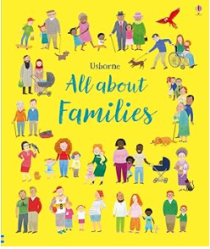  L2: How can I make friends?  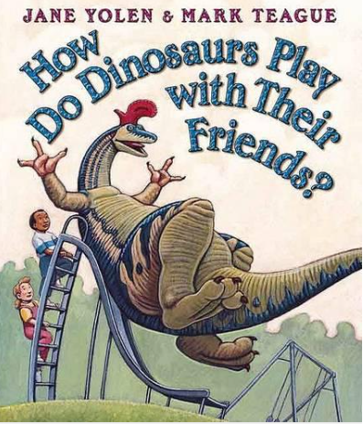  L3: What makes a good friend?  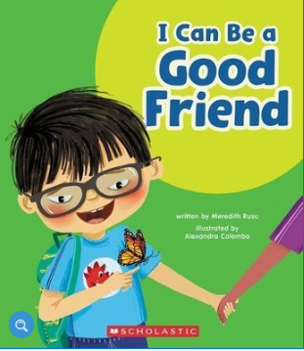  L4: What can I do if someone is unkind to me?  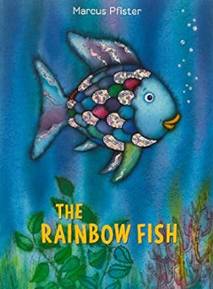 | My Happy Mind – Relate  Jigsaw – Relationships  L1- How can I be a good friend?  L2- How can unkind words hurt someone’s feelings? (bullying)  L3- What can I do if I am feeling lonely and how can I make friends?  L4 – What jobs do I and others have in my family? | My Happy Mind – Relate  Jigsaw – Relationships  L1 – What are different types of families?  L2- What does being a good friend mean to me?  L3 – What are appropriate ways to greet my friends? | My Happy Mind – Relate  Jigsaw – Relationships  L1 – Who are the different members of my family?  L2 –What physical contact is acceptable in a family?  L3- What causes conflict with my friends?  L4 – When is it good/not good to keep a secret? | My Happy Mind – Relate  Jigsaw – Relationships  L1 – What are the roles and responsibilities of members of my family?  L2 – How can I practice some skills of friendship?  L3 – How can I keep myself safe online? | My Happy Mind – Relate  Jigsaw – Relationships  L1 – What is jealousy and how can it affect our relationships?  L2 – Who is special to me and what are some special memories?  L3 – How do friendships change?  L4 – What is the meaning of boyfriend/girlfriend? | My Happy Mind – Relate  Jigsaw – Relationships  L1 – What consequences can belonging to an online community have?  L2 – What rights and responsibilities do I have when online gaming?  L3 – What is too much screen time? | My Happy Mind – Relate  Jigsaw – Relationships  L1 – What are different types of loss and grief?  L2 – When might people try to gain power or control?  L3 – How can I judge whether something online is safe and helpful for me?

 | Nursery | Reception | Year 1 | Year 2 | Year 3 | Year 4 | Year 5 | Year 6
Summer 1 | My Happy Mind – Engage  Online Safety – Circle Time – Book – This is How we Stay Safe  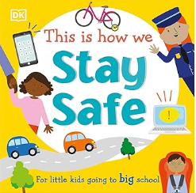 | My Happy Mind – Engage  Online Safety –  Online Relationships - LQ3: When should I ask for permission to do something online?  https://projectevolve.co.uk/toolkit/resources/content/online-relationships/early-years-7/i-can-give-examples-of-when-i-should-ask-permission-to-do-something-online-and-explain-why-this-is-important/?from=strands | My Happy Mind – Engage  Online Safe Online Relationships -  LQ3: Why is it important to be kind online? https://projectevolve.co.uk/toolkit/resources/content/online-relationships/early-years-7/i-can-explain-why-it-is-important-to-be-considerate-and-kind-to-people-online-and-to-respect-their-choices/?from=strands | My Happy Mind – Engage  Online Safety – Health, Wellbeing and Lifestyle  LQ3: Why do some online activities have age restrictions?  https://projectevolve.co.uk/toolkit/resources/content/health-well-being-and-lifestyle/7-11/i-can-explain-why-some-online-activities-have-age-restrictions-why-it-is-important-to-follow-them-and-know-who-i-can-talk-to-if-others-pressure-me-to-watch-or-do-something-online-that-makes-me-feel-uncomfortable-e-g-age-restricted-gaming-or-web-sites/?from=strands | My Happy Mind – Engage  Online Safety – Health, Wellbeing and Lifestyle -  LQ3: When might someone need to limit the amount of time they use technology?  https://projectevolve.co.uk/toolkit/resources/content/health-well-being-and-lifestyle/7-11/i-can-identify-times-or-situations-when-someone-may-need-to-limit-the-amount-of-time-they-use-technology-e-g-i-can-suggest-strategies-to-help-with-limiting-this-time/?from=strands | My Happy Mind – Engage  Online Safety – Online Relationships  - LQ3: How might some people I communicate with online be harmful?  https://projectevolve.co.uk/toolkit/resources/content/online-relationships/7-11/i-can-explain-that-there-are-some-people-i-communicate-with-online-who-may-want-to-do-me-or-my-friends-harm-i-can-recognise-that-this-is-not-my-our-fault/?from=strands | My Happy Mind – Engage  Online Safety – Health, Wellbeing and Lifestyle -  LQ3: How and why do some apps and games request payment for additional content?  https://projectevolve.co.uk/toolkit/resources/content/health-well-being-and-lifestyle/7-11/i-can-explain-how-and-why-some-apps-and-games-may-request-or-take-payment-for-additional-content-e-g-in-app-purchases-lootboxes-and-explain-the-importance-of-seeking-permission-from-a-trusted-adult-before-purchasing/?from=strands | My Happy Mind – Engage  Online Safety – Online Relationships - LQ3: What impact may taking or sharing inappropriate images have for the sharer and others?  https://projectevolve.co.uk/toolkit/resources/content/online-relationships/7-11/i-can-explain-that-taking-or-sharing-inappropriate-images-of-someone-e-g-embarrassing-images-even-if-they-say-it-is-okay-may-have-an-impact-for-the-sharer-and-others-and-who-can-help-if-someone-is-worried-about-this/?from=strands
Summer 2 | Finish any My Happy Mind lessons  Jigsaw – Changing Me  L1: How can I respect my body and others’?  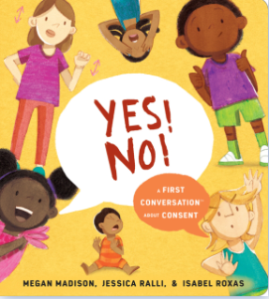  L2: How will I change as I grow up?  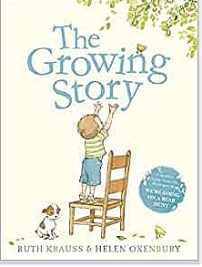  L3: How do I feel about moving classes?  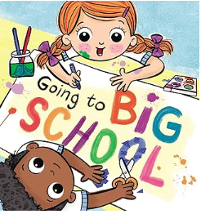  L4: What are my favourite memories from nursery? | Finish any My Happy Mind lessons  Jigsaw – Changing Me  L1 – What are different names of my body called?  L2 – How can I respect my body by making healthy choices?  L3 – How will I change as I grow up?  L4 and L5 – How do I feel about moving to Year 1?  L6 – What have been my favourite memories about Reception? | Finish any My Happy Mind lessons  Jigsaw – Changing Me  L1 – What happens to animals and humans as they get older?  L2- How has my body changed since I was a baby?  L3 – What body parts do boys and girls have? | Finish any My Happy Mind lessons  Jigsaw – Changing Me  L1 – How have I changed since I was a baby?  L2 – What are the physical differences between boys and girls?  L3 – What are different types of touch? | Finish any My Happy Mind lessons  Jigsaw – Changing Me  L1 – What does a baby need to live and grow?  L2 – Why do boys’ and girls’ bodies change?  L3 – How do boys’ and girls’ bodies change on the inside? | Finish any My Happy Mind lessons  Jigsaw – Changing Me  L1 – What makes me, me?  L2 – What are the responsibilities and joys of having a baby?  L3 – How do girls change during puberty? | Finish any My Happy Mind lessons  Jigsaw – Changing Me  L1 – What is my own self-image?  L2&3 – How do boys’ and girls’ bodies change during puberty?  L4 – How are babies made? (sex education) | Finish any My Happy Mind lessons  Jigsaw – Changing Me  L1 – How do boys’ and girls’ bodies change during puberty?  L2 – How does a baby develop from conception through pregnancy? (sex education)  L3 – How does physical attraction change the nature of a relationship?

