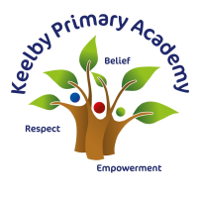
Reading Long Term Plan
EYFS/Year 1 will develop early reading skills within their wider English sessions, alongside the use of Little
Wandle Letters and Sounds for teaching phonics and ‘reading squad’ for fluency/comprehension.
EYFS – whole class reading discussions
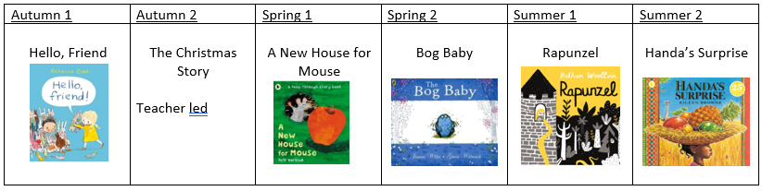
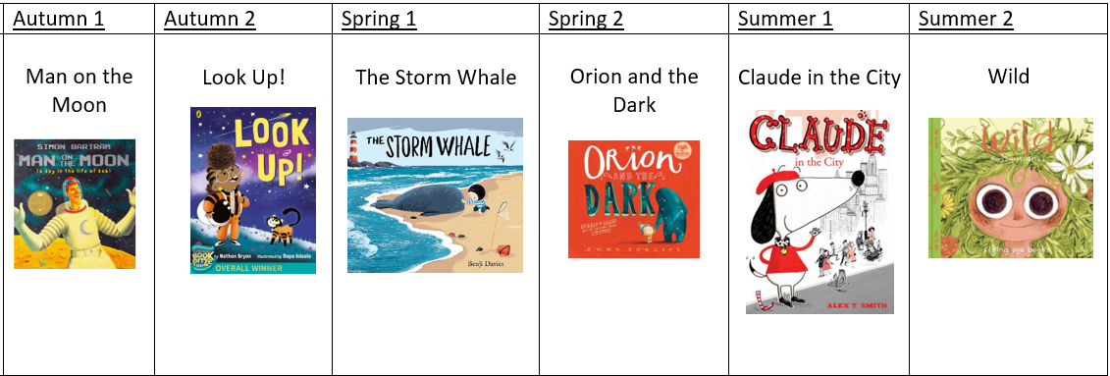
Year 1 – whole class reading discussions

 | Autumn 1 | Autumn 2 | Spring 1 | Spring 2 | Summer 1 | Summer 2
PoR Text | Man on the Moon  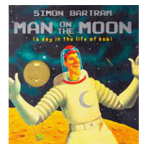 | 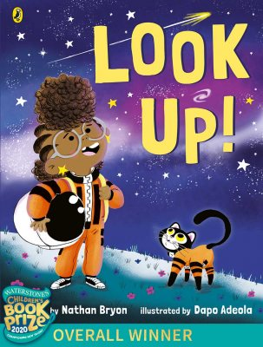  Look Up! | The Storm Whale  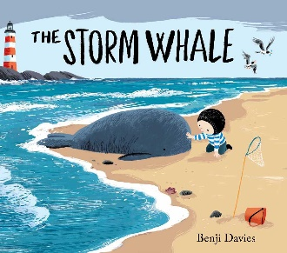 | Orion and the Dark  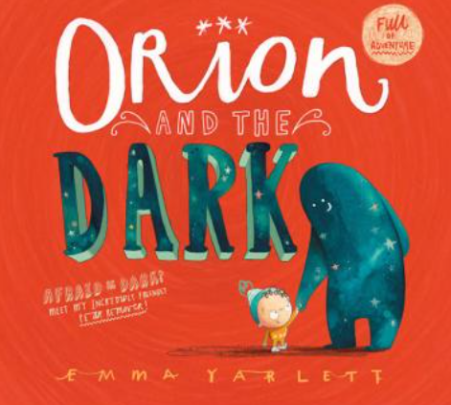 | 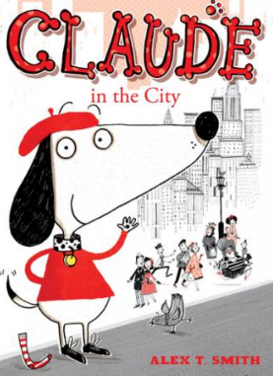  Claude in the City | Wild  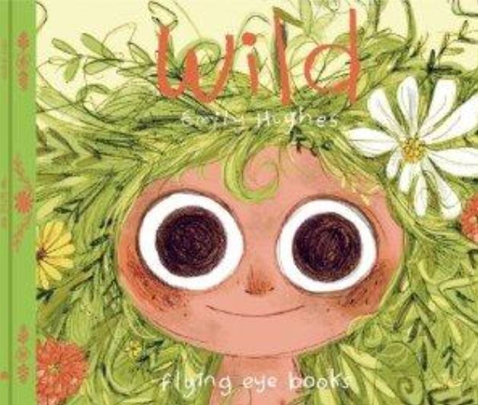
Other texts for independent application | 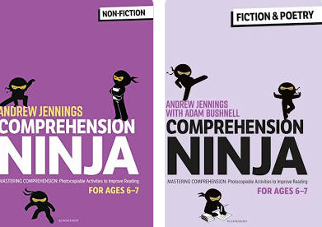
Year 2

Year 3
 | Autumn 1 | Autumn 2 | Spring 1 | Spring 2 | Summer 1 | Summer 2
PoR Text | Ug  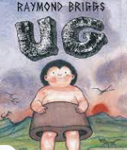 | I was a Rat!  Scarlett Slippers  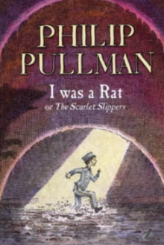 | Varjak Paw  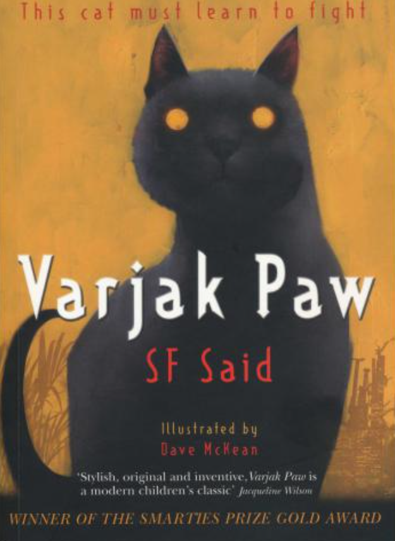 | The Great Kapok Tree  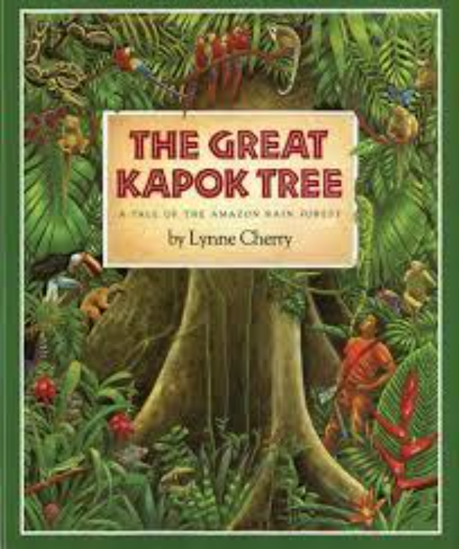 | The Miraculous Journey of Edward Tulane  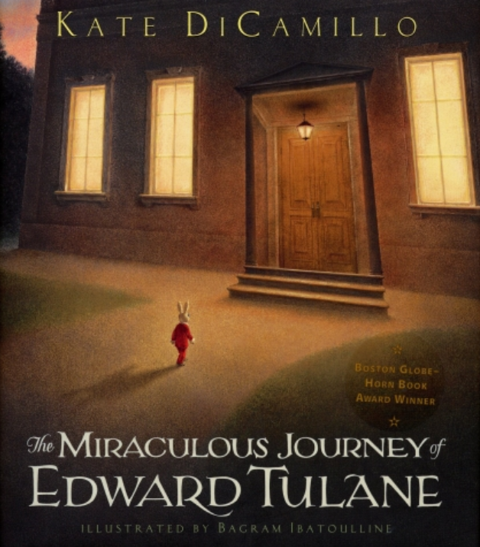 | KrindleKrax  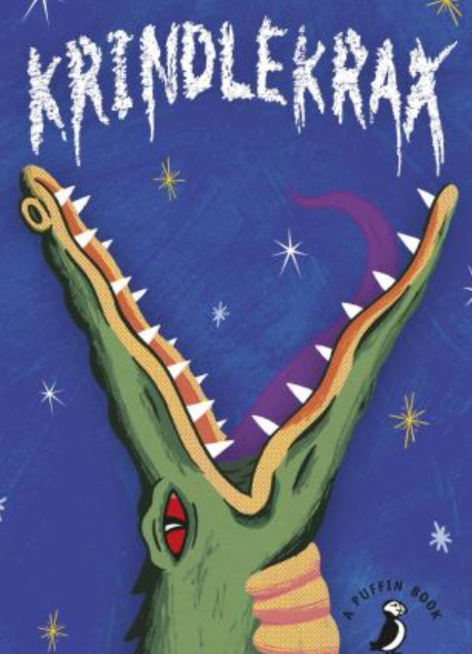
Other texts for independent application | 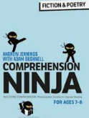  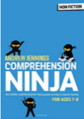

Year 4
 | Autumn 1 | Autumn 2 | Spring 1 | Spring 2 | Summer 1 | Summer 2
PoR Text | Charlotte’s Web  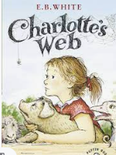 | The Boy at the back of the Class  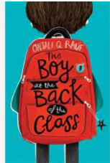 | The Iron Man 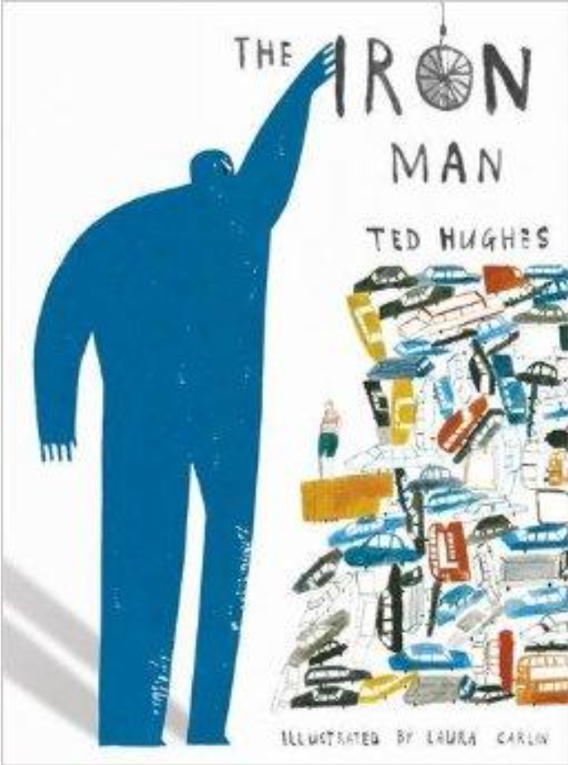 | Arthur and the Golden Rope  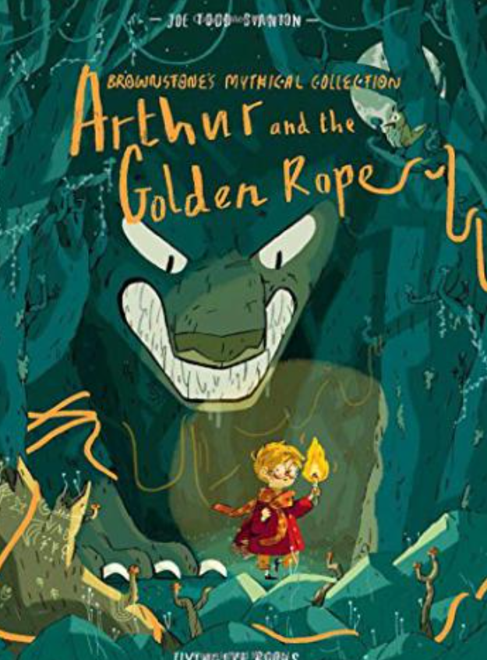 | Leon and the Place Between  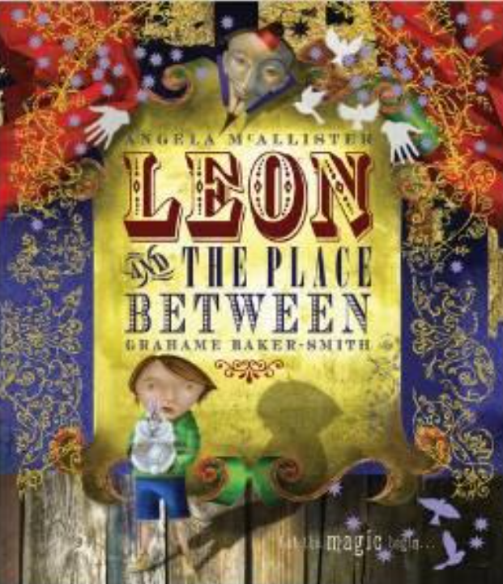 | Oliver and the Seawigs  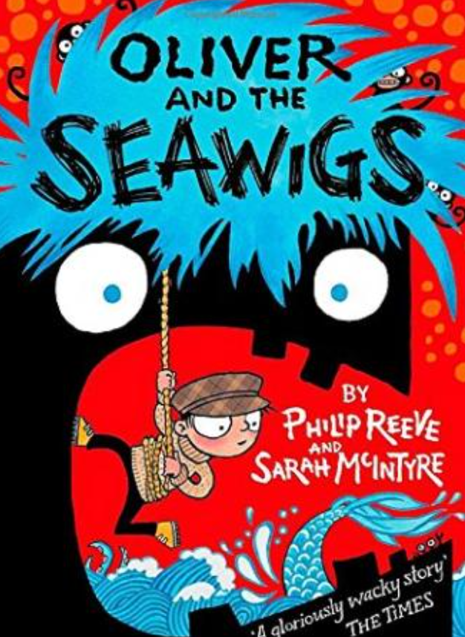
Other texts for independent application | 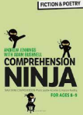  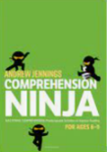

Year 5

 | Autumn 1 | Autumn 2 | Spring 1 | Spring 2 | Summer 1 | Summer 2
PoR Text | Rooftoppers  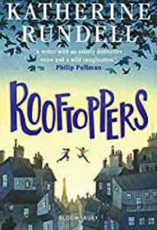 | Pax  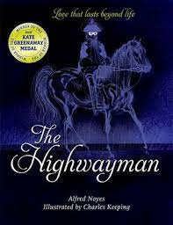 | Floodlands  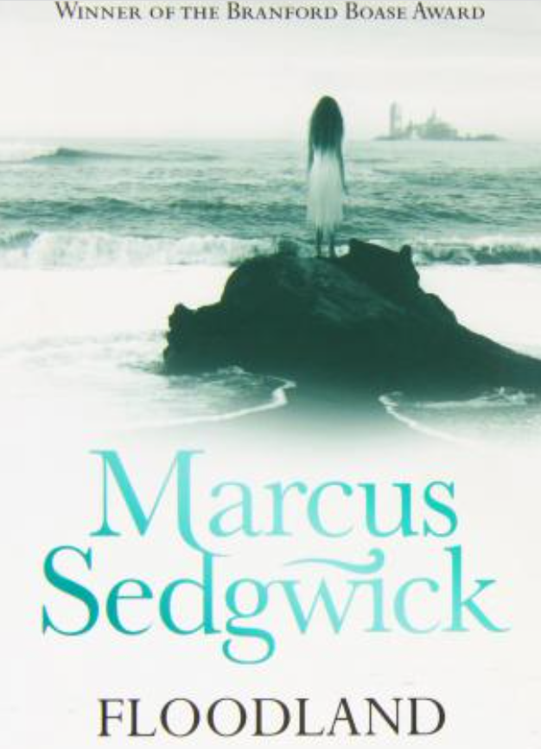 | Cosmic  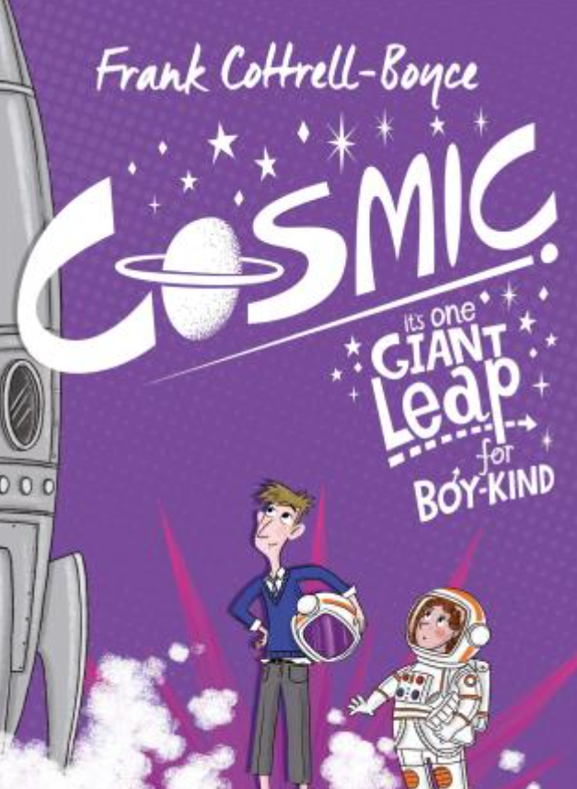 | Shackleton’s Journey  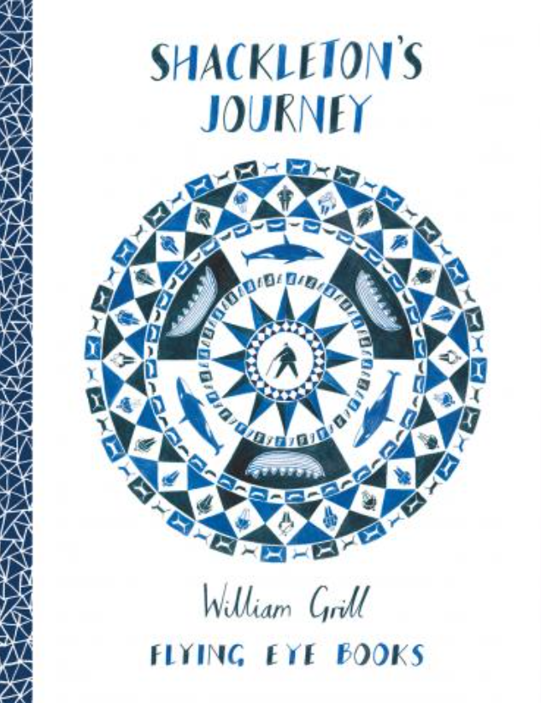 | Journey to a River Sea  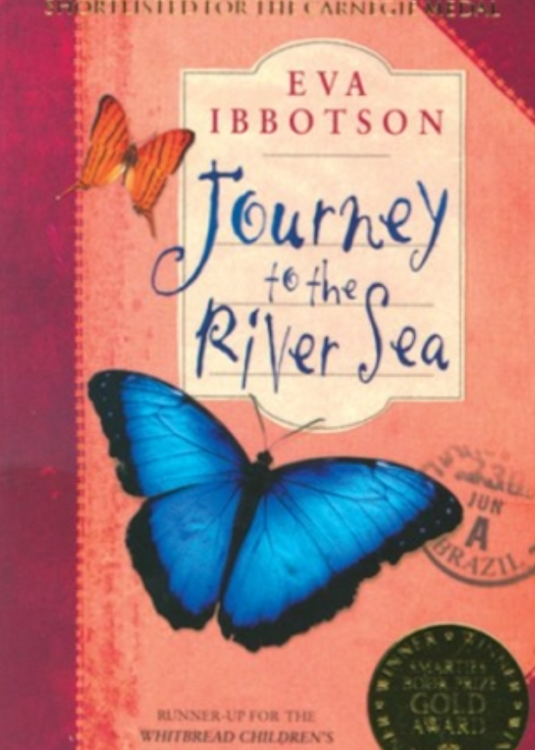
Other texts for independent application | 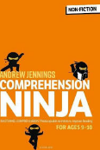  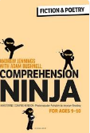
Year 6
 | Autumn 1 | Autumn 2 | Spring 1 | Spring 2 | Summer 1 | Summer 2
PoR Text | Goodnight Mr Tom  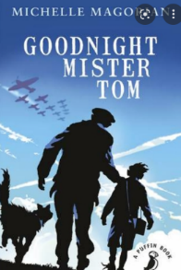 | Wonder  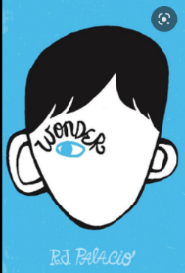 | The London Eye Mystery  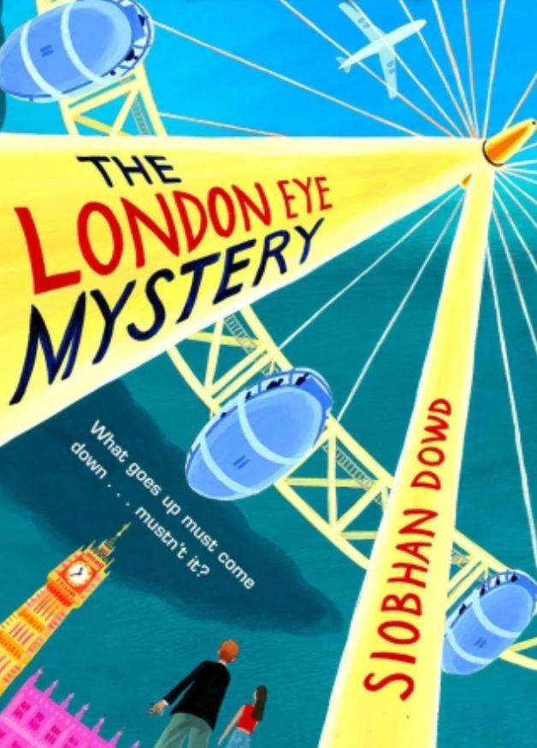 | Pig Heart Boy  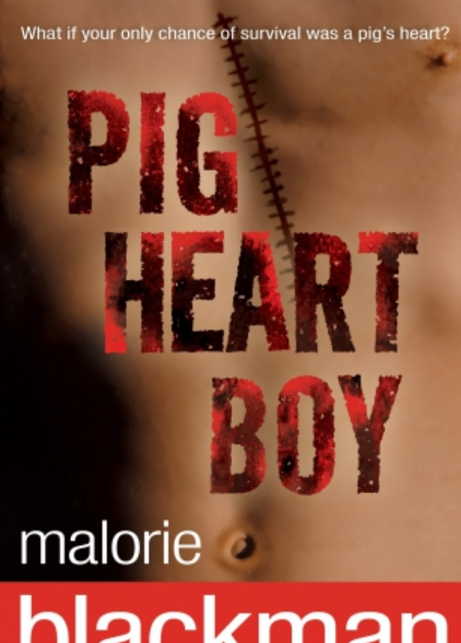 | Town is by the Sea  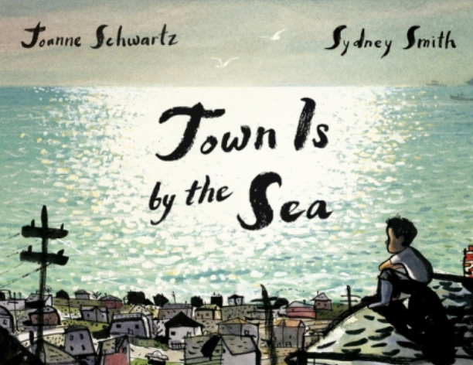 | The Last Wild  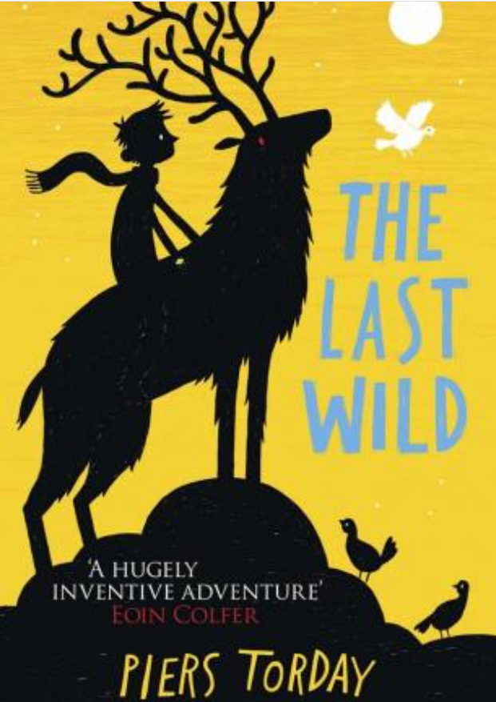
Other texts for independent application | 