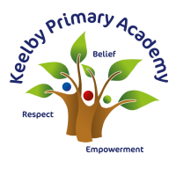
Long Term Plan Writing- Power of Reading Text Coverage with Writing Purpose Progression
The following plans have been written October/November 2022.
EYFS – “writing outcome” will change yearly to suit the interests of the cohort. Below are examples from 2022-23.
Autumn 1 | Autumn 2 | Spring 1 | Spring 2 | Summer 1 | Summer 2
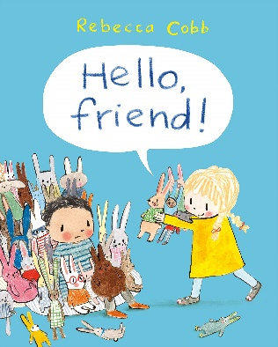  Hello, Friend  Writing outcome:  Our favourite toys in our classroom | The Christmas Story  Teacher led  Writing outcome:  Letters to Santa | 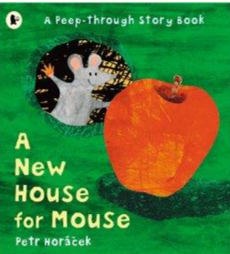  A New House for Mouse  Writing outcome: Leaflet | Bog Baby  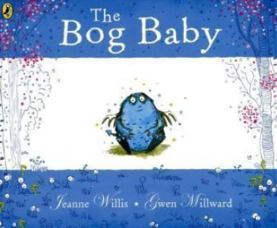  Writing outcome: | Rapunzel  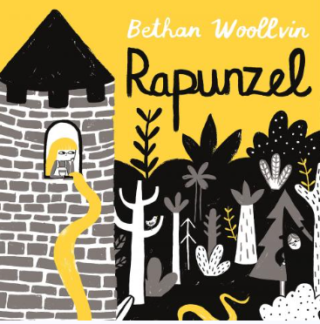  Writing outcome: | 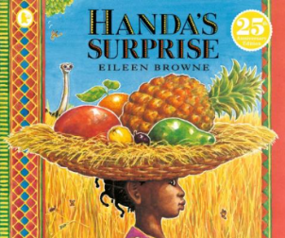  Handa’s Surprise  Writing outcome:

Year 1 and 2
Autumn 1 | Autumn 2 | Spring 1 | Spring 2 | Summer 1 | Summer 2
Man on the Moon  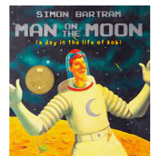  Writing Piece 1:  Letter to Bob  Writing Piece 2:  Alien narrative | 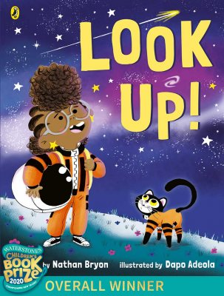  Look Up!  Writing Piece 1:  Character description  Writing Piece 2:  Personal recount | The Storm Whale  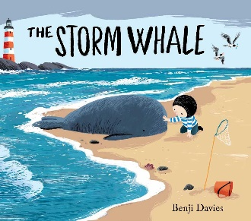  Writing Piece 1:  Setting description  Writing Piece 2:  Diary recount  Extra: storm poem | Orion and the Dark  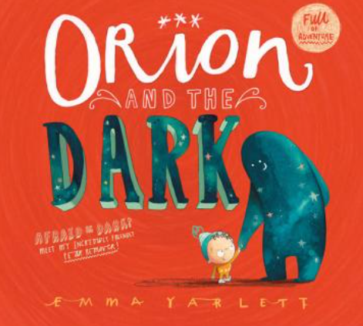  Writing Piece 1:  Character description  Writing Piece 2:  Narrative story | 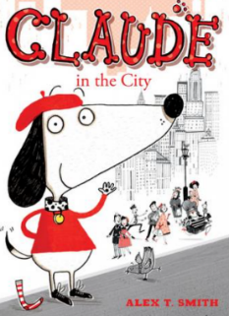  Claude in the City  Writing Piece 1:  Letter  Writing Piece 2:  Recount  Extra: city poem | Wild  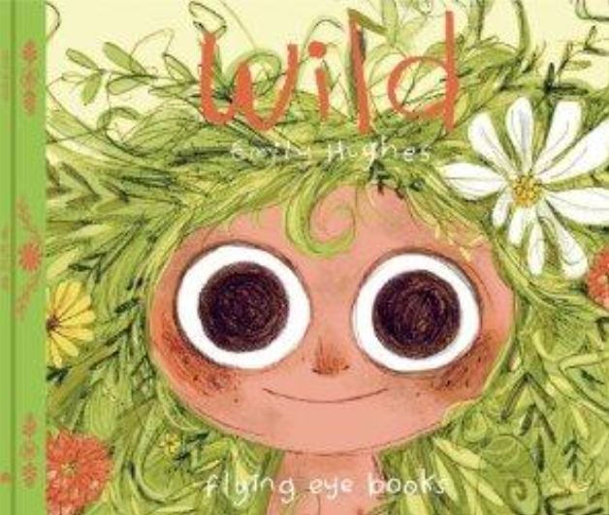  Writing Piece 1:  Narrative  Writing Piece 2:  Instructions
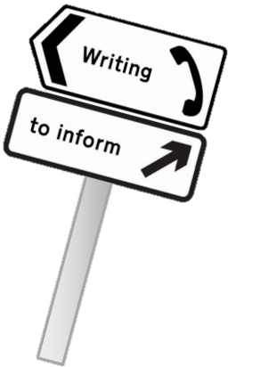
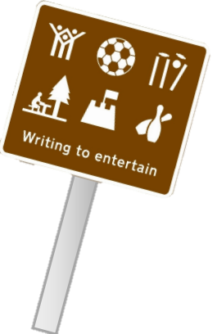

Year 3
Autumn 1 | Autumn 2 | Spring 1 | Spring 2 | Summer 1 | Summer 2
Ug  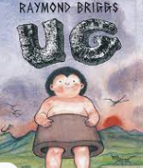  Writing Piece 1: Recount (diary)  Writing Piece 2:  Persuasive speech | I was a Rat!  Scarlett Slippers  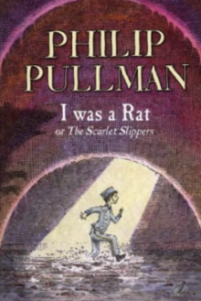  Writing Piece 1: Character description  Writing Piece 2: Letter to persuade | Varjak Paw  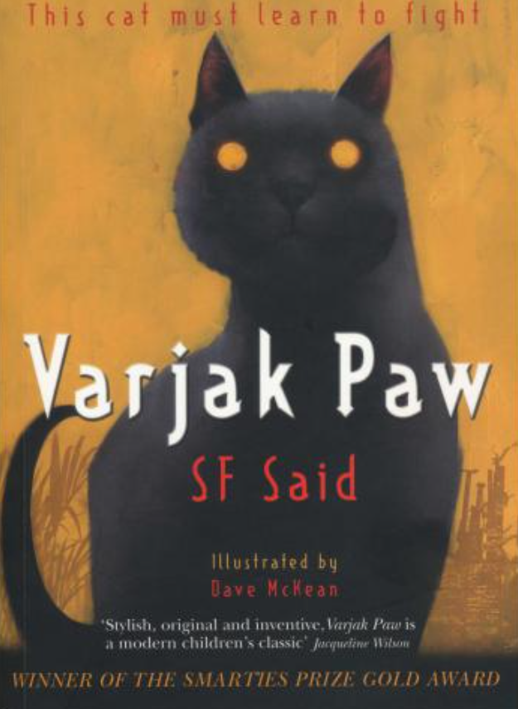  Writing Piece 1:  Recount  Writing Piece 2:  Narrative | The Great Kapok Tree  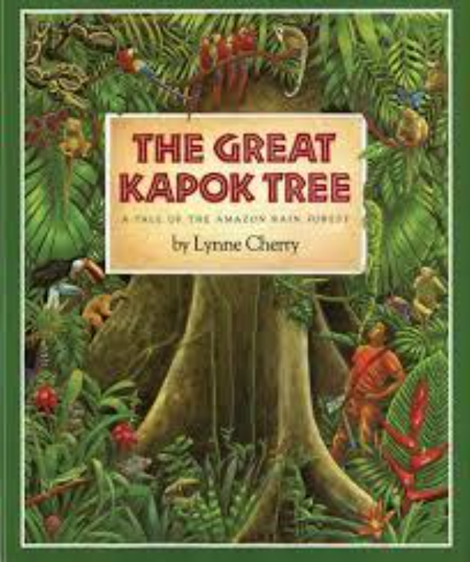  Writing Piece 1: Poetry  Writing Piece 2: Explanation | The Miraculous Journey of Edward Tulane  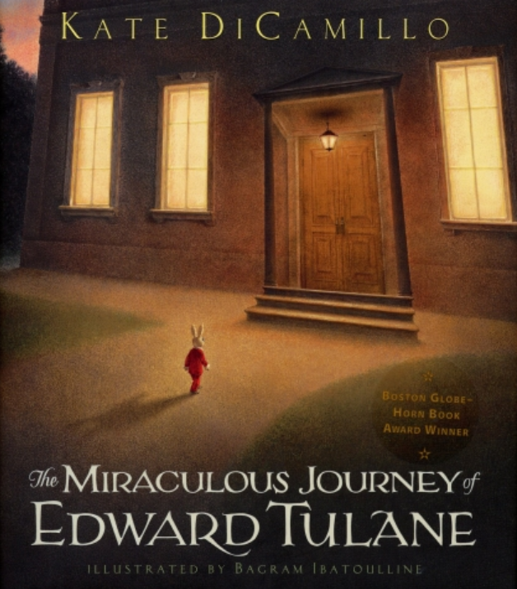  Writing Piece 1:  Newspaper  Writing Piece 2: Biography | KrindleKrax  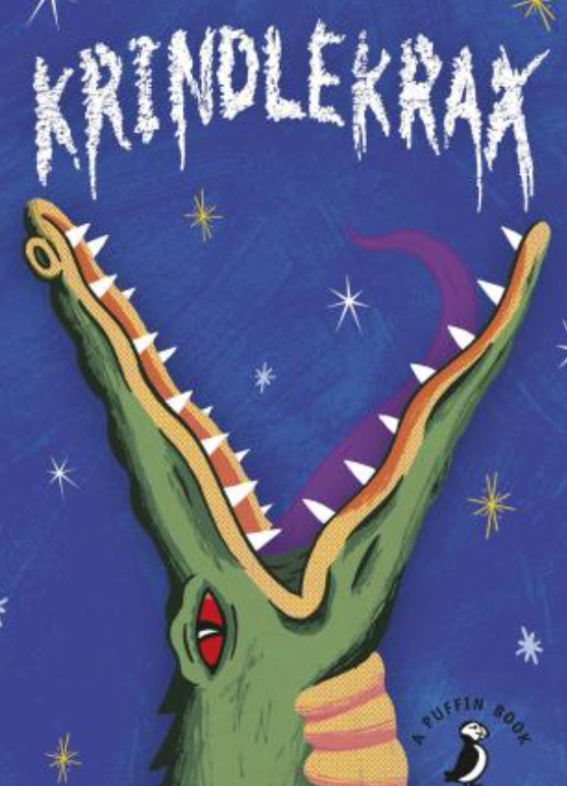  Writing Piece 1: Narrative  Writing Piece 2: Poetry  Extra: speech
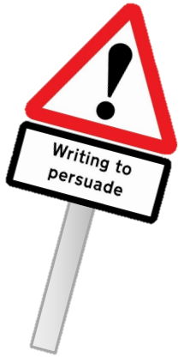

Year 4
Autumn 1 | Autumn 2 | Spring 1 | Spring 2 | Summer 1 | Summer 2
Charlotte’s Web  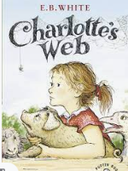  Writing Piece 1:  Diary entry recount  Writing Piece 2:  Non-Chron Report | The Boy at the back of the Class  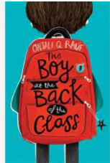  Writing Piece 1:  Narrative  Writing Piece 2:  Character description | The Iron Man 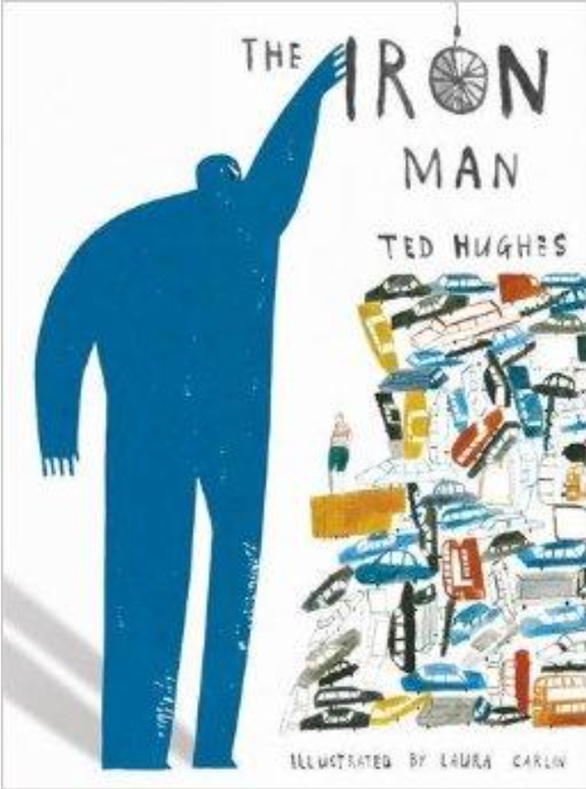  Writing Piece 1:  Recount  Writing Piece 2:  Newspaper report | Arthur and the Golden Rope  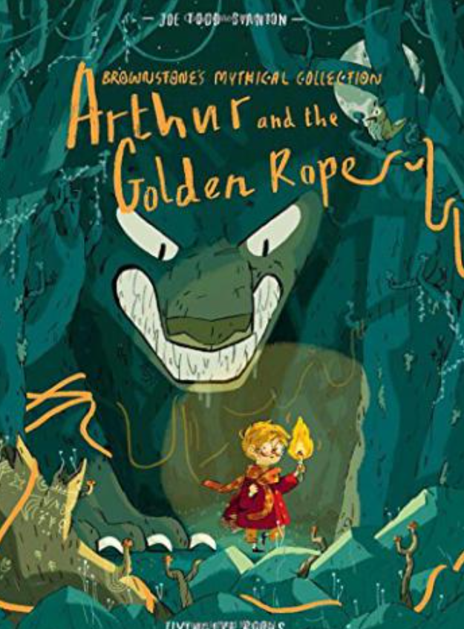  Writing Piece 1:  Poetry  Writing Piece 2:  Persuasive letter | Leon and the Place Between  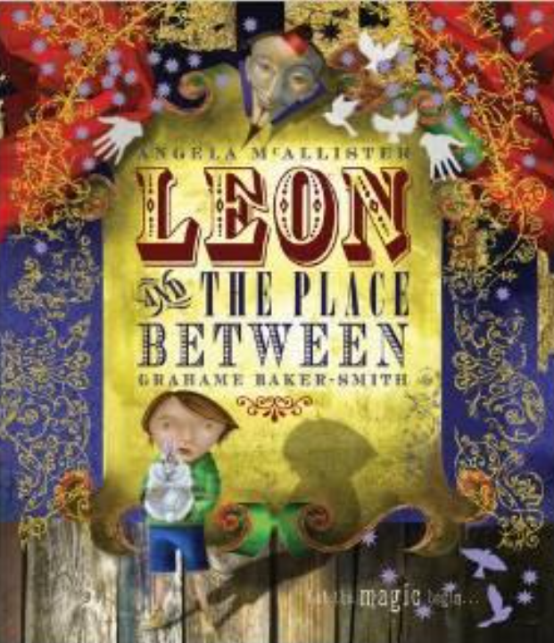  Writing Piece 1:  Biography  Writing Piece 2:  Persuasive advert | Oliver and the Seawigs  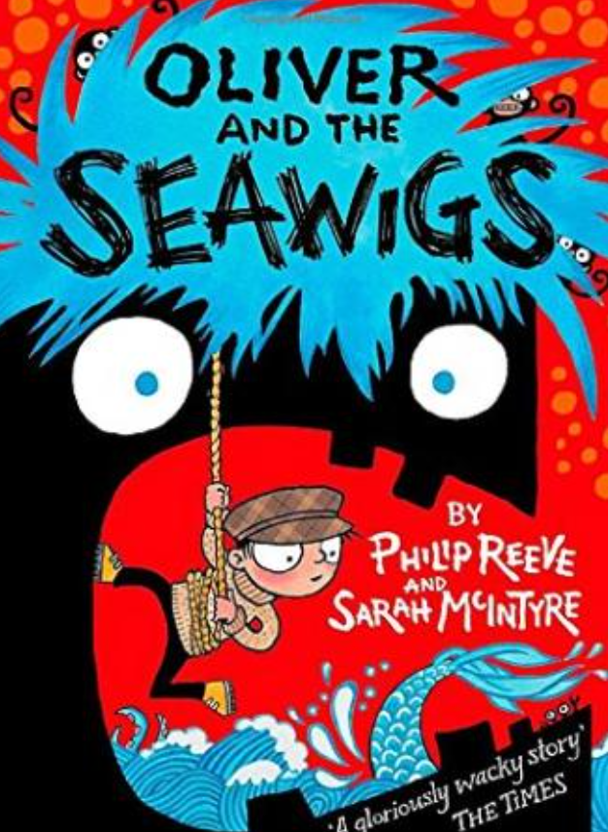  Writing Piece 1:  Narrative  Writing Piece 2: Persuasive speech  Extra: poem

Year 5
Autumn 1 | Autumn 2 | Spring 1 | Spring 2 | Summer 1 | Summer 2
Rooftoppers  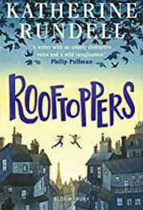  Writing Piece 1:  Character Description  Writing Piece 2  Diary recount  Extra: Non-chron | The Highwayman  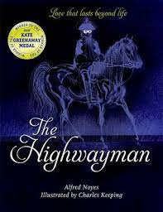  Writing Piece 1:  Poem  Writing Piece 2:  Description  Extra: Persuasive advert (DT) | Floodlands  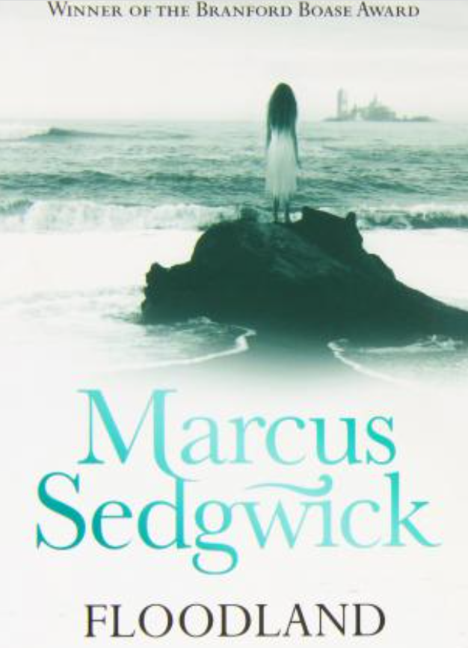  Writing Piece 1:  Narrative  Writing Piece 2:  Persuasive speech | Cosmic  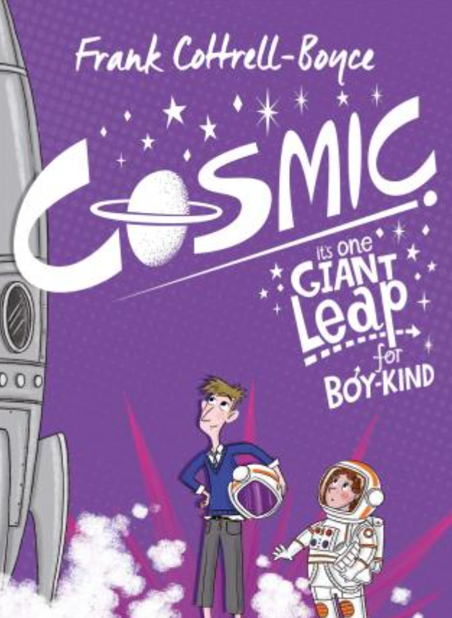  Writing Piece 1:  Persuasive leaflet  Writing Piece 2:  Balanced argument | Shackleton’s Journey  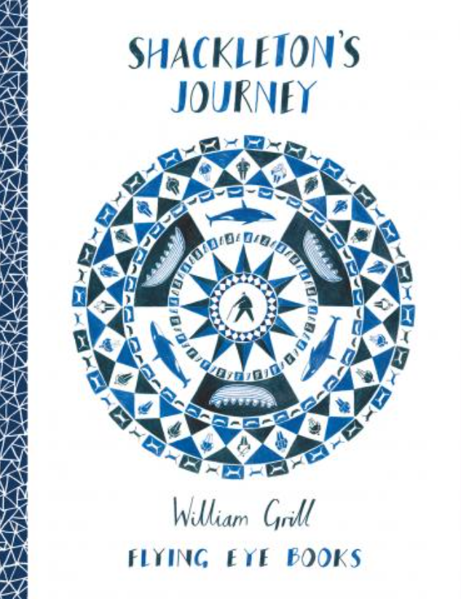  Writing Piece 1:  Newspaper report  Writing Piece 2:  Biography | Journey to a River Sea  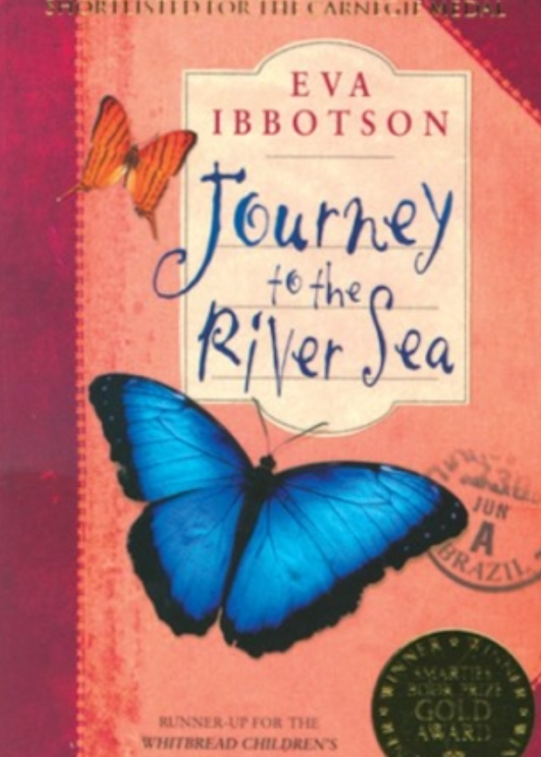  Writing Piece 1:  Narrative  Writing Piece 2:  Letter  Extra: poem
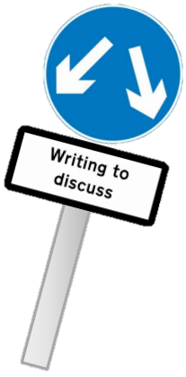

Year 6
Autumn 1 | Autumn 2 | Spring 1 | Spring 2 | Summer 1 | Summer 2
Goodnight Mr Tom  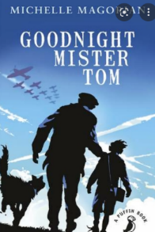  Writing Piece 1:  Advertising leaflet (linked to PGL)  Writing Piece 2: Newspaper report | Wonder  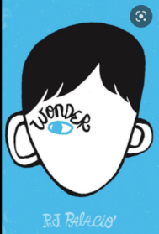  Writing Piece 1:  Suspense Narrative  Writing Piece 2: Non-chronological report (linked to Science) | The London Eye Mystery  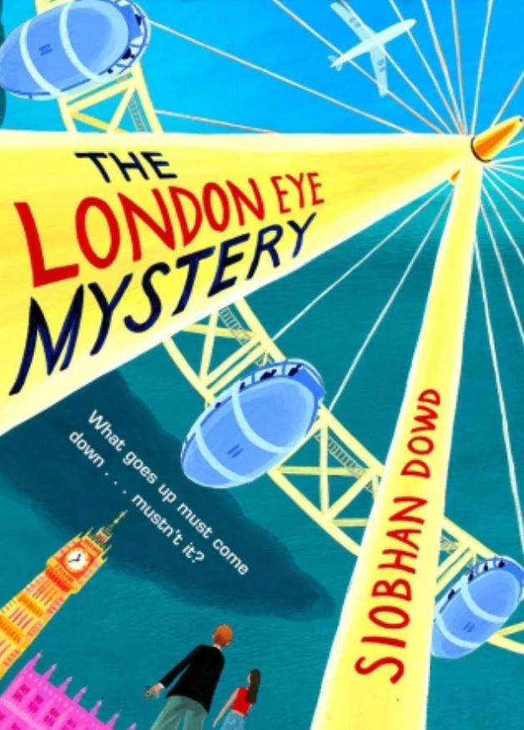  Writing Piece 1: Setting description  Writing Piece 2: Narrative  Additional: Balanced argument | Pig Heart Boy  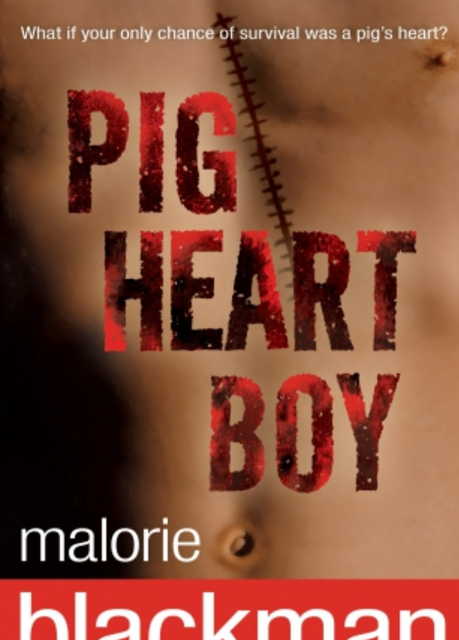  Writing Piece 1:  Narrative  Writing Piece 2:  Explanation  Additional: Diary entry recount | Town is by the Sea  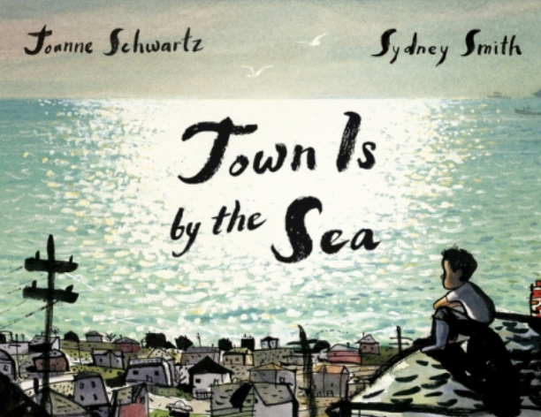  Writing Piece 1:  Poetry  Writing Piece 2: Biography  Additional: letter | The Last Wild  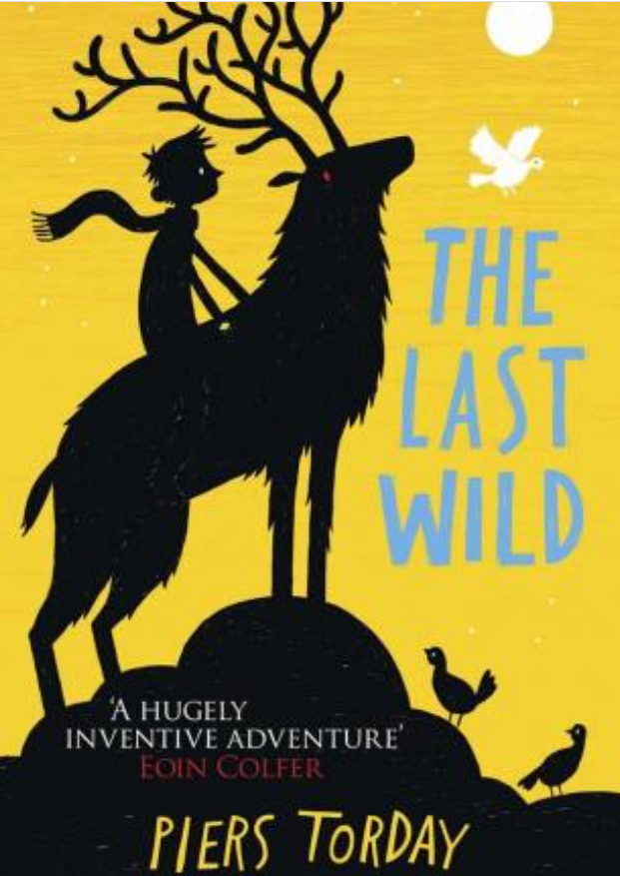  Writing Piece 1: Description  Writing Piece 2: Report  Extra: advert

