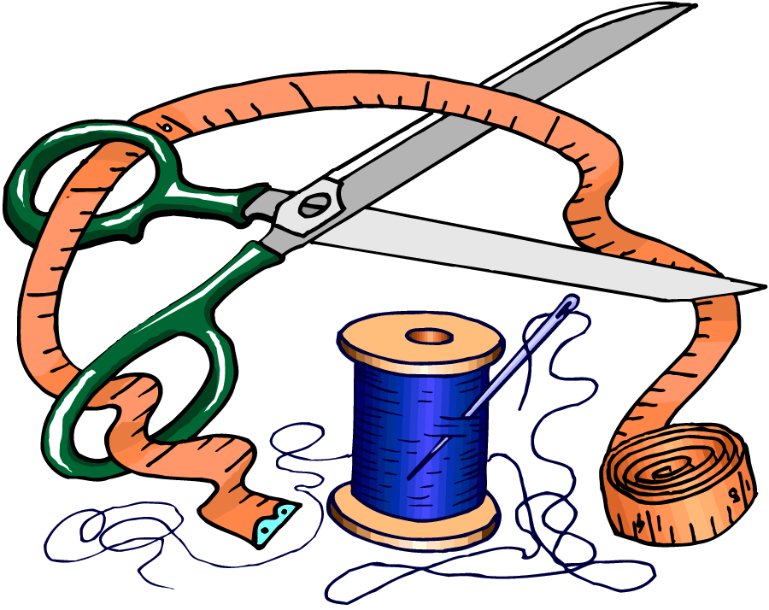
Skills Progression
Design Technology

 | Designing and Developing | Making and technical skills | Evaluating (own products and existing products) | Cooking and Nutrition
EYFS | - Think about and discuss what they want to make.  - Discuss problems and how they might be solved as they arise.  - Children should learn and use appropriate technical vocabulary linked to all their design and technology activity. | - Construct with a range of materials and tools.  - Use glue and tape to join materials.  - Children explore and use a range of construction kits.  - Children should be taught procedures for safety and hygiene.  - Children develop practical skills and techniques using a range of materials (food, textiles and construction materials)  - Children develop their knowledge and understanding in relation to mechanisms, structures, working with food and textiles. | - Be excited and able to share what I have made  - Reflect with children on how they have achieved their aims.  - Children ask questions about existing products.  - Children explore the designed and made world through the indoor and outdoor environment, and role-play. | - Prepare a range of simple dishes  - Safely use simple utensils to prepare food.
Vocab | Build, construct, design, glue, stick, attach, turn, spin, strong, stiff

Development Matters - Return to and build on their previous learning, refining ideas and developing their ability to represent them. Create collaboratively, sharing ideas, resources and skills.

 | Designing and Developing | Making and technical skills | Evaluating (own products and existing products) | Cooking and Nutrition
Year 1 | - Generate ideas from my own experiences  - Talk about my ideas and say what will be done  - Describe what I want to do using pictures and words  - Choose and make lists of materials and tools I will need | - Join two materials together, often with glue  - Use scissors or a knife to cut, sometimes with help  - Make simple models, not necessarily with a purpose  - Use simple construction kits – e.g. Lego  - Use wheels and axels in my construction.  - Use templates to measure and then cut textiles;  - Select appropriate fabrics.  - Sew and join fabrics with a running stitch. | - Talk about my work and what went well;  - Talk about existing products and how they work, and their materials;  - Say what is good, and what isn’t, about existing products.  - Explore a range of freestanding structures in the school and local environment. | - Wash hands and clean surfaces when cooking;  - Cut, peel and grate safely and with confidence.
 |  | - Distinguish between fixed and freely moving axles |  | - Know where different types of food come from (e.g. plant, animals)  - Know the link between foods and the seasons.
Vocab | - vehicle, wheel, axle, axle holder, chassis, body, cab  - assembling, cutting, joining, shaping, finishing, fixed, free, moving, mechanism  - names of tools, equipment and materials used  - design, make, evaluate, purpose, user, criteria, functional  - template, pattern pieces,  - flesh, skin, slicing, peeling, core, pip  - structure, names of shapes, cut, fold, join, fix

 | Designing and Developing | Making and technical skills | Evaluating (own products and existing products) | Cooking and Nutrition
Year 2 | - Generate ideas, and plan what to do next, using my experience of materials and components  - Use my knowledge of some working characteristics of materials when designing  - Use slides and levers in plans  - Use plans to show how to put my ideas into practice  - Explain how the product will be useful  - Draw pictures with labels and some description | - Begin to select tools for folding, joining, rolling  - Measure out and cut materials  - Select new and reclaimed materials and construction kits to build their structures.  - Use simple finishing techniques suitable for the structure they are creating.  - Select tools and techniques appropriate to the job  - Use levers or slides in my design;  - Measure and accurately cut textiles;  - Cut textiles from a template;  - Use more than 1 type of stitch. | - Recognise what I have done well and talk about what could be improved, thinking about the intended purpose.  - Respond to the feedback of others  - Predict how changes will improve the finished product.  - Evaluate different existing products that contain levers and sliders. | - Prepare a range of more complex dishes (Cook School)  - Use simple scales or balances  - Safely and hygienically prepare fruit and/ or vegetables using appropriate tools
 |  | - Follow basic safety rules  - Understand and use the terms related to structures, textiles, levers and slides;  - Know that different mechanisms result in different movements. | - Talk about how moving objects work  - Describe how a commercial product works  - Use like and dislike when evaluating or describing | - Understand and use the terms ingredient  - Understand main rules of food hygiene  - Understand about a healthy, varied and balanced diet;  - Understand about the “eat well plate” and “5-a-day”.
Vocab | - slider, lever, pivot, slot, bridge/guide  - card, masking tape, paper fastener, join  - pull, push, up, down, straight, curve, forwards, backwards  - design, make, evaluate, user, purpose, ideas, design criteria, product, function  - cut, fold, join, fix  - flesh, skin, slicing, peeling, core, pip  - structure, wall, tower, framework, weak, strong, base, top, underneath, side, edge, surface, thinner, thicker, corner, point, straight, curved

 | Designing and Developing | Making and technical skills | Evaluating (own products and existing products) | Cooking and Nutrition
Year 3 | - Build upon the ideas to develop my own ideas  - Ensure that plans are realistic and appropriate for the aim  - Show the order of working in plans  - Use models, pictures and words in designs  - Apply what they know about mechanisms to create movement when planning and designing (gears and pulleys)  - Investigate a range of products that use levers and linkages | - Measure and cut out using standard measurements  - Choose tools and equipment which are appropriate for the job  - Prepare for work by assembling components together before joining  - Use scoring and folding for precision  - Work out how to make shell structures stronger  - Alter and adapt materials to make them stronger  - To use levers and linkages to create a product  - Use multiple fabric shapes to make a 3D textiles product.  - Know how to strengthen and reinforce 3D fabrics | - Be clear about my ideas when asked  - Can alter and adapt original plans following discussion and evaluation  - Recognise what has gone well, but suggest further improvements for the finished article  - Suggest which elements I would do better in the future  - Evaluate existing products based on materials, how well they’ve been made, and fitness for purpose. | - Prepare a range of more complex dishes using a range of cooking techniques  - Begin to select my own ingredients when cooking or baking  - Make good presentation of food
 | - Recognise that designs must meet a range of needs  - Say why something will be useful | - Understand the effect of levers and linkages in a mechanical system.  - Distinguish between fixed and loose/ moving pivots  - Use technical vocabulary related to their product. | - Learn about the role of inventors, engineers and designers. | - Understand safe food storage  - Understand the principles of a healthy and balanced diet.
Vocab | - mechanism, lever, linkage, pivot, slot, bridge, guide  - system, input, process, output  - linear, rotary, oscillating, reciprocating  - user, purpose, function  - prototype, design criteria, innovative, appealing, design brief  - shell structure, three-dimensional (3-D) shape, net, cube, cuboid, prism, vertex, edge, face, length, width, breadth, capacity  - marking out, scoring, shaping, tabs, adhesives, joining, assemble, accuracy, material, stiff, strong, reduce, reuse, recycle, corrugating, ribbing, laminating  - font, lettering, text, graphics, decision, evaluating, design brief design criteria, innovative, prototype  - fabric, names of fabrics, fastening, compartment, zip, button, structure, finishing technique, strength, weakness, stiffening, templates, stitch, seam, seam allowance

 | Designing and Developing | Making and technical skills | Evaluating (own products and existing products) | Cooking and Nutrition
Year 4 | - Collect and use information to generate ideas  - Consider the way the product will be used  - Take users’ views into account  - Think ahead about the order of their work  - Add electricity to create motion or make light  - Produce step by step plans  - Make ongoing sketches and annotations | - Increasingly model my ideas before making  - Measure accurately using standard measures  - Combine materials for strength, durability or flexibility and to improve how the product looks  - Use permanent and temporary fastenings to join using a range of techniques (including those other than glue or tape e.g. split pins, dowel and washers etc)  - Strengthen joins and corners in a shell structure, using a variety of ways  - Use pneumatics in a design  - Use a simple circuit in a product, with a switch.  - Combine 2D textile shapes to make a 3D textile product. | - Analyse how existing products have been designed and made;  - Evaluate how well products work and achieve their purpose.  - Evaluate what went well with my product design giving reasons  - Develop my designs through my own reflection and the evaluation of others  - Make improvements based on testing | - Prepare a range of more complex dishes (Cook School) using a range of cooking techniques  - Select my own ingredients when cooking or baking  - Evaluate food by taste, texture, flavour etc.
 | - Understand how the properties of materials may be used for particular products  - Understand designs must meet a range of criteria and constraints | - Understand how pneumatics can be used to power a system.  - Use technical vocabulary related to their product. |  | - Understand about the seasonality of food;  - Understand about how land use and land type effects the food that is produced;  - Understand how seasonality effects diet.
Vocab | - components, fixing, attaching, tubing, syringe, plunger, split pin, paper fastener  - pneumatic system, input movement, process, output movement, control, compression, pressure, inflate, deflate, pump, seal, air-tight  - linear, rotary, oscillating, reciprocating  - user, purpose, function, prototype, design criteria, innovative, appealing, design brief, research, evaluate, ideas, constraints, investigate  - series circuit, fault, connection, toggle switch, push to make switch, push to break switch, battery, battery holder, bulb, bulb holder, wire, insulator,  - conductor, crocodile clip

 | Designing and Developing | Making and technical skills | Evaluating (own products and existing products) | Cooking and Nutrition
Year 5 | - Make more complex designs to include cams  - Plan my work considering potential problems  - Explore alternative ways of doing things  - Meet an identified need – e.g. a meal for an older person – by selecting ingredients or materials  - Use various sources of information and draw on them in design. | - Carry out tests to see if my design works  - Make improvements from design suggestions  - Measure and cut precisely to millimetres  - Make stable and strong joins to stand the test of time (including using joins other than glue or tape)  - Build a 3D product using a strong framework  - Use a series circuit with more than one component and a switch.  - Use cams in my design and create a system that uses cams to function  - Combine fabric templates to make a 3D product, using different stitches.  - Understand how 3D fabric can be strengthened or stiffened. | - Identify what is working well and what might be improved – and make choices from several alternatives  - Refine the quality of the finished product, including making annotations on the design  - Clarify ideas through drawing and modelling  - Increasingly use testing to improve models and finished products  - Evaluate existing products that contain linkages and levers, and identify how they work.  - Identify the user, use and design of an existing product;  - Evaluate the innovation and sustainability of an existing product | - Prepare a range of more complex dishes using a range of cooking techniques and recognising the seasonality of produce used.  - Use proportions when cooking, by doubling and halving recipes  - Know how to use utensils and equipment including heat sources to prepare and cook food.  - Understand about seasonality in relation to food products and the source of different food products.
 |  | - Know the key components in a more complex circuit and understand how a circuit and switch works;  - Understand the purpose of a cam in a mechanical system |  | - Work in a safe and hygienic way  - Understand how different types of food are grown/ reared/ caught/ processed;  - Understand the advantages and disadvantages of different types of food production (e.g. cost/ health benefits etc).  - Know and use relevant technical and sensory vocabulary.
Vocab | - cam, snail cam, off-centre cam, peg cam, pear shaped cam  - follower, axle, shaft, crank, handle, housing, framework  - rotation, rotary motion, oscillating motion, reciprocating motion  - annotated sketches, exploded diagrams  - mechanical system, input movement, process, output movement  - frame structure, stiffen, strengthen, reinforce, triangulation, stability, shape, join, temporary, permanent  - seam, seam allowance, wadding, reinforce, right side, wrong side, hem, template, pattern pieces  - name of textiles and fastenings used, pins, needles, thread, pinking shears, fastenings, iron transfer paper

 | Designing and Developing | Making and technical skills | Evaluating (own products and existing products) | Cooking and Nutrition
Year 6 | - Keep cost constraints in mind when selecting materials in design  - Be aware of commercial aspects and incorporate these into their designs  - Design including pulleys and/ or gears  - Draw diagrams using scales where appropriate | - Measure and cut out in precise detail, and make sure that finished products are carefully finished for strength and aesthetics  - Make separate elements of a model before combining into the finished article;  - Know how to stiffen/ strengthen/ reinforce a 3D frame.  - Use pulleys and / or gears to create a system.  - Use computer control within a system;  - Understand and use electrical systems in their products.  - Understand the use of computer control systems in products.  - Apply their understanding of computing to program, monitor and control their products.  - Pin and tack fabric pieces;  - Select the most appropriate stitch for a given purpose;  - Make a textile product that is attractive and strong. | - Research products using the internet  - Test and evaluate commercial products, understanding how this information supports my own designs  - Evaluate a range of different sources of information such as advertising and handbooks  - Evaluate different products that use different mechanical systems and explain how they work.  - Evaluate own product based on a success criteria and suggest improvements moving forwards.  - Evaluate what impact certain products have had beyond their intended purpose. | - Prepare a range of more complex dishes (Cook School) using a range of cooking techniques and recognising the seasonality of produce used.  - Plan and select ingredients for a savoury meal based on a given brief and audience.
- Knowledge of more complex circuits;
- Knowledge of how to use a computer control system
Understand the role of a pulley and/ or gear in a system
- Know and use technical vocabulary relevant to the project.
Vocab | Switch, transistor, potentiometer, LED, control, algorithm, input device, output device, commercial, drive, savoury, reinforce, structure, pin, tack. reed switch, toggle, push to make switch, push to break switch, light dependent  resist or ( LDR), tilt switch light emitting diode (LED), bulb, bulb holder, battery, battery holder, USB cable, wire, insulator, conductor, crocodile clip  control, program, system, input device, output device , series circuit, parallel circuit, function, innovative, design specification, design brief,  frame structure, stiffen, strengthen, reinforce, triangulation, stability, shape, join, temporary, permanent

