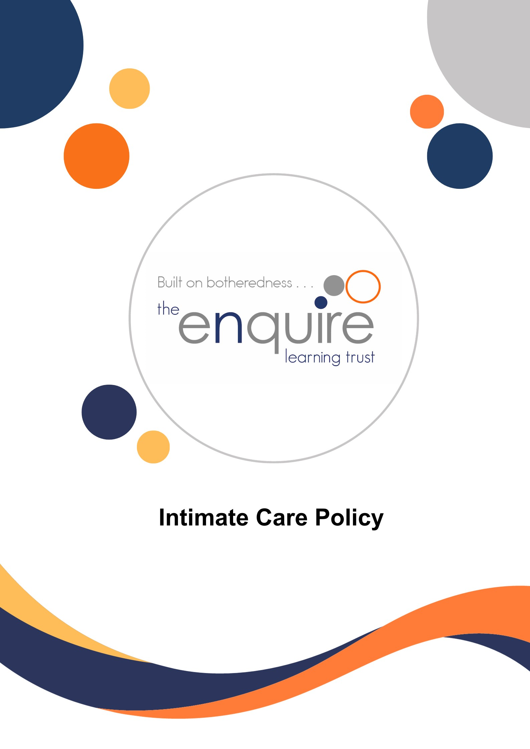

Contents

Section | Title | Page
1 | Introduction | 3
2 | Aims | 3
3 | Objectives | 3
4 | Individual Pupil Needs | 4
5 | Intimate Care Plans | 4
6 | Care Plan Agreements | 4
7 | Personal Care Procedures | 5
8 | Health and Safety Procedures | 5
9 | Child Protection | 6
10 | Monitoring and Review | 6
 | Appendix A – Written Care Plan | 7
 | Appendix B – Care Plan Agreements | 8
 | Appendix C – Personal Care Procedures | 9
 | Appendix D – Health and Safety Procedures | 10
 | Appendix E – Procedures for Changing Children | 11

Version History

Approved by: | Trustees
Last reviewed: | Sept 2025
Next review due by: | Sept 2026

Date | Author | Version | Comment
August 23 | Delyth Linacre | 1
September 24 | Delyth Linacre | 2 | Reviewed
September 25 | Delyth Linacre | 3 | Intimate Care Plan Appendix A has been updated.

1. Introduction

Intimate care can be defined as care tasks of an intimate nature, associated with bodily
functions, body products and personal hygiene which demand direct or indirect contact with
or exposure of the genitals. Examples include care associated with continence.

Within the Enquire Learning Trust we recognise that all children have different rates of development and differing needs during their time in our schools.

Most children achieve continence before starting full-time school. With the development of more early years’ education and the drive towards inclusion, however, there are many more children in mainstream educational establishments who are not fully independent. Some individuals remain dependent on long-term support for personal care, while others progress slowly towards independence.

The achievement of continence can be seen as the most important single self-help skill, improving the person’s quality of life, independence and self-esteem. The stigma associated with wetting and soiling accidents can cause enormous stress and embarrassment to the children and families concerned. Difficulties with continence severely inhibit an individual’s inclusion in school and the community. Children with toileting problems who receive support and understanding from those who act in loco parentis are more likely to achieve their full potential.

We are committed to ensuring that all pupils are able to access the whole curriculum and are able to be included in all aspects of school life. This includes providing suitable changes of clothing and attending to the continence needs of our pupils where necessary.

2. Aims

- To ensure that pupils with continence difficulties are not discriminated against in line with the Disability Discrimination Act (DDA) 1995.
- To support pupils in becoming fully independent in personal hygiene.
- To treat continence issues sensitively.
- To work with parents in delivering a suitable care plan where necessary.
- To ensure that staff dealing with continence issues work within guidelines that protect themselves and the pupils involved (link to Staff Code safeguarding and Child Protection Policy; Health and Safety Policy and staff Code of Conduct).

3. Objectives

To provide help and support to enable all children to become fully independent in their personal hygiene.
- To treat individual cases with sensitivity so as to maintain the self-esteem of the child.
- To liaise with parents and create a care plan agreement which details how home and school will work together to support individual pupils.
- To follow H&S guidelines (including the use of protective clothing for staff and the disposal of waste) when dealing with continence incidents.
- To provide suitable information to parents and staff on how incidents of continence will be dealt with.

4. Individual Pupil Needs

The staff working within our early years settings and SEND provision work hard to build effective relationships with the parents/carers of the young children attending our academies. Any particular need that a child may have will be dealt with sensitively and appropriately, working with parents/carers to ensure that each child can access the curriculum. Any child who has personal care or continence needs will be attended to in a designated area within school. Parents will only be contacted in extreme cases where soiling is severe and/or linked to illness eg. sickness and diarrhea, or when a child refuses to let a member of staff change their clothing.

5. Intimate Care Plans

Where a pupil has a particular need (eg wearing nappies or pull-ups regularly or has continence difficulties which are more frequent than the odd ‘accident’, staff will work with parents/carers (and health visitors/school nurse, if appropriate) to set out a care plan to ensure that the child is able to attend daily.

The written care plan (Appendix A and B) will include:

- Who will change the child?
- Where changing will take place.
- What resources will be used (cleansing agents used or cream to be applied?)
- How the product, if used will be disposed of, or how wet or soiled clothes will be kept until they can be returned to the parent/carer.
- What infection control measures are in place.
- What the staff member will do if the child is unduly distressed by the experience or if the staff member notices marks or injuries.

Care Plans (Appendix A) should be uploaded on to CPOMS.

6. Care Plan Agreements

The parent:
- agreeing to ensure that the child is changed at the latest possible time before being brought to the setting/school.
- providing the setting/school with spare nappies or pull ups and a change of clothing.
- understanding and agreeing the procedures that will be followed when their child is changed at school – including the use of any cleanser or wipes.
- agreeing to inform the setting/school should the child have any marks/rash.
- agreeing to a ‘minimum change’ policy i.e., the setting/school would not undertake to change the child more frequently than if s/he were at home.
- Agreeing to review arrangements should this be necessary.

The Academy:
- agreeing to change the child during a single session should the child soil themselves or become uncomfortably wet.
- agreeing how often the child would be changed should the child be staying for the full day.
- agreeing to monitor the number of times the child is changed to identify progress made.
- agreeing to report should the child be distressed, or if marks/rashes are seen.
- agreeing to review arrangements should this be necessary.

This kind of agreement should help to avoid misunderstandings that might otherwise arise, and help parents feel confident that the setting/school is taking a holistic view of the child’s needs.

Should a child with complex continence needs be admitted, the school will consider the possibility of special circumstances and/or provision being made. In such circumstances, an appropriate health care professional (School Nurse or Family Health Visitor) will be closely involved in forward planning.

Care plan agreements (Appendix B) should be uploaded onto CPOMS.

7. Personal Care Procedures

The staff within our academies will follow agreed procedures (see Appendix C) when attending to the care or continence needs of any pupil within the setting, whether this be a child with a care plan agreement or a child who has had an occasional ‘accident’.

All children who require intimate care are always treated respectfully. The child's welfare and dignity are of paramount importance.

There is careful communication with each child who needs help with intimate care in line
with their preferred means of communication (verbal, symbolic, etc.) to discuss the child’s
needs and preferences. The child is aware of each procedure that is carried out and the
reasons for it.

As a basic principle, children will be supported to achieve the highest level of autonomy that is possible given their age and abilities. Staff will encourage each child to do as much for themselves as they can. This may mean, for example, giving the child responsibility for washing themselves.

Each child's right to privacy will be respected. Careful consideration will be given to each
child's situation to determine how many carers might need to be present when a child needs help with intimate care. Where possible one child will be cared for by one adult, with
another adult in attendance, whenever possible.
Each child/young person will have an assigned member of staff to act as an advocate to
whom they will be able to communicate any issues or concerns that they may have about
the quality of care they receive.

8. Health and Safety Procedures

When dealing with personal care and continence issues, staff will follow agreed health and safety procedures (see Appendix D) to protect both the child and the member of staff.

9. Child Protection

Education Child Protection Procedures will be accessible to staff and adhered to.

Where appropriate, all children will be taught personal safety skills carefully matched to their level of development and understanding.

The normal process of changing continence or wet/soiled clothes should not raise child protection concerns, and there are no regulations that indicate that a second member of staff must be available to supervise the changing process to ensure that abuse does not take place. Few settings/schools will have the staffing resources to provide two members of staff for changing and DBS checks are carried out to ensure the safety of children with staff employed in our schools. If there is known risk of false allegation by a child, then a single practitioner will not undertake changing. A student on placement will not change a child.

Wherever possible, the same named, member of staff will change the child. This reduces the risk to the child and promotes their dignity.

If a member of staff has any concerns about physical changes in a child's presentation, e.g., marks, bruises, soreness etc. s/he will immediately report concerns to the school Child Protection Officer or Deputy Child Protection Officer. A clear record of the concern will be completed and referred to social care. Parents will be asked for their consent or informed that a referral is necessary prior to it being made unless doing so is likely to place the child at greater risk of harm. [See Safeguarding / Child Protection Policy and Procedures).

If a child becomes distressed or unhappy about being cared for by a particular member of staff, the matter will be looked into and outcomes recorded. Parents/carers will be contacted at the earliest opportunity as part of this process to reach a resolution. Staffing schedules will be altered until the issue(s) are resolved so that the child's needs remain paramount. Further advice will be taken from outside agencies if necessary.

If a child makes an allegation against a member of staff, all necessary procedures will be followed [see The Allegation Against a Member of Staff guidelines].

10. Monitoring and Review

- If intimate care is used outside of a Care Plan e.g., a one-off accident, this should be recorded on CPOMS.
- The lead persons for the setting/s (Early Years Leader/SENDCo/SEND Provision Teacher) will take responsibility for monitoring that agreed procedures are being followed and are meeting the needs of children and families.
- It is the lead person’s responsibility to ensure that all practitioners follow the school policy.
- Any concerns that staff have about child protection issues will be reported in line with the academy’s child protection procedures.

This policy runs alongside other school policies, particularly Safeguarding, Child Protection, SEND, and Health and Safety. It will be reviewed on an annual basis.

APPENDIX A

Written Intimate Care Plan

Name of child: ........................................................................................................................

Name of person(s) to change the child/Key Person: ..............................................................

Where changing will take place: ............................................................................................

Disposal of product in: ...........................................................................................................

Detail of assistance needed / Frequency of support: ..............................................................

.................................................................................................................................................

.................................................................................................................................................

..................................................................................................................................................

Any agreed strategies to support independence: ....................................................................

...................................................................................................................................................

...................................................................................................................................................

Infection control measures:

- Staff to wear disposable gloves and aprons while dealing with the incident.
- Soiled continence product used to be double wrapped or placed in a hygienic disposal unit (identified bin in disabled toilet) if the number produced each week exceeds that allowed by Health and Safety Executive’s limit.
- Changing area to be cleaned after use with agreed cleaning products.
- Hot water and liquid soap available to wash hands as soon as the task is completed.
- Paper towels available for drying hands.

If the child is unduly distressed, a member of staff will contact the parent/carer.

NB If the above named member of staff is not available due to illness or staff training, then another person, familiar to the child will attend to the child’s needs.

*A copy of this document should be uploaded onto CPOMS.

APPENDIX B

Care Plan Agreements

The parent:
- I agree to ensure that the child is changed at the latest possible time before being brought to the setting/school.
- I will provide the setting/school with spare nappies or pull ups and a change of clothing.
- I understand and agree the procedures that will be followed when my child is changed at school – including the use of any cleanser or wipes.
- I agree to inform the setting/school should the child have any marks/rash.
- I agree to a ‘minimum change’ policy i.e., the school will not undertake to change the child more frequently than if s/he were at home.
- I agree to review arrangements should this be necessary.

Signed: .................................................................................... (parent/carer)

The school:
- We agree to change the child during a single session should the child soil themselves or become uncomfortably wet.
- We agree to monitor the number of times the child is changed to identify progress made.
- We agree to report should the child be distressed, or if marks/rashes are seen.
- We agree to review arrangements should this be necessary.

Signed: ........................................................................................ (school member of staff)

Name: ………………………………………………………………………………………………..

Date: .....................................................................................................................................

*A copy of this document should be uploaded onto CPOMS.

APPENDIX C

Personal Care Procedures

The staff in our academies will follow agreed procedures:

- Change the child’s clothing as appropriate, as soon as possible.
- Where a ‘Care Plan’ is in place, this should be followed.
- Use appropriate cleaning products and adhere to health and safety procedures (see Appendix D).
- Ensure clear communication with the child who needs intimate care in line with their preferred means of communication (verbal, symbolic, etc). Ensure they know what is happening and why.
- Report any marks or rashes to parents and DSL if appropriate.
- Inform parent/carer that a continence issue has arisen during the session.
- Contact a parent/carer only where soiling is severe and/or linked to illness eg. sickness and diarrhea, or when a child refuses to let a member of staff change their clothing.
- Place a ‘Do not enter’ sign (visually illustrated) on the toilet door to ensure that privacy and dignity are maintained during the time taken to change the child.

APPENDIX D

Health and Safety Procedures

When dealing with personal care and continence issues, staff will follow agreed health and safety procedures:

- Staff to wear disposable gloves and aprons while dealing with the incident.
- Soiled continence product used to be double wrapped or placed in a hygienic disposal unit (identified bin in disabled toilet) if the number produced each week exceeds that allowed by Health and Safety Executive’s limit.
- Changing area to be cleaned after use with agreed cleaning products.
- Hot water and liquid soap available to wash hands as soon as the task is completed.
- Paper towels available for drying hands.

APPENDIX E

Procedures for Changing Children:

The process of changing a child must be done in a positive, happy environment, where the child feels relaxed. Before changing make sure you are aware of any particular need of the individual child.
These procedures may be adapted to suit the academy’s individual facilities.

- Children must be changed in an identified / designated changing area.
- Only employed staff may change children.
- Ensure all items are within reach in the changing area.
- Staff must wash their hands prior to changing a child.
- Disposable gloves must be worn. New gloves must be used for each child.
- Children must not be left unattended. Ensure the child is always safe. i.e be aware of slipping hazards.
- Children must be washed using the shower facilities if necessary and be dried with a towel.
- Encourage the child to be as independent as possible e.g pulling up underpants, drying themselves etc.
- Check that the child’s outer clothing is clean. Change clothes if appropriate.
- Wet/soiled clothes must be placed in a bag. Personal items should be returned to the child’s bag.
- Wet/Soiled clothes bags must stay hung in the changing area on the hooks provided.
- Any wipes/ pull-ups must be wrapped in a plastic bag and placed in a sealed bin.
- Ensure the area is left clean and tidy. Mats or floor should be cleaned after use and sprayed using antibacterial spray.
- Ensure that the child washes their hands.
- Staff must wash their hands.

