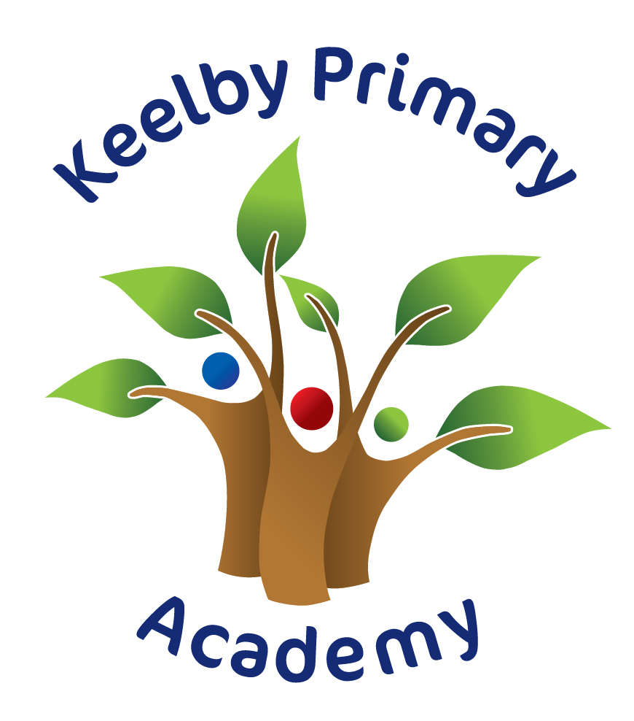

Parent Guide to Live Lessons

and Live Meets on Teams @ Keelby

2020/2021

At Keelby we will use Microsoft Teams as our digital platform to share lessons and meets remotely.

Sign in method

You can download the Teams App on to your computer, laptop, phone or tablet. This makes it quicker and simpler to log in and has more functions than using the web page. Once logged in, you may remain logged into Teams but please ensure that you keep your login information secure, as you are responsible for protecting your child’s password.

Finding your way around Microsoft Teams

My Teams

Once your child has logged in to Teams, they will be able to see their class which has been pre-made for them by their class teacher.



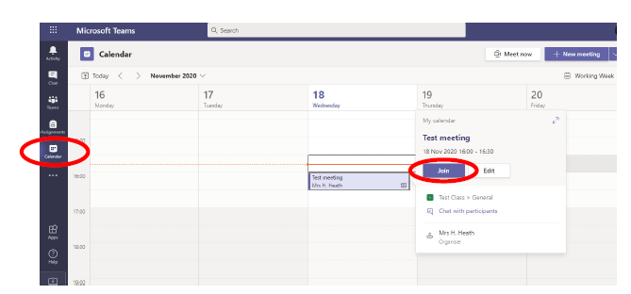

The live lessons indicated on the class timetable will appear in calendar as above. You simply click the lesson box and then click join.

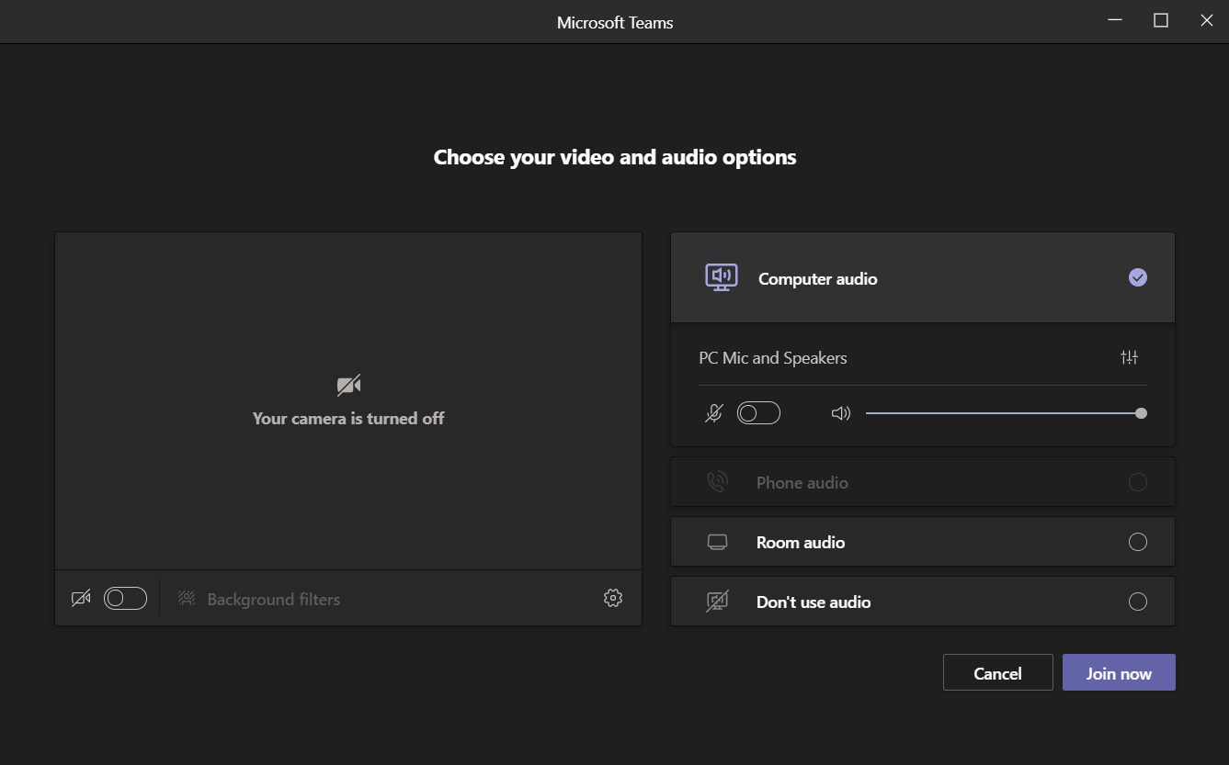

This screen will appear. Please ensure that the microphone is turned off but the camera is turned on. The teacher will give children the opportunity to switch the camera off later in the lesson if you prefer. The teacher will also ask the children to unmute their microphone at different points during the lesson.

Click Join now and you will wait in the lobby until the teacher admits you at the start of the lesson.

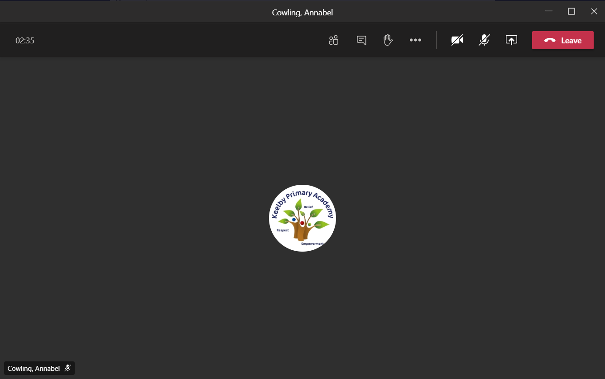

Children are asked to raise their ‘virtual hand’ if they would like to answer questions or ask for any help.

Private Chat

Please note that the private chat functions have been disabled for all children. All communication on Teams is monitored by staff. All live sessions are recorded by staff. Children should only use Teams to communicate with teachers during live sessions.

More Information

For more information on expectations please refer to the Keelby Remote Learning Policy and Pupils Remote Learning Acceptable User Guide.