Keelby Primary Academy
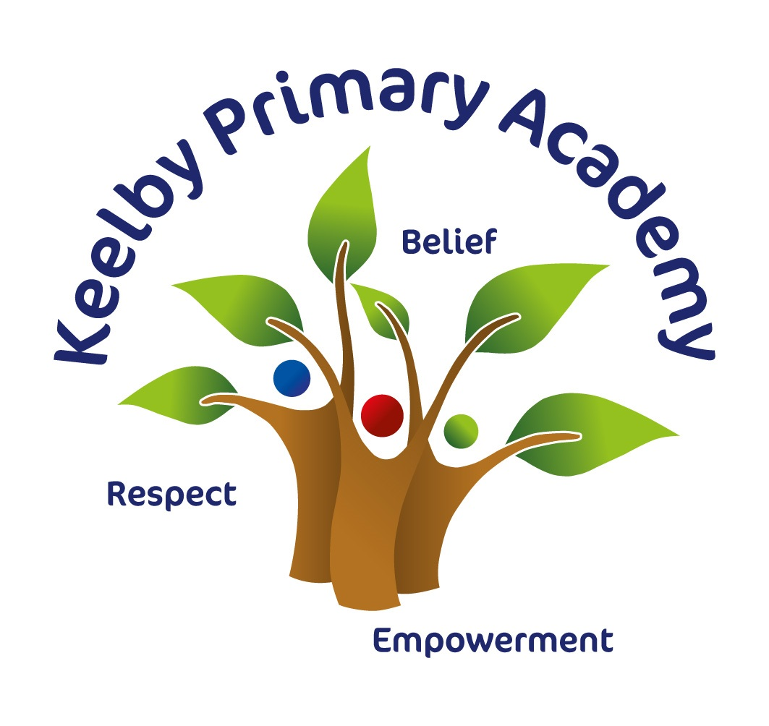
Personal Development Curriculum
2022-23
Personal Development at Keelby Primary Academy:

Our curriculum extends far beyond the academic, to allow pupils to develop in many diverse aspects of life. This is encapsulated in our Personal Development Curriculum.

We aim to ensure that, over their time at Keelby, learners receive a Personal Development programme that gives them the knowledge that they need to make decisions, to strengthen them personally and to allow them to develop their character and personality. We provide these rich experiences in a coherently planned way, in the curriculum and through extra-curricular activities.

At Keelby, there are four key drivers that underpin our Personal Development approach:
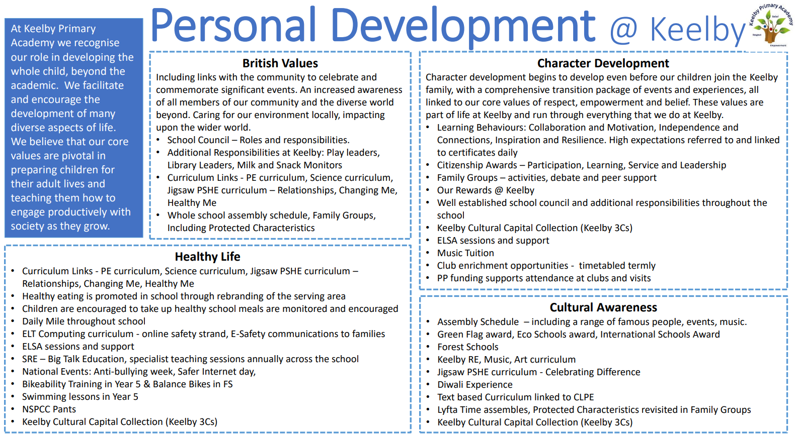
Personal Development Curriculum Overview:

Some areas of our personal development approach are taught through subjects with their own curriculum, e.g. our PSHE curriculum, or the online safety strand of our Computing curriculum. Other aspects are taught discretely. The following table illustrates which aspects are taught through which approach.

 | Aspect of Personal Development |  | Integrated area of wider school curriculum | Discrete personal development curriculum
Healthy Life  Including; Relationship Education, Sex Education, Physical Health, Mental Wellbeing, Wider Safety |  | - Jigsaw PSHE curriculum – Healthy Me, Relationships, Changing Me  - Rising Stars PE curriculum  - Computing Curriculum – online safety strand  - Whole-school mental health approach supported by ELSA |  | - Anti-bullying week  - E-safety days  - NSPCC Pants  - Mini First Aid (Y4, Y5 & Y6)  - Bikability Training (Y5)  - Big Talk Education  - Swimming
Cultural Awareness  Including; Economic Understanding, Understanding Media and Technology, Spiritual, Social, Moral, Cultural |  | - Jigsaw PSHE curriculum – Dreams & Goals  - Discovery RE Curriculum  - Individual, ongoing subject contribution to SMSC |  | - BBC Newsround  - Charity events and fundraising  - E-safety day – February  - An evening with Y6 (Dinner party planning)
Character Development  Including; development of character, confidence and resilience, citizenship, wider opportunities |  | - Jigsaw PSHE curriculum – Being Me In My World, Celebrating Difference,  - School values  - Commando Joes curriculum (RESPECT framework)  - School Learning Behaviours  - Extra-curricular clubs programme (Example APPENDIX 3)  - Instrument tuition programme  - Rewards at Keelby (Appendix 2)  - Christmas performances & other performances (e.g. music) |  | - Cultural Capital Collection or 3Cs (Appendix 1)  - Residential Trip (Y2, Y4, Y6)  - Charity opportunities e.g. Comic Relief, Children In Need  - Character Development Award  - Pupil leadership roles (PD reps, Eco-club, librarians, play leaders)
British Values  Including; Democracy, Rule of Law, Respect & Tolerance, Individual Liberty. This also includes elements of citizenship. |  | - Jigsaw PSHE curriculum – Being Me In My World, Celebrating Difference  - Ongoing subject contribution to British Values  - Discovery RE Curriculum  - School Council |  | - British Values assembly programme  - Current events  - Family Groups linked to Protected Characteristics  - PD Reps

Discrete Personal Development Long Term Plan:

 | Autumn 1 | Autumn 2 | Spring 1 | Spring 2 | Summer 1 | Summer 2
Discrete personal development curriculum (lesson time) | Safe behaviours:  NSPCC PANTS (EYFS & KS1)  SJA: First Aid (KS2)  British Values  (in Jigsaw time)  Discrimination (KS2) | Safe behaviours:  Anti-Bullying  British Values  (in Jigsaw time)  Democracy (KS2) | Safe behaviours:  NSPCC Speak Out Stay Safe  British Values  (in Jigsaw time)  Rule of law – the big legal lesson |  | Safe behaviours:  Soltan Sunready | Awareness of the world:  Economic Understanding (summer fayre)
Example of Special Events/ Days | National Poetry Day  (6/10/22)  Harvest Festival  (7/10/22)  Black History Month – each year group to have a famous person to study  Promotion of Healthy lunches  (6/10/22)  McMillan coffee morning  (27/09/22)  Open the Book- Bible Stories Assembly  (27/09/22)  World Mental Health Day  (14/10/22) | Christmas Performances (December)  Children In Need (18/11/22)  Anti-Bullying Week (including workshops)  Christingle Service- Vicar in school  Remembrance Service at Cenotaph  (11/11/22)  Book Fayre  (9/11/22)  Christmas Lunch  (14/12/22)  Christmas Fayre  (2/12/22) | Promotion of Healthy lunches  (2/02/23)  Chinese New Year  (2/2/23)  Safer Internet Day  (7/2/23) | World Book Day  (2/3/23)  British Science Week  (w/c 14/3/23)  Bike ability  (20/2/23)  Move more in March  Comic Relief  (17/3/23)  Mini first Aid (KS2)  (7/3/23)  Local Artist workshop (FS,Y3, 4, 5)  School Art Gallery open to Public- (30/3/23) | Earth Day  (22/4/23)  Promotion of Healthy lunches  (18/05/23)  Yr4 Residential Whitby  (11-12/05/23)  Year workshop – Artist Andy P  (15/05/23)  Performing Arts- Theatre Trip  (21/5/23) | Pride & Diversity Week - each year group to have a famous person to study  (w/c 26/6/23)  Y6 Swimming lessons  Big Talk Education- Whole school SRE  (7/6/23)  Sports Days  FS/KS1- 21/6/23  KS2- 22/6/23  Summer Fayre  (30/6/23)  Perming Arts club performance- (11/7/23)  An evening with Y6- (17/6/23)

APPENDIX 1:
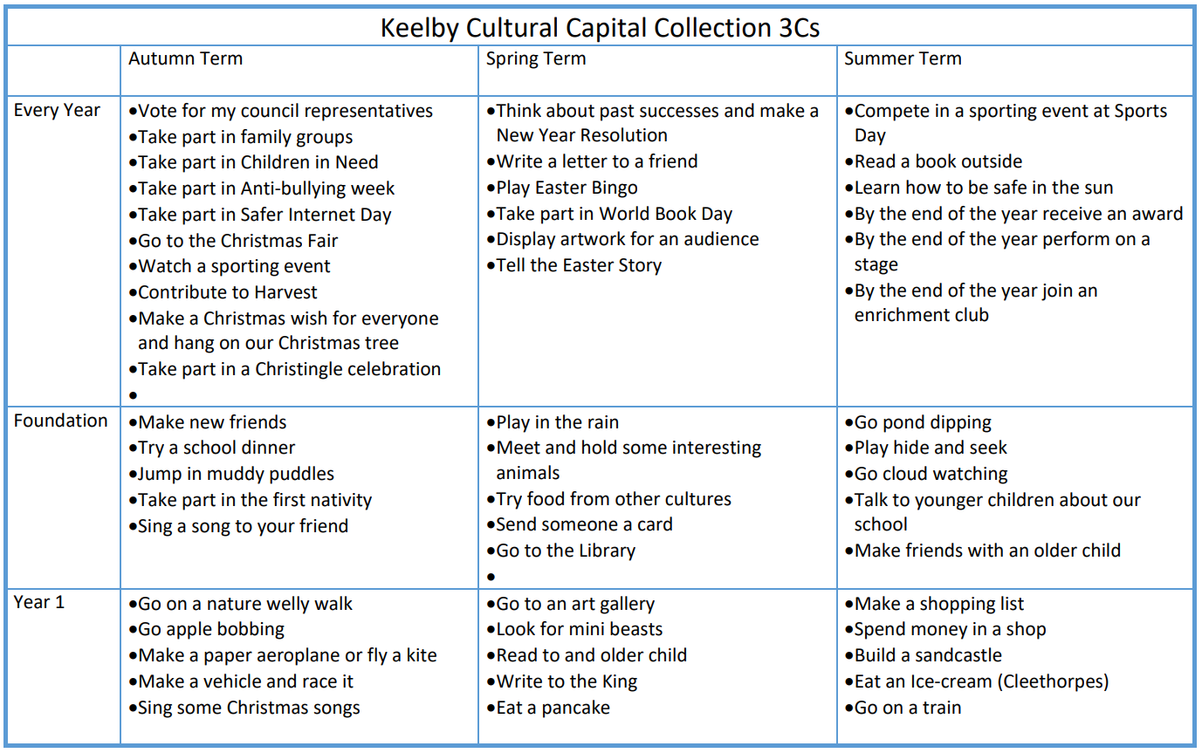
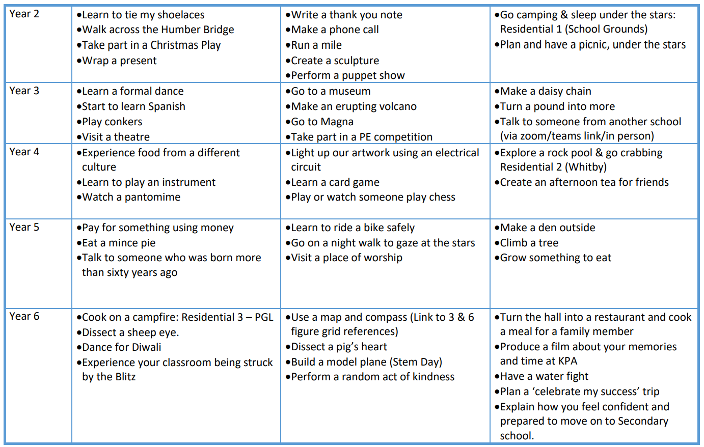

APPENDIX 2:
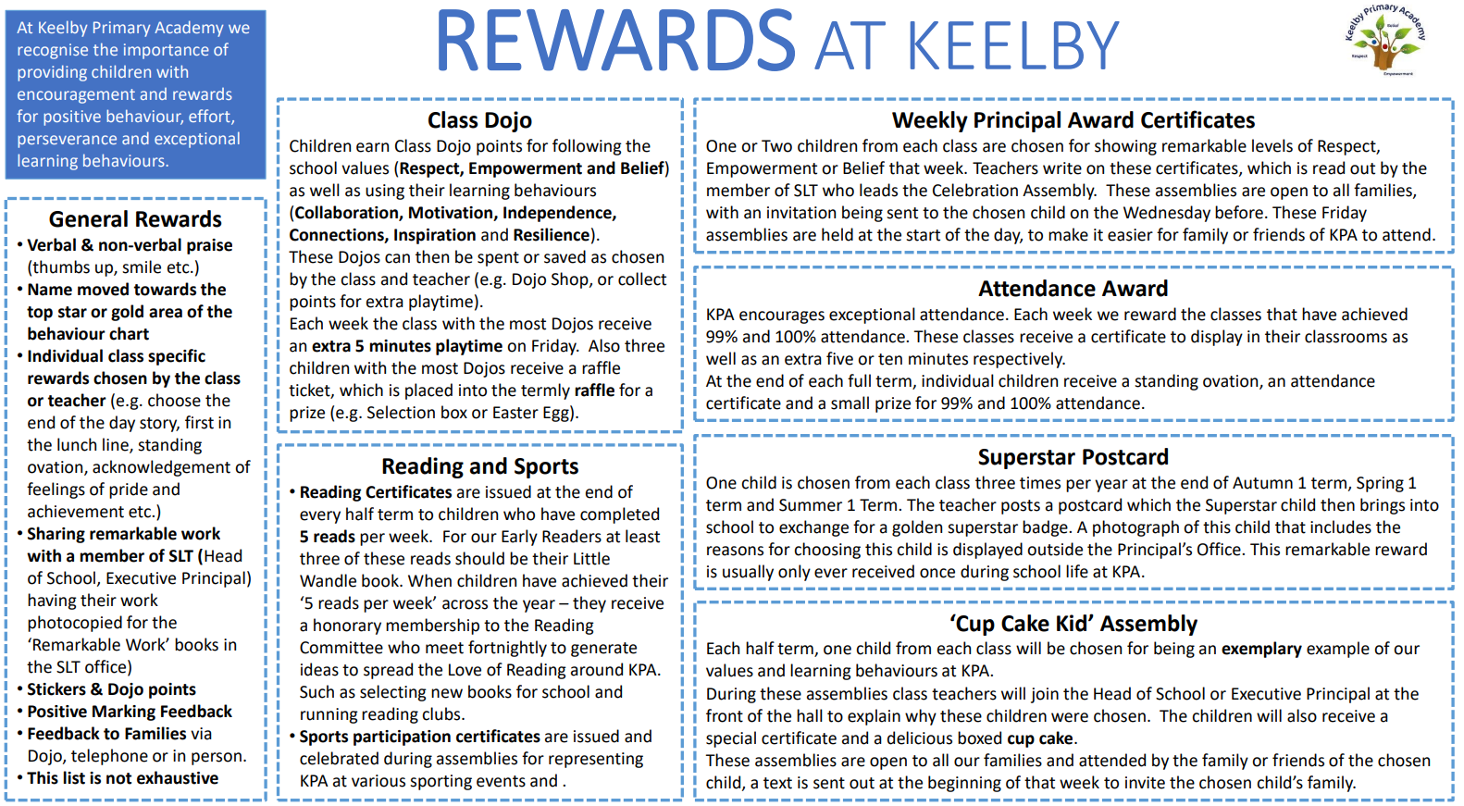

APPENDIX 3:
