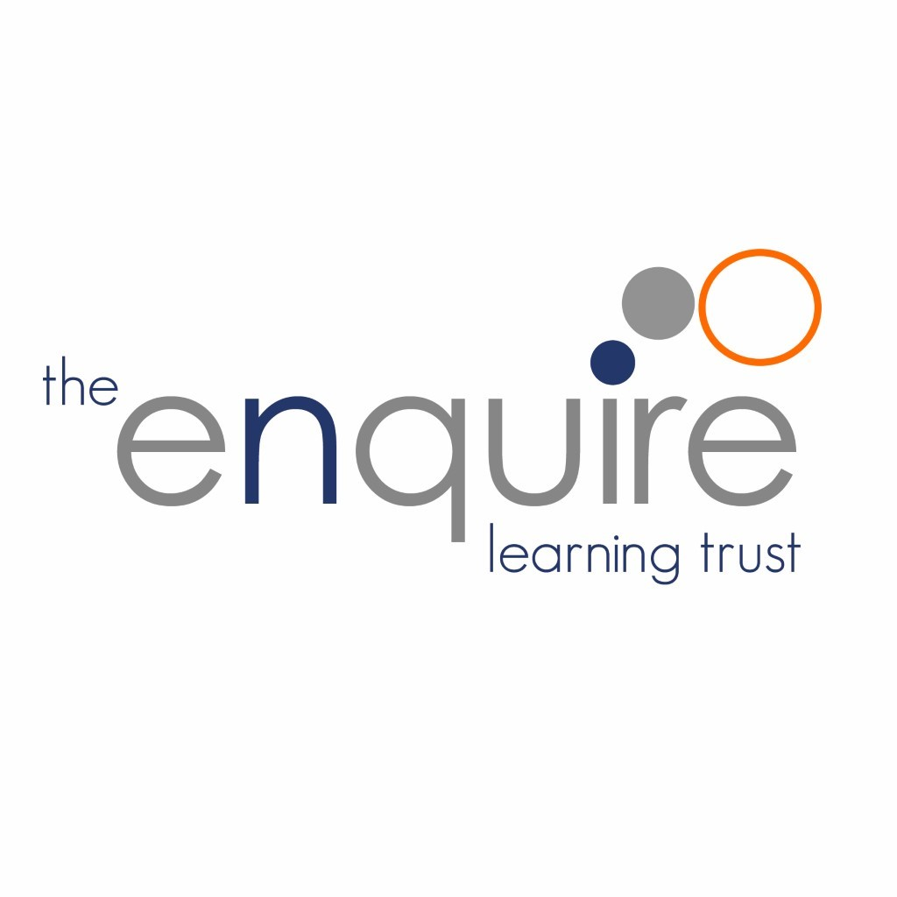
Relationships and Sex Education Policy

Contents

1. | Aims | 3
2. | Statutory requirements | 3
3 | Policy Development | 4
4. | Definition | 4
5. | Curriculum | 4
6. | Delivery of RSE | 5
7. | Roles and Responsibilities | 6
8. | Parents’ right to withdraw | 6
9. | Training | 6
10. | Monitoring arrangements | 7
11. | Appendix 1: Curriculum map | 8
12. | Appendix 2: By the end of primary school pupils should know | 9
13. | Review of this Policy | 12

Version History

Date | Author | Version | Comment
Sept 2020 | A Cowling | V1 | New Policy
Sept 2021 | A Atkin | V2 | Updated version

1. Aims

The aims of relationships and sex education (RSE) in our Trust are to:
- Provide a framework in which sensitive discussions can take place
- Prepare pupils for puberty, and give them an understanding of sexual development and the importance of health and hygiene
- Help pupils develop feelings of self-respect, confidence and empathy
- Create a positive culture around issues of sexuality and relationships
- Teach pupils the correct vocabulary to describe themselves and their bodies

We believe that knowledge empowers and protects children as long as it is age-appropriate. At secondary school Sex Education is statutory and we believe that primary schools should prepare children with accurate knowledge about puberty and human reproduction before they transfer to secondary school. Correct terminology for body parts is introduced early to normalise this biological vocabulary and to support safeguarding. These words are not used in isolation but always in conjunction, ensuring children know these are private parts of their bodies.

2. Statutory requirements

As a Trust we must provide relationships education to all pupils as per section 34 of the Children and Social work act 2017.

We do not have to follow the National Curriculum but we are expected to offer all pupils a curriculum that is similar to the National Curriculum including requirements to teach science which would include the elements of sex education contained in the science curriculum.
In teaching RSE, we are required by our funding agreements to have regard to guidance issued by the secretary of state as outlined in section 403 of the Education Act 1996.
At The Enquire Learning Trust we teach RSE as set out in this policy.

This policy complies with our funding agreement and articles of association.

3. Policy development

This policy has been developed in consultation with staff, pupils and parents. The consultation and policy development process involved the following steps:
- Review – a Director pulled together all relevant information including relevant national and local guidance

- Staff consultation – all school staff were given the opportunity to look at the policy and make recommendations

- Parent/stakeholder consultation – parents and any interested parties were invited to attend a meeting about the policy

- Pupil consultation – we investigated what exactly pupils want from their RSE

- Ratification – once amendments were made, the policy was shared with governors and ratified

4. Definition
RSE is about the emotional, social and cultural development of pupils, and involves learning about relationships, sexual health, sexuality, healthy lifestyles, diversity and personal identity.
RSE involves a combination of sharing information, and exploring issues and values.
RSE is not about the promotion of sexual activity.

5. Curriculum
Our curriculum is set out as per Appendix 1 but we may need to adapt it as and when necessary.
We have developed the curriculum in consultation with parents, pupils and staff, taking into account the age, needs and feelings of pupils. If pupils ask questions outside the scope of this policy, teachers will respond in an appropriate manner so they are fully informed and don’t seek answers online.
Our school works with BigTalk Education, an award-winning team of specialist RSE facilitators led by Lynnette Smith, who is the Chair of the Sex Education Forum’s Advisory Group (the SEF is part of the National Children’s Bureau). BigTalk Education’s Growing Up Safe: Whole School Approach (GUS programme) has been recognised by the Family Planning Association and Children and Young People Now Awards as a Finalist in their Safeguarding Award.
The BigTalk team then deliver to each class within school. Our teaching staff observe the BigTalk Education RE and RSE lessons as part of their CPD programme to ensure they can reinforce the lesson content and answer any follow up questions throughout the academic year.

For more information about our curriculum, see our curriculum map in Appendix 1.

6. Delivery of RSE.
RSE is taught within the personal, social, health and economic (PSHE) education curriculum. Biological aspects of RSE are taught within the science curriculum, and other aspects are included in religious education (RE).

Relationships education focuses on teaching the fundamental building blocks and characteristics of positive relationships including:
- Families and people who care for me
- Caring friendships
- Respectful relationships
- Online relationships
- Being safe
For more information about our RSE curriculum, see Appendices 1 and 2.

These areas of learning are taught within the context of family life taking care to ensure that there is no stigmatisation of children based on their home circumstances (families can include single parent families, LGBT parents, families headed by grandparents, adoptive parents, foster parents/carers amongst other structures) along with reflecting sensitively that some children may have a different structure of support around them (for example: looked after children or young carers).

7. Roles and responsibilities
7.1 The Board of Trustees
The Trustees will approve the RSE policy, and hold the Principal to account for its implementation.
7.2 The Principal
The Principal is responsible for ensuring that RSE is taught consistently across the academy, and for managing requests to withdraw pupils from components of RSE (see section 8).
7.3 Staff
Staff are responsible for:
- Delivering RSE in a sensitive way
- Modelling positive attitudes to RSE
- Monitoring progress
- Responding to the needs of individual pupils
- Responding appropriately to pupils whose parents wish them to be withdrawn from the components of RSE
Staff do not have the right to opt out of teaching RSE. Staff who have concerns about teaching RSE are encouraged to discuss this with the Principal.
All teaching staff are responsible for teaching RSE to their classes.
7.4 Pupils
Pupils are expected to engage fully in RSE and, when discussing issues related to RSE, treat others with respect and sensitivity.

8. Parents’ right to withdraw

Parents do not have the right to withdraw their children from relationships education.
Parents have the right to withdraw their children from the [non-statutory/non-science] components of sex education within RSE.
Requests for withdrawal should be put in writing using the form found in Appendix 3 of this policy and addressed to the headteacher.
Alternative work will be given to pupils who are withdrawn from sex education.

9. Training

Staff are trained on the delivery of RSE as part of their induction and it is included in our continuing professional development calendar.
The Principal will also invite visitors from outside the academy, such as school nurses or sexual health professionals, to provide support and training to staff teaching RSE.

10. Monitoring arrangements

The delivery of RSE is monitored by the Principal through: enquiries and lesson observations.
Pupils’ development in RSE is monitored by class teachers as part of our internal assessment systems.
This policy will be reviewed by the Board of Trustees annually.

11. Appendix 1: Curriculum map
Health,Relationships and sex education curriculum map

Year group | Term | Topic/theme details | Resources
FS | Spring 2 | Healthy Me:  - I understand that I need to exercise to keep my body healthy  - I understand how moving and resting are good for my body  - I know which foods are healthy and not  - I know how to help myself go to sleep and understand why sleep is good for me  - I can wash my hands thoroughly and understand why this is important  - I know what a stranger is and how to stay safe if a stranger approaches me
FS | Summer 1 | Relationships:  - I can identify some of the jobs I do in my family and how I feel like I belong  - I know how to make friends to stop myself from feeling lonely  - I can think of ways to solve problems and stay friends  - I am starting to understand the impact of unkind words  - I can use calm me time to manage my feelings  - I know how to be a good friend
FS | Summer 2 | Changing Me:  - I can name parts of the body  - I can tell you some things I can do and foods I can eat to be healthy  - I understand that we all grow from babies to adults  - I can express how I feel about moving to Year 1  - I can talk about my worries and the things I am looking forward to in Year1  - I can share my memories and the best bits of this year  Big Talk:  - I know the differences between boys and girls, naming body parts, correct scientific words, private areas of the body, good touches and bad touches.  - I can identify happy situations within relationships, and those which may be risky (e.g., other children or adults taking improper photographs of them, inappropriate touches, exposure to unsuitable media etc.)  - I know who I can talk to if I am worried. | Large paper big enough to fit the outline of a child on  Post-its or labels of body parts Book: ‘Look Inside Your Body’ by Louie Stowell  Book: ‘Tell Me What It’s Like To Be Big’, by Joyce Dunbar  Book: ‘I Wonder Why Kangaroos Have Pouches’, by Jenny Wood  Picture cards showing different developmental stages of life ranging from baby to elderly
Year 1 | Spring 2 | Healthy Me:  - Being healthy  - Healthy choices  - Clean and healthy  - Medicine safety  - Road safety
Year 1 | Summer 1 | Relationships:  - Families  - Making friends  - Greetings  - People who help us  - Being my own best friend  - Celebrating special relationships
Year 1 | Summer 2 | Changing Me:  - I am string to understand the life cycles of animals and humans  - I can tell you some things about me that have changed and some that have stayed the same.  - I can tell how my body has changed since I was a baby  - I can identify body parts that make boys and girls different and use the correct names for these: penis, testicles, vagina and anus  - I understand that every time I learn something new I change a little bit  - I can tell you about changes that have happened in my life  Big Talk:  - I know the differences between boys and girls, naming body parts, correct scientific words, private areas of the body, good touches and bad touches.  - I can identify happy situations within relationships, and those which may be risky (e.g., other children or adults taking improper photographs of them, inappropriate touches, exposure to unsuitable media etc.)  - I know who I can talk to if I am worried.. | Male/female animal PowerPoint, PE hoops or flipchart paper, Body parts cards, PowerPoint of body parts,
Year 2 | Spring 2 | Healthy Me:  - Being Healthy  - Being Relaxed  - Medicine Safety  - Healthy Eating  - Healthy Eating
Year 2 | Summer 1 | Relationships:  - Families  - Keeping safe and physical contact- know that some physical contact in a family is acceptable and some is not  - Friends and conflict  - Secrets  - Trust and appreciation
Year 2 | Summer 2 | Changing Me:  - I can recognise cycles of life in nature  - I can tell you about growing from young to old  - I can recognise my how body has changed from being a baby  - I can recognise the physical differences between boys and girls, use the correct names for body parts (penis, anus, testicles, vagina) and appreciate that some parts of my body are private  - I understand that there are different types of touch and can tell which ones I like and don’t like  Big Talk:  - I know the differences between boys and girls, naming body parts, correct scientific words, private areas of the body, good touches and bad touches.  - I can identify happy situations within relationships, and those which may be risky (e.g., other children or adults taking improper photographs of them, inappropriate touches, exposure to unsuitable media etc.)  - I know who I can talk to if I am worried. | Body parts cards (2 sets so you have duplicates of some cards), A bag or laundry-type basket containing a collection of girls’ and boys’ clothes including underwear and swim suits,
Year 3 | Spring 2 | Healthy Me:  - Being fit and healthy  - Being fit and healthy  - What do I know about drugs?  - Being safe- people and place I need to keep safe from, know strategies for keeping safe, who to go to for help and how to call the emergency services  - Safe or unsafe
Year 3 | Summer 1 | Relationships:  - Families roles and responsibilities  - Friendship- being a good listener  - Keeping myself safe online  - Being a global citizen 1  - Being an global citizen 2
Year 3 | Summer 2 | Changing Me:  - I understand that in animals and humans lots of changes happen between conception and growing up, and that usually it it the female who has the baby  - I understand how babies grow and develop in the mothers uterus, I understand what a baby needs to grow  - I understand that boys and girls bodies grow and change on the outside  - I know that boys and girls bodies change on the inside and can say why these changes are necessary to make babies  - I can start to realise stereotypical ideas I might have about parenting and family roles  Big Talk:  - I know the differences between boys and girls, naming body parts, correct scientific words, private areas of the body, good touches and bad touches.  - I can identify happy situations within relationships, and those which may be risky (e.g., other children or adults taking improper photographs of them, inappropriate touches, exposure to unsuitable media etc.)  - I know who I can talk to if I am worried. | Outline figure of a body on large flipchart paper, Set of Body Change cards, PowerPoint slides: Body Changes,  PowerPoint slides: Changes on the inside, Animations (moving diagrams): Male and Female Reproductive Systems, ‘
Year 4 | Spring 2 | Healthy Me:  - My Friends and me  - Group dynamics  - Smoking  - Alcohol  - Healthy Friendships
Year 4 | Summer 1 | Relationships:  - Jealousy  - Love and Loss  - Memories  - Getting on and Falling out  - Girlfriends and Boyfriends- understand that this is a special relationship for when I get older
Year 4 | Summer 2 | Changing Me:  - I understand that some of my characteristics have come from my birth parents- I am made from the joining of their egg and sperm  - I can name and label the human parts that are necessary for making a baby  - I know girls bodies change ready for them to have babies as adults- menstruation (having periods) is a natural part of this.  - I know how a circle of change works  - Accepting change beyond my control  Big Talk:  - I know there are different kinds of families, similarities and differences between boys and girls, the emotional and physical changes of growing up (puberty) how babies are made, then develop in the womb etc. (reproduction).  - I know how to look after my body and how to be safe and healthy. | How do I feel about puberty?’ cards, Jigsaw Chime, ‘Calm Me’ script, A ‘bag of tricks’ – a mystery bag containing a collection of items relating to puberty and growing up- see lesson plan for suggestions, Animation:The Female Reproductive System, PowerPoint slide of internal female organs, Sets of Menstruation Cards
Year 5 | Spring 2 | Healthy Me:  - Smoking – know the health risks  - Alcohol- know the risks of alcohol misuse  - Emergency Aid- getting help  - Body Image- social media  - Relationships with food- eating disorders
Year 5 | Summer 1 | Relationships:  - Recognising Me- characteristics and qualities  - Safety with online communities  - Being in an online community  - Online gaming  - My relationship with technology- screen time  - Relationships and technology
Year 5 | Summer 2 | Changing Me:  - I am aware of my own self-image and how my body image fits into that  - I can explain that a girls body changes during puberty  - I can describe how a boys body changes during puberty  - Conception- I understand that sexual intercourse can lead to conception and that’s how babies are made  - I can identify what I’m looking forward to about being a teenager  Big Talk:  - I can ask questions about puberty and reproductions.  - I can ask questions and know more about the development of babies and how they are born.  - I know there is someone in school as well as at home if they want help, advice or more information etc. (Information at this stage is vital to protect them as they move onto Secondary School and to provide an alternative to Google etc.) | Animation: The Female Reproductive System, Menstruation Card Match, A range of sanitary products,  Animation: The Male Reproductive System, PowerPoint slide: Male organs, Boys ‘n’ Puberty Quiz  The Female Reproductive System and The Male Reproductive System, Having A Baby, Diamond 9 cards, PowerPoint slides: A Baby in the Womb, The Truth About Conception and Pregnancy
Year 6 | Spring 2 | Healthy Me:  - Taking responsibility for my own health and well being  - Drugs- know about different types of drugs  - Exploitation- I understand that some people can be exploited and its against the law  - Gangs  - Emotional and mental health  - Managing stress and pressure
Year 6 | Summer 1 | Relationships:  - What is mental health?  - My mental health  - Love and Loss- different stages of grief  - Power and control- when people are trying to gain control  - Being online: Real or Fake? Safe or unsafe?  - Using Technology responsibly
Year 6 | Summer 2 | Changing Me:  - My self image- I am aware of my own self image  - Puberty- I understand how our bodies change and how to look after ourselves  - Babies- Conception to birth- I can describe how a baby develops from conception through nine months of pregnancy and how it is born  - Boyfriends and girlfriends- I understand how being attracted to someone changes the nature of the relationship  - Real self and ideal self- positive self esteem  - The year ahead- transition into secondary  Big Talk:  - I can ask questions about puberty and reproductions.  - I can ask questions and know more about the development of babies and how they are born.  - I know there is someone in school as well as at home if they want help, advice or more information etc. (Information at this stage is vital to protect them as they move onto Secondary School and to provide an alternative to Google etc.)

12. Appendix 2: By the end of primary school pupils should know
Topic | Pupils should know
Families and people who care about me | - That families are important for children growing up because they can give love, security and stability  - The characteristics of healthy family life, commitment to each other, including in times of difficulty, protection and care for children and other family members, the importance of spending time together and sharing each other’s lives  - That others’ families, either in the academy or in the wider world, sometimes look different from their family, but that they should respect those differences and know that other children’s families are also characterised by love and care  - That stable, caring relationships, which may be of different types, are at the heart of happy families, and are important for children’s security as they grow up  - That marriage represents a formal and legally recognised commitment of two people to each other which is intended to be lifelong  - How to recognise if family relationships are making them feel unhappy or unsafe, and how to seek help or advice from others if needed
Caring friendships | - How important friendships are in making us feel happy and secure, and how people choose and make friends  - The characteristics of friendships, including mutual respect, truthfulness, trustworthiness, loyalty, kindness, generosity, trust, sharing interests and experiences and support with problems and difficulties  - That healthy friendships are positive and welcoming towards others, and do not make others feel lonely or excluded  - That most friendships have ups and downs, and that these can often be worked through so that the friendship is repaired or even strengthened, and that resorting to violence is never right  - How to recognise who to trust and who not to trust, how to judge when a friendship is making them feel unhappy or uncomfortable, managing conflict, how to manage these situations and how to seek help or advice from others, if needed
Respectful relationships | - The importance of respecting others, even when they are very different from them (for example, physically, in character, personality or backgrounds), or make different choices or have different preferences or beliefs  - Practical steps they can take in a range of different contexts to improve or support respectful relationships  - The conventions of courtesy and manners  - The importance of self-respect and how this links to their own happiness  - That in the academy and in wider society they can expect to be treated with respect by others, and that in turn they should show due respect to others, including those in positions of authority  - About different types of bullying (including cyberbullying), the impact of bullying, responsibilities of bystanders (primarily reporting bullying to an adult) and how to get help  - What a stereotype is, and how stereotypes can be unfair, negative or destructive  - The importance of permission-seeking and giving in relationships with friends, peers and adults
Online relationships | - That people sometimes behave differently online, including by pretending to be someone they are not  - That the same principles apply to online relationships as to face-to face relationships, including the importance of respect for others online including when we are anonymous  - The rules and principles for keeping safe online, how to recognise risks, harmful content and contact, and how to report them  - How to critically consider their online friendships and sources of information including awareness of the risks associated with people they have never met  - How information and data is shared and used online
Being safe | - What sorts of boundaries are appropriate in friendships with peers and others (including in a digital context)  - About the concept of privacy and the implications of it for both children and adults; including that it is not always right to keep secrets if they relate to being safe  - That each person’s body belongs to them, and the differences between appropriate and inappropriate or unsafe physical, and other, contact  - How to respond safely and appropriately to adults they may encounter (in all contexts, including online) whom they do not know  - How to recognise and report feelings of being unsafe or feeling bad about any adult  - How to ask for advice or help for themselves or others, and to keep trying until they are heard  - How to report concerns or abuse, and the vocabulary and confidence needed to do so  - Where to get advice e.g. family, academy and/or other sources

13. Review of this Policy

Trustees to review this policy every 3 years. It may however review this policy earlier than this if the government produces new regulations, or if it receives recommendations on how this policy might be improved

