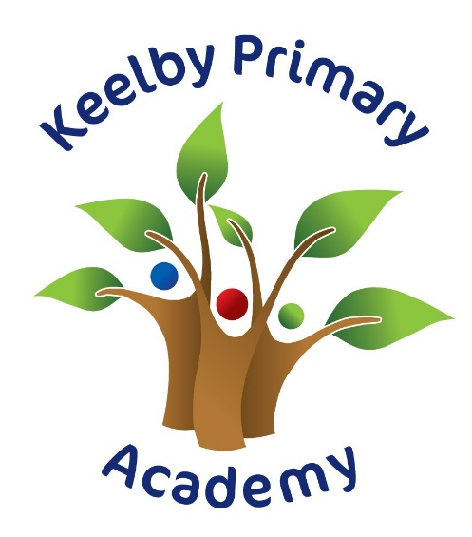
Spanish KS2 Mixed-Age Intent, Implementation, Impact
Intent

Learners will
- Develop resilience in language learning as well as enjoyment of it through a challenging scheme of work
- Acquire language learning strategies for memorisation and retrieval as well as for listening, reading and understanding
- Be able to manipulate language to speak or write sentences creatively using prior knowledge of grammar and key features
- Have a sound grasp of the key sounds of the Spanish language and be able to apply this knowledge when speaking, listening and reading aloud
- Recognise some of the language patterns of Spanish and how these differ or are similar to English
- Appreciate and be able to copy the sound of the language at text level through songs, stories and rhymes
- Have a deeper understanding of cultural differences and similarities
- Demonstrate substantial progress in learning Spanish and work towards or meet the targets of the KS2 Programme of Study for Languages
Skills and Knowledge
See the ‘MFL Primary Spanish Overview’ document for specific learning objectives and content.
Skills (Years 3 and 4 / Years 5 and 6)
- Listen, read and show understanding of single words / more complex familiar phrases and sentences in texts
- Listen, read and show understanding of short phrases in texts as well as songs and rhymes /
more complex sentences using familiar and unfamiliar words
- Recognise a familiar question and respond
- Ask and answer several simple and familiar questions / more complex familiar questions
- Write and say a sentence with single familiar words and a connective with support and confident to attempt it without / a simple or more complex phrase to describe people, places and things with a language scaffold as well as be confident to do the same without support
- Recognise some letter strings and pronounce them in familiar words
- Read aloud short familiar sentences / more complex familiar sentences and pronounce unfamiliar words in a sentence with a high degree of accuracy using knowledge of phonics
- Use strategies for memorising vocabulary
- Join in with the actions of familiar songs, stories and rhymes sometimes from memory / follow the text of a familiar rhyme, song or story and identify the meaning of the words
- Read aloud the text of familiar songs, rhymes and stories

Knowledge

- Awareness that Spanish is spoken in other countries besides Spain
- Awareness that there are 2 groups of nouns in Spanish (masculine and feminine)
- Awareness that letters in Spanish can make a different sound to English and the top tip rules for correct pronunciation
- Formation of a question with rising intonation
- Awareness of silent ‘h’
- Rules for making nouns plural
- Rules of agreement of adjectives in the singular and plural
- Position of majority of adjectives in a sentence
- Making a sentence say not
- Position of colour adjectives in a sentence
- Use of singular and plural possessive adjectives
- Traditional songs and rhymes

Implementation

- Pupils currently have 1 x lesson per week of Spanish in blocks of 5 or 6 weeks (alternate terms)
- Lessons are designed to be progressive and build on prior learning, moving from word to sentence level
- Lessons include support for the less able and extension tasks for the more able
- Lesson activities are challenging, varied and interactive and develop listening, reading, speaking and writing skills
- Interactive resources with audio support are used
- The choice of vocabulary ensures exposure to all the key phonic sounds and ability to build sentences using grammatical knowledge
- Formative assessment in each lesson informs the planning and teaching of subsequent lessons

Impact

- All activities/tasks deliver the aims and subject content of the KS2 Languages Programmes of Study and in particular to those of the appropriate year groups as detailed above
- Pupils self-assess their progress at the end of each term using a traffic light system and comment on their grasp of the new knowledge
- Low-stake quizzes and end of term summative assessment to gather evidence of attainment and progress
- Based on the evidence, class teachers can inform parents/guardians of this, using reporting statements which relate to the expected targets of each year group (see Skills section)
- To enhance the impact on enjoyment and intercultural understanding, school leaders could consider organising language events and competitions, provide access to out-of-school online materials, take-home bags of resources, purchase class readers in the target language etc.
- All of the above provides evidence that the ‘statements of intent’ are met

