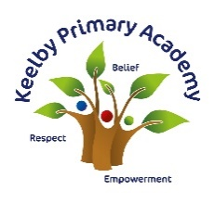
Vocabulary Intent, Implementation and Impact
at Keelby Primary Academy
Intent
‘Listening to and talking about stories and non-fiction develops children’s vocabulary... Understanding vocabulary is vital for comprehension and so also for wider learning and progress.’
- The Reading Framework (DfE, 2022)
At Keelby, we place high value on bridging the vocabulary gap because we know that having a good understanding of vocabulary will unlock understanding across all areas of life and learning. We dedicate time to the teaching of vocabulary, both discretely and incidentally. We know that vocabulary cannot be ‘caught’; it must be taught. We intend for our pupils to be able to use their rich understanding of vocabulary in order to be successful in all areas of their learning and communication: most importantly, to be able to access what they read and to sharpen their writing.
Implementation
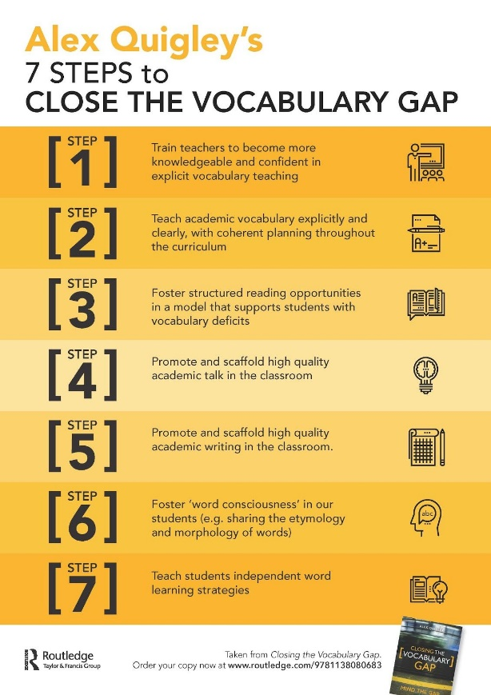
Vocabulary teaching practice at Keelby is research-informed. We base our teaching on the findings from Alex Quigley and Kelly Ashley, who have delved into the importance behind closing the vocabulary gap and what we can do to close this effectively. At Keelby, we are very aware that children’s life chances can depend on their level of vocabulary. We are therefore committed to planning and teaching vocabulary across all subject areas, and have placed vocabulary at the heart of our curriculum.
Our reading and writing curriculum centre around language-rich texts where children will explore language choices and the intentions behind them. Children will use these high-quality, vocabulary-rich texts as models for their own writing and vocabulary use.
In Key Stage 1 & 2, teachers teach a ‘Weekly Top Ten’ words. These ‘Top Ten’ words are carefully chosen in order to pre-teach vocabulary which children will encounter – or may choose to use themselves – throughout the week in their reading and writing. Children may expand their Weekly Top Ten by finding appropriate synonyms.
From Year 2, we follow the Jane Considine spelling approach, which focuses on etymology and morphology of words. Children make connections with new word meanings based on their weekly spelling investigations, which will include root word, prefix and suffix meanings.
In Key Stage 1 & 2, there is a central focus in wider curriculum subjects on vocabulary. All units of learning in our curriculum have a relevant and aspirational set of ‘Tier 3’ words which children will be taught explicitly. The curriculum vocabulary for each unit is revisited and revised across terms, and across year groups. Leaders have mapped out connections to these words in our 3D curriculum. We have also mapped out ‘Tier 2’ language coverage to be taught.
Impact
Our children will have developed schemas of word meaning based on the etymology and morphology of words they have learned. They make connections with vocabulary to be able to work out the meaning of new words. At Keelby, children are articulate with spoken word and also have good word comprehension.

