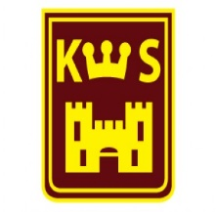
KENILWORTH PRIMARY SCHOOL
TERM DATES FOR THE ACADEMIC YEAR
2023 – 2024
Autumn Term 2023
Friday 1st September | School Closed - staff training day
Monday 4th September | School Closed – staff training day
Tuesday 5th September | First Day of Term – children return to school
Monday 23rd October –  Friday 27th October | Half Term Holiday
Friday 24th November | School Closed - Occasional Day
Wednesday 20th December | Last Day of Term – School Closes 1:30pm
Spring Term 2024
Thursday 4th January | First day of term – children return to school
Monday 19th February –  Friday 23rd February | Half Term Holiday
Thursday 28th March | Last Day of Term – School Closes 1:30pm
Summer Term 2024
Monday 15th April | First Day of Term – Children Return to School
Monday 6th May | School Closed – Bank Holiday
Monday 27th May-Friday 31st May | Half Term Holiday
Monday 3rd June | Staff training Day
Friday 19th July | Last day of term-school closes-1:30pm
Monday 22nd July | School closed – staff training day
Tuesday 23rd July | School closed – staff training day

Please Note
Absence for holidays should not be taken during term time and will only be authorised in exceptional circumstances. Please contact Mrs Ajose before any booking is made. Parents of Year 6 children: please avoid taking your child out of school for appointments etc during the months of April and May when end of Key Stage 2 SATS assessments usually take place.

