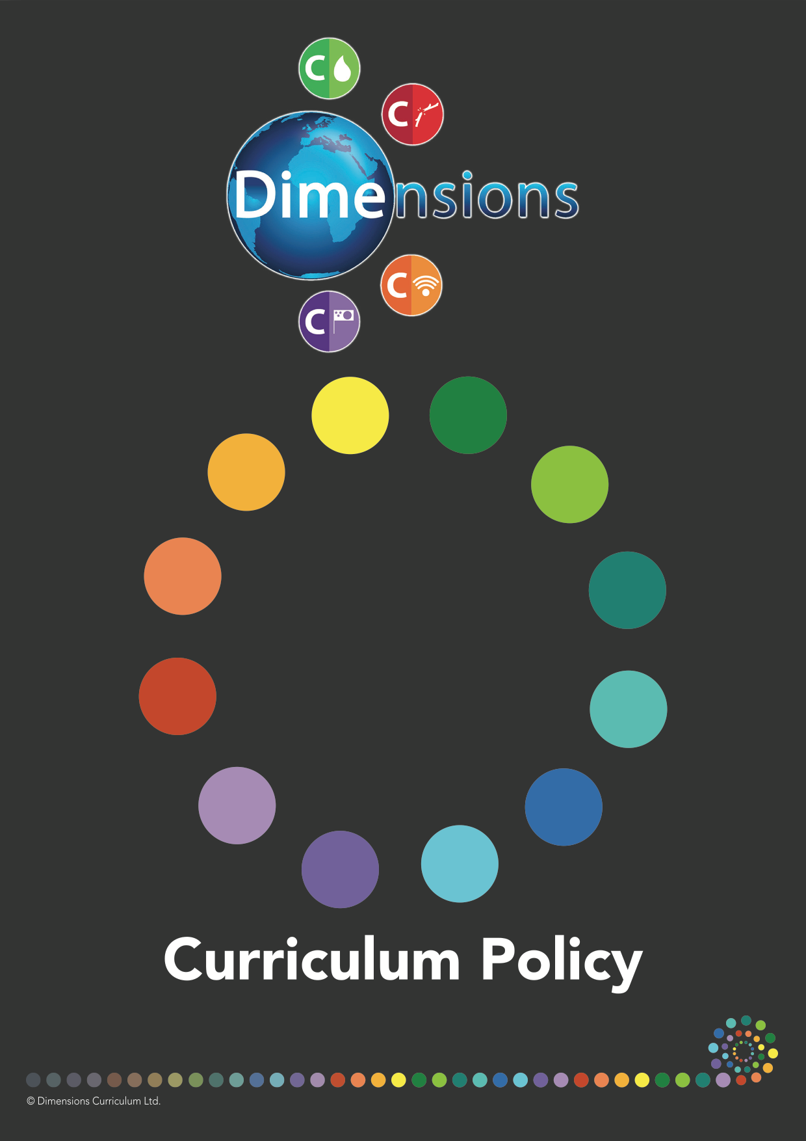
Foundation Subjects
February 2022
Insert Logo
Contents
Introduction | 3
The 4Cs  Communication  Conflict  Conservation  Culture | 4  4  4  4  4
Curriculum Depth | 5
Curriculum Breadth | 5
Curriculum Aims | 6
Subject Coverage  English  Mathematics  Science  Foundation Subjects  PSHE | 6  6  6  7  7  7
Curriculum Mapping | 7
Theme Cycles | 8
Curriculum Subject Overviews | 10
Assessment | 16

Introduction
Our personalised, cohesive ‘Learning Means the World’ curriculum is innovative, forward-thinking and highly relevant – dealing with tomorrow’s issues today. It is devoted to providing pupils with a broad and deep level of learning, developing fully rounded individuals, fuelling creativity and resulting in positive change.
Written outside the constraints of the National Curriculum, and yet with over 85% coverage, it is meticulously planned and fully resourced to develop pupils’ resilience, communication and life skills within real-life contexts.
Our curriculum is knowledge-rich and skills-based, providing the perfect blend of learning for pupils in a fast-changing and inter-dependent world.
‘Learning Means the World’ reflects the real world. It is a brave, forward thinking, buzzing, relevant curriculum that promotes independence, creativity and curiosity to help pupils become collaborators, innovators and leaders.
‘Learning Means the World’ takes an inter-disciplinary approach to learning and puts great emphasis on curriculum depth. It is ‘hands-on’, ‘minds-on’ and ‘hearts-on’ and makes pupil agency a key feature of the curriculum. The thematic approach to teaching and learning is designed to support children’s natural curiosity, stimulate their creativity and promote an appetite for, and love of, learning. It offers children the chance to engage in deep learning giving them the time they need to reflect, consolidate and transfer their learning.
Our Skills Ladder is the bedrock of our curriculum model, giving a clear upward trajectory of subject-specific, skills-based learning. Coupled with a system of knowledge progression, called Knowledge Building, this ensures rigour and coverage and provides subject leaders with a clear, birds-eye view of progression. Knowledge is sequenced and mapped deliberately with six distinct fundamental learning pillars for each subject using progressive cognitive blocks. These are then applied to each thematic unit in the form of knowledge statements, that increase in complexity through the key stages and provide a big picture of knowledge progression throughout the school.
Elements such as our Catalyst Questions, Pupil-Led Activities and Essential Learning Experiences also ensure a greater depth of learning. Concept Flows give a logical sequence to learning and the Learning Pathways ensure pupils experience clear progression in the defined characteristics of effective learning.

The 4Cs
At the forefront of ‘Learning Means the World’ are world issues centred around the four Cs of Communication, Conflict, Conservation and Culture.
Communication
Communication is the foundation of all human relationships and affects all aspects of our lives. It spreads knowledge and information across cultures, countries and generations. With more means of communication than ever, there are now even more ways to be misunderstood than ever. Having good communication skills involves being aware of both sender and receiver. Pupils need to learn how to communicate clearly and positively, using verbal and non-verbal skills to get their ideas and feelings across, to receive other people’s messages and to resolve conflict.
Conflict
Poverty and political, social, and economic inequalities between groups predispose them to conflict. Eight out of 10 of the world's poorest countries are suffering, or have recently suffered, from large scale violent conflict. Wars in developing countries have heavy human, economic, and social costs and are a major cause of poverty and underdevelopment. Understanding world history would be impossible without understanding the conflicts that have shaped it. Pupils need to learn how to handle disagreements constructively and resolve their differences without yelling and screaming, ignoring and sulking, whining and moaning or resorting to violence. Conflict can be seen as an opportunity for learning about and understanding our differences.
Conservation
The population of human beings has grown enormously in the past two centuries and billions of people use up resources quickly. It’s normal to feel powerless when faced with the enormity of world conservation issues, but pupils need to know that small actions can make a big difference.
Culture
Cultures evolve continuously, as people interact with one another, producing an intermingling of values, and material ways of life. Our communities are becoming increasingly diverse, creating a fusion of people of many religions, languages, economic and cultural groups. An understanding and appreciation of, and establishing relationships with people from, other cultures is vital in building and maintaining successful communities. An appreciation of cultural diversity goes hand-in-hand with a just and equitable society and helps to overcome and prevent racial and ethnic divisions. Pupils need to learn how culture affects perception, influences behaviour and shapes personalities.
Curriculum Depth
Our curriculum focuses on common attributes that ensure the provision of a deep curriculum and that underpin our thematic units:-
- Meaning and relevance
- Opportunities for enquiry
- Development of critical, creative and high order thinking skills
- Integration of subjects

- Provision of access to information from a range of sources and viewpoints
- Authenticity of end products
Curriculum Breadth
As well as the full breadth of subject coverage, our curriculum includes the use of a breadth of pedagogical approaches and offers a broad range of learning experiences.
Curriculum Aims
- To excite and enthuse learners and teachers
- To inspire stimulating learning environments
- To create purposeful, immersive and memorable learning
- To develop and deepen pupils’ skills, knowledge and understanding across the curriculum through a diverse range of themes
- To ensure a cohesive curriculum, where learning is built on systematically, improving and emphasising consistency and progression throughout the school
- To equip learners to become agents of change, exploring and championing global causes
- To support pupils in exploring challenging and controversial global and social justice issues
- To help pupils to make sense of our inter-connected world
- To help pupils to understand their place in the worldwide community, so that they understand their own worth and the worth of others
- To create strong learning links through a joined-up approach
- To empower pupils and boost their confidence
- To allow pupils to display their understanding in multiple ways
- To ensure inclusivity through an accessible and relevant curriculum
- To value, support and celebrate cultural diversity
Subject Coverage
Foundation Subjects
The foundation subjects of Art and Design, Design Technology, Geography, History, ICT / Computing, Music and RE are taught through thematic units. Each subject is taught using a combination of specific subject knowledge, subject skills, enquiry and, where relevant, fieldwork. Learning takes place both inside and outside the classroom.
PSHE is taught throughout the themes and is also delivered through the accompanying 3D PSHE Programme.
Science and Computing
Science is taught in isolation as a core subjects through independent schemes. Where relevant links are made to the dimensions topic, but no tenuous links that weaken the subject delivery. Science is taught through working scientifically (involving practical investigation, observation and application skills, enquiry and research) alongside specific taught subject knowledge. Learning takes place both inside and outside the classroom.

Curriculum Mapping
Our comprehensive, thematic, creative curriculum is mapped out to ensure progression in learning across the school.

Assessment
Rigorous and meaningful assessment at pupil, class and subject level, is vital for consolidation, self-evaluation, to celebrate achievement and to reflect on progress made. Track Zone, our online tracking area, enables recording, monitoring and updating of assessments in real-time, helping to identify gaps in learning and highlighting any areas for development. Subject Leader Assessment Packs enable in-depth scrutiny of the clear progression in skills and knowledge and what learning has been acquired.
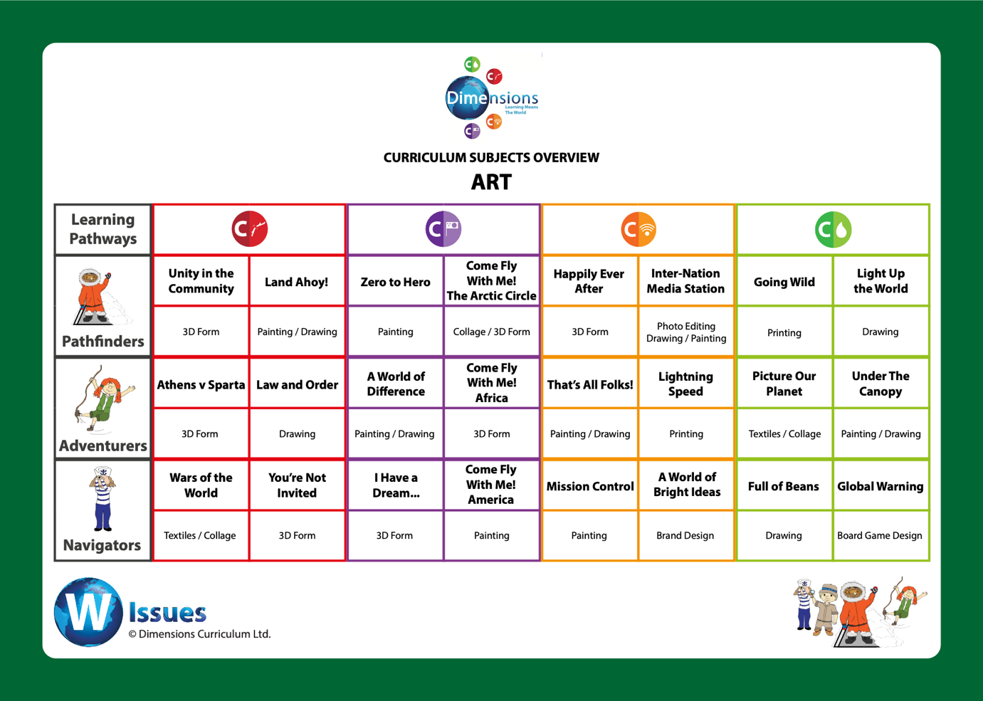
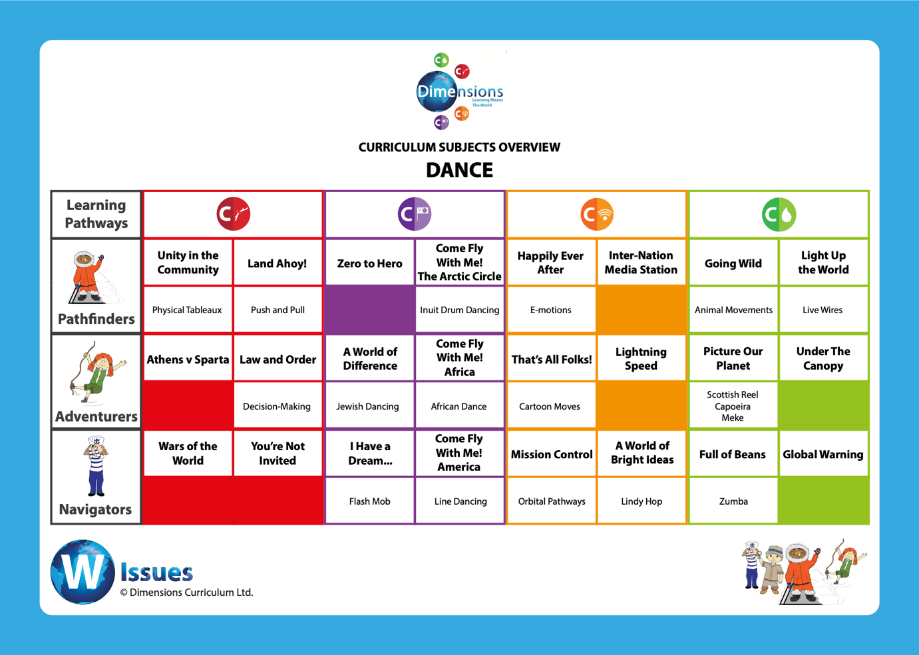
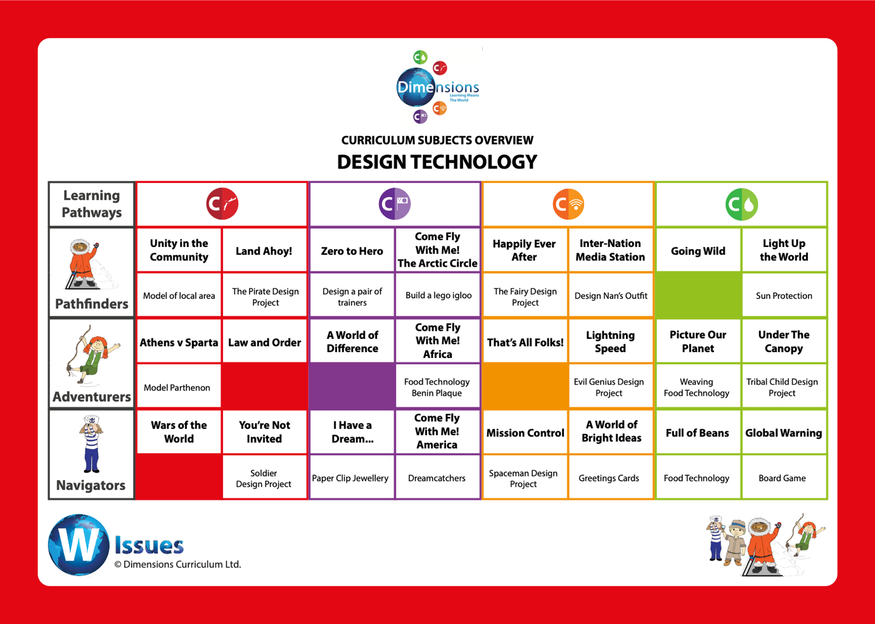
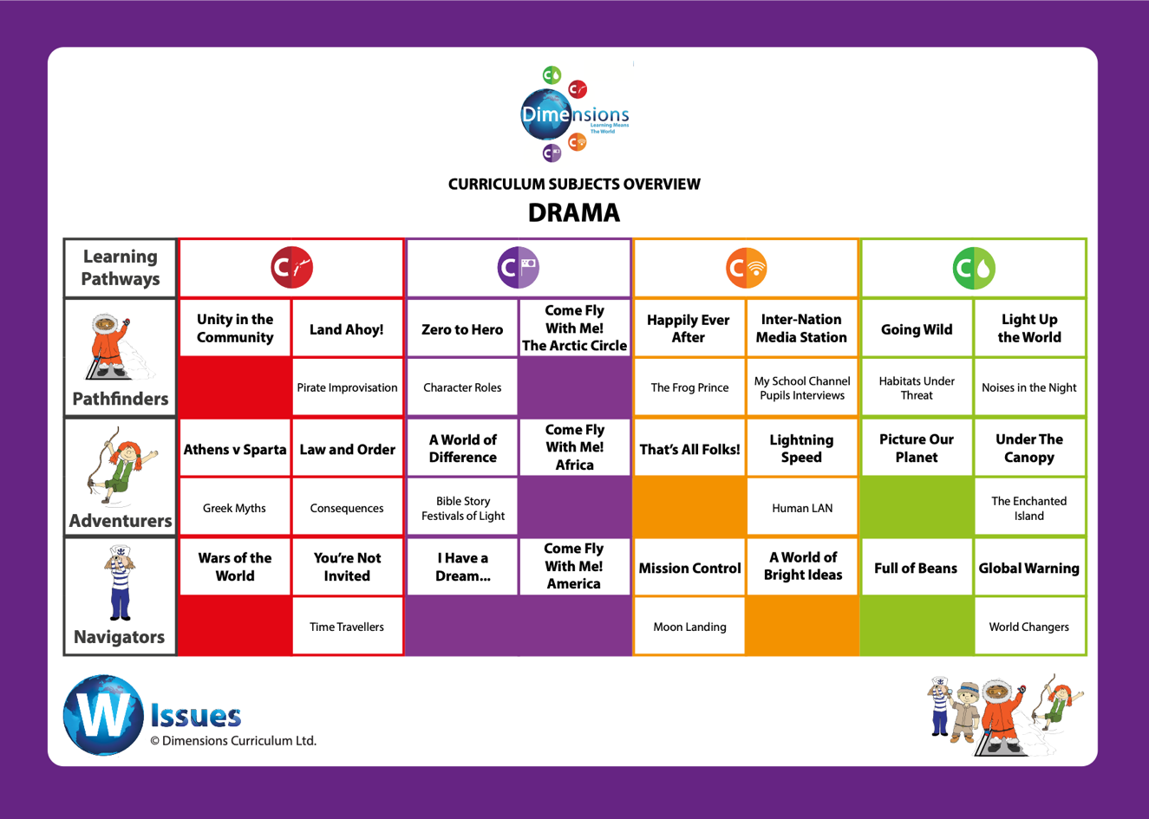
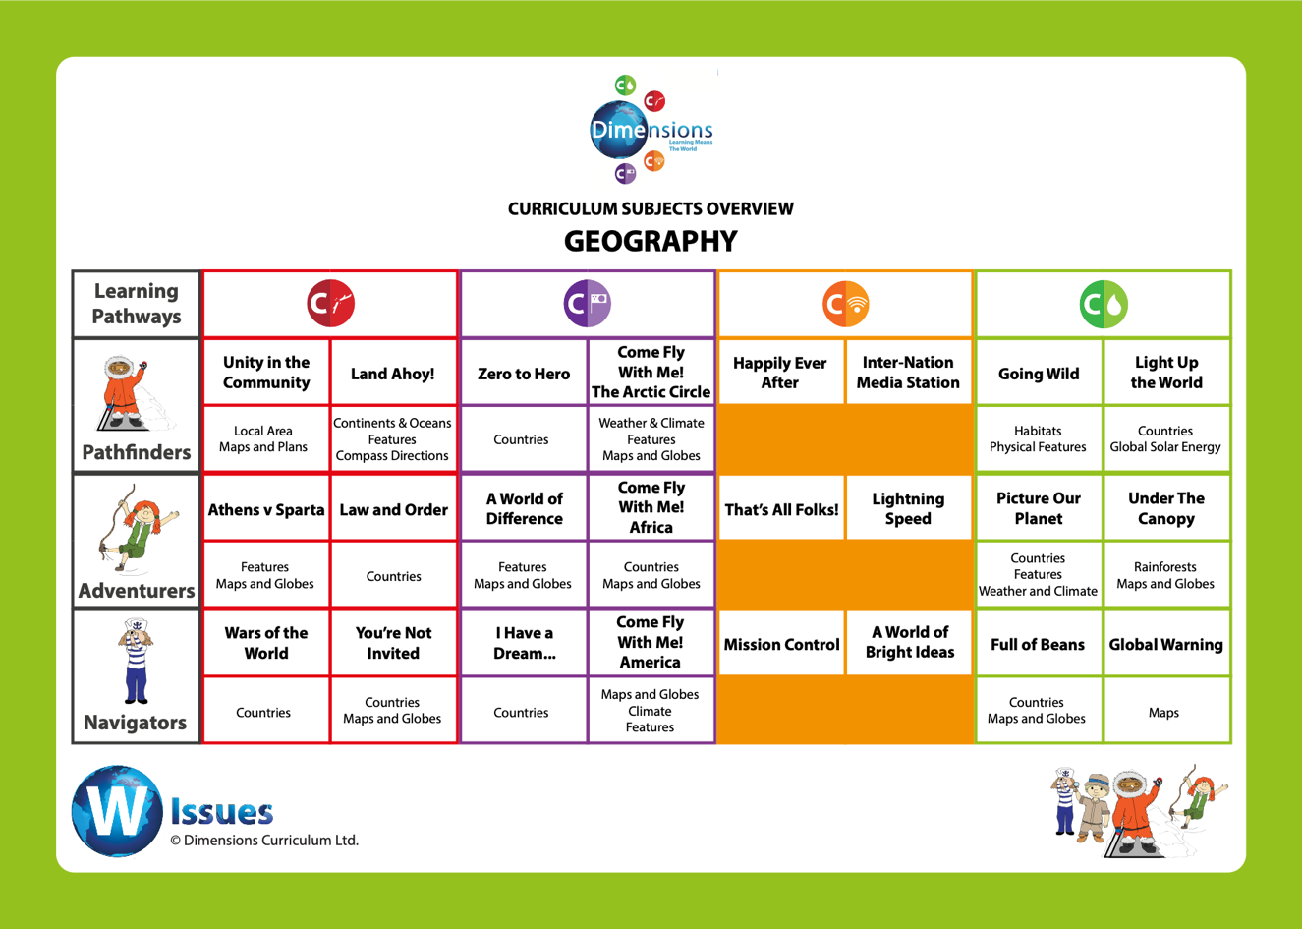
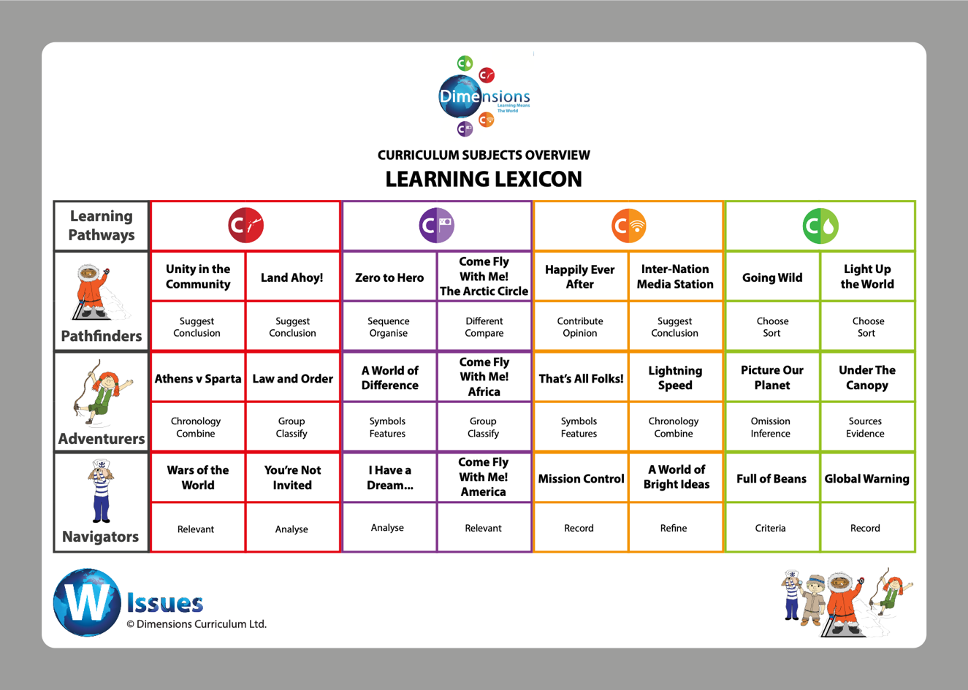
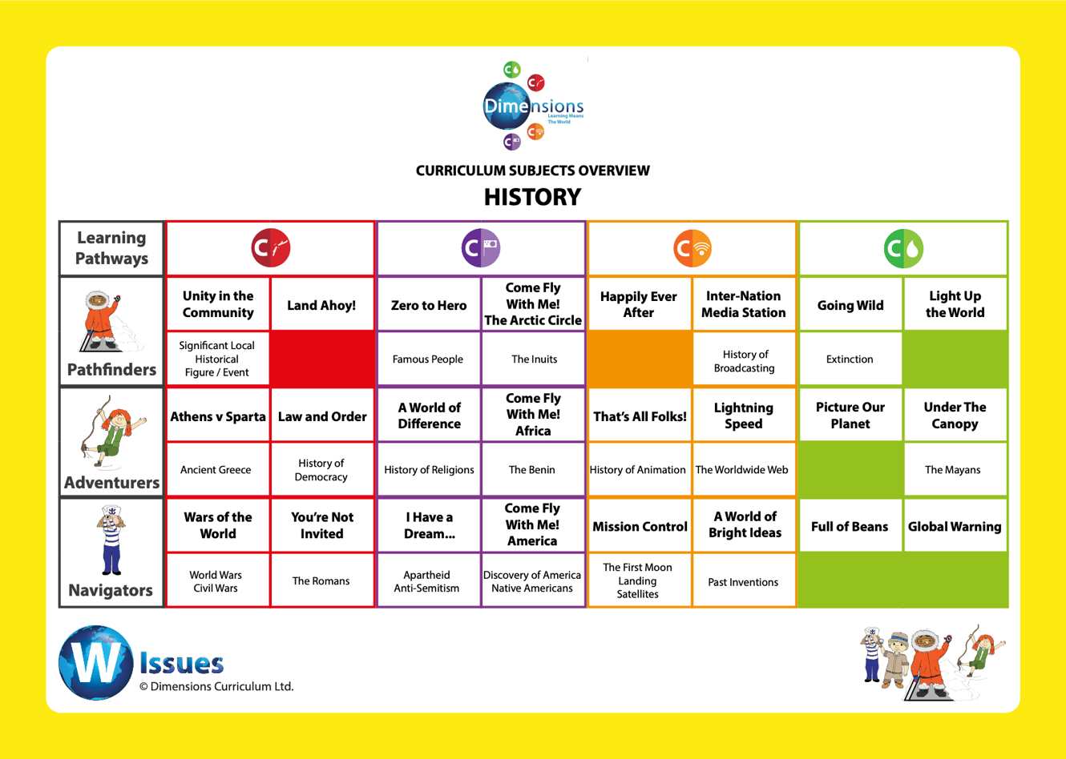

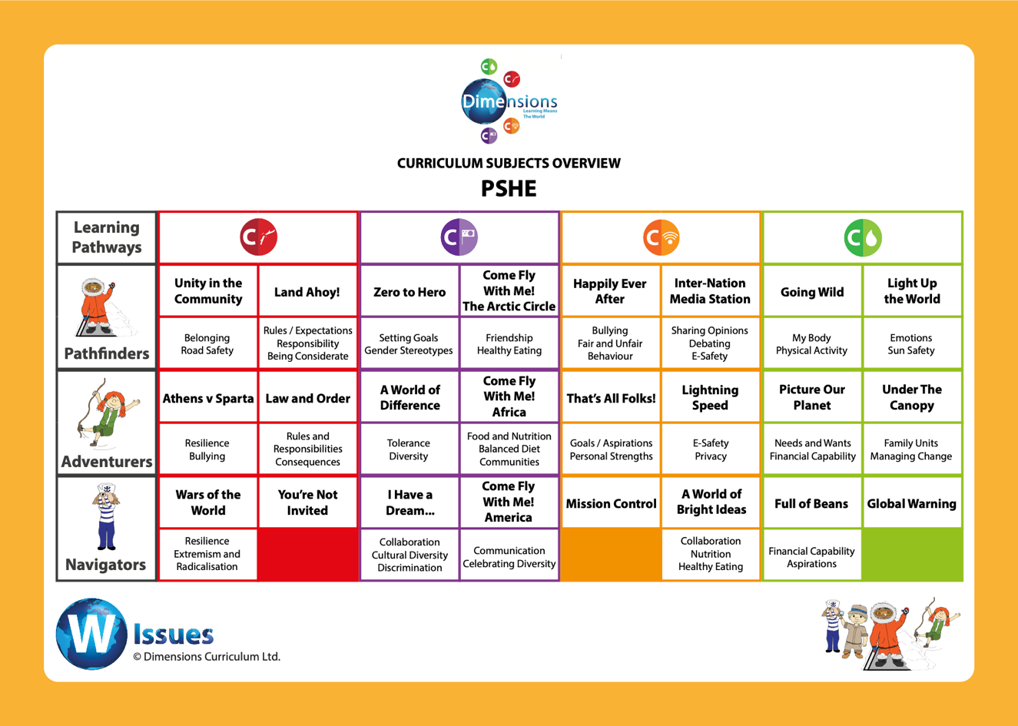
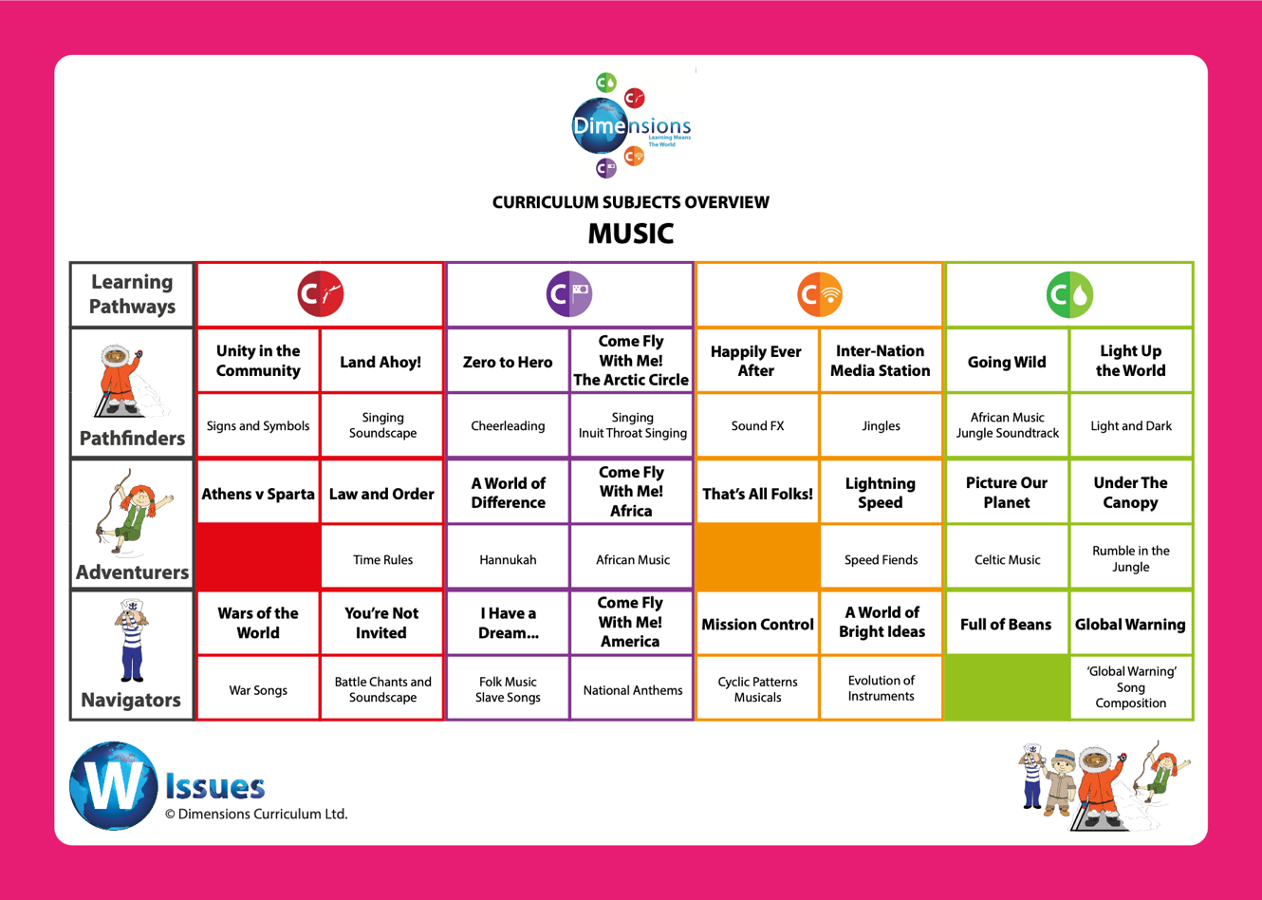
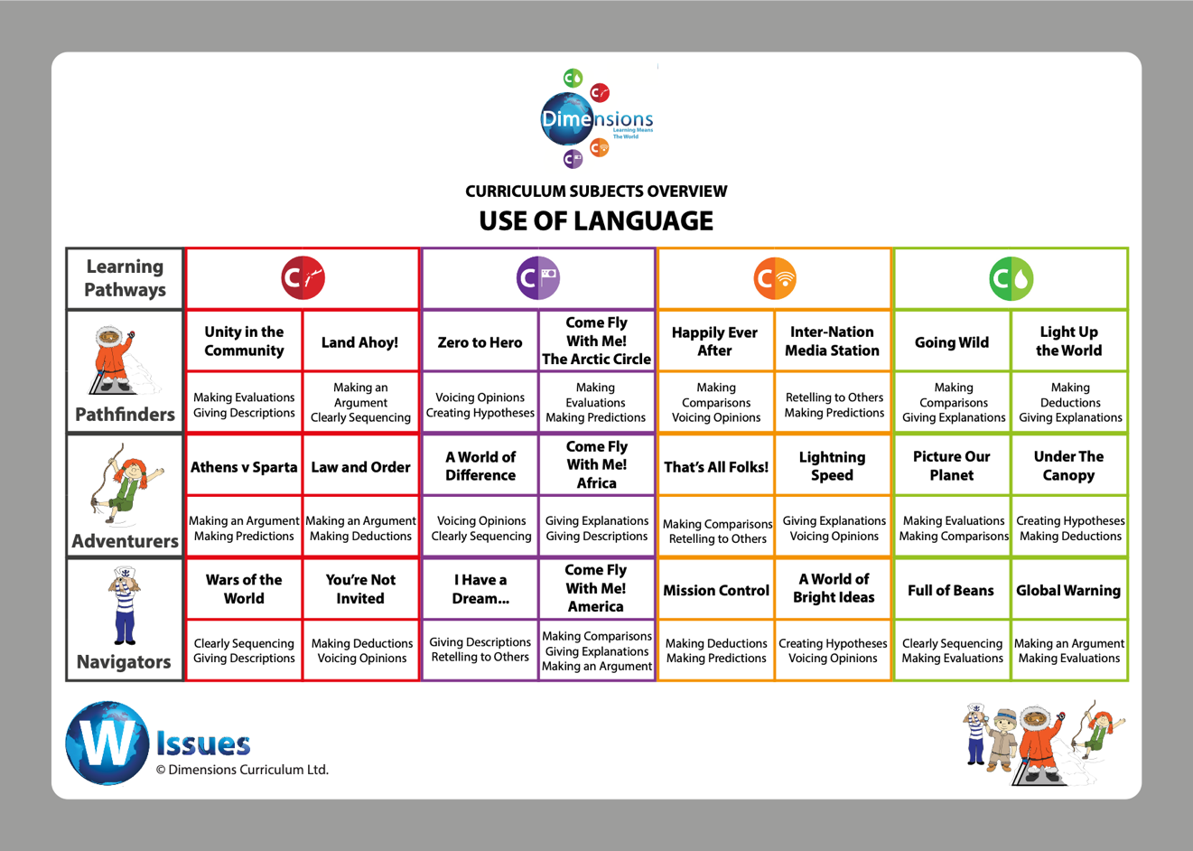

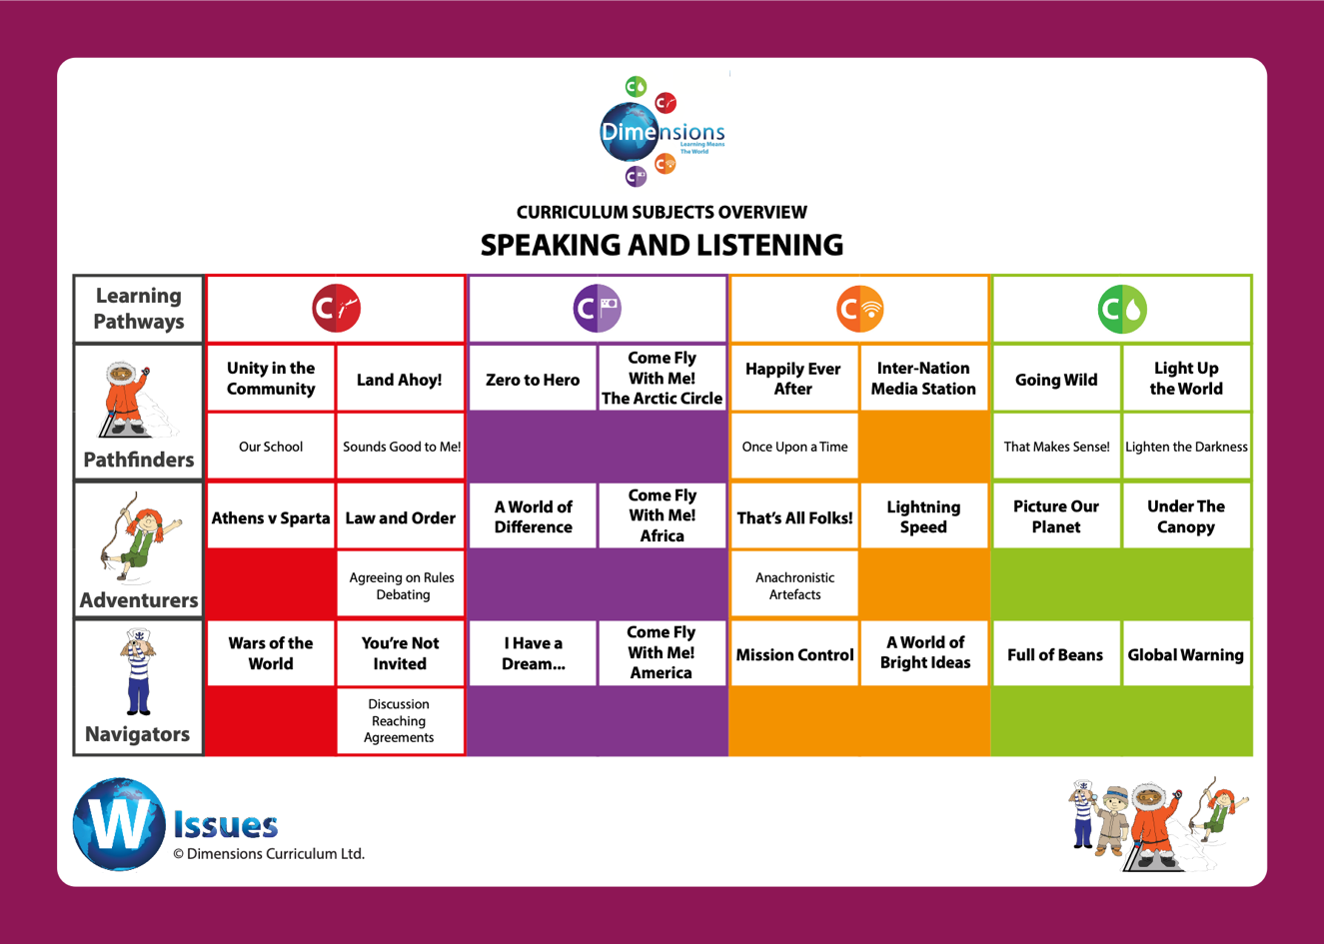

Science | 1 | 2 | 3 | 4 | 5 | 6
Communication | Happily Ever After  -Animals Including Humans | Inter-Nation Media Station  -Uses of materials | That’s all folks  -Light | Lightning speed  -Electricity | Mission Control  -Earth and Space | A world of bright ideas  -Living things
Conflict | Unity in the community  -Plants | Land Ahoy  -Plants | Athens vs. Sparta  -Forces and magnets | Law and Order  -Sound | You’re not invited  -Forces | War of the world  -Light
Culture | Come fly with me – arctic circle  -States of matter | Zero to Hero  -All Living Things | Come fly with me – Africa  -Animals including humans | Cry freedom  -Animals including humans | Come fly with me – America  -All living things | I have a dream  -Evolution
Conservation | Light up the word  -Seasonal Change | Going Wild  -Animals including humans | Under the Canopy  -Plants | Picture our planet  -All Living Things | Global Warming  -States of Matter | Full of beans  -Electricity
NC Essentials | Geography  -Never Eat Shredded Wheat | Geography  -Paddington’s Passport | Geography  -Out and about  Science  -Rocky the findosaur | Geography  -Three giant steps  Science  -Rocky the findosaur | Science  -Go with the flow (animals including humans)  Geography  -In your element | Science  -Go with the flow (animals including humans)  Geography  -Time team

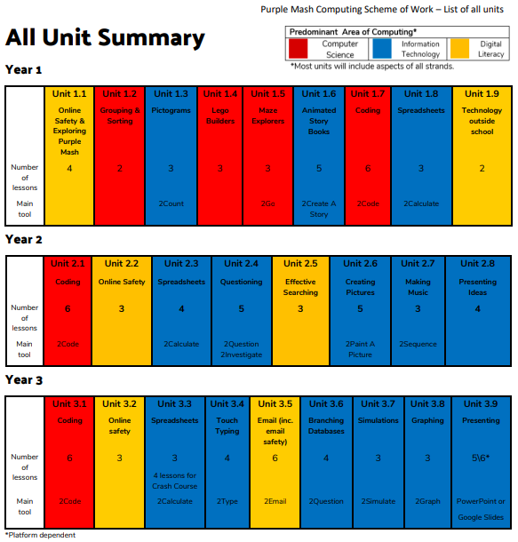
Computing
