

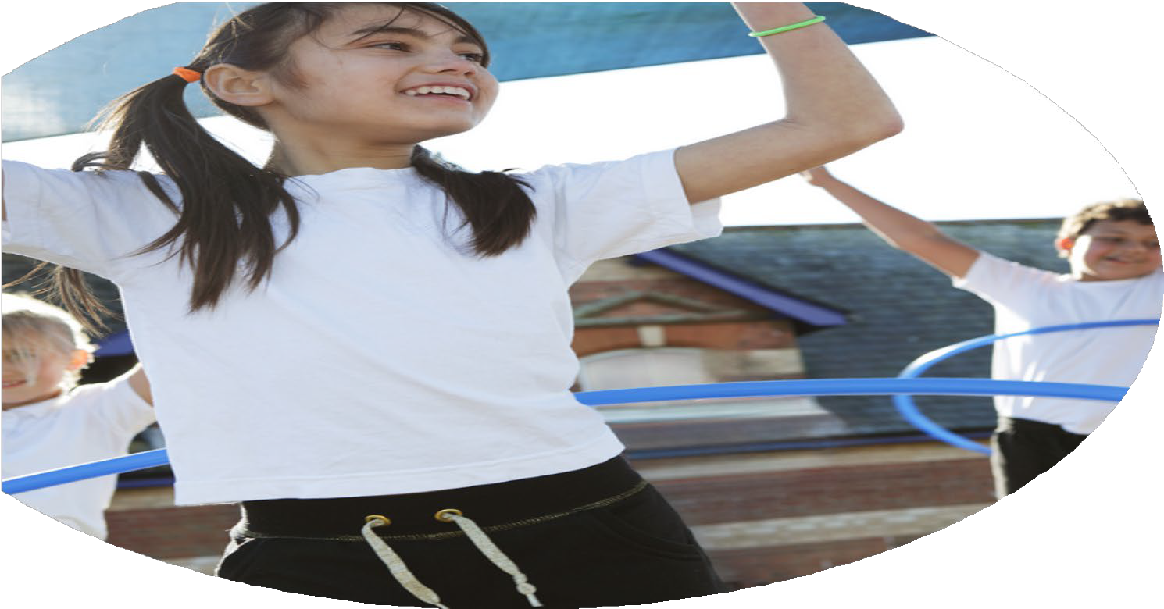





PE Funding

Evaluation Form

Commissioned by

Created by

Images courtesy of Youth Sport Trust
PE Funding Evaluation Form

It is intended that this template should be used as preparation for the completion of the statutory digital reporting tool being introduced this academic year. You can upload data (including swimming) from this template onto this platform once it becomes accessible.
Before you decide how you are going to use the funding for this academic year you should reflect and evaluate the impact of your use of the funding in 2023/24.
All spending of the funding must conform with the terms outlined in the Conditions of Grant document. The template is a working document that you can amend/update during the year.
Based on your evaluation of last year’s funding you should decide what you intend to do this academic year, how you will do it, and what impact you expect it to have.

It is important that the funding is used effectively and based on your school’s needs.
You must use the funding to make additional and sustainable improvements to the PE and sport in your school. You must develop and add to the PESSPA activities that your school already offers.

Summative digital reporting from June 2025 will continue to include swimming and water safety information therefore funding can be used to provide top-up lessons where necessary to ensure pupils meet national curriculum swimming requirements.
We recommend that you start by reflecting on the impact of current provision and reviewing your previous spend

What went well? | How do you know? | What didn’t go well? | How do you know?
Increasing staff confidence across key areas of learning, for example gymnastics safety and teaching technique.  Queens School Partnership introduced a number of sports. Collaborative working with a number of local schools through competitive supports. Gymnastics, athletics and  Sports Ambassadors Encourage physical activity, arrange games/sports for lunch time, Sports Day supporters, increase participation and healthy lifestyle choices.  For every child to see themselves as an athlete. Athlete visit, how they have overcome SEN need.  Extra-Curricular clubs | Staff CPD  Staff Voice  Staff Survey | Monitoring sessions/PE observations (timing issues).  Consistent Daily Mile throughout classes each day. | Lack of observation lessons to collect pupil voice with additional context.  Staff reported limited time for Daily Mile, especially during afternoon.

What are your plans for 2024/25? | How are you going to action and achieve these plans?
Intent | Implementation
To promote ‘Active 60’ across all year groups.  To identify ‘less active’ pupils and provide opportunities to increase time spent exercising (PPG, SEN focus).  To identify ‘less active’ pupils and provide opportunities to increase time spent exercising (PPG, SEN focus).  Using formative assessment to adapt lessons to increase understanding (in turn, improving summative assessment).  To increase range of Extra-Curricular Clubs taking place.  To increase participation in Extracurricular clubs.  ‘Personal Challenges’ linked to PE starters (implementation of School Games Mark).  Further development of diverse curriculum, including opportunities for alternative sports, eg Tri Golf 🡪 Linking to PPG opportunities, eg Get Golfing with Arkley Golf Club holiday camps. | Staff meeting introducing ‘Active 60’ including positives of physical exercise and providing activities to teachers that have low prep times and do not require lots of equipment.  Less active student questionnaire, also sent to parents to identify those children who would benefit from additional clubs, both outside and inside of school hours.  Coordinating with outside agencies to provide wide range of sports, different to those covered in the curriculum.

What impact/intended impact/sustainability are you  expecting? | How will you know? What evidence do you have or  expect to have?
Promoting ‘Active 60’ will contribute towards leaving a lasting legacy, giving the children a secure understanding of why physical activity is important. This would also continue the legacy of our first ‘Sports Week’ and increase the profile of the upcoming week at the end of the year.  Identifying ‘less active’ pupils will enable us to provide support to not only children, but parents/families on ways to increase exercise. This may include running extra-curricular clubs linked to their interest or providing suggestions on ways they can increase time spent outdoors (for minimal cost).  By increasing the range of extra-curricular clubs on offer, we will increase participation and exercise across the school. This will be further supported by ‘Active 60’ being promoted across the school by all staff members, also linking to lunch times (MSA). This is a sustainable step as the children will be taught games and activities in these sessions using minimal equipment that can be set up at lunch times and independently when the club ends. | Continued monitoring of activity levels every term (KS2 children to complete Google Form independently in Computing.  KS1 children to do a hands up survey with teachers). Promoting activity outside of school through teachers - sharing love for activity (does not have to be sports, could be walking, time spend outside etc).

What impact/sustainability have you seen? | What evidence do you have?
Staff CPD - Staff confidence is high on our priority list. If staff are not confident or able to teach a series of lessons, adaptations are made to ensure they can happen successfully.  Get Golfing - Through working with Get Golfing, we have been able to introduce students to a new sport that they had not tried before (Tri Golf). Equipment purchased for this to enable children to continue exploring the sport.  Sports Week - Annual event where we arrange for 2x athletes to visit school and run workshops with the children. This inspires them to take part in physical activity and increases the profile of PE across the school.  Events - We work in collaboration with our SGO who runs sporting competitions. We attend a variety of the events, promoting a love for exercise and supporting the development of teamwork and social skills.  After school clubs - These clubs provide children with the opportunity to develop a sport that they have a particular interest in. Sports club are free of charge, reducing any financial barriers for parents. | Open communication with staff who bring their concerns to me. Worries/concerns discussed and addressed with appropriate staff members to arrange adaptations (eg cover, CPD etc).  Pupil voice - All children engaged with Get Golfing sessions and raised positive points in regards to the sessions. Children from Kenilworth attending holiday camps at Arkley (free).  Pupil voice - Children excited about Sports Week, continued discussion through the year about Sports Week linking to school values (resilience, kindness etc).  Increased participation in competitions, pupil voice.  Increased levels of participation, pupil voice.

